CONVERGING AND DIVERGING LENS LAB

### Introduction

### Purpose To investigate qualitatively convergence and divergence of lenses.

**Discussion**

If a piece of glass or other transparent material takes on the appropriate shape, it will be capable of taking parallel rays of incident light and either converging them to a point or appear to diverge them from a point. Such a piece of glass is referred to as a lens.

A **lens** is a carefully ground or molded piece of transparent material which refracts light rays in such a way as to form an image. Lenses can be thought of as a series of tiny refracting prisms or lenses, each of which refracts light to produce their own image. When these prisms act together, they produce a bright enough image focused at a point.

There are two types of lenses: converging (convex) and diverging (concave). All lenses produce a REVERSED image.

**Materials** Video Links

<http://somup.com/cFf0F9V5Gq> Converging Lenses (2:05)

<http://somup.com/cFf0FsV5Gl> Diverging Lenses (1:37)

<http://somup.com/cFfhb7VpOt> Near Sighted Vision (2:05)

<http://somup.com/cFfO3EVEo7> Far Sighted Vision (0:58)

### Procedures

1. Watch the video links and complete the appropriate data table for each one.

2. Answer the questions and complete the diagrams in the next section.

### Calculations and Data

**Convex Lens (**Converging Lenses)

When the object is **beyond the focal point** …

|  |  |
| --- | --- |
| Describe the image. | |
| Erect or inverted image? |  |
| Regular or reversed image? |  |
| Smaller, same size, larger image? |  |

When the object is **inside the focal point**…

|  |  |
| --- | --- |
| Describe the image. | |
| Erect or inverted image? |  |
| Regular or reversed image? |  |
| Smaller, same size, larger image? |  |

**Concave Lens (**Diverging Lenses)

|  |  |
| --- | --- |
| Describe the image. | |
| Erect or inverted image? |  |
| Regular or reversed image? |  |
| Smaller, same size, larger image? |  |

**Near Sighted (Myopia)**

Draw a condition of near sightedness (myopia), showing light rays entering the eye and coming to a focal point in relation to the retina. How is this corrected?

**Far Sighted (Hyperopia)**

Draw a condition of far sightedness (hyperopia), showing light rays entering the eye and coming to a focal point in relation to the retina. How is this corrected?

### CONCLUSIONS AND QUESTIONS

1. What general kind of lenses were used in this lab?

2. What are the names of the converging and diverging lenses according to their curved shapes? Be sure to make clear what the converging lens is called and so forth.

3. What kind of images do these lenses normally produce (real or virtual)? Explain the difference between a real and virtual image.

**Honors**

1. Make a drawing of a convex lens with the object located at 2F from the lens. Show three incident rays and the resulting refracted rays.

2. Make a diagram showing how virtual image is produced using either a converging or diverging lens.

**Convex Lens (**Converging Lenses)

When the object is **beyond the focal point** …

|  |  |
| --- | --- |
| Describe the image. | |
| Erect or inverted image? | **Inverted** |
| Regular or reversed image? | **Reversed** |
| Smaller, same size, larger image? | **Smaller** |

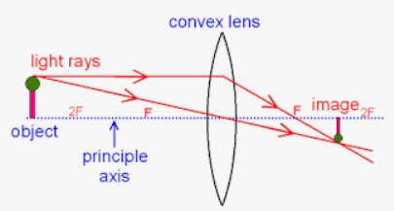

When the object is **inside the focal point**…

|  |  |
| --- | --- |
| Describe the image. | |
| Erect or inverted image? | **Erect** |
| Regular or reversed image? | **Reversed** |
| Smaller, same size, larger image? | **Enlarged (magnifying glass)** |

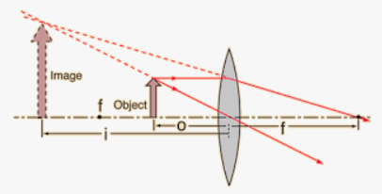

**Concave Lens (**Diverging Lenses)

|  |  |
| --- | --- |
| Describe the image. | |
| Erect or inverted image? | **Erect** |
| Regular or reversed image? | **Reversed** |
| Smaller, same size, larger image? | **Smaller** |

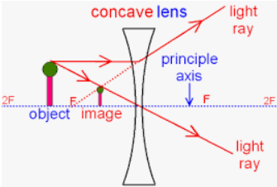

### Near Sighted (Myopia)

Draw a condition of near sightedness (myopia), showing light rays entering the eye and coming to a focal point in relation to the retina. How is this corrected?

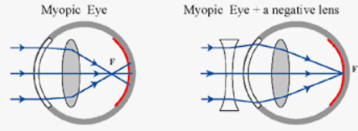

Near sightedness occurs because light converges to a focus BEFORE the retina, causing blurred vision for distant objects. People with myopia can see objects up close relatively clearly.

The condition is corrected using a diverging (concave) lens which diverges the incident rays so that the point at which they converge inside the eye is at the retina.

**Far Sighted (Hyperopia)**

Draw a condition of far sightedness (hyperopia), showing light rays entering the eye and coming to a focal point in relation to the retina. How is this corrected?

### 

Far sightedness occurs because light converges to a focus AFTER the retina, causing blurred vision for closer objects. People with hyperopia can see distant objects relatively clearly.

The condition is corrected using a converging (convex) lens which converges the incident rays so that the point at which they converge inside the eye is at the retina. Unfortunately, the convex eyeglasses causes magnification so people can see the wearer’s eyes as larger than normal.

### CONCLUSIONS AND QUESTIONS

1. The convex lens is a **converging** lenses. The concave lens is a **diverging** lens.

### Converging lenses are called convex lens and are thicker at their center than at the ends. Diverging lenses are called concave lenses and are thicker at the ends than in the center.

1. **Converging (convex) lenses** usually produce **REAL** images unless the object is inside the focal point. Then, it produces a virtual image**. Diverging lenses** usually produce **VIRTUAL** images. **Real images** are produced by **actual light rays and light energy**. Virtual images are only seen in our eye, but are not produced by actual light rays and light energy.

**Honors**

1. Make a drawing of a convex lens with the object located at 2F from the lens. Show three incident rays and the resulting refracted rays.

### F

### 2F

### 2F

### F

2. Make a diagram showing how virtual image is produced using either a converging or diverging lens.

