Heading

Title

**Introduction** This lab deals with a property of matter called density.

**Purpose**

To utilize an intensive property (density) in order to identify various materials and to investigate a real-life application of density.

**Background Information**

extensive properties

intensive properties

density

ways to measure volume

In this lab, you will determine the density of 4 substances and predict the order these substances will take on if mixed together.

|  |
| --- |
|  |
|  |
|  |

**Hypothesis**

If water, vegetable oil, and copper coins are mixed together, they will separate out according to their densities as follows:

**Materials**

Metric ruler 100 ml Graduated Cylinder Mass Balance

Water Vegetable Oil (yellow) 10 pennies / copper coins

Small wood block (regularly shaped to measure LWH) Food Coloring

12 oz. Diet Pop 12 oz. Regular Pop

###### **Procedures**

A. Finding Volumes

You will use THREE (3) different techniques to determine volume.

1. **Direct Measurement** of a **liquid** using the 100 ml graduated cylinder (ml).

Read the volume **measurement** shown on the graduated cylinder (*see sketch to the right*) by looking at the **meniscus** (*bottom of the “bubble”*).

20 ml

The reading to the right is ~22.5 ml. The last number (“.5”) is an estimate and may vary within reason.

2. **Regularly Shaped Solids**: Measure the Length (longest side) and the width (opposite length) and the height of a regularly shaped solid like the small block of wood. Then, multiply length (L) times width (W) times height (H) to get the cubic volume (cm3). cm3 = ml.

**L** (cm) **x W** (cm) **x H** (cm)= ____ cm3

**3. Water Displacement for NON-regularly shaped solids.**

a. Add a known amount of water to the graduated cylinder.

b. Read the volume to the nearest 0.1 ml (e.g. 4.0 ml to the left).

c. Gently add the copper coins to the graduated cylinder (to avoid water splashing out).

d. Read the meniscus of the water in the graduated cylinder (e.g. 6.0 ml).

e. Subtract the original volume of water in the cylinder to determine the volume of the substance.

(6.0 ml – 4.0 ml = **2.0 ml**)

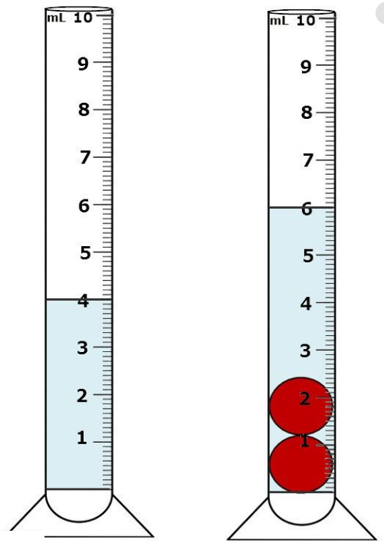

B. Finding Mass

You will use TWO (2) different techniques to determine the mass of a substance.

1. **Direct Measurement** of a **solid** using the mass balance (grams).

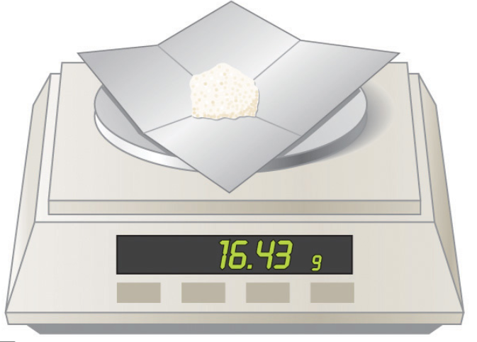

a. To protect your mass balance, add a filter paper or something to keep the surface clean. Then, “zero” the balance so as NOT to include the mass of the paper with the mass of the substance.

b. Read the mass of the **solid** shown on the balance to the nearest TENTH of a gram (e.g. 16.4 g).

2. **NON-Direct Measurement** of a **liquid** using the 100 ml graduated cylinder and the mass balance (grams).

a. Find the mass of the graduated cylinder ALONE.

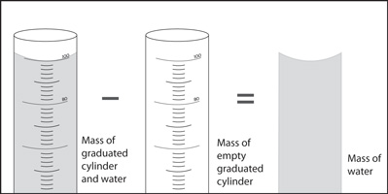

b. Find the mass of the graduated cylinder AND the liquid (water or vegetable oil) combined.

Mass of liquid ALONE.

Mass of graduated cylinder & liquid.

c. Subtract the mass of the EMPTY graduated cylinder FROM the mass of the graduated cylinder AND liquid (water or vegetable oil) combined.

d. Express the mass of the liquid ALONE to the nearest TENTH of a milliliter.

C. Procedures for the Density Lab

1. Determine the mass of the DRY, EMPTY Graduated Cylinder before doing any other measurements. Record this mass in the Calculations and Data section above the data table.

2. Find the mass of the 10 **copper coins** using the mass balance. Record this mass in the Calculations and Data section in the data table.

3. Find the mass of the **wood block** using the mass balance. Record this mass in the Calculations and Data section in the data table.

4. Measure the length (longest side), the width (opposite longest side), and the height of the **wood block**. Record these measurements in the Calculations and Data section below the data table.

5. Add a specific amount of **water** to the graduated cylinder that is an exact multiple of 10 ml (e.g. 20.0 ml, 30.0 ml, 40.0 ml).

a. Read and record this volume in the Calculations and Data section in the data table.

b. Place the graduated cylinder with the water on the mass balance. Record this mass in the Calculations and Data section in the data table.

6. Carefully/Slowly add the 10 **copper coins** (*to avoid water splashing out of the graduated cylinder*) and read the NEW volume to the nearest 0.1 ml. Record this volume in the Calculations and Data section in the data table.

7. Dry out the graduated cylinder as best as possible.

8. Add an amount of **vegetable oil** to the graduated cylinder between 10.0 and 20.0 ml. Read and record this volume in the Calculations and Data section in the data table.

9. Place the graduated cylinder with the vegetable oil on the mass balance. Record this mass in the Calculations and Data section in the data table.

10. Add a drop of food coloring to a small glass of water (at least 20 ml). The food coloring is just to make it easier to see the volume measurements. SLOWLY / CAREFULLY pour the colored water into the graduated cylinder that contains the vegetable oil.

a. The amount of water added does not have to be exact or recorded, but should occupy at least 20 ml in the graduated cylinder.

b. SLOWLY add ONE of the copper coins to the graduated cylinder.

c. Record your observations in the Calculation and Data section.

11. Take a picture or draw a sketch of what is in the graduated cylinder. Especially note the layers of the substances.

D. Real Life Application: Observing the effect of the density difference between Diet Versus Regular Pop.

1. Obtain a 12 ounce (355 ml) can of Pepsi or Coke, and a 12 ounce can of Diet Pepsi or Diet Coke (any diet brand should work).

2. Determine the mass of the soda pop cans and record on your data table in the calculations and data section.

3. Calculate the density of diet and regular pop.

4. Obtain a large pitcher or container that can completely submerse the cans. Fill the large container with water, leaving about 2 inches from the top. The water should be deep enough so you can easily tell which cans are floating and sinking.

5. Slowly place each can into the water one at a time. Record your observations.

6. Take a picture of the results and include it in the Calculations and Data section.

**Calculations and Data**

Mass of the EMPTY Graduated Cylinder:  **____ g**

**Density Data Table**

|  |  |  |  |  |  |  |  |
| --- | --- | --- | --- | --- | --- | --- | --- |
|  | Mass of  grad cyl | Mass of cyl + substance | Mass of substance | Volume (grad cyl) | Volume  (L x W x H) | Density | Identity of Substance |
| 1 | g | g | g | ml |  | g/ml | Vegetable Oil |
| 2 |  |  | g |  | cm3 | g/cm3 | Wood Block |
| 3 | g | g | g | ml |  | g/ml | Tap  Water |
| 4 |  |  | g |  | ml | g/ ml | 10 copper coins |

1. For the wood block #2 … show work for calculating the volume

length x width x height = ____ cm3

2. For 10 copper coins … show work for calculating the volume

(Volume of grad cyl, water, coins) - (Volume of grad cyl with water) = ____ ml

3. Show Work for Calculating the Density of each substance (to the nearest tenth):

a. Vegetable Oil #1

g / ml = g/ml

b. Wood Block #2

g / cm3 =

c. Water #3

g / ml = g/ml

d. Copper Coins #4

g / ml = g/ml

e. Diet Pop

g / ml = g/ml

f. Regular Pop

g / ml = g/ml

4. Include a picture of at least ONE of the substance measurements. Explain its relevance to the lab.

5. Include a picture of the pop can experiment. Explain its relevance to the lab.

The following Density Table gives densities as guidance for the substances in this lab.

|  |  |  |  |  |
| --- | --- | --- | --- | --- |
| Substance | Vegetable Oil | Wood Block | Water | Penny |
| Density | 0.9 g/ml | 0.6 g/ cm3 | 1.0 g/ml | 7.0 g/ml |

**Calculate the Percent Error for ONE of the substances based on your results:**

% Error = │(Accepted – Your Results)│ x 100% =

Accepted

D2. Diet Versus Regular Pop Data Table.

|  |  |
| --- | --- |
| **Data Type** | **Measurement of Data** |
| *Mass of Regular Pop (g)* |  |
| *Volume of Regular Pop (mL)* |  |
| *Density of Regular Pop (g/mL)* |  |
|  | |
| *Mass of Diet Pop (g)* |  |
| *Volume of Diet Pop (mL)* |  |
| *Density of Diet Pop (g/mL)* |  |

## 3. Show the density calculation

## Conclusions

Layers of Substances

|  |
| --- |
|  |
|  |
|  |

Address Hypothesis

Analysis

(*address content from background information using evidence from the lab*)

Questions

1. What kind of quantifying properties are mass, weight and volume?

2. What kind of quantifying property is density? How is this kind of property different than those in question #1?

3. Given that the density of glycerol is 1.261 g/mL, how much will 15.00 mL of glycerol weigh?

4. Based on the percent error calculated for one of your density measurements, were you accurate and/or precise? Explain.

5. Based on real life application, how can one tell that one type of soda pop is different than another using density?

**Error**

**Bibliography**