**Introduction**

**Purpose** To observe and classify animals according to phyla and class.

# **Materials** Class Notes, Textbook, internet Animal Phyla Project PPT

1. Download and open the “Animal Phyla Project PPT” (PowerPoint) from Learning CTR Online.

2. Click on the first slide and make a title page using the text art button. Include:

* Title of Power point (*your choice*)
* course (*Biology*)
* date
* topic (*Classification of Animals*)
* your name

3. Go to the second slide to begin with the first INVERTEBRATE organism based on the phyla in the animal kingdom from simplest to most complex.

1. Include the following on each of the invertebrate slides:
2. phylum of invertebrates and an example
3. image(s) of organism(s) in the phylum
4. Description / Characteristics of organisms in that phylum – **USE THE INTERNET science websites only (not Wikipedia, encyclopedias, etc.)**.
5. Images are stored in a Google Drive file or use the internet
6. You will need to get permission from the teacher to access “Google Drive” where images are stored.
7. Locate the “Animal Phyla Project” folder on google drive … click on that folder.
8. Click on the “a” folder for this slide, the “b” folder for the next slide, etc.

4. Create slides for the phyla in folders “a” – “h”. Use class notes, textbook, or the internet to insert the required information:

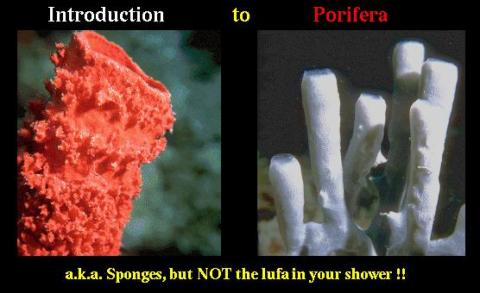

* The first phylum is Porifera.
* Sponges are an example.
* Insert an image.
* Give description or characteristics of Porifera.

You may use images from the internet. Be sure to cite the reference below the image if you do.

5. After completing the non-chordate invertebrate phyla slides, click on the “Chordate” folder of the “Animal Phyla Project”, designated with an “i”.

6. Create slides for each **CLASS** of Chordate in the Chordate folder (i).

* The first ‘class’ is Agnatha.

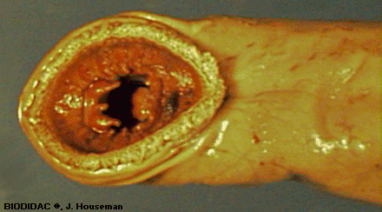

* Lamprey are an example.
* Insert an image.
* Give description or characteristics of Agnatha – **USE THE INTERNET science websites only (not Wikipedia, encyclopedias, etc.)**.

7. You should have slides for folders “a” – “g” from the Chordate phylum.

Final Notes

* Be creative.
* You may include extra slides to show more pictures or place more than one picture on a slide. Most folders contain multiple pictures of organisms.
* There is a sample “Animal PPT Sample” as a guideline. Do you own work!
* **When completed,**

1. **Go to “File”.**
2. **Scroll down to “Save As”.**
3. **Make a PDF version of your FINAL Power Point.**
4. **Email the PDF to** [**learningctronline@gmail.com**](mailto:learningctronline@gmail.com) **.**