**Trees 2**

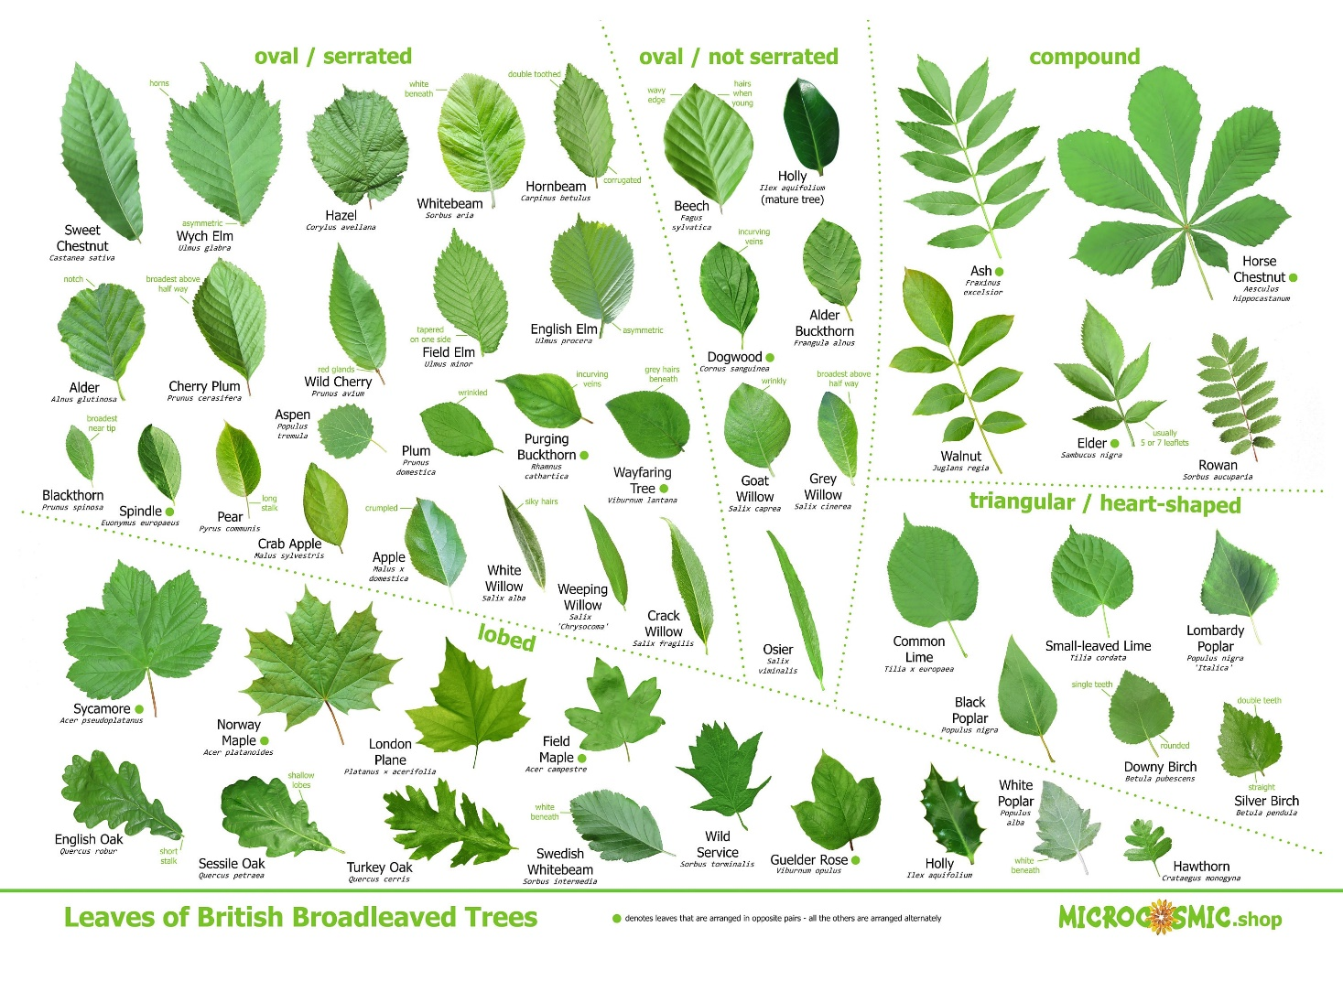

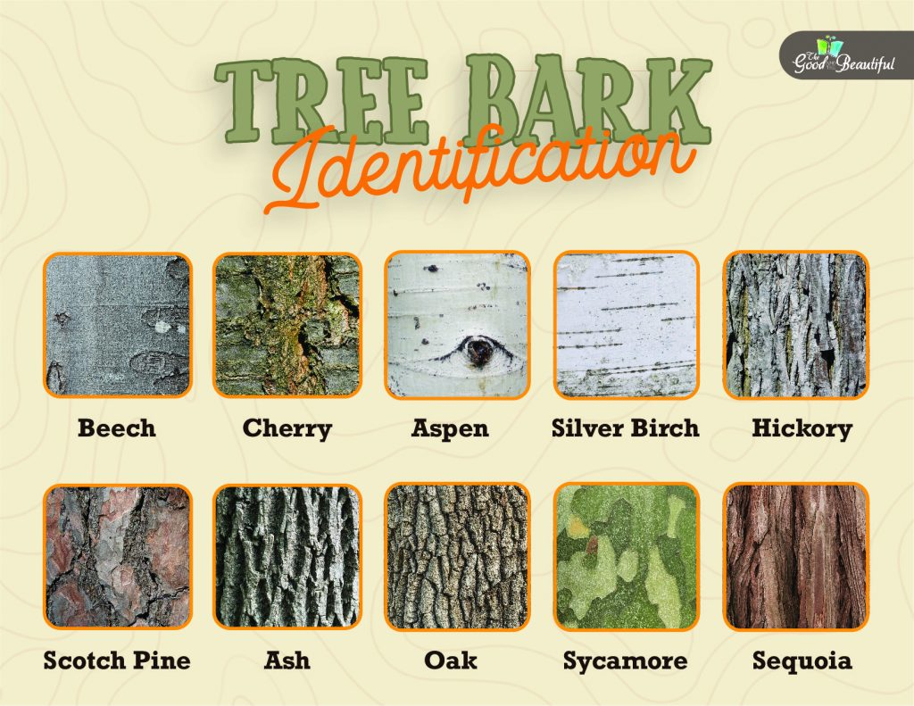

**See** [**https://www.learningctronline.com/courses**](https://www.learningctronline.com/courses) **for Materials and Resources.**

**Topics:**

1. Trees

**Objectives:**

* + Identify Trees Using Dichotomous Key
  + Continue Tree & Poisonous Plant Scrapbook Project

TAKE NOTE

1. Review Tree & Poison Plant Scrapbook [due in 2 weeks]
2. In Class 🡪 Dichotomous Tree Key with PowerPoint (Alternate Branching)
3. Tree ID Lab using PPT
4. Field Activity – Key Out Trees Outdoors
5. Week 6 Devotional (<https://www.learningctronline.com/devotional>)

**Text**: Peterson Field Guide to Trees

**Reference Material: Tree ID PowerPoint**

**Homework**:

* Work on Tree & Poisonous Plant Scrapbook
* Field Guide Trees from Library

**Lab**: Tree ID

* Use the PowerPoint “Tree ID Lab” and the worksheet provided.
* Save the document into your LAB folder in the Projects in Science folder on your desktop.

**Lab**: Field Activity – Key Out Trees Outdoors

* Use the dichotomous key to identify at least 10 trees in your yard or nearby fields.
* Complete the “Field Activity Keying Out” Worksheet provided.
* Save the document into your LAB folder in the Projects in Science folder on your desktop.

**TEST: Tree ID (Slide Show 1-26)**

1) the academic integrity policy

* Tests must be completed **WITHOUT** referring to books, notes, the internet, people, or any outside resources.
* Students **MAY** use the approved Periodic Tables, approved Reference Tables, or approved equation (formula) sheet (provided by the teacher) along with calculators and scratch paper.
* A guardian should be proctoring the test. Proctoring means to monitor the following:

2) Take the **"in one sitting"**, meaning that once you start the test, you must complete it without interruption.

3) There is a **15-minute time limit** on this test. Please have the proctor write the time taken at the top of your answer sheet with their signature or initials.

4) Proctors should NOT be reading the test or engaging students during the test.

5) Do NOT use RED font. Black font is best.

Supplemental Resources (Optional)

1. Websites Worksheet
2. Field Guide to Trees