Electrochemistry

E_____ translates the _____ energy of a reduction–oxidation reaction into _____ energy.

* In a _____ reaction, if the substance being oxidized and the substance being reduced are in _____ with one another, a transfer of energy as _____ accompanies the transfer of _____.
* When the substances being oxidized and reduced are _____ from one another, the _____ _____ is accompanied by a transfer of _____ energy instead of heat energy.

_____ Types of Electrochemical Cells

* _____ cells: Chemical reactions generate _____ energy; _____
* _____ cells: Electrical energy decomposes _____ compounds; _____

Electrochemical Cells

1. When the substances involved in oxidation and reduction half–reactions are _____ _____, it is called an _____ cell.

2. Each half reaction occurs on the surface of an electrically conductive solid called an _____.

3. Each electrode is immersed in an _____ solution containing _____ needed for the _____ –reaction.

4. The electrodes are connected by a wire so that _____ can move _____ the _____ half–reaction ___ the _____ half–reaction.

5. The solutions are connected by a _____ _____ or porous membrane so _____ can move between solutions.

6. The chemical potential energy can be harnessed as the substances undergoing oxidation push _____ through the wire to the substances undergoing reduction.

Components of Electrochemical Cells

_____

* The electrode in the electrochemical cell where _____ occurs.
* Anions are attracted to the anode (negatively charged in this case) that is _____ electrons in the half reaction.
* i.e. Zn0*(s)* 🡪 Zn+2(aq) + 2 e-

_____

* The electrode in the electrochemical cell where _____ occurs.
* Cations are attracted to the cathode (positively charged in this case) that is _____ electrons in the half reaction.
* i.e. Cu+2*(aq)* + 2 e- 🡪 Cu0*(s)*

_____ _____

* The salt bridge (porous membrane) allows _____ of _____ into those solutions to maintain electric _____ without mixing of solutions.
* Different kinds of electrochemical cells (electrolytic vs. voltaic) use different kinds of salt bridges or solutions.
* Contains _____ solution. Allows ions to flow between half-cells. Prevents _____ of charge on the electrodes. Completes the electrical _____ by allowing ions to flow.

STANDARD _____ POTENTIAL (SRP)

* Since one half-reaction does not occur without the other half-reaction, it is impossible to measure electrode potentials of the separate half-reactions directly.
* The _____ cell potential is the difference between the reduction potential of the cathode and the reduction potential of the anode (reverse reaction to oxidation):

E0cell = E0_____ + E0_____ .

* The term “_____” comes from using the hydrogen electrode as the _____ half–reaction: [2___+ + 2 *e*– 🡪 ___2]. This electrode is defined as having an electrode potential of exactly ___ V.
* To obtain standard _____ potentials, the magnitude is the same, but the sign is _____. [SRP = -3.05; SOP = +3.05]
* E0cell = E0_____ + E0_____ is used to determine the standard cell _____ for any electrochemical cell.

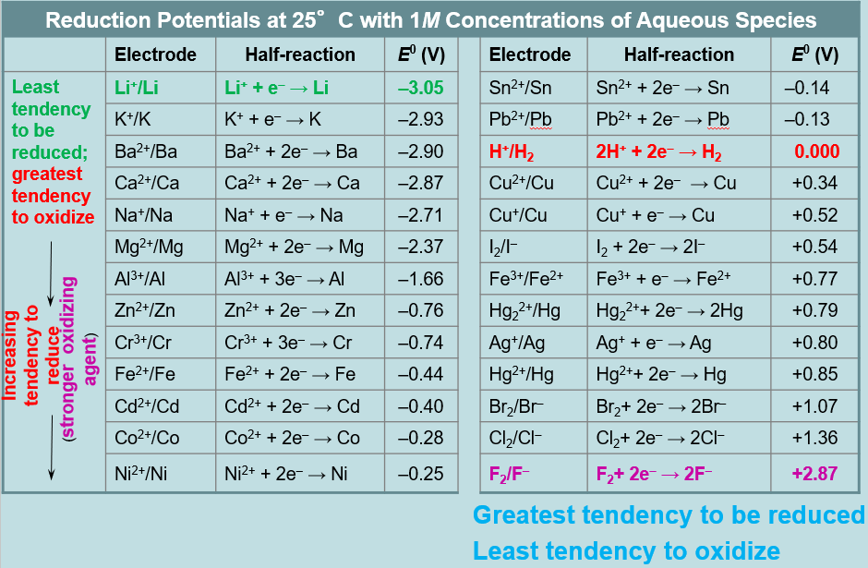

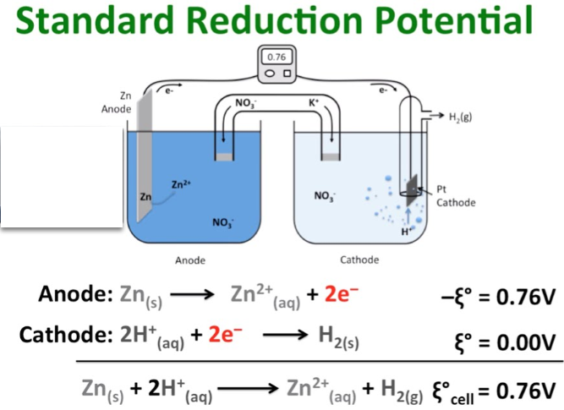

CALCULATING POTENTIALS IN HALF REACTIONS

Consider the reaction between magnesium metal & copper ions:

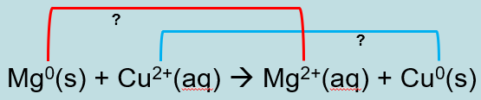

* In this reaction magnesium metal (Mg) is being _____ to magnesium ion, while copper (Cu) in aqueous solution is being _____ to copper metal (solid).
* Looking at the standard reduction potentials table for each element we find the following:

Mg2+ (aq) + 2 e- 🡪 Mg (s) E0 = _____volts (SRP)*  
Cu2+ (aq) + 2 e- 🡪 Cu (s) E0 = _____ volts (SRP)

*\*notice magnesium is NOT reduced but oxidized*

Change the SRP to match the actual reaction. In the above reaction, magnesium is oxidized and copper is reduced. Therefore:

*Oxid ½ reaction*: ___(s) 🡪 ___2+(aq) + 2 e- E0 = _____ volts*

*Red ½ reaction*: ___2+(aq) + 2 e- 🡪 ___(s) E0 = _____ volts

net potential for the overall reaction: _____ V

*\*notice the sign for the oxidation ½ reaction was reversed*

This represents the _____ voltage produced in this electrochemical cell.

Types of Electrochemical Cells

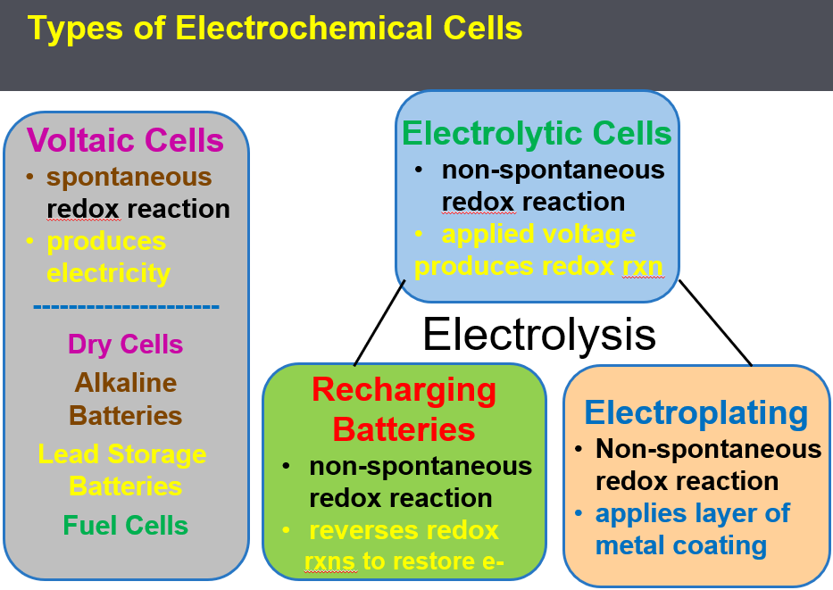

Voltaic Cells

* Also called _____ Cells. Electrons are _____ produced at the _____ (_____) and migrate to the _____ so that _____ can occur. Each electrode is placed in an aqueous solution matching the electrode. The half reactions are kept separate in “cells,” connected by a salt bridge.
* Redox reactions in voltaic cells [_____ *cells,* _____ *storage &* _____ *batteries,* _____ _____ *as in cars*] take place in aqueous solutions (*in this case ZnSO4(aq) & CuSO4(aq)*) to allow ion migration.
* The electrons are “pumped” from the _____ towards the _____, supplying _____ to some resistance (*bulb, motor, cell, door bell, keypad, etc*.).

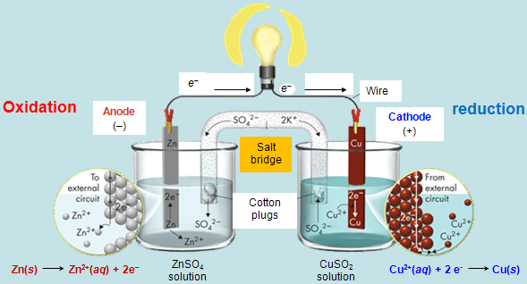

* Electrons are produced at the _____ so it is designated with a _____ charge in voltaic cells. The electrons migrate and are attracted to the cathode, therefore, the cathode is often denoted with a positive sign.
* To maintain electrical _____, _____ must migrate: cations towards the cathode and anions towards the anode.
* The _____ bridge completes the _____ so that current (_____) can flow. If the circuit is “broken,” the half reactions will not occur.
* The _____ are the source of potential in the voltaic cell.
  + As the electrons _____ the anode (Zn), the Zn metal disintegrates.
  + As the electrons _____ at the cathode (Cu), the Cu metal increases in mass at the cathode.
* Once the redox reaction reaches _____, the voltage is _____.

Calculate the _____ of the Zinc-Copper   
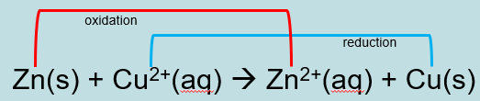

Zn2+(aq) + 2 e- 🡪 Zn(s) E0 = - 0.76 volt (SRP)  
Cu2+(aq) + 2 e- 🡪 Cu(s) E0 = +0.34 volts (SRP)

*Oxid ½ reaction*: ___(s) 🡪 ___2+(aq) + 2 e- E0 = _____ volts*

*Red ½ reaction*: ___2+(aq) + 2 e- 🡪 ___(s) E0 = _____ volts

net potential for the overall reaction: _____ V

*\*notice the sign for the oxidation ½ reaction was* _____

Voltaic Cells

* A _____ cell is a voltaic cell in which the electrolyte is a paste. Dry cells have a _____ shelf life and a voltage drop when used.
* The _____ battery is an improved dry cell. This change eliminates the _____ of ammonia gas and maintains the zinc electrode, which corrodes more slowly under basic, or alkaline, conditions.
* A _____ Storage Battery is a group of voltaic cells connected together. A 12-V _____ battery consists of six voltaic cells connected together. The electrolyte for both half-cells is _____ acid. Using the same _____ for both half-cells allows the cell to operate without a salt bridge or porous separator.
* _____ Cells are voltaic cells in which _____ energy is _____ obtained. Fuel cells do not have to be recharged.
* Fuel cells consist of an [anode](https://en.wikipedia.org/wiki/Anode), a [cathode](https://en.wikipedia.org/wiki/Cathode), and an [electrolyte](https://en.wikipedia.org/wiki/Electrolyte) that allows positively charged hydrogen ions (or protons) to move between the sides of the fuel cell. Fuel cells are 2-3 times more efficient than combustion engines, producing water and heat.
* Scientists use the known standard oxidation-reduction potentials to predict _____: *E*0cell value. E0cell = E0_____ + E0_____

Electrolytic Cells

* _____ uses an electric current (“electro”) to _____ (“lysis”) a compound into its elements, including many important industrial reactions such as the electrolysis of brine (*NaCl into sodium and chorine gas*), electrolysis of aluminum oxide to _____ and oxygen gas, and the electrolysis of _____ into hydrogen and oxygen gases.

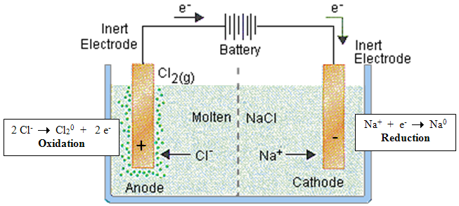

* _____ -spontaneous: The electrons are being _____ in a direction opposite of a spontaneous reaction using an _____ DC _____.
* The _____ (_____) is designated _____ [*cations (positive sodium ions above) are attracted to it*]. The power source forces reduction at the cathode: Na+ + e- 🡪 Na0, forming sodium metal.
* The _____ (oxidation) is _____ [anions (*negative chlorine ions above*) are attracted to it]: 2 Cl- 🡪 Cl20 + 2 e-, forming chlorine gas

Use the SRP reference table to determine the potential required to electrolyze sodium chloride into its elements.

Oxid ½ reaction: 2 Cl- 🡪 Cl20 + 2 e- E0 = _____ volts

Red ½ reaction: 2(Na+ + e- 🡪 Na0) E0 = _____ volts

E0cell = E0oxid + E0red = (_____ V) + (_____ V) = _____ V

Non-Spontaneous Redox Reaction

Electrolytic Cells - _____

* _____ -Spontaneous Redox Reaction requiring a _____ source.
* Electroplating is the _____ of a metallic _____ [*nickel in this case*] on an object at the _____ by exposing it to a salt solution [*e.g. nickel chloride in this case*] of the metal to be deposited and then, putting a negative charge on the object, so positively charged metal ions [*Ni+2 ions in this case*] in the salt solution are reduced to the metallic form at the anode.

The Process of Electroplating

* _____ (_____) [+ terminal] … Cu0(s) 🡪 Cu2+ + 2 e-
  + The anode is made of the metal _____ for the plating
  + The anode metal gets _____ _____
* _____ (_____) [- terminal] … Cu2+ + 2 e- 🡪 Cu0(s)
  + The cathode metal gets _____
* Electroplating is used to prevent _____, increase wear resistance, enhance the _____ of an object, and to build up thickness on undersized parts.

_____ Batteries

* When a battery (_____ cell) is discharged [image below on the left], _____ proceeds at the _____ electrode (_____), and _____ occurs at the _____ electrode _____.
* To _____ a battery (electrolysis), the direction of electric _____ flow is _____ so the opposite reactions take place. [image below on the right]
* Reduction proceeds at the former anode (negative electrode … now the cathode), and oxidation takes place at the former cathode (positive electrode … now the anode).

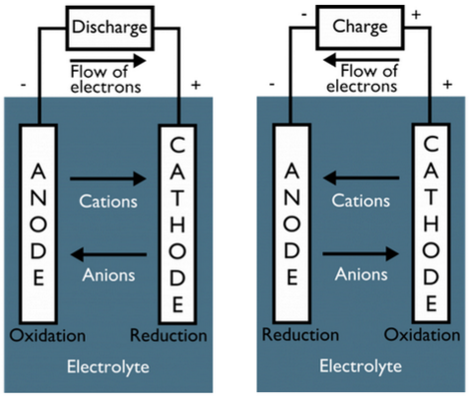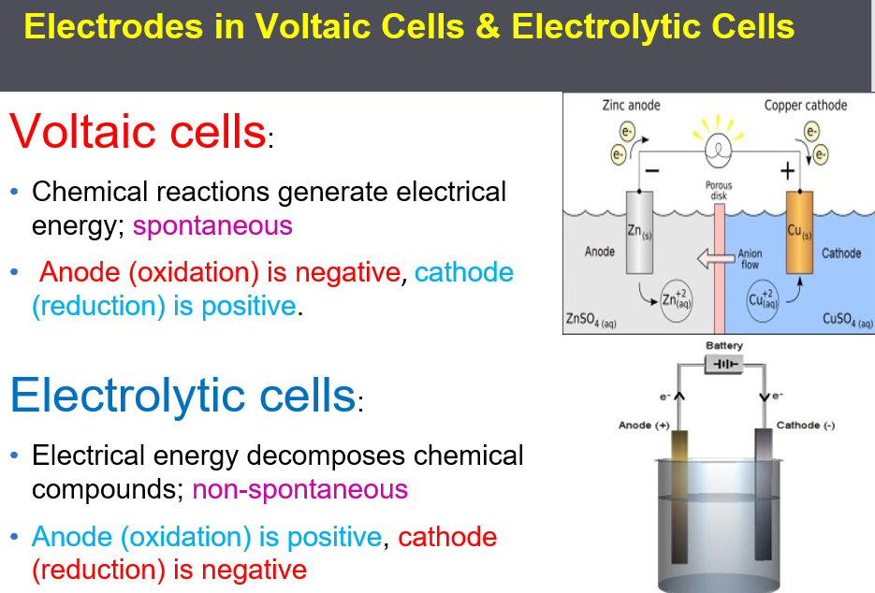

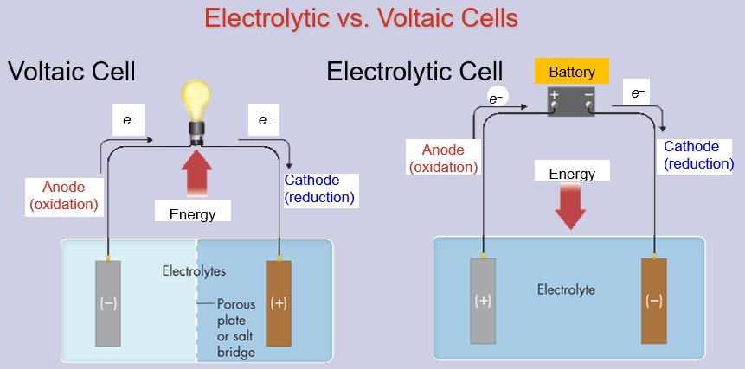

* In both voltaic and electrolytic cells, (_____ flow (_____ the anode (_____ the cathode in the external circuit.
* In a voltaic cell, the flow of electrons is the result of a (_____ redox reaction, whereas in an electrolytic cell, electrons are caused to flow by an (_____ power source, such as a battery.
* In a voltaic cell, the (_____ is the negative electrode and the (_____ is the positive electrode. In an electrolytic cell, the signs are (_____.