Name _____ Teacher, Day, Time ____

State Objective: E3.3A Explain how plate tectonics accounts for the features and processes (sea floor spreading, mid-ocean ridges, subduction zones, earthquakes and volcanoes, mountain ranges) that occur on or near the Earth’s surface.

Scientists have found that the top solid part of the Earth, the lithosphere, is broken into a number of large pieces called ***plates***. These plates are constantly in motion, with some plates moving into one another, while others are separating. **Label the plates below:**

Click on the link: <https://seismic-explorer.concord.org/>

1. Click on “Data Type” at the bottom of the screen. Click on Volcanic Eruptions.

2. Click on start and let the simulation run and STOP it at each major time interval (1990, 2000, 2010, 2024).

How does the volcanic activity change over time from 1980 to 2024?

3. Click on “Data Type” at the bottom of the screen again. Click on Plate Boundaries, Plate Names, Continent and Ocean Names.

Go to the next page and label the plates.

4. Click on “Data Type” at the bottom of the screen again. Unclick all the options and then click on Plate Movement.

Identify the type of plate movement by clicking on the smallcase “i” at one of each of the colored movement types.

Describe the different types of plate movement (yellow, green, pink).

Yellow 🡪

Green 🡪

Pink 🡪

Label the Tectonic Plates

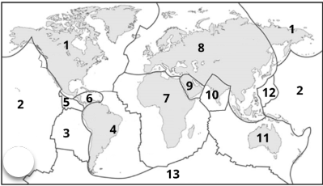

**1. 8.**

**2. 9.**

**3. 10.**

**4. 11.**

**5. 12.**

**6. 13.**

**7. 14.**

Pacific, North American, Eurasian, African, Antarctic, Indian, Australian, South American, Nazca, Philippines, Arabian, Caribbean, Cocos



**Observations**:

1. On which plate is most of the continental United States located?
2. On which plate is the southwestern portion of California located?
3. The place where two plates in answers #1 and #2 meet is called the San Andreas Fault. Why do you think many earthquakes form there?
4. Notice that part of Asia is on the Indian plate that includes Australia (some scientists call this the “Indo-Australian Plate”). What country is located on its northwestern tip?
5. The part of Asia where India lies is moving northwest into the rest of Asia. The Himalayan Mountains are located where these two plates meet. How do you think these mountains were formed?

ANSWERS

Click on the link: <https://seismic-explorer.concord.org/>

1. Click on “Data Type” at the bottom of the screen. Click on Volcanic Eruptions.

2. Click on start and let the simulation run and STOP it at each major time interval (1990, 2000, 2010, 2024).

How does the volcanic activity change over time from 1980 to 2024?

**There is significantly MORE volcanic eruptions over time.**

3. Click on “Data Type” at the bottom of the screen again. Click on Plate Boundaries, Plate Names, Continent and Ocean Names.

Go to the next page and label the plates.

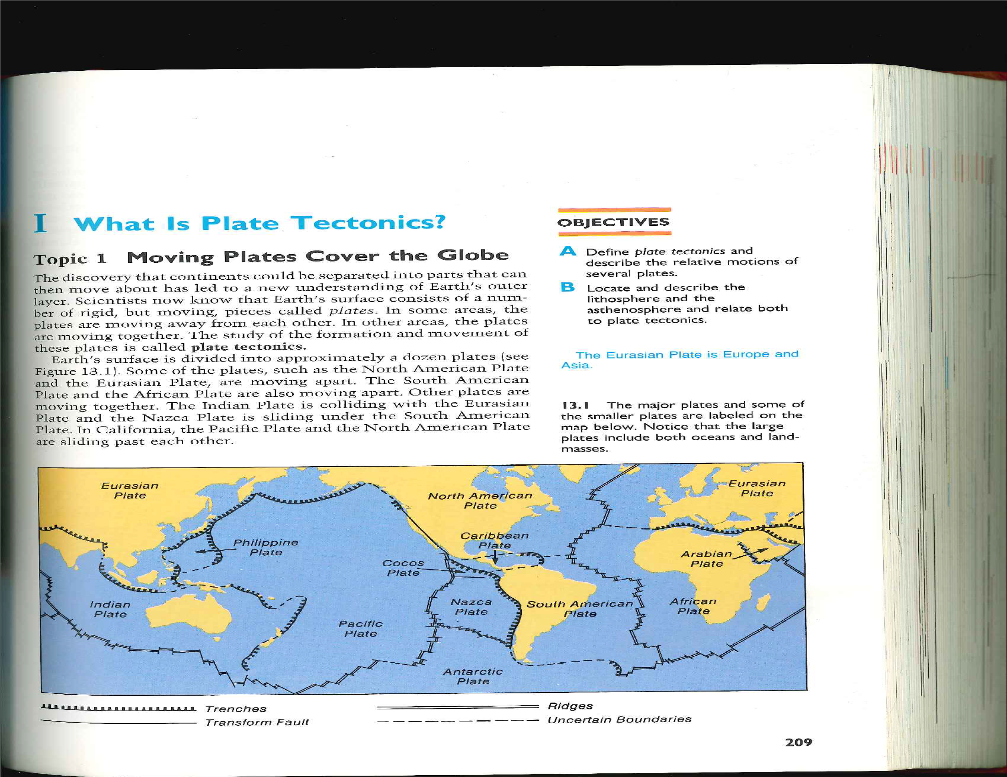

4. Click on “Data Type” at the bottom of the screen again. Unclick all the options and then click on Plate Movement.

Describe the different types of plate movement (yellow, green, pink).

Yellow 🡪 **CONVERGENT, the movement is TOWARD the plate boundary perpendicular to the boundary**

Green 🡪 **DIVERGENT, the movement goes AWAY from the plate boundary on both sides perpendicular to the boundary**

Pink 🡪 **TRANSFORM, the movement goes AWAY from the plate boundary on both sides ALONG the boundary**

**Observations**:

1. On which plate is most of the continental United States located?

***Most of the continental United States is located on the North American Plate.***

2. On which plate is the southwestern portion of California located?

***The southwestern portion of California is located is located on the Pacific Plate.***

3. The place where two plates in answers #1 and #2 meet is called the San Andreas Fault. Why do you think many earthquakes form there?

***Since the tectonic plates are constantly shifting (moving), it allows earthquakes to form.***

4. Notice that part of Asia is on the Indian plate that includes Australia (some scientists call this the “Indo-Australian Plate”). What country is located on its northwestern tip?

***India & Pakistan are located on the northwestern tip of the Indian Plate.***

5. The part of Asia where India lies is moving northwest into the rest of Asia. The Himalayan Mountains are located where these two plates meet. How do you think these mountains were formed?

***The Himalayan Mountains were formed by the collision of two continents, creating folded mountains where the tectonic plates met. In this case, the Indian and Eur-Asian plates met.***