Name ______________________________________

Use the class notes and labs to answer the following:

1. How old is the universe? Earth? _____

2. Is there any direct evidence of the earliest years of Earth’s history? _____

3. What information do rocks provide us? _____

4. Where are fossils found? _____

5. What former theory was proved incorrect, suggests that life comes from non-living matter?

6. _____ are evidence of organisms that lived a long time ago in great variation.

List the six major types of fossils:

7. 10.

8. 11.

9. 12.

13. Who are the scientists that study fossils and ancient life? _____

Finish the following (#14-16) … about #13 and their use of fossils:

14. To determine the kinds of …

15. To gain knowledge about …

16. They can make deductions about the …

17. In layers of rock, which layer would typically have the oldest fossils? _____

18. Why are fossils not found in other rocks (e.g. metamorphic)?

19. What technique is used to determine the age of various fossil? _____

20. What is the basis of #19? _____

Name the type of fossil shown in the image provided:

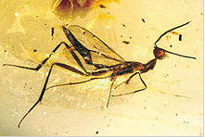

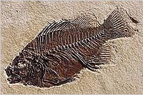

1. _____ 2. _____

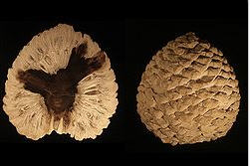

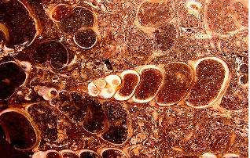

3. _____ 4. _____

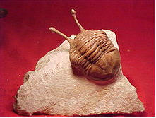

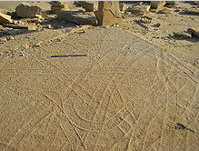

5. _____ 6. _____

Answer Key

1. How old is the universe? Earth? **13 Billion years;** **4.6 billion years**

2. Is there any direct evidence of the earliest years of Earth’s history? **no**

3. What information do rocks provide us? **Diversity of life that existed on the planet**

4. Where are fossils found? **In sedimentary rock layers at the earth’s surface.**

5. What former theory was proved incorrect, suggests that life comes from non-living matter? **spontaneous generation**

6. **Fossils** are evidence of organisms that lived a long time ago in great variation.

List the six major types of fossils:

7. **trace fossils** 10. **Petrified**

8. **casts** 11. **carbonized**

9. **molds** 12. **Preserved (Amber, frozen, etc.)**

13. Who are the scientists that study fossils and ancient life? **paleontologists**

Finish the following (#14-16) … about #13 and their use of fossils:

14. To determine the kinds of … **organisms that lived in the past**

15. To gain knowledge about … **ancient climate and geography**

16. They can make deductions about the … **the geography of past environments**

17. In layers of rock, which layer would typically have the oldest fossils? **lower**

18. Why are fossils not found in other rocks (e.g. metamorphic)?

**Heat, pressure and chemical reactions would destroy any fossils**

19. What technique is used to determine the age of various fossil? **Radioactive dating**

20. What is the basis of #19? **Half-life**

Types of Fossils





1. Amber preserved and frozen 2. Molds





3. Petrified 4. Carbonized





5. Trace Fossils 6. Casts