# GENERAL Biology students are only responsible for the notes in BLACK font type on this study guide.

# HONORS students are responsible for ALL the class notes (including yellow highlighted notes on this study guide).

# Chapter 21 – Kingdom Eubacteria and Archaebacteria

1. Bacteria

A. Characteristics

* + 1. Bacteria are _____.
       1. A prokaryotic cell: does not have a _____ or membrane-bound _____
       2. Prokaryotes are smaller than _____ cells.
       3. Bacteria are found _____.
          1. In the _____ and _____
          2. On and in our _____
          3. In the _____
       4. Some bacteria cause disease, but the vast majority are harmless
    2. Bacteria exist in three basic shapes
       1. _____ – spherical
       2. _____ – rod-shaped
       3. _____ – spiral shaped

B. External Features contribute to the success of Prokaryotes

1. Most _____ have a _____ _____.

* + - 1. provide physical protection
      2. prevent the cell from bursting in a _____ environment.
      3. Main way of classifying bacteria is _____ _____, which is based on the characteristics of bacterial cell walls.
      4. Divides bacteria in two main groups: Gram _____ and Gram _____.
         1. GRAM-POSITIVE, with simpler cell walls containing _____.
         2. GRAM-NEGATIVE, with less peptidoglycan. These bacteria are more complex and more likely to cause _____.

2. The Cell Wall of many prokaryotes is covered by a _____,

a. a sticky layer of sugars or proteins.

b. enables prokaryotes to adhere to their substrate.

c. shields _____ prokaryotes from attacks by their host’s _____ system.

3. _____ are adaptations that enable them to move about in response to signals in their environment.

a. _____-like projections called _____ enable prokaryotes to stick to a surface or each other, latch onto the host cells they colonize.

C. The Genome of a Prokaryote typically

1. has about one-thousandth as much _____ as a eukaryotic genome
2. is one long, circular ____ packed into a distinct region of the cell: Nucleoid Region
3. Many prokaryotes also have additional small, circular DNA molecules called _____, which replicate independently of the chromosome.

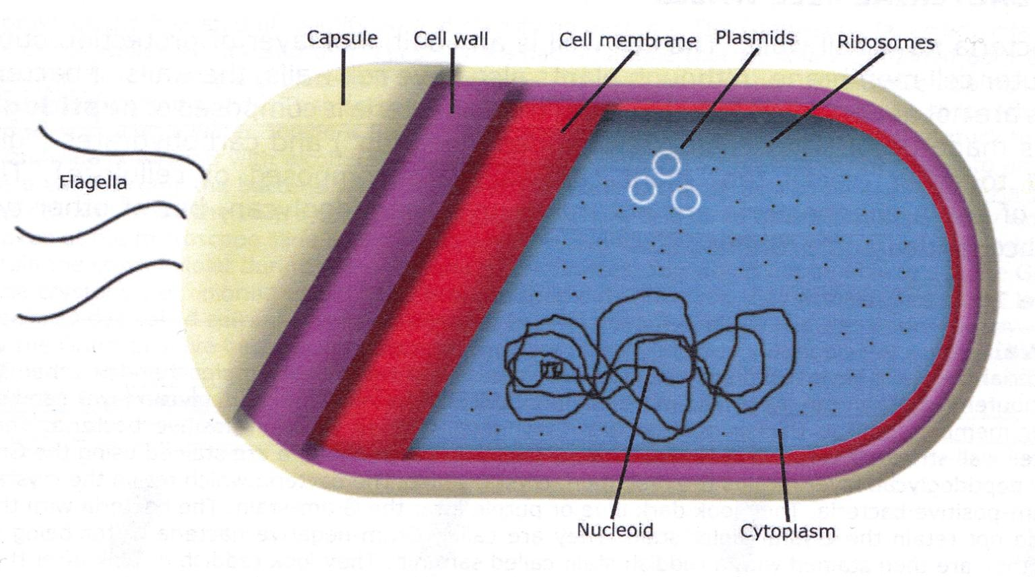

4. Prokaryotes can _____ rapidly to changes in the environment.

1. Some prokaryotes form specialized cells called _____ that remain _____ through harsh conditions.
   1. Endospores can survive _____ heat or cold.
   2. When the endospore receives environmental cues that conditions have improved, it absorbs _____ and resumes _____.

5. Prokaryotes have unparalleled Nutritional Diversity

1. Prokaryotes exhibit much more _____ diversity than eukaryotes, allowing them to inhabit almost every nook and cranny on Earth.
2. Two sources of _____ are used.
   1. _____ capture energy from sunlight.
   2. _____ harness the energy stored in chemicals, organic or inorganic (Sulfur, Ammonia, etc.)

c. Two sources of _____ are used by prokaryotes.

* + 1. Autotrophs obtain carbon atoms from _____ _____.
    2. _____ obtain their carbon atoms from the organic compounds present in other organisms.

6. The terms that describe how prokaryotes obtain Energy and Carbon are combined to describe their modes of nutrition:

1. _____ harness sunlight for energy and use CO2 for carbon.
2. _____ obtain energy from sunlight but get their carbon atoms from organic sources.
3. _____ harvest energy from inorganic chemicals and use carbon from CO2 to make organic molecules.
4. _____ acquire energy and carbon from organic molecules ; Largest and most diverse group of Prokaryotes.

II. Studies of representative genomes of prokaryotes and eukaryotes strongly support the _____-Domain view of life.

1. _____ belong to the domain EUKARYA.
2. _____ are now classified into two domains:
   * 1. E_____
     2. A_____
3. Archaea inhabitants of _____ environments have unusual proteins and other molecular adaptations that enable them to metabolize and reproduce effectively.
4. Extreme _____ thrive in very _____ places.
5. Extreme _____ thrive in very _____ water, such as geysers.
6. Methanogens
7. live in _____ environments
8. give off methane as a _____ product from
9. the digestive tracts of cattle and deer
10. _____ materials in landfills

III. Characteristics of Bacteria

A. Some Bacteria Cause _____

1. All organisms are almost constantly exposed to _____ Bacteria.
2. Most often, our body’s defenses prevent pathogens from affecting us.
3. Most bacteria that cause illness do so by producing a _____ (poison).
   1. _____ are _____ that bacterial cells secrete into their environment.
   2. Examples – bacteria that produce diphtheria or tetanus
   3. Endotoxins are components of the cell _____ of gram-_____ bacteria that are released when the cell dies.
   4. All endotoxins induce the same general symptoms: _____, _____, and sometimes a dangerous drop in blood pressure.
      * Examples: Bacteria that produce Typhoid Fever or Meningitis
4. The weapon form of *Clostridium botulinum* is the exotoxin it produces, Botulinum, which is the deadliest poison known.
   1. Botulinum blocks transmission of the nerve signals that cause muscle contraction, resulting in paralysis of the muscles required for breathing.
   2. This effect is also responsible for a more benign use of **botulinum**— relaxing facial muscles that cause wrinkles.

B. Human Uses for Bacteria

1. Bacteria are used to produce a wide variety of _____ and _____.
2. Examples: sour cream, _____, _____.
3. Some bacteria can digest _____ and are helpful in cleaning up oil spills.

C. Bacteria can Transfer _____ in Three Ways

1. Bacteria are very valuable as microbial models in genetics research:
2. Most of a bacterium’s DNA is found in a _____, closed-loop _____.
3. Bacterial cells divide by replication of the bacterial chromosome and then by _____ _____.
4. Because binary fission is an _____ process, bacteria in a colony are genetically _____ to the parent cell.
5. Bacteria use three mechanisms to move genes from cell to cell.
   1. _____ is the uptake of DNA from the surrounding environment.
   2. _____ is gene transfer by bacteriophages.
   3. _____ is the transfer of DNA from a donor to a recipient bacterial cell.

D. A_____

1. Antibiotics are compounds that _____ bacteria.
2. They are effective against bacteria, but have no effect on _____.
3. They work to _____ a bacterial function that the host does not perform. That way they are able to kill the bacteria and not harm the _____.
4. Some antibiotics work by inhibiting the bacteria’s ability to make the cell _____ (penicillin, cephalosporin).
5. Antibiotic _____: Most occur by bacteria acquiring resistance _____.

# Chapter 22 – Kingdom Protista

I. What is a Protist?

A. Description

1. A protist is any organism that is _____ a plant, an animal, a fungus or a prokaryote.
2. Protists are _____ that are not members of the kingdoms: Plantae, Animalia, or Fungi.
3. Most protists are _____, but a few are colonial and a few are multicellular.
4. Because most protists are unicellular; they are considered the _____ eukaryotic organisms, but their cells are extremely complex.
5. They must carry out within a single cell all the basic functions performed by specialized cells, such as: digestion, gas exchange, circulation & excretion.
6. In multicellular organisms, essential biological functions are carried out by organs. Unicellular protists carry out the same essential functions, but they do so using _____ organelles, rather than with multicellular organs.

B. Protists make up a significant part of _____

1. Starting point in food _____
2. Produces majority of _____ in atmosphere
3. _____: Algae
4. _____: Protozoa
5. Protists can be divided into three categories:
6. _____:
   1. Ingestive (_____)
   2. _____ -like protists
7. _____:
8. P_____
9. (_____)
10. _____ -like protists
11. _____ _____:
12. _____ (External Digestion),
13. _____ -like protists.

II. _____ – Plant-like Protists

A. Description

1. All of the algae are _____. They are _____, have _____, and make their own food by _____.
2. Algae are a very diverse group of protists. They range in size from microscopic single-celled organisms to large multicellular seaweeds.
3. The unicellular algae are found floating near the surface of the oceans and inland waters.
4. Together with small invertebrates, they form the _____ of the oceans.
5. Algae are _____ in the food chain.
6. They are responsible for much of the atmospheric _____.
7. They are classified by _____.
8. They all contain _____, but the _____ _____ may be masked by other pigments.
9. There are green algae, red algae, brown algae, golden brown, and yellow algae.

B. Differentiating Protists from Plants

1. Algae LACK the specialized _____ that are found in the true plants.
2. Algae LACK vascular tissue (_____ and _____) that is found in the true plants.
3. Algae LACK true _____, _____ & _____.
4. Algae form gametes in single-celled gametangia. True plants produced gametes in multicellular gametangia. (Gametangia are “gamete chambers” where sex cells are produced.)
5. All algae contain _____, which is required for photosynthesis.
6. Some phyla have accessory pigments that give them a characteristic _____.

C. Structure of Algae

1. The body of an alga is called a “_____”.
2. Based on the plant thallus, four types of algae are recognized: Unicellular, Colonial, Filamentous, and Multicellular.
3. U_____: mostly Phytoplankton
4. C_____: Groups of individual algal cells that function together in a coordinated way – Volvox.
5. F_____: Body made of rows of algal cells linked together end to end – Spyrogyra.
6. M_____: Large, complex thallus – Ulva (sea lettuce)
7. G_____ algae:
8. Exhibit all 4 types of algae
9. “Closest relative to land plants”
10. B_____ algae:
11. Seaweed or Kelp
12. Many are edible
13. Used to thicken processed foods: Pudding, ice cream, salad dressing, etc.
14. R_____ algae:
    1. Seaweed or Kelp
    2. Source of Agar, used for culturing bacteria and other microbes
15. D_____:
16. Most _____ algae
17. Cell walls made of _____, which is the primary component of glass
18. Dinoflagellates:
19. Some emit their own light (_____)
20. Severe bloom causes _____ _____
21. Golden Algae
22. E_____:
23. E_____
24. _____-like and _____-Like characteristics
25. Contractile vacuole to eliminate excess water

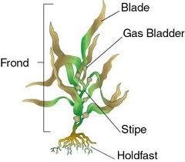

1. The body of Brown Algae consists of three general regions:

a) H_____ – a _____ like structure that anchors the algae

b) S_____ – a _____ like structure that supports the leaf like structure

c) B_____ – a _____ like structure that is the photosynthetic surface

8. Euglenoids have both plant and animal characteristics:

1. Animal – like Characteristics:
2. They are highly _____ and move with a flagella.
3. They can take in food through the cell membrane.
4. There is _____ cell wall.
5. Plant – like Characteristics: They have _____ and carry out photosynthesis.
6. A_____ of Generations
7. Life cycle in which the organism exists in the
   1. _____ state (n) in one generation: _____
   2. and in the _____ state (2n) on the next generation: _____

2. alternates between:

* + - * 1. a _____ and _____ stage.
        2. a _____ and _____ generation.
        3. a _____ and a _____ generation.

1. The SPOROPHYTE generation is always diploid and the GAMETOPHYTE generation is always haploid.
2. The _____ sporophyte produces _____ _____ by _____.
3. The spores divide by _____ to produce the male and female _____.
4. The _____ gametophytes produce gametes.
5. _____ of haploid gametes results in a _____ _____.
6. This diploid zygote is the first step to the sporophyte generation.
7. Reproduction in Multicellular Algae
8. Ulva (sea lettuce) lives as a _____ producing, _____ (n) Gametophyte in one generation.
9. Gametophyte produces haploid (n) “plus” and “minus” gametes (by mitosis).
10. Gametes _____ with one another to form a _____ (2n).

III. _____ – Animal Like Protists

1. Description
2. _____; some Parasitic
3. U_____
4. Make a large part of the _____ population
5. They have a _____ Vacuole: membrane-bound chamber in which they break down their nutrients with enzymes.
6. Classified by how they _____: flagella, cilia, pseudopods, spores.
7. _____ (Amoeba)
8. Move by Cytoplasmic _____:
   1. _____ moves inside the amoeba, which causes the surface of the cell membrane to move in different directions
   2. As cytoplasm and cell membrane move, it pulls the amoeba
9. _____: extension of cell _____ formed as a result of cytoplasmic streaming.
10. They can form pseudopods to _____ and trap _____.
11. Then form a food vacuole to break down food in the cytoplasm.
12. _____ Vacuole – collects extra _____ and expels it from cell.
13. Some species cause Amoebic _____ (fever, diarrhea, bleeding, damage to intestinal wall).
14. _____ (Paramecium)
15. Move beating tiny _____ called Cilia: help organisms _____, get _____, and _____ its environment.
16. Have at least 2 nuclei:
    1. _____: cell’s metabolism
    2. _____: cell’s reproduction
17. Asexual and Sexual Reproduction
18. 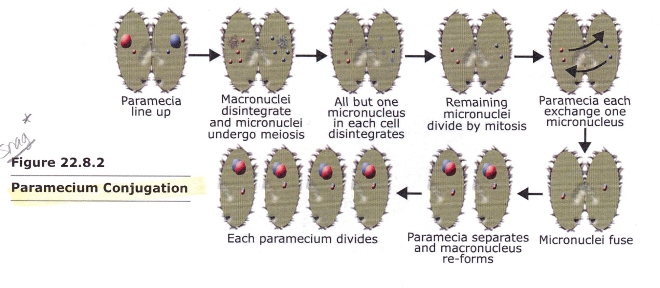Sexual Reproduction by _____
19. Z_____
20. Use whip-like extension called _____ to move
21. Some cause diseases:
    1. Trypanosoma: African Sleeping Sickness
    2. Giardia: Hiker’s Diarrhea
    3. Trichomonas: Sexually Transmitted Disease (STD)
22. Most reproduce by _____ _____.
23. _____ (parasites)
24. Cause the most human disease of any organisms on earth (parasites)
25. Adult forms _____ move
26. _____: Organism that transports the parasite
27. _____: Organism infected
28. Plasmodium sp.
29. _____ caused by Plasmodium.
30. Causes _____, tiredness, _____, kidney failure, and death.
31. Vector: Anopheles mosquito
    * 1. Sporozoite and Gametocyte forms
32. Host: Humans
    * 1. Sporozoite, Merozoite, and Gametocyte forms
33. _____ that has _____ in the stomach (which fuse to form Sporozoites) bites a human – Sporozoites introduced in the host’s blood.
34. Sporozoites infect liver and mature into Merozoites – infect Red Blood Cells (RBCs).
35. At regular intervals, RBCs break open causing fevers, anemia, and other symptoms.
36. Some merozoites mature into Gametocytes in the RBCs.
37. When _____ person is bitten by mosquito, _____ are taken into the stomach – combine to form _____.
38. Whole cycle starts over.

IV. Slime Molds & Water Molds – _____-Like Protists

1. _____ Molds
2. Slime molds are typically found growing on damp soil, _____ logs, or _____ leaves.
3. They appear as _____ masses of slime that may be white, red or yellow.
4. They spend part of their life in a _____, amoeba-like feeding form, engulfing organic materials, and part of their life in a _____ reproductive stage.
5. The slime molds play a key role in the _____ of organic material (_____).
6. Water Molds
7. A water mold is a fungus-like organism composed of branching _____ of cells.
8. Most water molds are _____, but some live in the soil, and others are parasitic.
9. Water molds are sometimes seen as the white fuzz on diseased aquarium fish.
10. _____ Blight killed potato plants and caused Irish famine in mid 1800s

# Chapter 23 – Kingdom Fungi

I. General Characteristics of Fungi

A. Overview

1. Fungi are NOT plants (No Chlorophyll)
2. Eukaryotes
3. Heterotrophic
4. Non-motile
5. Grow best in warm, moist environments
6. Most are saprophytes (decomposers)

B. Absorptive heterotrophs

1. Digest food first and then absorb it into their bodies (Extracellular Digestion).

2. Release digestive enzymes to break down organic material or their host.

1. Important decomposers and recyclers of nutrients in the environment.
2. Most are multicellular, except unicellular yeast.
3. Lack true roots, stems or leaves (no tissues).
4. MYCOLOGY is the study of fungi.

II. Specific Characteristics of Fungi

A. The visible body and underground structure of a multicellular fungus are made up of long chains of cells called HYPHAE, that are entwined to form a mass, the MYCELIUM.

1. Mycelia digest, absorb, and transport nutrients for the rest of the fungus.

2. A multicellular fungus consists of an above-ground FRUITING BODY and a below-ground MYCELIUM.

3. Cell walls are made of CHITIN (complex carbohydrate).

B. Hyphae

1. Thin filaments that compose a fungus.

2. Septated – in most fungi, including mushrooms, cross walls (septa) divide the hyphae into cell-like compartments.

3. Coenocytic (no septa) – in some other fungi, the hyphae lack cross walls and contain many nuclei.

C. Reproduce sexually and asexually through SPORES.

1. Classified by the form of sexual reproduction it carries out

* 1. Most fungi exist in the haploid state and reproduce by SPORES, that are produced asexually or sexually.
  2. Either way, spores that land on a suitable habitat can germinate and give rise to haploid hyphae, starting a new organism.
  3. ASEXUAL reproduction is the most common method and produces genetically identical organisms (mitosis).
  4. Fungi reproduce SEXUALLY when conditions are poor and nutrients scarce.

D. Asexual Reproduction

1. FRAGMENTATION – part of the mycelium becomes separated and begins a life of its own.
2. BUDDING – a small cell forms and gets pinched off as it grows to full size.

* Used by Yeasts

1. ASEXUAL SPORE PRODUCTION –
   1. Most common method
   2. Sporangiophore: Specialized hyphae where spores are formed within an enclosure, called Sporangium.
      * 1. Conidiophore: Specialized hyphae where spores are formed at the tips of the hyphae. Spores are called Conidia.

E. Sexual Reproduction

1. Haploid hyphae from 2 mating types (+ and -) FUSE (Fertilization).
2. Form a FRUITING BODY (DIPLOID) that will produce diploid Zygotes.
3. Zygotes go through meiosis to produce haploid SPORES.
4. Haploid Spores germinate and give rise to haploid hyphae, starting a new organism.

F. Reproduction by Spores. Spores may be Formed:

* 1. Directly on tips of Hyphae (asexual) … *Penicillium*
  2. Inside Sporangia (asexual) … *Pilobolus*
  3. On Fruiting Bodies (sexual) … *Amanita*

III. Kingdom Fungi

A. Fungi are classified according to the **form of sexual reproduction** they carry out.

B. Four main groups of Fungi

1. Phylum **Zygomycota:** The common Molds; Bread mold; *Penicillium*
2. Phylum **Ascomycota:** The Sac fungi; Yeasts
3. Phylum **Basidiomycota:** The Club fungi; (Mushrooms)
4. Phylum **Deuteromycota:** The Imperfect fungi (athlete’s foot)

C. Zygomycota

1. Commonly called Molds; Includes bread mold *Rhizopus stolonifera*.

2. The life cycle of the common bread mold has both asexual and sexual components.

a. Reproductive Process

1. The sporangium produces asexual spores.
2. The sporangium is held up in the air by a Sporangiophore (special kind of hyphae).
3. Stolons spread the fungus across the surface of the substrate.
4. Rhizoids anchor the fungus in the bread. They absorb water and nutrients.
5. The spores produced by the sporangium are released.
6. Spores germinate into new hyphae.
7. The tips of the hyphae contain gametes that are neither male nor female, but rather, are referred to as “plus” and “minus”.
8. Hyphae containing haploid gametes (+ and -) fuse.
9. Fusion of gametes produces a diploid zygote.
10. Zygotes develop into thick walled zygospores. The zygospore may remain dormant for months, and can withstand unfavorable conditions.
11. When conditions become favorable, the zygospore germinates, and undergoes meiosis.
12. The sporangium releases new, haploid spores.
13. The spores germinate and grow into new hyphae.
14. This process insures genetic variation.
15. It produces new combinations of genetic information that may help the organism meet changing environmental conditions.

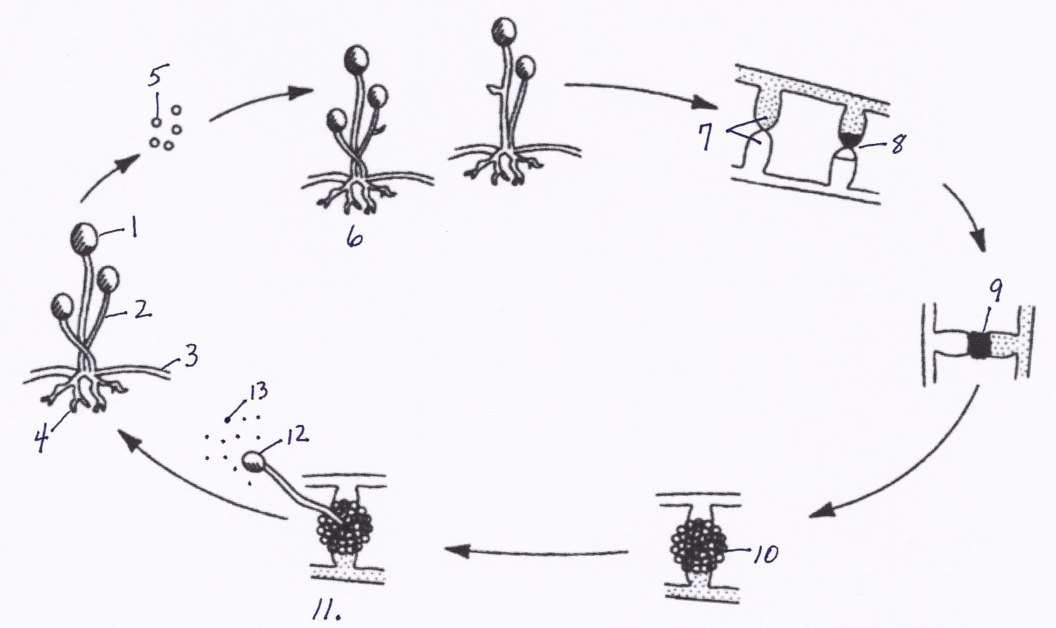

D. Ascomycota – the sac fungi

1. All of the fungi in this phylum are so named because they have an “ascus” or sac.
2. An ascus is a reproductive structure that contains sexual ascospores.
3. This is the largest phylum of fungi, containing over 30,000 different species.
4. Includes Cup fungi, morels, truffles, yeasts, and mildew.
5. May be plant parasites (Dutch Elm disease and Chestnut Blight).
6. *Penicillium*
7. Asexual spores called Conidia form on the tips of special hyphae called Conidiophores.
8. Ascus (fruiting body): visual Sexual reproductive structure that produces sexual spores (Ascospores).
9. General Characteristics
   1. Yeasts reproduce asexually by budding (buds break off to make more yeast cells).
   2. Truffles and morels are good examples of edible *ascomycota*.
   3. *Penicillium* mold makes the antibiotic penicillin.
   4. Some *ascomycota* also give flavor to certain cheeses.
   5. *Saccharomyces cerevesiae* (yeast) is used to make bread rise & to ferment beer & wine.
   6. A package of yeast contains dry granules containing ascospores. These ascospores become active when placed in a moist environment.
   7. Prior to baking, yeasts are mixed with a thick, rich dough. This is an environment containing very little oxygen.
   8. Yeasts survive using the process of alcoholic fermentation. In fermentation, the sugar of the bread dough is converted to energy.
   9. Two waste products are produced: carbon dioxide and alcohol. The carbon dioxide gas makes beverages bubble and breads rise.
   10. The alcohol evaporates during baking.

E. Basidiomycota – the club fungi

* + - 1. Mushrooms, bracket & shelf fungi, puffballs, stinkhorns, toadstools, rusts & smuts.
      2. Some are used as food (mushrooms)
      3. Others damage crops (rusts and smuts)
      4. Seldom reproduce asexually
      5. The visible mushroom is a Fruiting Body (sexual reproductive structure)
      6. Fruiting Body (Basidiocarp) is made of a stalk called the Stipe and a flattened Cap with Gills.

1. Inside walls of gills: Basidia (club-shaped hyphae that produce spores sexually).
2. Basidiospores (sexually produced gametes found in Basidia) are released during reproduction and are dispersed by wind, water, or animals.
3. Mycelium network found below ground.

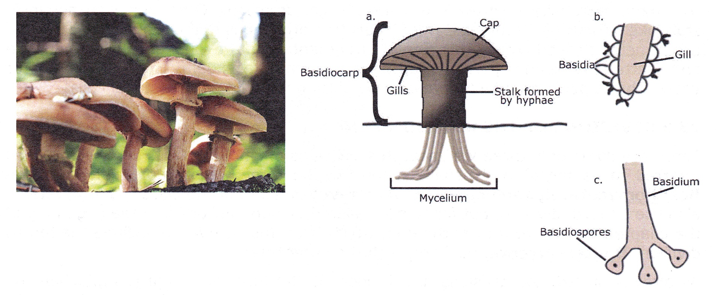

1. Life cycle of a club fungi
2. The mycelium lives underground and may grow for years, reaching an enormous size.
3. When the favorable conditions of moisture and nutrients are present, fruiting bodies will appear above ground.
4. These fruiting bodies are mushrooms.
5. Mushrooms appear and grow at a very rapid rate. Their growth is caused by cell enlargement, not cell division. The cells enlarge by rapidly taking in water.
6. The mushroom opens, exposing hundreds of tiny gills. Each gill is lined with basidia.
7. A diploid zygote in the basidium undergoes meiosis forming clusters of haploid basidiospores.
8. A single mushroom can produce billions of spores and a giant puffball can produce trillions!

F. Deuteromycota – the “imperfect” fungi

1. Not known to have any sexual reproductive cycle.
2. Ringworm, Athlete’s foot, and some other human parasitic fungi.
3. The term “imperfect fungi” does not mean that there’s anything wrong with the organism. It simply means that our understanding of the life cycle is “imperfect”.
4. Whenever a mycologist discovers a sexual stage in one of these fungi, the species is moved from the imperfect category to a particular phylum, depending on the type of sexual structures.

IV. Lichens

1. A lichen is a combination of a specific fungus and a green alga.
2. A lichen shows mutualism.
3. The alga provides food for the fungi. The fungus provides water and shelter in which to live for the algae.
4. Since they are very resistant to drought and cold, they are often the first organisms to begin the colonization of barren environments.
5. They break down the rocks upon which they grow, the first step in the formation of soil.
6. They are very sensitive to air pollution and are often used as an indicator of poor air quality.

V. Mycorrhizae

1. This is a symbiotic (mutualistic) relationship between a fungus and the roots of plants.
2. The mass of fungal hyphae is found wrapped around the true roots of plants.
3. The fungal hyphae help to increase the surface area for the absorption of water.
4. The hyphae also improve the delivery of phosphate ions and other minerals to plants.
5. The plant provides food for the fungus.
6. Almost all vascular plants have mycorrhizae and rely on their fungal partners for essential nutrients.

VI. FUNGI: PRACTICAL ASPECTS

A. Primary decomposers in the world – They break down organic substances into simple, soluble forms that plants can use.

B. General Information

1. Ergot of Rye: fungus that causes a purplish black swelling in rye grain.
2. “St. Anthony’s Fire”: Vomiting, Gangrene, Hallucinations, etc. – Believed to have been the cause behind accusations of witchcraft in Massachusetts in 1600s.
3. Chestnut Blight and Dutch Elm disease have destroyed many trees in the USA

C. The Importance of Decomposition

1. Fungi play an essential role in nearly every ecosystem by breaking down the bodies and wastes of other organisms.
2. This promotes the recycling of nutrients and essential chemicals.
3. Without decomposition, these elements and compounds would be forever locked in the bodies of dead organisms.
4. Life on Earth depends upon the chemical elements being returned to the ecosystem so that they may be used in the bodies of new organisms.
5. If these materials were not returned, the soil would quickly be depleted, and Earth would become lifeless.

D. Practical Uses of Fungi

1. Edible Mushrooms
2. Making of Cheese
   1. Yeast in Baking
3. Yeast to ferment beer and wine
4. Yeast to make ethanol added to gasoline
5. Antibiotics - Penicillin