Name _____ Day, Time _____

Date _____

Late Pleistocene Extinction

* Approximately _____ years ago, many animals went extinct across North America (this happened towards the end of the Pleistocene epoch).
* Before this extinction occurred, many of the animals that existed in North America were _____ (in size and diversity) to animals in _____-day Africa.
* These animals were referred to as “_____” which means “large animals.”
* Although scientists don’t exactly know the cause of extinction, they have identified three mechanisms which may have caused the extinction:

(1) Human _____

(2) _____ causes related to climate change,

(3) _____ (highly infectious disease)

We are in an Ice Age right now! Glaciers are _____ today.

* When the _____ ice caps cover a smaller area, such as present day, it is referred to as an _____ period.
* When the polar ice caps cover a larger area, it is referred to as a _____ period.

An ice age consists of two parts that make up one Milankovitch cycle:

(a) Glacial period (_____ with at least one polar ice cap),

(b) Interglacial period (_____)

90% of the Earth’s history, no polar ice caps were present. There have been ___ major ice ages:

* 2 billion years ago
* 840 million years ago (lasted for 240 million years!)
* 2 ice ages (during the Paleozoic era)
* Present ice age (began approximately ___ million years ago)

It is unclear what causes Ice Ages to occur, but current theories point to the changing position of the continents which causes:

* 1. _____ building events
  2. Different global _____ patterns
  3. Different global _____ current patterns
  4. Amount of _____ spreading (effects sea level)

The Ice Age Theory as described by Serbian scientist, Milutin Milankovitch, points to three variations in the earth-sun geometry:

E_____ – stretching of earth’s orbit (100,000 year cycle)

O_____ – change of the earth’s axial tilt (41,000 year cycle)

P_____ – “wobble” of the earth’s axis of rotation (~26,000 year cycle)

Eccentricity

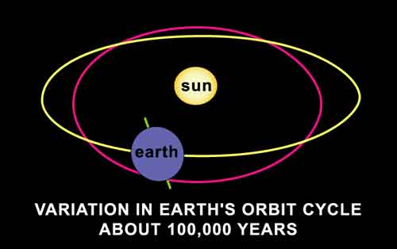

* The shape of Earth’s orbit is like a “stretched out” circle or an oval or “_____”
* Scientists use a _____ to describe this, and call it the eccentricity of the ellipse.

Obliquity

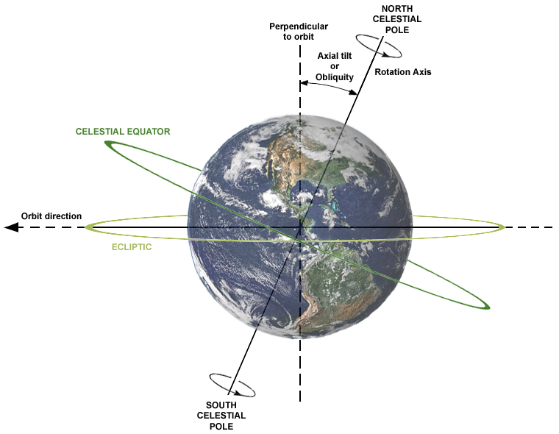

* Also known as axial _____ which is the angle between an object's rotational axis and its orbital axis
* Axial tilt affects the distribution of _____ radiation on Earth’s surface
* When tilt is decreased, polar regions receive _____ sunlight. When tilt is increased, polar regions receive _____ sunlight.
* The earth’s axial tilt varies from _____° to ______° at periods close to 41,000 years

Precession

* 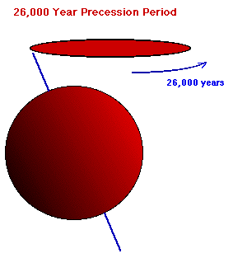The Earth's _____ axis is not fixed in space.
* Like a rotating toy top, the direction of the rotation axis executes a slow precession with a period of _____ years.
* Is a change in the _____ of the rotational axis of a rotating body.
* Precession affects how severe or moderate the _____ are depending on which portion of the “_____” the earth is on.
* For example, you could have a cool summer which allows _____ in higher latitudes to last throughout the summer.

Paleoclimatology

* The study of ancient _____.
* Using _____ core samples, _____ core samples, _____ ring and _____ samples, scientists can piece together some of the history of the earth’s climate.

Label the type of sample over the top of each picture.

? ? ?

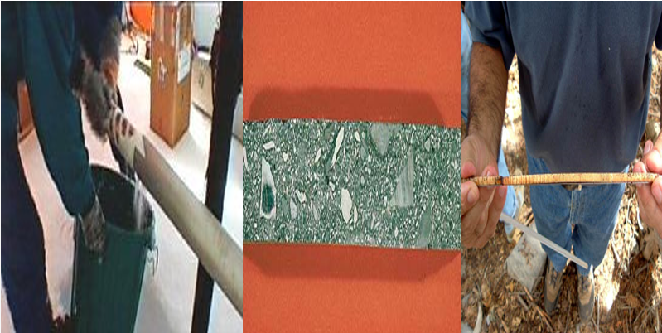

Graphs

* Note the many years of _____ climate than today.
* _____ periods are warmer and last 10-15,000 years
* _____ periods are when ice _____ expand & last 50-100,000 years

**Glaciers and Glaciation**

Types of Glaciers

A_____ – Formed in mountainous areas; relatively small in size.

C_____ – large expansive ice sheets (these cover Antarctica and Greenland today); these are the glaciers we will be studying.

What forms a glacier?

* Ice is formed from _____ snow
* Individual flakes of snow turn to _____ chunks of icy material
* As more snow falls, the pressure _____ the layers of the icy snow
* When the glacier gets big enough, ice at the base _____ and the glacier _____

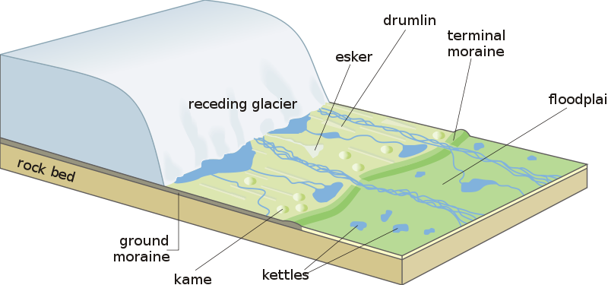

Using Maps to Identify Glacial Features

* T_____ Maps show lines called _____. These lines connect equal areas of elevation.
* Areas that have contour lines _________ together indicate that there is a greater change in _____ in a short distance (either up or down).
* Notice the contour lines that make _____ circles … they are closer together

Formation of the Great Lakes

* During the last glacial period, lobes of _____ carved their way into softer sediment over this region of North America.
* When the climate warmed, the glacier _____, and melted into the _____ left by the ice lobes, creating the great lakes.

I_____ Rebound

* Due to the _____ weight of the ice sheet, the _____ of the earth was pushed deeper into the asthenosphere in the locations where the ice was.
* As the glacial sheet _____ back, the lithosphere began to slowly “_____” back up – and still is adjusting back up.
* For this reason, the great lakes drain to the _____ and east, out the St. Lawrence River to the _____ Ocean.

Graph 1 What does the zero line on the graphs represent? Why would this number be used?



Describe in words the average global temperature for the past 2,400 years compared to the zero line.



Graph 2 … Describe the significance of graph #2.



Graph 3 From approximately 100,000 years ago to 15,000 years ago the earth’s temperature was below the “normal” temperature. What is this period?



Graph 4 What is the pattern in graph #4? According to the pattern, how should the earth’s temperature change in the next 1,000 – 3,000 years?



What is a significant difference between glacial periods and interglacial periods?



Graph 5 Describe the significance of graph #5. How has the earth’s climate changed over the past 3 million years?