Poisonous/Invasive Plants: Field Guide

“A Field Guide to Wild Edible Plants” by L.A. Peterson

WORKSHEET: How to use a field guide

Look up TEN different poisonous plants and give the following information about EACH plant as shown in the example below:

CN: The common name of the plant as given in the field guide. *There may be more than one common name. If so, write them all.*

PN: The page number on which you found the plant. If there is a color plate in the center section of the field guide, include that “Plate Number” also. *The information will tell you whether there is a plate number or not.*

SN: The scientific name (Genus species) of the plant.

WF: “Where Found”: the habitat of the plant.

PW: “Poison Warning”: Give the part of the plant or parts of the plant that are poisonous, and tell how they are poisonous.

AS: “Audubon Society Field Guide”: look up the picture number of a picture of the specimen; be sure to look at the picture for you will need to identify each plant.

EXAMPLE: “Buttercup”

The following is an example of what you should enter into your notebook for EACH of the nine poisonous plants listed in this activity. Copy this example into your notebook and look up the information in the field guide so that you can do the other TEN plants on your own.

PLANT # example

Include an image of your specimen.

CN: Buttercup

PN: 70

SN: Ranunculus acris

WF: fields, meadows

PW: intestinal irritation if eaten, and skin blisters if handled

AS: picture 264

Using the EXAMPLE above, look up and record the same information (Labeled and in order as shown in the EXAMPLE) for the first NINE poisonous plants. Use the internet to find information on plants 10-12 (invasive):

1. Jimson Weed 6. Skunk Cabbage 10. Common Buckthorn

2. Jack in the Pulpit 7. Bittersweet Nightshade 11. Garlic mustard

3. Elderberry 8. Stinging Nettle 12. Wild grape

4. Pokeweed 9. May Apple

5. Poison Ivy

Field Guide Activity – Poison Plants Answer Key

Plant # example

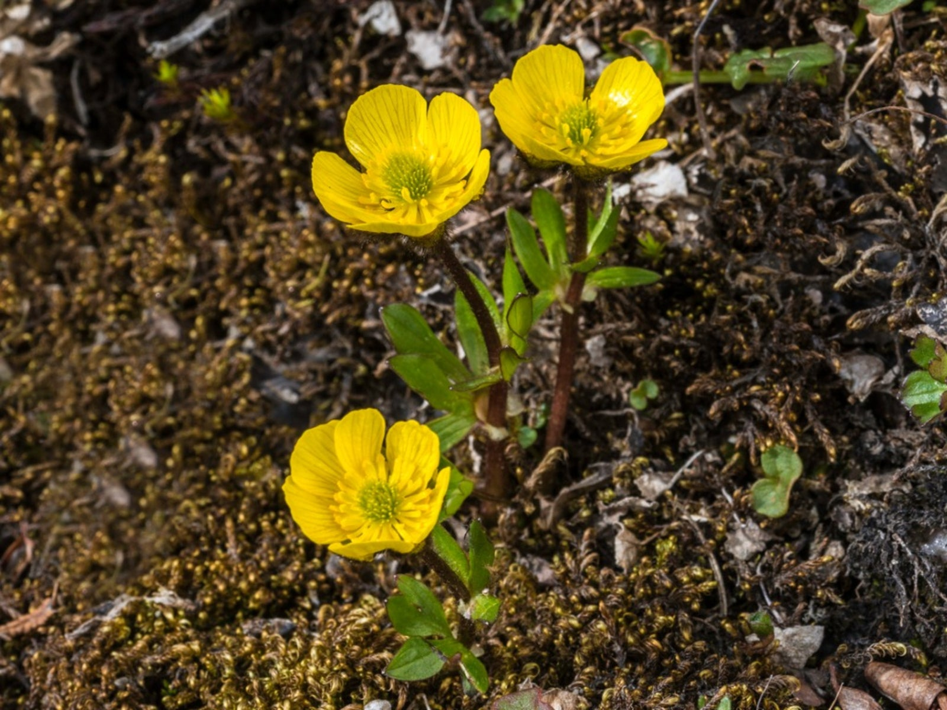

a) CN: buttercup

b) PN: p. 70

c) SN: Ranunculus acris

d) WF: fields, meadows

e) U/P: intestinal irritation if eaten, and skin blisters if handled

f) AS: picture 264

Plant #1

a) CN: Jimson Weed (also called “Thorn Apple”)

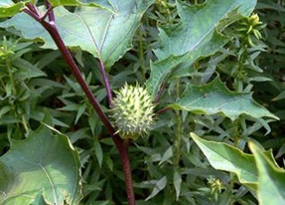

b) PN: p. 20

c) SN: Datua stramonium

d) WF: waste places; most of our area

e) U/P: all parts are extremely poisonous

f) AS: picture 86

Plant #2

1. CN: Jack in the Pulpit

b) PN: p. 156

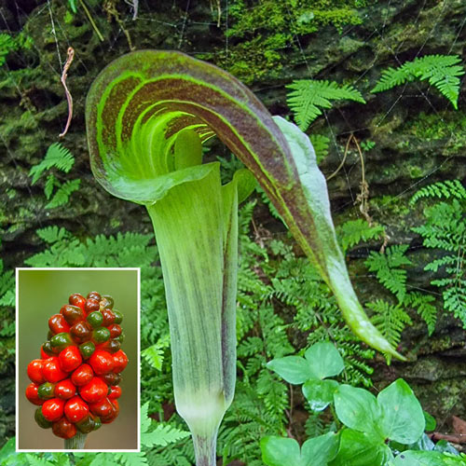

c) SN: Arisaema atrorubens

d) WF: rich soil; wood, thickets, swamps

e) U/P: raw corms: intense burning sensation in the mouth (calcium oxalate)

f) AS: picture 9, 390, 443

Plant #3

1. CN: Elderberry
2. PN: p. 172; plate #2

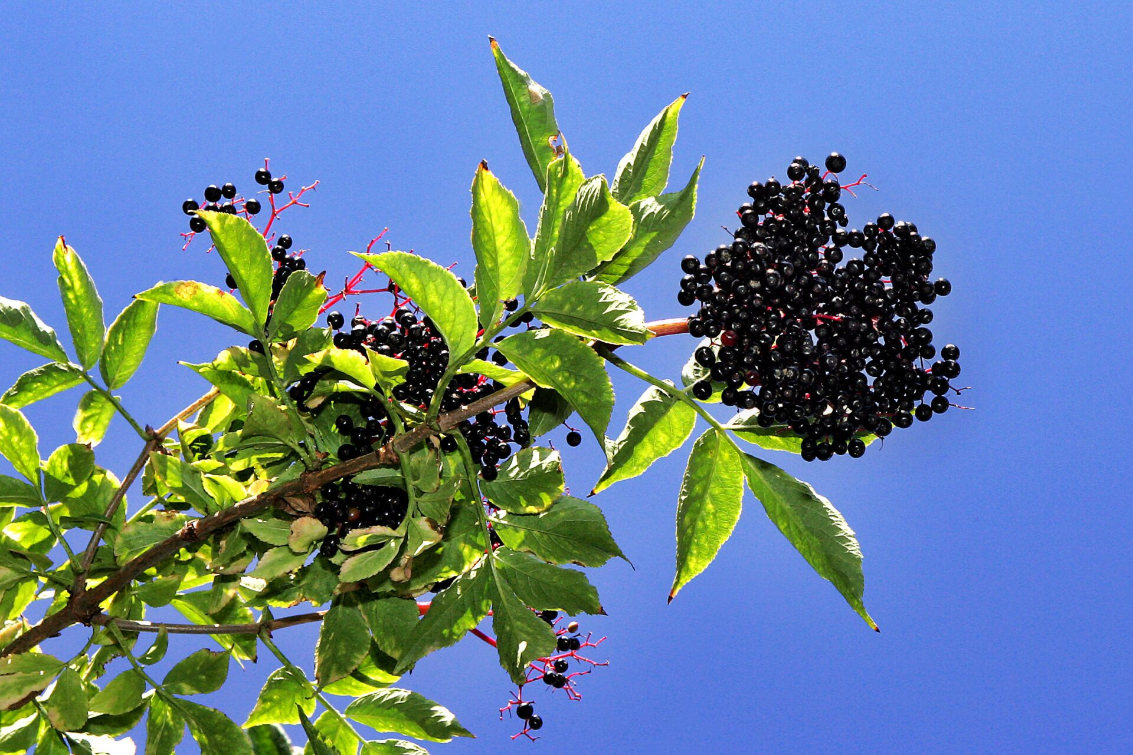

1. SN: Sambucus canadensis
2. WF: wet or damp rich soils; streambanks, thickets, roadside ditches

e) U/P: green berries (unripe) are poisonous along with roots, stems and leaves

f) AS: picture 217

Plant #4

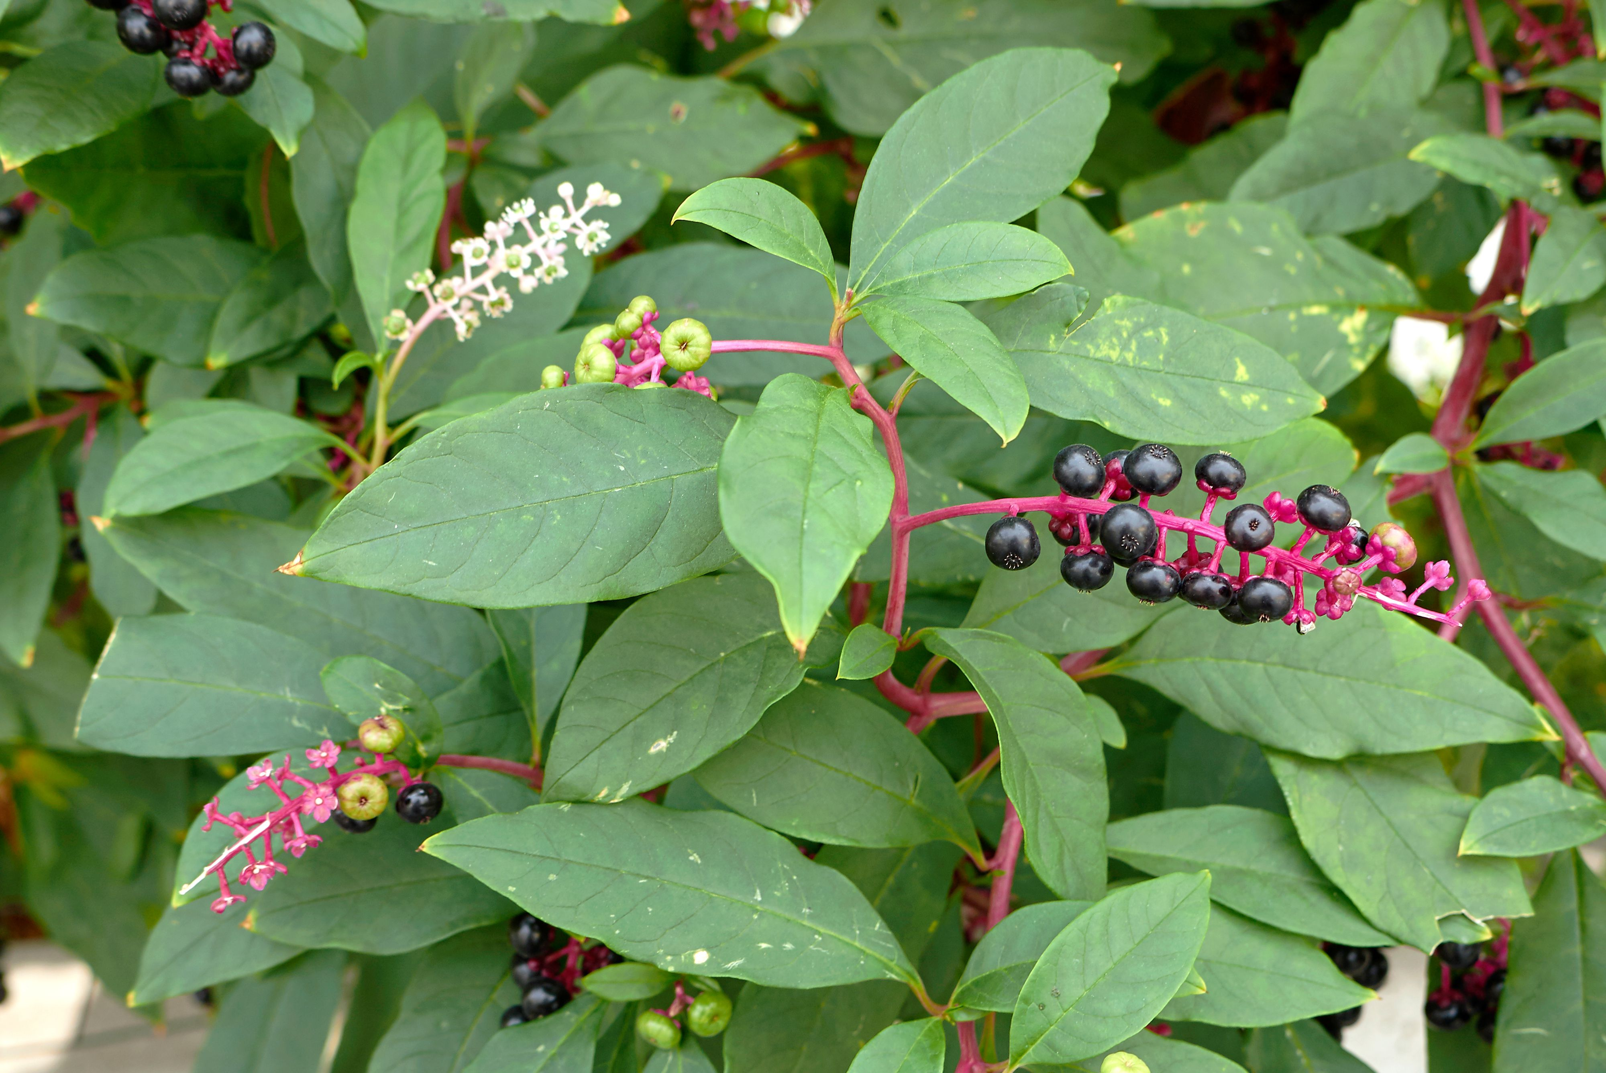

a) CN: Pokeweed

b) PN: p. 46; plate #8

c) SN: Phytolacca americana

d) WF: roadsides, cultivated fields, waste places

e) U/P: root, seeds and mature stems and leaves are extremely poisonous

f) AS: pictures 143, 656

Plant #5

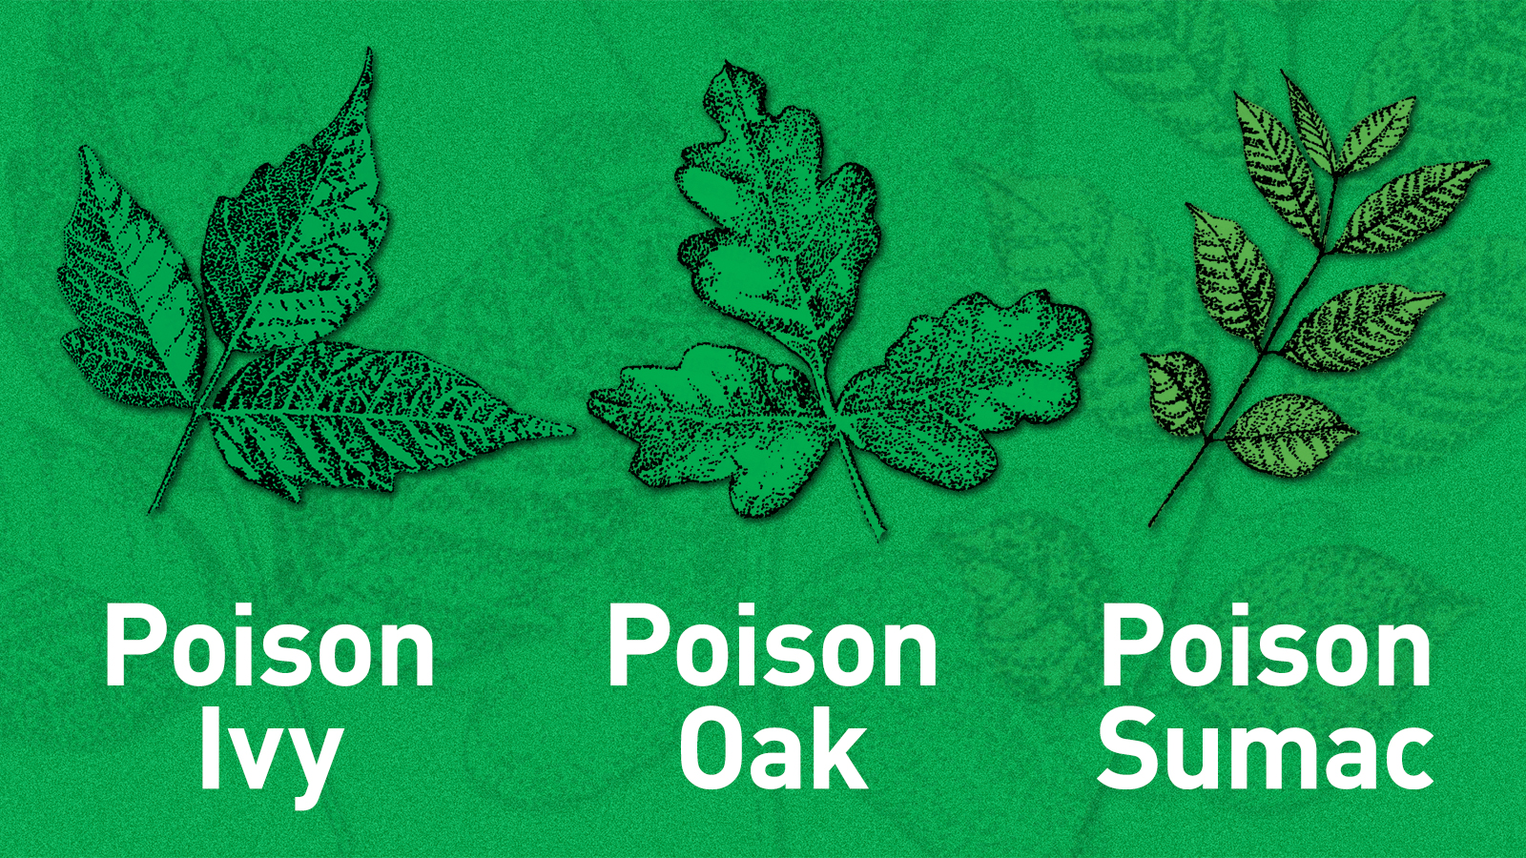

a) CN: Poison Ivy

b) PN: p. 182

c) SN: Rhus radicans

d) WF: woods, thickets

e) U/P: do not touch: dermatitis

f) AS: picture 224

Plant #6

a) CN: Skunk Cabbage

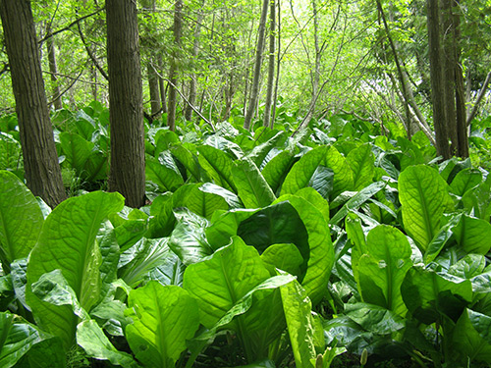

b) PN: p. 1 56

c) SN: Symplcarpus foetidus

d) WF: wet woods, open swamps

e) U/P: calcium oxalate: raw plants causes intense burning sensation in the

mouth

f) AS: picture 391

Plant #7

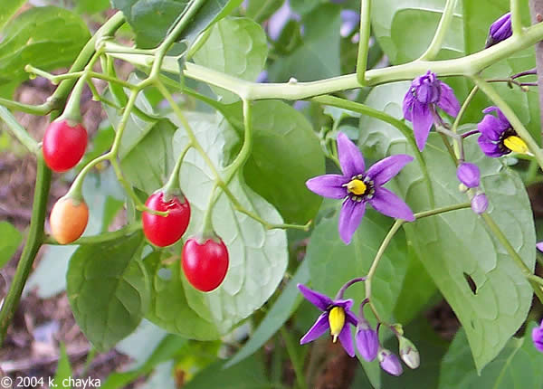

a) CN: Bittersweet Nightshade

b) PN: p. 134, 198

c) SN: Solanum dulcamara

d) WF: moist thickets, clearings

e) U/P: ruby-red berries are very poisonous

f) AS: pictures 448, 653

Plant #8

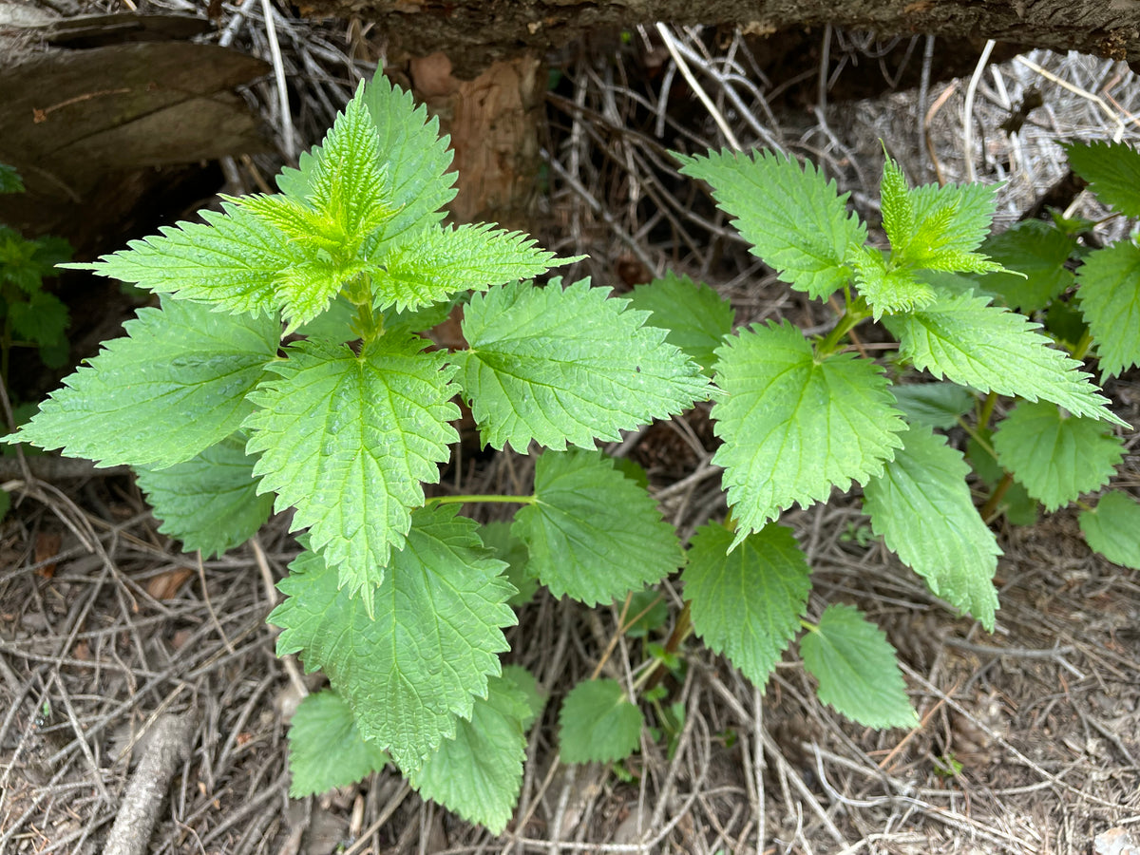

a) CN: Stinging Nettle

b) PN: p. 150; plate #9

c) SN: Urtica dioica

d) WF: roadsides, waste groud, light soils

e) U/P: stinging hairs inject into skin: dermatitis

f) AS: picture 22

Plant #9

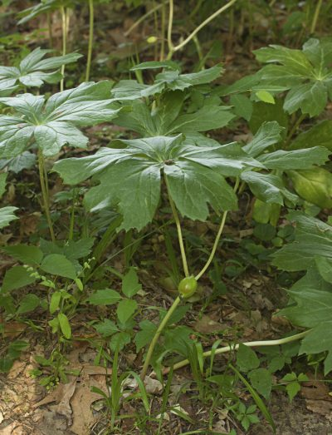

a) CN: May Apple

b) PN: p. 20

c) SN: Podophyllum peltatum

d) WF: moist woods, openings

e) U/P: roots, leaves, seeds and green fruit are strongly cathartic (laxative)

f) AS: picture 87

Plant #10

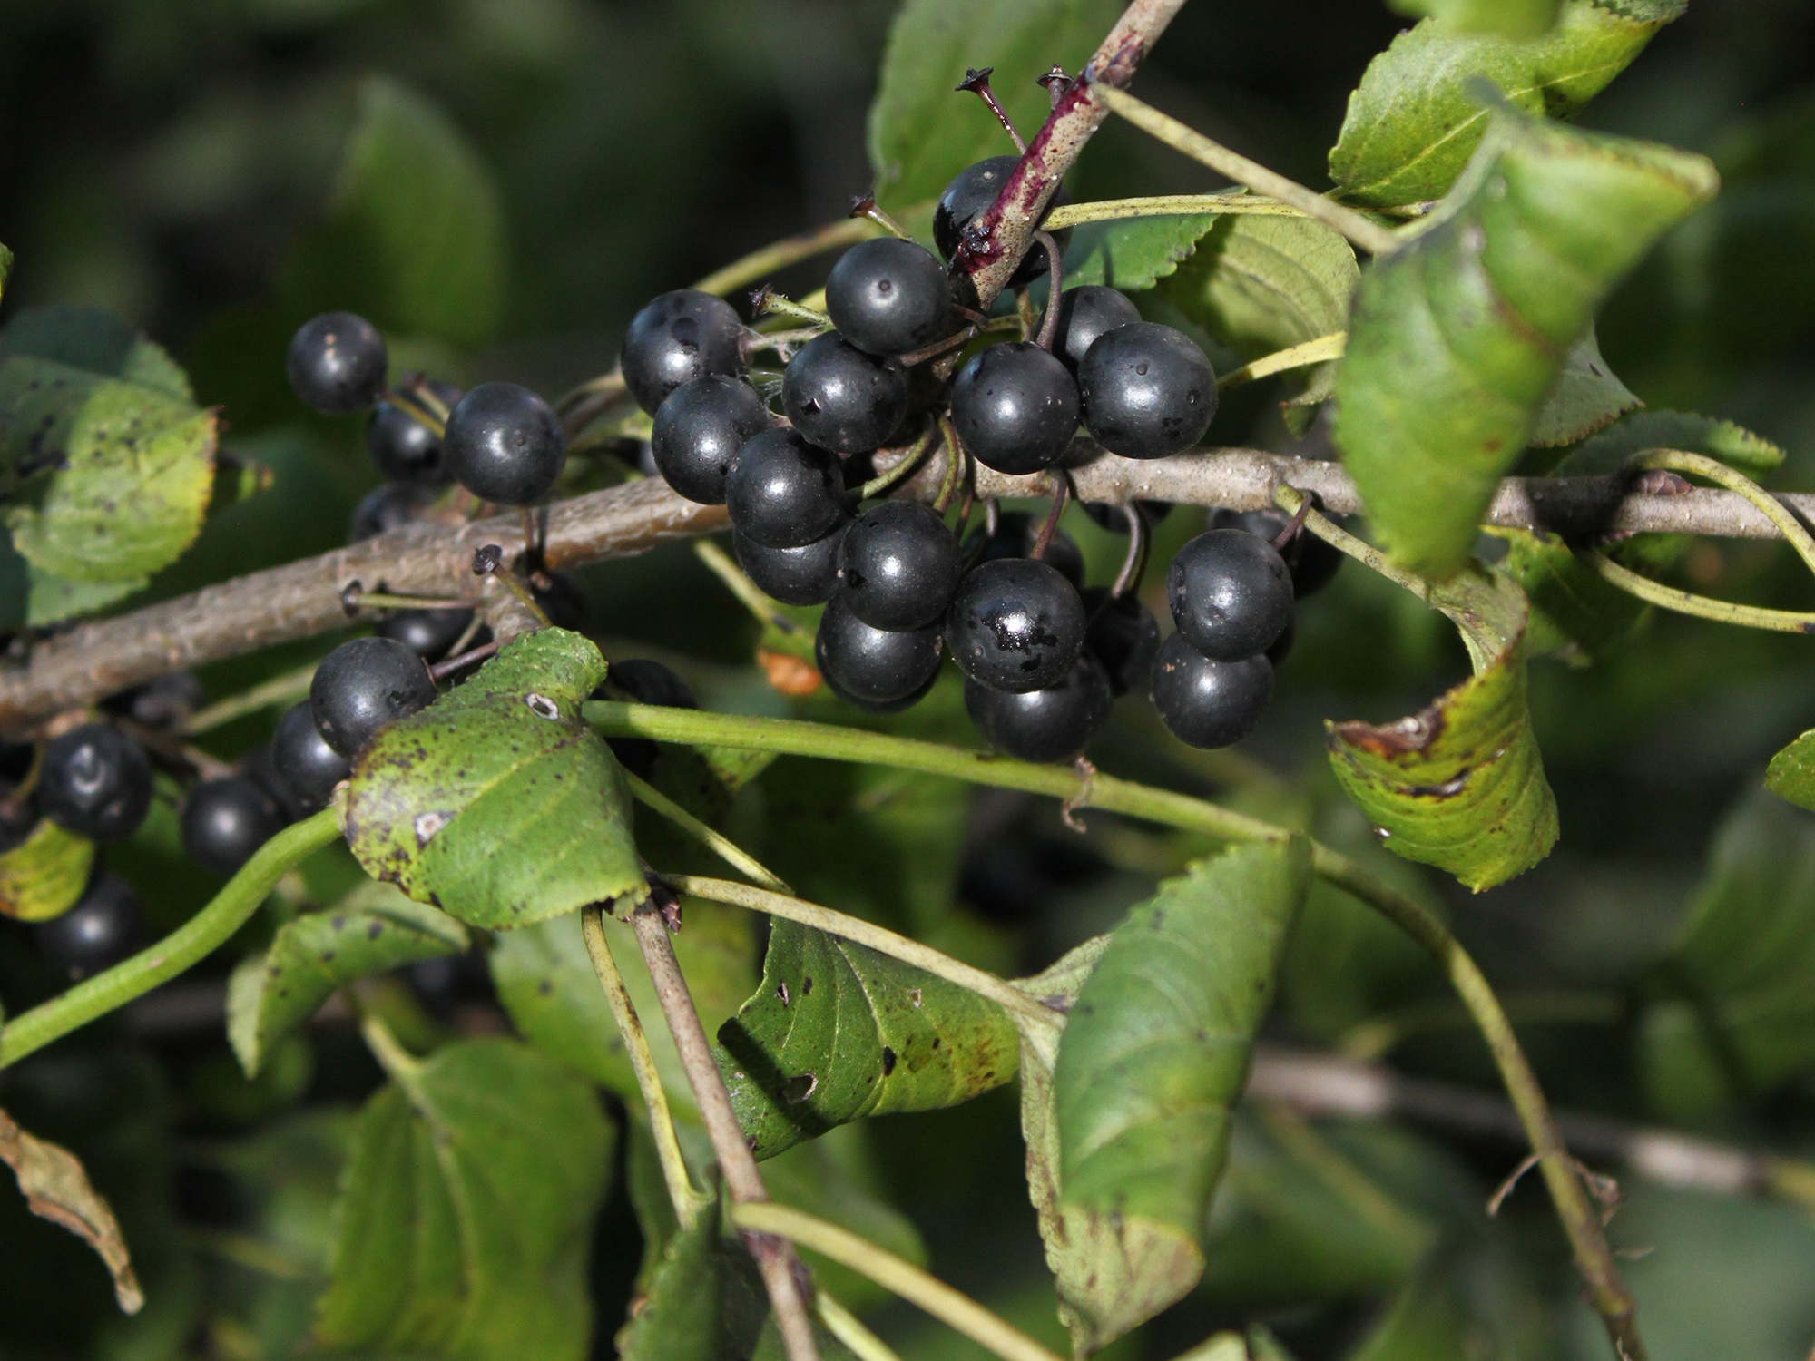

a) CN: Common Buckthorn

b) PN: n/a

c) SN: Rhamnus cathartica

d) WF: roadsides, pastures, fields

e) U/P: outcompetes native plants (light, water)

f) AS: n/a

Plant #11

a) CN: Garlic Mustard

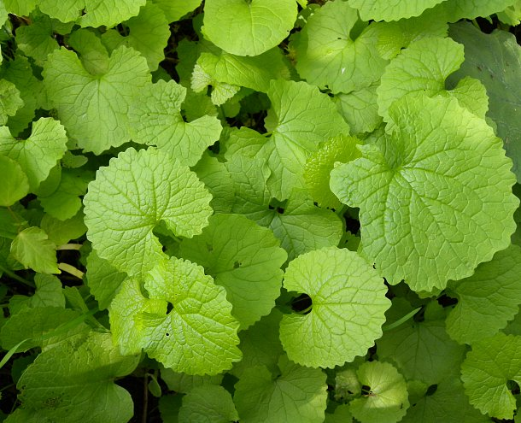

b) PN: n/a

c) SN: Alliaria petiolata

d) WF: lawns, roadsides, trails, forest (shade tolerant)

e) U/P: quickly becomes dominant plant

f) AS: n/a

Plant #12

a) CN: Wild Grape

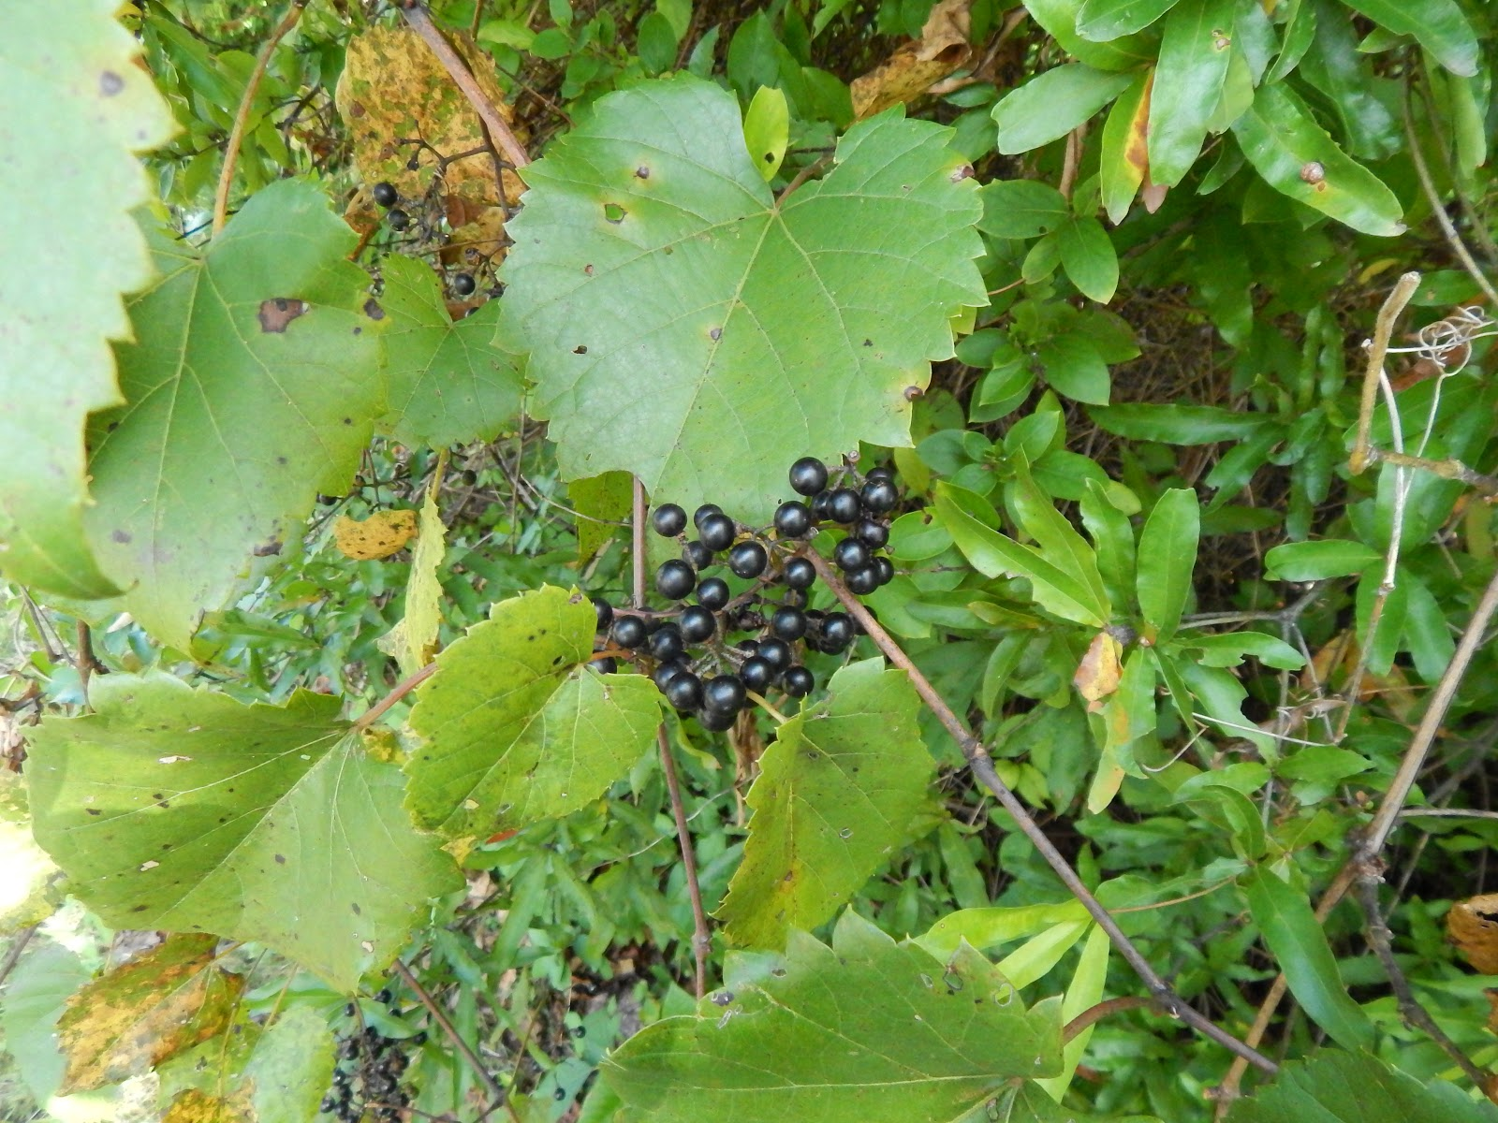

b) PN: n/a

c) SN: Vitis spp.

d) WF: forest edge, fields, disturbed sites, riverbanks

e) U/P: shades out trees, outcompetes plants

f) AS: n/a