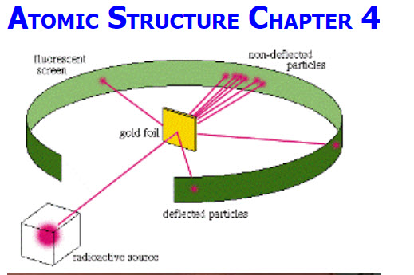

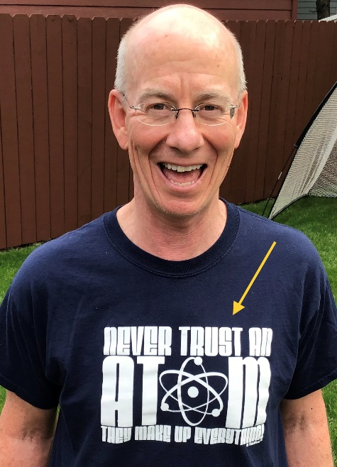

**“Never Trust an Atom … They make up everything!”**

**See** [**https://www.learningctronline.com/courses**](https://www.learningctronline.com/courses) **for Materials and Resources.**

**Topics:**

1. Atomic Structure

**Objectives:**

1. Explain Atomic History from specific scientist’s perspectives (Democritus, Dalton, Thomson, Millikan, Goldstein, Chadwick, Rutherford).
2. Understand subatomic particles in a typical atom (charge, mass, location).
3. Explain what makes elements (atomic number, mass), use nuclear symbols, and understand isotopes.
4. Determine the weighted average of an element on the Periodic Table using relative abundance.

TAKE NOTE

1. Notes/Study Guide (1 week)
2. Density Lab (Formal Lab Report due in four days)
3. Lesson Check/Sample problems
4. Electrostatic Forces Activity (Lab)
5. Nuclear Symbols for Elements 1 – 20
6. Test Corrections Measurement
7. Week 6 Devotional (<https://www.learningctronline.com/devotional>)

**Text**: Chapter 4: Atomic Structure pp. 100-125

Read the assigned pages in the text.

**Class Notes: PowerPoint or PDF**

**Notes/Study Guide:** Fill in the Chapter 4 worksheet to understand the class notes.

**Homework**:

(1) Answer the KEYED **"Lesson Check"** questions at the end of each.

(2) Answer the **"Sample problems"** found in the "Sample Problem" boxes throughout the chapter. An answer KEY is provided for you to use to self-correct your homework problems.

* Put your answers into complete thoughts in a Word document. Do NOT just put the answer, but write a phrase or sentence that you can study from for your tests. Save your work in a WORD document and SAVE into your HOMEWORK folder in the Chemistry folder on the desktop.
* Assignments will be “spot checked” during class or submitted via email.

(3) Use the periodic table and write nuclear symbols for elements 1 – 20.

**Alternate Homework**:

**Lab**: Electrostatic Forces Activity

* Perform the "Electrostatic Forces Activity" using the Electrostatic Forces Activity Worksheet provided.
* Answers are provided at the end of the worksheet for guidance and reinforcement. You may use them AS LONG AS YOU REWORD your answers in YOUR OWN WORDS versus copying and pasting.
* Save document into your LAB folder in the Chemistry folder on your desktop.

**Lab**: Density Lab (Formal Lab Report)

Perform the "Density: A Characteristic Property" lab using the Density Lab Worksheet provided. This would include doing the calculations so you practice determining density of various items. You will write up a Formal Lab Report following the guidelines in the Lab Report Format Document within 4 days.  
  
The formal Lab Report is due FOUR (4) days after THIS week's class.

* DO NOT FORGET to subtract out the mass of the graduated cylinder before trying to calculate the mass of the substance alone. Otherwise, your density calculations will be incorrect.
* Give units for all measurements.
* Be sure to SHOW WORK for the density calculations in the Calculations and Data section.
* Include at least THREE PICTURES or IMAGES of your observations and/or objects that you used to calculate the density (e.g. show the object on the electronic scale for mass and the volume in the graduated cylinder). Explain the relevance of the image to the lab. Images must be 600 pixels or less.  
    
  Ideally, a picture should be included for each item. You must include a picture of Experiment 5 results.
* There are questions that you need to include in the Conclusion Section of the lab report which are in the Density Lab Worksheet. Do NOT copy and paste or leave these questions, but label their number and make statements. Make sure you answer them in complete sentences that convey a complete thought, giving evidence from the lab experiment to support your answers.

[Density Lab Help Video](https://screencast-o-matic.com/watch/cYjqYzmnN6) (8:54) ... This video goes over how to write the lab report.  
  
Consider using the Lab Report Checklist to ensure that you include ALL aspects of the Formal Lab Report. This is a Formal Lab Report and must be done technically correct.

**TEST:** The test will be given after next week’s lesson.

Supplemental Resources (Optional)

1. PHET Simulation: Atomic Models
2. Nuclear Symbols Simulation

[Isotopes & Weighted Atomic Mass (Relative Abundance)](http://screencast-o-matic.com/watch/cD6bF9jBKQ) (5:17) ... completes class notes  
  
-----------------------------------------------  
  
[Van Der Graaf Demo [Charges Exist]](http://somup.com/cFQ22DVSKM) (1:15)  
  
[The Atom: Electrostatic Force Demonstrations ctr](http://somup.com/cF6elPnVza) (2:59) ... first 1:30 minutes is the Acrylic Tape Demo; Then, a balloon demo shows friction, induction and conduction.  
  
[Crookes' Tube: Cathode Ray deflected by Magnet (Electrons)](http://somup.com/cF6eVJnVy6) (1:07)  
  
[Millikan Oil Drop Experiment (Mass to Charge Ratio)](http://somup.com/cF6eVdnVyl) (1:14)  
  
[The Nucleus: Atoms are mostly empty space](http://somup.com/cF6eVsnVyD) (0:48)  
  
[Rutherford's Experiment: Atom's center is a Nucleus](http://somup.com/cF6eVMnVyb) (0:47)  
  
[Atomic History Song (Mark Rosengarten](http://somup.com/cFQ22rVSKR) (4:14)  
  
[The Race Set Before Us 1 Corinthians 9:24-27; Runner](http://somup.com/cYhI28jrpo) (5:11)