Give the metric units and what they measure (volume, distance, mass).

What are the steps of the scientific method and what is involved in each?

A student using a ruler marked in centimeters is asked to measure a large box, which is known to be 1.7 meters long. How long is the box in centimeters?

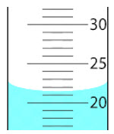

The image above represents a portion of a 100-milliliter graduated cylinder. What is the most precise volume of the liquid in the graduated cylinder?

Which of the following properly expresses 0.0045 in scientific notation?

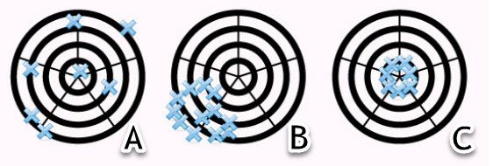

Based on the image above, which letter represents poor accuracy but good precision?

Before opening a can of paint, one shakes the can vigorously to remix the settled-out particles. Paint is a

a. colloid.

b. suspension.

c. solution.

d. compound.

Which action involves a chemical change only?

a. precipitate

b. gas formation

c. color change

d. fire

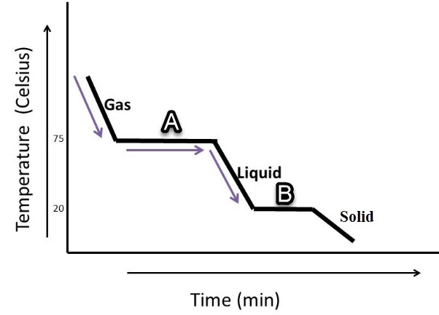

What kind of energy/heat flow is shown on the graph?

a. exothermic, heating curve

b. endothermic, cooling curve

c. endothermic, heating curve

d. exothermic, cooling curve

Which class of matter does NOT "fit" with the others related to composition and fixed proportion?

a. heterogeneous mixture

b. element

c. compound

d. pure substance

Which statement is NOT true related to sublimation and deposition?

a. They represent chemical changes.

b. They represent physical changes.

c. They involve the gas and solid states of matter.

d. Energy is absorbed or released.

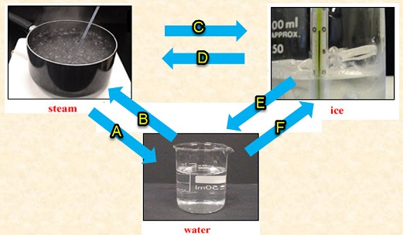

Which letter shows the liquid particles absorbing heat energy and being broken apart to produce a more random arrangement?

A

B

C

D

E

F

Give the number of protons, neutrons, and electrons in a neutral atom represented by 5B11.

a. 5 protons, 11 neutrons, and 5 electrons

b. 11 protons, 6 neutrons, and 5 electrons

c. 6 protons, 5 neutrons, and 6 electrons

d. 5 protons, 6 neutrons, and 5 electrons

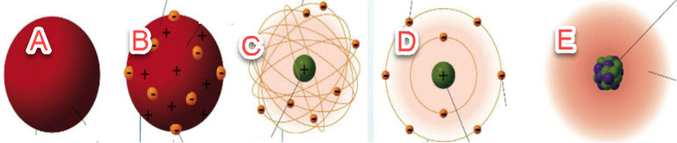

Which scientist goes with each model?

Atoms

a. are composed of equal numbers of protons, electrons, and neutrons.

b. have isotopes containing different numbers of electrons.

c. are mostly empty space.

d. have atomic numbers that indicate the number of neutrons.

A neutral atom has 30 protons and 35 neutrons. Which shows the correct nuclear symbol and number of electrons?

C12 and C13 are

a. radioactive atoms of carbon, containing a different number of electrons.

b. isotopes of carbon, containing a different number of neutrons.

c. atoms of carbon, containing a different number of protons.

d. isotopes of carbon, containing the same number of neutrons.

Based on the meaning of each statement, which statement does NOT belong with the other three?

a. atomic number

b. number of protons in an atom

c. number of electrons in a neutral atom

d. atomic mass

The terms malleable, ductile, conductors, hard and strong all describe ___.

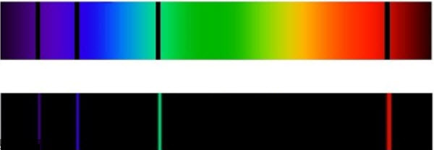

Which statement is TRUE related to atoms gaining and releasing energy?

a. Both images represent atoms that gaining energy so its electrons move from a lower to higher energy level.

b. The top image represents an atom releasing energy so its electrons move from a higher to lower energy level.

c. The top image represents an atom gaining energy so its electrons move from a lower to higher energy level.

d. The bottom image represents an atom gaining energy so its electrons move from a lower to higher energy level.

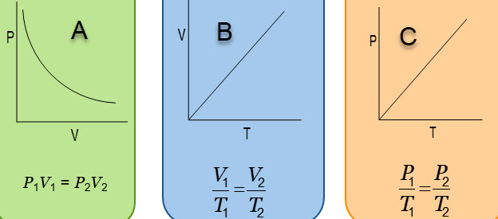

Which graph represents Charles' Law?

Which graph shows an inverse relationship between the variables?

When a neutral atom gains an electron, it forms a(n)

What decreases from left to right on the periodic table?

a. metallic character

b. non-metallic character

c. atomic number

d. atomic mass

Know the contribution of each scientist

a. Moseley

b. Mendeleev

c. Dobereiner

d. Newlands

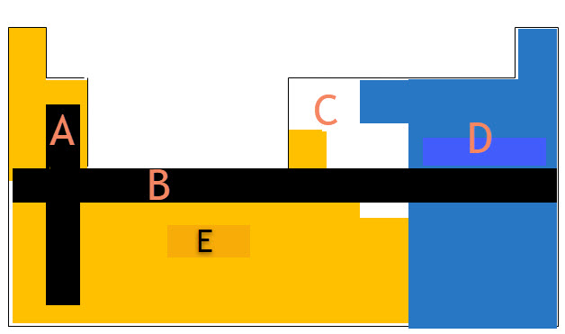^^^

Which letter corresponds to "periods"?

A

B

C

D

E

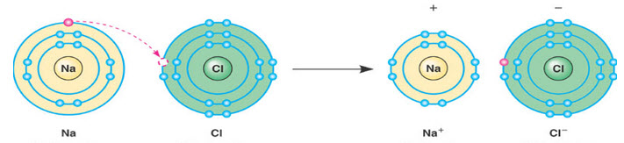#

What type of bonding is shown in the image?

a. covalent

b. metallic

c. network

d. ionic

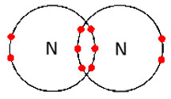

What type of bond is shown? What is involved (electrons)?

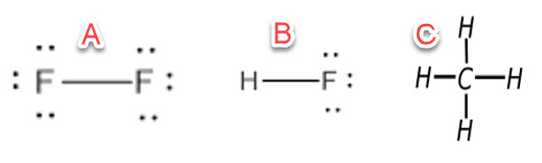

Which of the molecules in the image shows polar bonds, but a non-polar molecule?

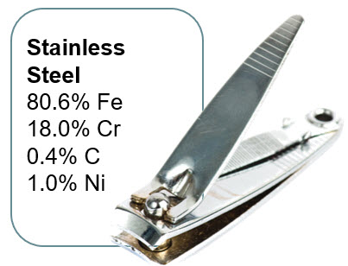

The image shows a(n)

a. metallic element.

b. non-metallic element.

c. covalent molecule.

d. alloy.

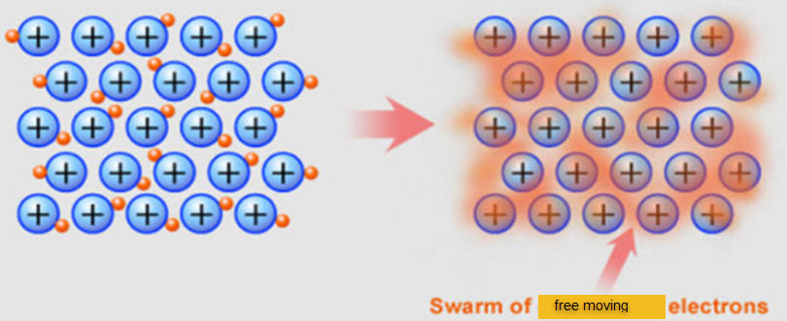

What type of bonding is shown in the image?

a. ionic

b. covalent

c. metallic

d. network

For the reaction: N2(g) + 3H2(g) 🡪 2NH3(g) + heat, what will happen if temperature (heat) is increased?

a. The equilibrium will shift to the RIGHT (reverse reaction is favored).

b. The equilibrium will shift to the LEFT (forward reaction is favored).

c. The equilibrium will shift to the LEFT (reverse reaction is favored).

d. The equilibrium will shift to the RIGHT (forward reaction is favored).

A balanced equation of the skeleton reaction: Na + H2O ⇌ H2 + NaOH is

a. 2Na + 2H2O ⇌ H2 + 2NaOH.

b. Na + H2O ⇌ H2 + NaOH

c. 2Na + H2O ⇌ H2 + 2NaOH

d. 3Na + 3H2O ⇌ H2 + 3NaOH

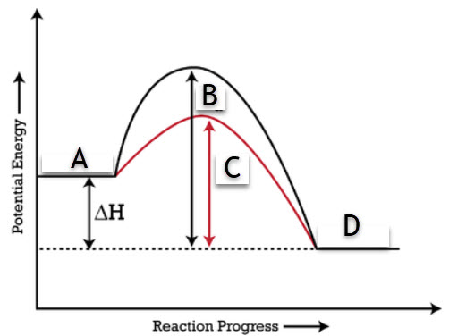

Which letter represents the activation energy of the reaction involving a catalyst?

Know examples of each type of chemical reaction

a. single replacement

b. double replacement

c. synthesis

d. combustion

e. decomposition

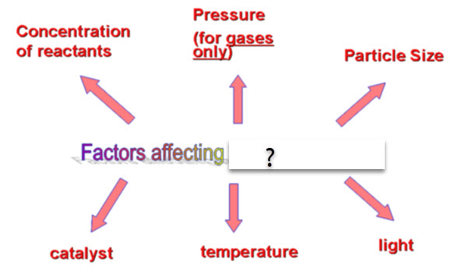

The image shows factors affecting ___.

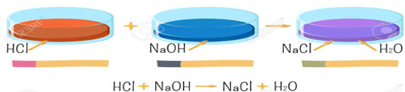

What type of reaction is shown in the image?

Which of the follow can affect how fast a solute dissolves in a solvent?

a. the size of the solute particles

b. heating the solution

c. stirring the solution

d. all the choices.

When solute is added to water

a. the freezing point increases.

b. it immediately becomes saturated.

c. there is no significant impact.

d. the boiling point increases.

Which statement BEST describes a solution?

a. A solvent is dissolved in a solute.

b. The solute is the larger part of the solution.

c. A solute is dissolved in a solvent.

d. The solute is always a solid.

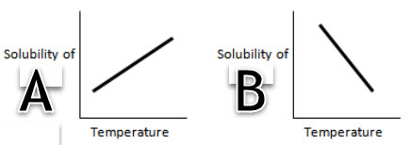

Which graph shows an inverse relationship (as temperature increases, solubility decreases) and which state of matter does it relate to?

a. A 🡪 solids

b. B 🡪 gases

c. A 🡪 gases

d. B 🡪 solids

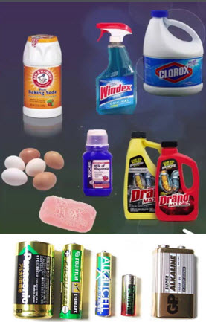

The image shows

a. bases.

b. acids.

c. non-electrolytes.

d. buffers.

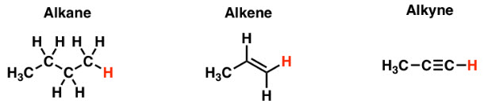

Which of the images shows a saturated hydrocarbon?

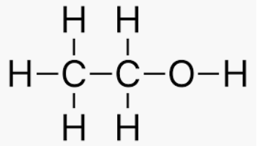 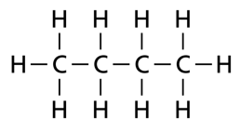 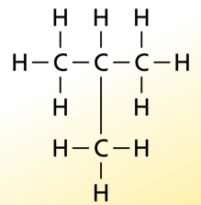 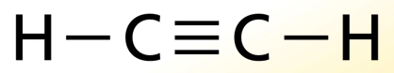

ethanol CH3CH2OH butane C4H10 isobutane C4H10 ethyne C2H2

Which images represent isomers?

How many bonds does a typical carbon atom have in a hydrocarbon?

What is the daughter product of alpha decay of 86Rn220?

What is the daughter product in the beta decay of 58Ce144?

The half-life of the radioactive decay of an element is 50 years. If 100 grams of the substance is measured and allowed to sit for 200 years, theoretically how much of the element will remain?