**Purpose** To investigate heat transfer involving convention.

**Background Information**

Heat can be transferred by radiation (waves moving through space without particles), conduction (particle to particle), and convection (particles move from one place to another).

Convection involves a transfer of energy (heat) due to differences in density or temperature. The cooler material will sink, and warmer material will rise. Particles in warmer regions flow towards cooler regions. Both density and temperature differences produce convection currents, observed in weather systems, ocean currents and movement of hot rock in Earth’s interior.

**Hypothesis**

If a colder object is placed into a warmer region, then a convection current will be produced.

**Materials** Ice Cube Tray Food Coloring Table Salt

Tap Water 2 - 250 ml Beakers / Glasses

<https://screencast-o-matic.com/watch/cYfrqwAh9V>

# Procedures

1. Add ~200 ml of tap water to a 250 ml beaker / glass. (*Approximate measurements are fine*.)

2. Add several drops of food coloring to the water and stir until the mixture is consistent.

3. Pour the colored water into an ice cube tray to make ice cubes.

4. Place the ice cube tray in the freezer (*preferably overnight*).

----------------------------------------------------------------------------------------------------------------

5. Add ~200 ml of tap water to a 250 ml beaker. Add a teaspoon of salt to this beaker and stir thoroughly for one minute.

6. Add ~200 ml of tap water to a second 250 ml beaker.

7. Place one COLORED ice cube in each of the two beakers AT THE SAME TIME and observe.

a. Notice in which beaker the ice cube melts faster.

b. Make a drawing/sketch (on the next page) of the melting process in both beakers.

## Calculations and Data

1. Sketch and describe what happened as the ice melts in the two beakers:

Tap Water Salt Water

2. In which beaker did the ice melt the quickest?

# Conclusions and Questions

1. What accounts for the ice melting the way it did?

2. Which beaker contains the liquid that is most dense? How do you know?

1. Sketch and describe what happened as the ice melts in the two beakers:

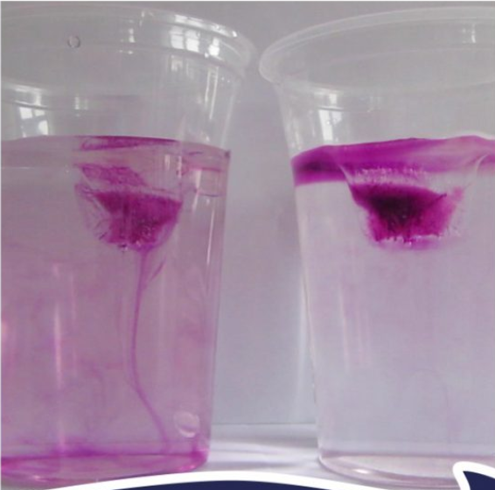

Tap Water Salt Water

*The color forms “streams” and drops in the tap water beaker, but forms a kind of “layer” in the salt water beaker.*

2. In which beaker did the ice melt the quickest?

*The ice melted quicker in the tap water beaker*

# Conclusions and Questions

1. What accounts for the ice melting the way it did?

*Salt water produces a layer of “water” and a layer of “salt water” with little convection. The tap water allows convection so the ice melts quicker due to more area affecting the ice.*

2. Which beaker contains the liquid that is most dense? How do you know?

*Salt water is more dense. You can see a “layer” established as the ice melts.*