**Erwin Chargaff** has been called the “Father of Molecular Biology” and is credited with discovering the chemical composition of DNA in 1935. He found that DNA has four nitrogen bases called Adenine (A), Thymine (T), Guanine (G), and Cytosine (C). His work showed that there was always the same number of Adenines (A) as there were Thymines (T). He also found out there was always the same number of Cytosines (C) as Guanines (G).

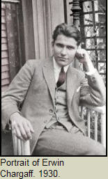

Sketch / draw / make a model of the DNA knowing the following:

1. DNA is a long chain-like molecule composed of small subunits.

2. Subunit molecules are like links in a chain and are attached to each other by covalent bonds.

3. There are four sub units that were studied by Chargaff as described above.

**Rosalind Franklin**’s X-Ray diffraction picture demonstrated that DNA has a helical shape. A helix is the shape a pipe cleaner makes if you twist it around a pencil, like a spiral staircase. The picture also shows that the molecule is uniform along it’s length. Many argue that Franklin should have been awarded the NOBEL prize rather than Watson & Crick.

Sketch / draw / make a new revised model of DNA following the information from Franklin’s X-Ray Diffraction photo:

1. DNA has 2 long chains of subunits twisted around each other to form a double helix.

2. The diameter of DNA is uniform in length.

1. The 2 long chains have a sugar and phosphate backbone that alternates between sugars (S) and phosphates (PO4).

4. The bases discovered by Chargaff are between the 2 backbones.

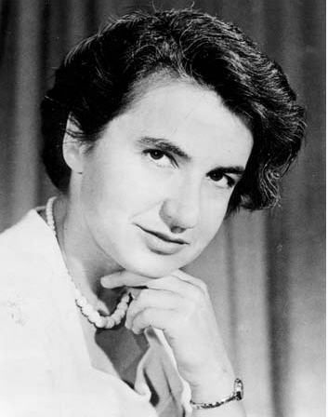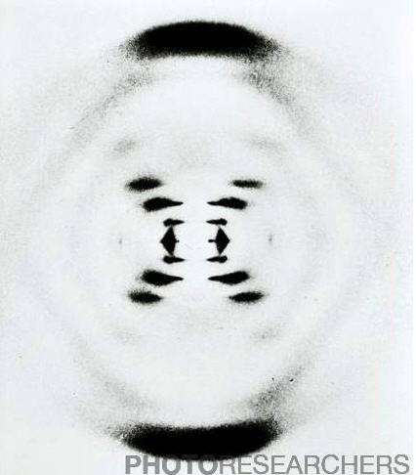

These two men, **James Watson** and **Francis Crick**, put the information from Chargaff, Franklin and several other scientists together to make a working model of DNA that is still used today. They received the NOBEL prize for their work.

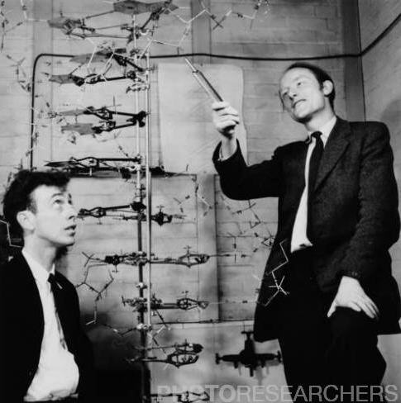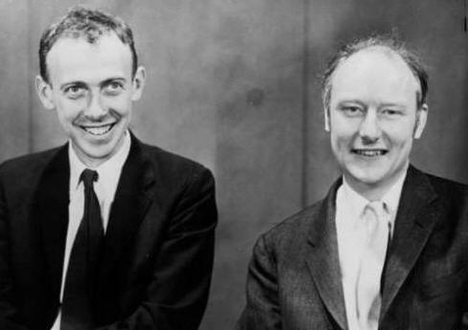

*Watson* *Crick*

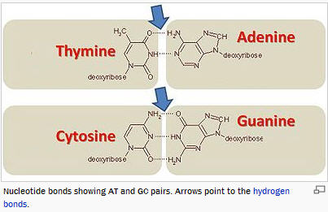

Sketch / draw / make a final modified model of DNA using the previous discoveries of Chargaff and Franklin along with the additional information from Watson and Crick:

1. DNA contains subunits that are bonded together by hydrogen bonds between Adenine (A), Thymine (T), Guanine (G), and Cytosine (C).

2. The order of the bases in one strand of DNA determines the order of subunits of the other strand of DNA. [*The bases are “complimentary.”*]

3. DNA can make an exact copy of itself and is the blueprint for proteins.

4. The diagram to the left of Thymine – Adenine (T – A) and Cytosine – Guanine (C – G) illustrates the bonding of the nitrogen bases.

5. Franklin’s double helix, sugars and phosphates concepts are incorporated in Watson & Crick’s model.