<https://www.physicsclassroom.com/Physics-Interactives/Refraction-and-Lenses/Optics-Bench/Optics-Bench-Refraction-Interactive>

Draw ray diagrams for the following **convex lenses**:

Object beyond 2f

Object less than f

Object between f and 2f

Draw ray diagrams for the following **convex lenses**:

Object between f and 2f

Object less than f

Draw ray diagrams for the following **concave lens**:

Object beyond 2f

Draw ray diagrams for the following **concave mirrors**:

Object beyond 2f

Object at 2f

Object between f and 2f

Object at f

Object less than f

Draw ray diagram for the following **convex** **mirror**:

Object beyond 2f

**Ray Diagrams for Convex Lenses**

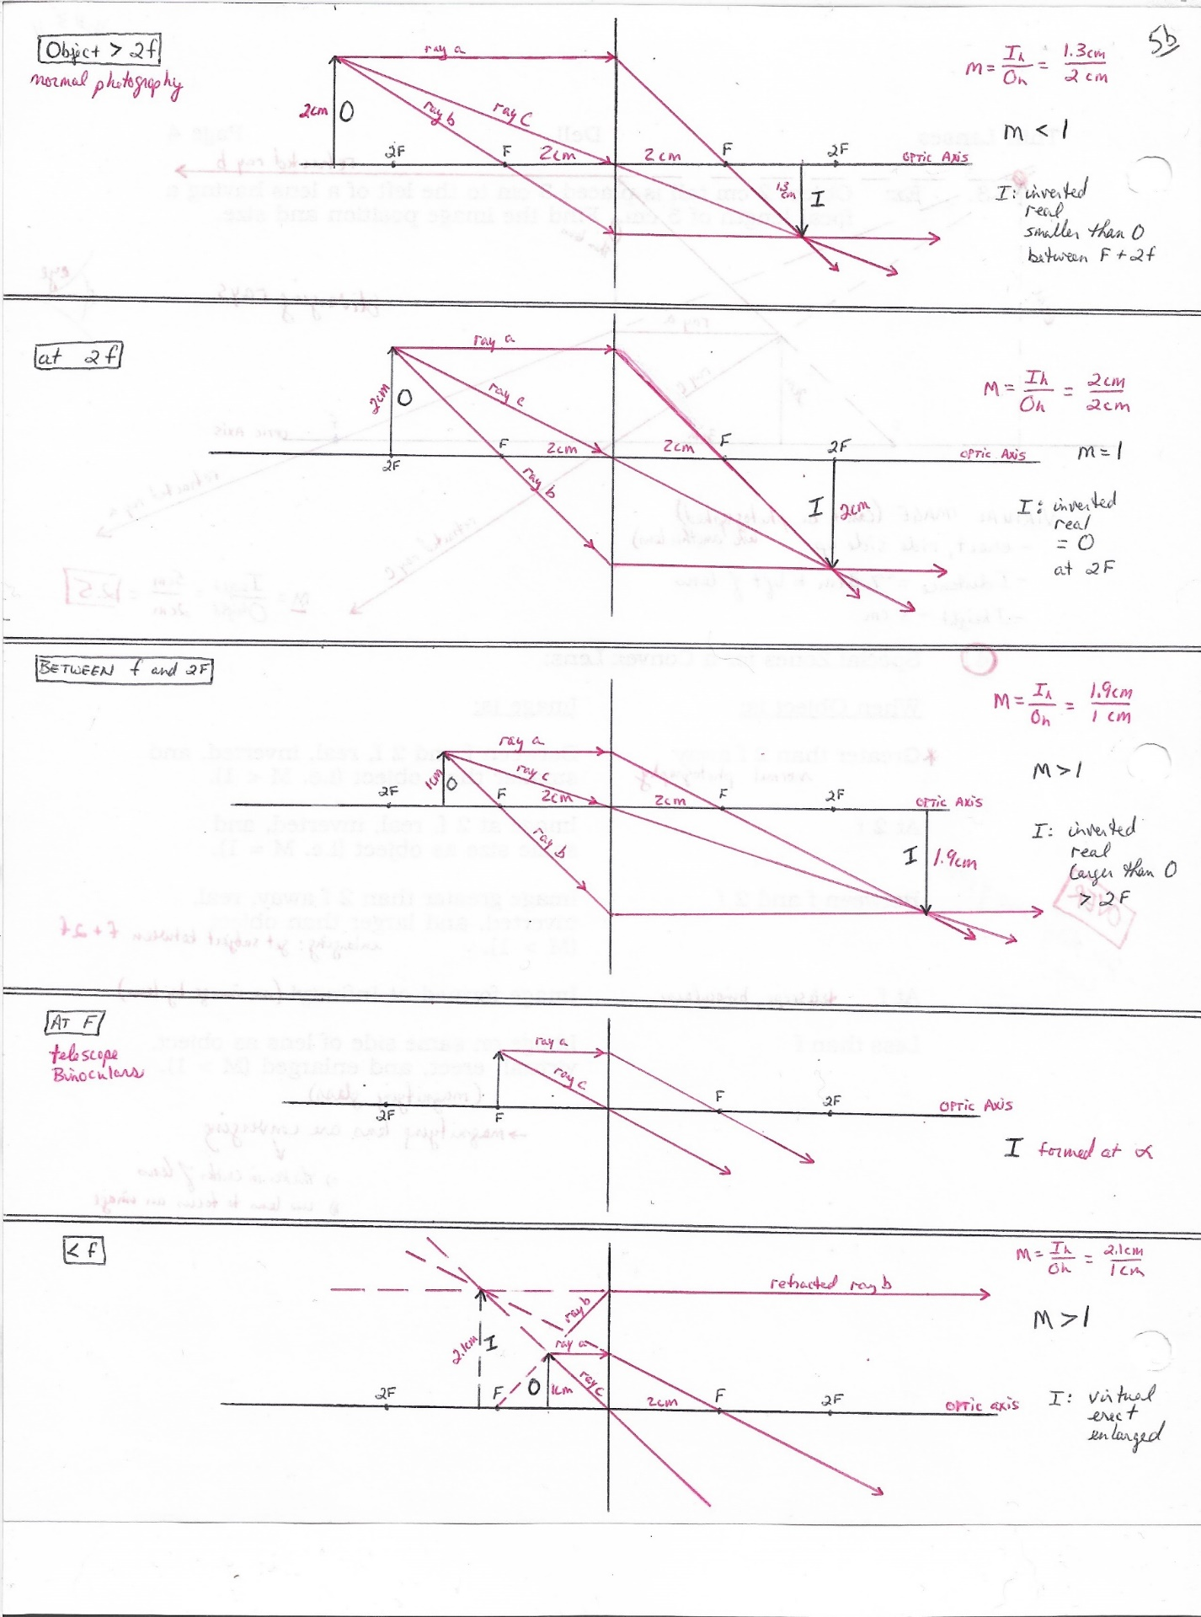

**Ray Diagrams for Convex Lenses**



**Ray Diagrams for Concave Lenses:**

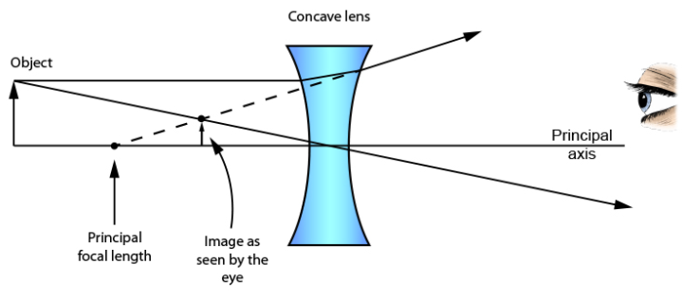

Image 🡪 erect, virtual, reduced

**Concave Mirror (object beyond 2f)**

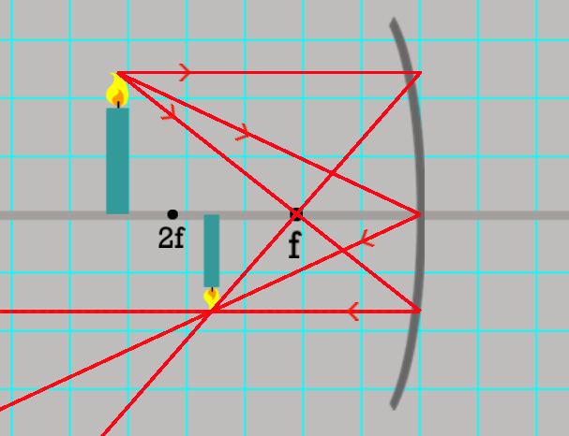

Image 🡪 inverted, reduced, real

**Concave Mirror (object at 2f)**

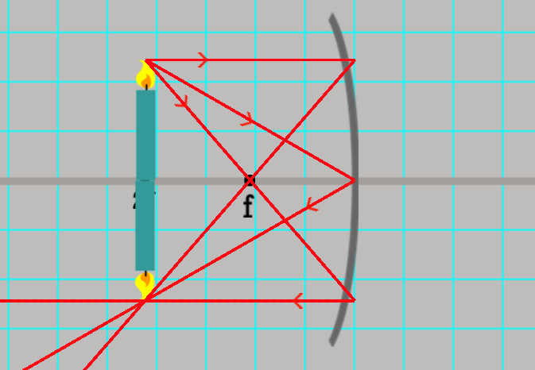

Image 🡪 inverted, same size, real

**Concave Mirror (object between f and 2f)**

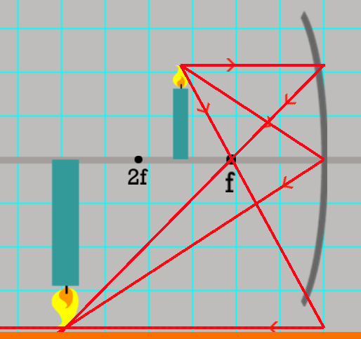

Image 🡪 inverted, enlarged, real

**Concave Mirror (object at f) … image at infinity (no image)**

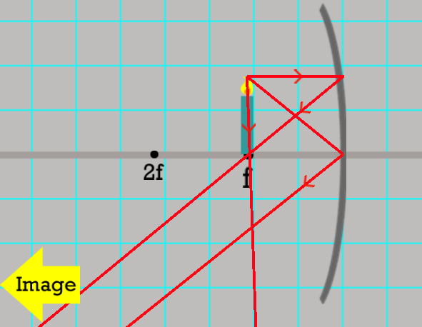

**Concave Mirror (object less than f)**

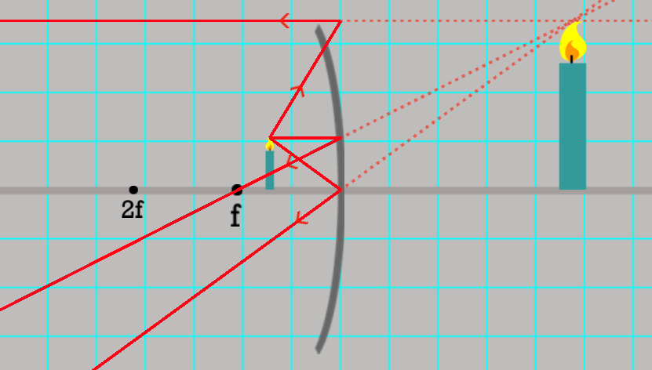

Image 🡪 enlarged, erect, virtual

**Convex Mirror (object beyond 2f)**

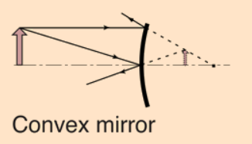

Image 🡪 reduced, erect, virtual