Static Electricity Movement of Charge

## PART I What Happens When Materials Become Electrified?

# **Introduction**

# **Purpose** To investigate what actually happens when objects become electrified through a transfer of electrical charge in an electrostatic system.

**Discussion**

In the previous electrostatic investigations, you determined that “charges” transfer from object to object in order to produce the electrostatic forces of attraction and repulsion. For instance, we “know” that like charges repel and unlike charges attract. We have learned in the past and continue to use the term “charge” to signify the opposite nature of microscopic particles interacting within materials. Actually, Benjamin Franklin discovered opposite entities in materials which he was going to name “A” and “B” when he investigated electricity. He eventually chose to use the convention “+” and “-” to designate what we now call “charges.”

**MATERIALS**: 2 Plastic / black combs Paper punches from hole punch

Balloons (small, large) Wool cloth or sweater

Acrylic tape silk cloth

wool cloth or sweater piece of Styrofoam

**PROCEDURES & DATA**

*Acrylic Tape (*<https://screencast-o-matic.com/watch/cF6elPYlbr> *)*

### 1. Take TWO separate pieces of acrylic tape ~ 7.5 cm long (3 inches).

### 2. Hold them “back” to “back” so the NON sticky sides are facing each other.

### 3. Bring them together slowly and observe. Record what you see.

### 4. NOW, take TWO other separate pieces of acrylic tape ~7.5 cm long (3 inches).

### 5. Hold them by the ends and place one on top of the other on your table so that one sticks to the table & the other sticks to the NON sticky side of the one on the table.

### 6. Pull the pieces off the table. Pull them apart and then bring them together slowly “back” to “back” & observe. Record what you see.

*Balloon with Paper Punches*

(<https://screencast-o-matic.com/watch/cF6elPYlbr> 2nd demonstration)

1. Find a table with a smooth, glassy top or finish (*a wood table will work if it has a smooth top*).

a. Clean the table top with Windex or some other cleaner.

b. Then, wipe the table top off carefully so that it is absolutely dry.

c. Find a clean, dry, absorbent cloth to do a final wipe off of the table top.

2. Obtain at least 30-50 paper punches from a hole punch and spread out evenly on the table top so that the punches are very close to each other, but touching as little as possible.

3. Fill a LARGE balloon (20-30 cm length) as full as possible without popping it, and tie it off.

4. Hold the balloon at the tied end and RUB the inflated balloon vigorously and all over using a wool cloth (or sweater) for about 30 seconds.

5. Quickly hold the balloon about 10-15 cm ABOVE the small paper punches.

a. Rotate the balloon without changing its level above the paper punches.

b. If nothing happens, lower the balloon 2-3 cm and rotate again.

c. Repeat this process until you see something happen. Record your observations.

d. What is the name of the process involved?

6. Watch closely for a few paper punches to “jump off” the balloon and fly up to 20 cm away. Why?

### statics balloon 1

A few pieces “fly” off

What is the name of the process involved?

### *Balloon sticking to the wall*

1. What happens to a small balloon after being rubbed and placed on the wall?

<https://screencast-o-matic.com/watch/cbe2b96An0>

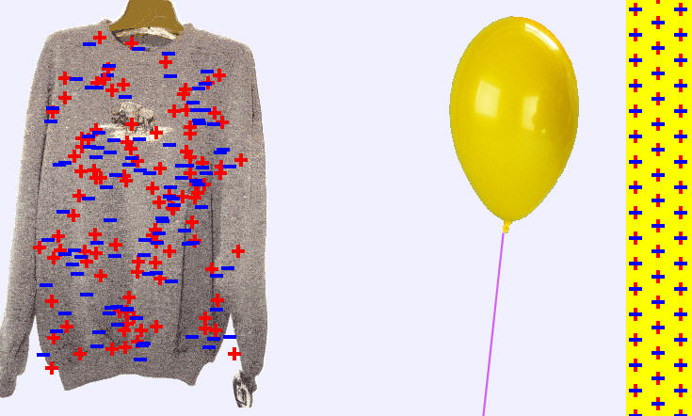 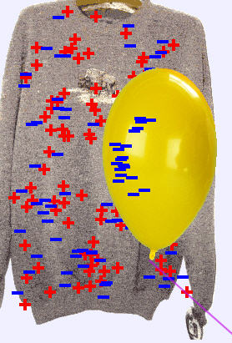 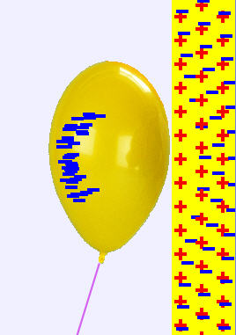

Before Static Forces Wool Sweater & Balloon rubbed balloon & wall

2. Observe the sweater and wall BEFORE doing anything. Consider and write what is meant by having a “neutral” charge.

3. Rub one side of the balloon against the sweater ONCE. Notice the charge on the sweater and the balloon. Record what happens.

4. Move the balloon to the wall and again notice the charges on the balloon and the wall. Record what happens.

## Conclusions and Questions

1. What caused the paper punches to act the way they did in this activity? (Why did it take time for some punches to move and others to reverse direction?)

2. Consider three factors that were involved in this electrostatic reaction.

3. Why didn’t all the charges “repel” off the charged balloon (*when the punches jump to the charged balloon, charge is transferred from the balloon to the paper punches*)?

## Part 2 Friction, Conduction and Induction

# **Introduction**

# **Purpose** To distinguish between various ways of producing electrostatic forces.

**Discussion**

Based on several pieces of evidence collected over the past couple of lab activities, we may assume that **negative charges** mainly **flow** when electrical forces are involved. This does not mean that we can say positive charges never flow. However, our evidence does support the former discovery. We have also observed various ways of producing electrostatic forces without making conclusions based on those observations. This will focus on electrostatic forces produced by **friction** (*rubbing materials together*), **conduction** *(transfer due to touching materials together*) and **induction** (*alignment or polarization due to bringing materials near one another*).

**Materials** Soda Can Apparatus Styrofoam Square Hula Can Wool Cloth

Pie Tin Apparatus LED Diode Large Balloon Paper Punch

**Procedures**

Hula Can

Coffee can

Styrofoam Cup

Tinsel

1. Make a “Hula Can” (*Bare,* *large coffee can apparatus with tinsel pieces around its “belly”*) as shown. Be sure to remove all outer labels, etc., from the coffee can.

a. Place 8-9 individual pieces of tinsel around the middle of the coffee can (on the outside) using clear tape.

b. Place 1-2 pieces of tinsel on the inside of the coffee can using clear tape.

c. Tape or glue an inverted Styrofoam cup to the bottom of the can as a holder.

2. Hold the **HULA CAN** upright (using the Styrofoam cup base) so that its opening is facing upwards.

3. Obtain a Styrofoam square (use a piece that is at least 8 inches square) and a wool cloth. Rub the Styrofoam square with the wool cloth vigorously for 30 seconds. Bring the Styrofoam square near, but NOT TOUCHING the Hula Can. Notice the tinsel both on the outside and inside of the Hula can. Record your observations. What charge is on the Hula Can after the Styrofoam is brought near?

4. Rub the Styrofoam square or plate with the wool cloth again. Firmly TOUCH the side of the Hula can with the rubbed Styrofoam square, pull it back and hold the Styrofoam nearby the can. Notice the tinsel both on the outside and inside of the Hula can. Record your observations. What charge is on the Hula Can after the Styrofoam touches it?

5. Rub the Styrofoam square or plate with the wool cloth again. Firmly TOUCH the side of the Hula can with the rubbed Styrofoam square AND your index finger from the hand not holding the Hula can. Then, pull back the Styrofoam plate and hold it nearby the can. Notice the tinsel both on the outside and inside of the Hula can. Record your observations. What charge is on the Hula Can after the Styrofoam touches it?

6. Rub the Styrofoam square with the wool cloth again. Quickly drop the wool into the Hula can. Notice the tinsel both on the outside and inside of the Hula can. Record your observations. What charge is on the Hula Can after the wool is dropped inside the can?

## Conclusions and Questions

1. Distinguish between friction, conduction and induction for electricity.

2. Based on your observations of the tinsel inside the Hula can, where do static electric charges build up? (*Do they accumulate throughout a material, on all surfaces, on outer surface only*)

3. What does “grounding” do to electrostatic charges? How does the electric charge move when an item is grounded? Give one example of how grounding effects electrostatics.

**ANSWER KEY**

### *Acrylic Tape*



### 1. Take TWO separate pieces of acrylic tape ~ 7.5 cm long (3 inches).

### 2. Hold them “back” to “back” so the NON sticky sides are facing each other.

### 3. Bring them together slowly and observe. Record what you see.

**“Attraction”**

<https://screencast-o-matic.com/watch/cF6elPYlbr>

### 4. NOW, take TWO other separate pieces of acrylic tape ~7.5 cm long (3 inches).

### 5. Hold them by the ends and place one on top of the other on your table so that one sticks to the table & the other sticks to the NON sticky side of the one on the table.

### 6. Pull the pieces off the table. Pull them apart and then bring them together slowly “back” to “back” & observe. Record what you see.

+

+

+

+

+

+

**“repulsion”**

**Acrylic tends to become POSITIVELY charged when rubbed because the electrons transfer from the acrylic into your finger.**

### *Balloon with Paper Punches*

5. Quickly hold the balloon about 10-15 cm ABOVE the small paper punches.

a. Rotate the balloon without changing its level above the paper punches.

b. If nothing happens, lower the balloon 2-3 cm and rotate again.

c. Repeat this process until you see something happen. Record your observations.

* ***The paper pieces were attracted to the balloon without touching it***
* ***Most paper pieces clung to the balloon.***

d. What is the name of the process involved?

***Induction (charges transfer without touch)***

6. Watch closely for a few paper punches to “jump off” the balloon and fly up to 20 cm away. Why?

* ***Some pieces “flew” off the balloon because conduction (charge transfer by touch) caused the same charge and repulsion)***

### statics balloon 1

A few pieces “fly” off

## Conclusions and Questions

1. What caused the paper punches to act the way they did in this activity? (Why did it take time for some punches to move and others to reverse direction?)

**Induction. Charges had to build up until they were strong enough to move the paper punches.**

2. Consider three factors that were involved in this electrostatic reaction.

**Friction (rubbing), conduction (touching), induction (bringing nearby but not touching)**

3. Why didn’t all the charges “repel” off the charged balloon (*when the punches jump to the charged balloon, charge is transferred from the balloon to the paper punches*)?

**The attractive force on the balloon overpowered most of the paper punches. However, some built up enough charge to repel off the balloon. Both the paper punches and the balloon surfaces were negatively charged.**

### *Balloon sticking to the wall*

1. What happens to a small balloon after being rubbed and placed on the wall?

<https://screencast-o-matic.com/watch/cbe2b96An0>

2. Observe the sweater and wall BEFORE doing anything. Consider and write what is meant by having a “neutral” charge.

***Neutral means the same number of negatives and positives***

3. Rub one side of the balloon against the sweater ONCE. Notice the charge on the sweater and the balloon. Record what happens.

***The balloon picks up negative charge, and the sweater has more positive charges than negative charges.***

4. Move the balloon to the wall and again notice the charges on the balloon and the wall. Record what happens.

***The negative charges in the balloon and the wall repel each other. The positive charges of the wall are attracted to the negative charges in the balloon, holding it to the wall.***

  

Before Static Forces Wool Sweater & Balloon rubbed balloon & wall

## Part 2 Friction, Conduction and Induction

**Procedures**

3. Hold the **HULA CAN** upright so that its opening is facing upwards. Rub the Styrofoam square with the wool cloth. Bring the Styrofoam square near, but not touching the Hula Can. Notice the tinsel both on the outside and inside of the Hula can. Record your observations. What charge is on the Hula Can after the Styrofoam is brought near?

**The tinsel OUTSIDE the can were attracted to the rubbed Styrofoam plate. The tinsel INSIDE the can did nothing. The wool rubbed Styrofoam has a NEGATIVE charge and induces a POSITIVE (temporary) charge on the tinsel (repelling electrons and attracting protons).**

4. Rub the Styrofoam square with the wool cloth again. Firmly TOUCH the side of the Hula can with the rubbed Styrofoam square, pull it back and hold the Styrofoam nearby the can. Notice the tinsel both on the outside and inside of the Hula can. Record your observations. What charge is on the Hula Can after the Styrofoam touches it?

**The wool rubbed Styrofoam plate has a NEGATIVE charge and electrons are conducted from the Styrofoam plate into the coffee can and tinsel. The tinsel OUTSIDE the can were repelled from the coffee can and stick straight out. The tinsel INSIDE the can did nothing.**

**When bringing the Styrofoam plate nearby, the tinsel are repelled and crunch up against the coffee can.**

5. Rub the Styrofoam square with the wool cloth again. Firmly TOUCH the side of the Hula can with the rubbed Styrofoam square AND your index finger from the hand not holding the Hula can. Then, pull back the Styrofoam plate and hold it nearby the can. Notice the tinsel both on the outside and inside of the Hula can. Record your observations. What charge is on the Hula Can after the Styrofoam touches it?

**The wool rubbed Styrofoam plate has a NEGATIVE charge. When it touches the coffee can and you touch the can with your index finger simultaneously, the electrons from the Styrofoam plate jump to your finger, leaving the coffee can and tinsel POSITIVELY charged. The tinsel OUTSIDE the can were repelled from the coffee can and stick straight out. The tinsel INSIDE the can did nothing.**

**When bringing the Styrofoam plate nearby, the tinsel are strongly ATTRACTED to the Styrofoam plate (opposite to the last procedure).**

6. Rub the Styrofoam square with the wool cloth again. Quickly drop the wool into the Hula can. Notice the tinsel both on the outside and inside of the Hula can. Record your observations. What charge is on the Hula Can after the wool is dropped inside the can?

**The wool after rubbing the Styrofoam plate has a slightly POSITIVE charge. The tinsel INSIDE the can took on the positive charge of the wool … so did the can, and were repelled from the coffee can and stick straight out. The tinsel OUTSIDE the can did nothing.**

## Conclusions and Questions

1. Distinguish between friction, conduction and induction for electricity.

**Friction is rubbing and sliding between objects which causes a transfer of charge. Conduction is when charges transfer due to TOUCH between objects. Induction is a realigning of charge when objects are nearby, but do NOT touch.**

2. Based on your observations of the tinsel inside the Hula can, where do static electric charges build up? (*Do they accumulate throughout a material, on all surfaces, on outer surface only*)

**Static charges build up on surfaces only, not inside materials. A practical example of this is driving during a Thunderstorm. Lightning may strike the outside of the car and as long as you are completely inside the car, the static electricity will flow from the OUTSIDE surfaces of the car into the GROUND because of the tires contacting the road.**

3. What does “grounding” do to electrostatic charges? How does the electric charge move when an item is grounded? Give one example of how grounding effects electrostatics.

**Grounding causes the transfer of charge between objects. In the Hula Can experiment, your index finger caused the grounding, the transfer of electrons from the can to your finger.**

**A practical example of grounding is driving during a Thunderstorm. Lightning may strike the outside of the car, but the static electricity will flow from the OUTSIDE surfaces of the car into the GROUND because of the tires contacting the road. As long as passengers are completely inside the car, they are safe.**