1. According to the law of reflection,

a. the normal is parallel to the angle of reflection.

b. the incident ray and the reflected ray are in different planes.

c. light rays are reflected in the same direction from a smooth surface.

d. the angles of reflection and incidence are equal.

2. From which of the following surfaces would light rays undergo specular reflection?

a. white construction paper

b. a telescope mirror

c. a black piece of cloth

d. a concrete sidewalk

3. Refraction occurs when

a. light travels through two adjacent media with different optical densities.

b. light strikes the boundary of two media with the same optical density.

c. the angle of incidence equals zero.

d. the angle of reflection equals zero.

4. When light rays travel from an optically-dense medium into a less-dense medium,

a. the rays travel more quickly.

b. the angle of refraction is smaller than the angle of incidence.

c. the refracted rays bend toward the normal.

d. the angle of incidence equals the angle of refraction.

5. Which of the following is **NOT** true of Snell’s law?

a. Light rays traveling between any two media are related by a constant, *n*.

b. As the angle of incidence increases, the angle of refraction increases. [Assume light travels from a less dense to more dense medium.]

c. The sines of the angles of refraction and incidence are inversely proportional to the indices of refraction of the two media.

d. Light moving from a substance with a smaller *n* to a larger *n* is bent toward the normal.

6. The incident angle for which a refracted ray emerges tangent to the surface of a medium is the ___ angle?

a. reflected

b. zero

c. critical

d. normal

7. A rainbow is a phenomenon caused by

a. a mirage.

b. refraction.

c. total internal reflection.

d. two choices are correct.

e. all choices are correct.

8. Which of the following statements is **NOT** true?

a. When light rays strike a rough surface, the rays are reflected in many directions.

b. Specular reflection occurs when parallel rays of light strike a flat, smooth surface and the reflected rays are parallel.

c. When light rays strike a rough surface, the rays are reflected parallel to each other.

d. Reflection from a rough surface is called diffuse.

9. Which equation expresses the relationship between indices of refraction for a light ray traveling from one medium into another?

a. n1 = n2 sin θ2 / sin θ1.

b. n1 sin θ2 = n2 sin θ1.

c. i = r.

d. n1 / n2 = sin θ1 / sin θ2

10. Sometimes in the evening the sun appears larger than normal. Also, the sun is still visible over the horizon after sunset. These things occur because

a. Sunlight reflects off the earth’s atmosphere.

b. Sunlight travels faster through the air than it does in space, causing the refraction observed.

c. Sunlight refracts due to the earth’s rotation.

d. Sunlight travels slower through the air than it does in space, causing the refraction observed.

11. The index of refraction of halite, or table salt, is 1.54. What is the speed of light in this mineral?

12. Light travels 2.26 x 108 m/s into water from air. What is the index of refraction of the water?

13. A light ray enters a substance from air at an angle of 55⁰ and is refracted 35⁰ from the normal. What is the index of refraction for the second medium?

14. Light rays traveling through air enters zircon at an angle of 33.0⁰. The index of refraction of zircon is 1.92. At what angle do the light rays bend?

15. The mineral calcite, CaCO3, has an index of refraction of 1.66. What is the critical angle of calcite if light goes from calcite into air?

16. When light travels from a diamond into air, it has a critical angle of 24.4⁰. What is the index of refraction for diamond?

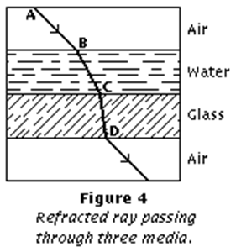

17. A ray of light passes from water into crown glass at an angle of 23.2⁰. Find the angle of refraction.

18. Light goes from flint glass (n = 1.61) into ethyl alcohol (ethanol). The angle of refraction in the ethanol is 25.0⁰. What is the angle of incidence in the glass?

c

b

d

a

e

45⁰

n = 1.52

19. A ray of light enters from air into crown glass at an angle of 45.0⁰. Find all the angles shown (a – e). Explain or show work for each angle.

*“a”*

*“b”*

*“c”*

*“d”*

*“e”*

20. What is the critical angle of crown glass?

Answers

1. According to the law of reflection,

a. the normal is parallel to the angle of reflection.

b. the incident ray and the reflected ray are in different planes.

c. light rays are reflected in the same direction from a smooth surface.

**d. the angles of reflection and incidence are equal.**

*The normal is perpendicular to the principle axis. The incident and reflected rays are in the same plane. Light rays reflect off surfaces at the same angle as the incident rays (i = r).*

2. From which of the following surfaces would light rays undergo specular reflection?

a. white construction paper

**b. a telescope mirror**

c. a black piece of cloth

d. a concrete sidewalk

*Diffuse reflection is off rough surfaces. Specular reflection is off smooth surfaces.*

3. Refraction occurs when

**a. light travels through two adjacent media with different optical densities.**

b. light strikes the boundary of two media with the same optical density.

c. the angle of incidence equals zero.

d. the angle of reflection equals zero.

*Light is unaffected when media have the same optical density (n). If the angle of incidence is zero, there is no refraction.*

4. When light rays travel from an optically-dense medium into a less-dense medium,

**a. the rays travel more quickly.**

b. the angle of refraction is smaller than the angle of incidence.

c. the refracted rays bend toward the normal.

d. the angle of incidence equals the angle of refraction.

*Light travels faster in a less dense medium, so the angle of refraction is greater than its incidence, and light bends away from the normal.*

5. Which of the following is **NOT** true of Snell’s law?

a. Light rays traveling between any two media are related by a constant, *n*.

b. As the angle of incidence increases, the angle of refraction increases. [Assume light travels from a less dense to more dense medium.]

c. The sines of the angles of refraction and incidence are inversely proportional to the indices of refraction of the two media.

**d. Light moving from a substance with a smaller *n* to a larger *n* is bent toward the normal.**

6. The incident angle for which a refracted ray emerges tangent to the surface of a medium is the ___ angle?

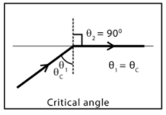

a. reflected

b. zero

**c. critical**

d. normal

7. A rainbow is a phenomenon caused by

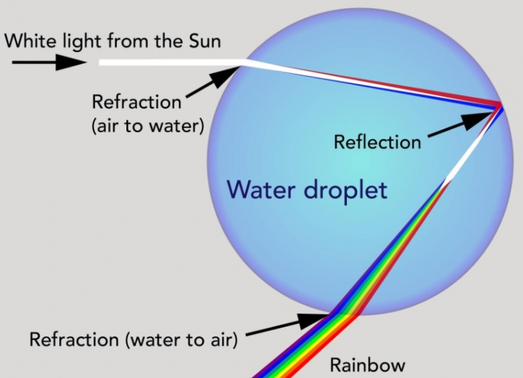

a. a mirage.

b. refraction.

c. total internal reflection.

**d. two choices are correct. (b & c)**

e. all choices are correct.

8. Which of the following statements is **NOT** true?

a. When light rays strike a rough surface, the rays are reflected in many directions.

b. Specular reflection occurs when parallel rays of light strike a flat, smooth surface and the reflected rays are parallel.

**c. When light rays strike a rough surface, the rays are reflected parallel to each other.**

d. Reflection from a rough surface is called diffuse.

*Choices “a, b, and d” are true.*

9. Which equation expresses the relationship between indices of refraction for a light ray traveling from one medium into another?

**a. n1 = n2 sin θ2 / sin θ1.**

b. n1 sin θ2 = n2 sin θ1.

c. i = r.

d. n1 / n2 = sin θ1 / sin θ2

*Snell’s law 🡪* ***n1 sin θ1 = n2 sin θ2***

10. Sometimes in the evening the sun appears larger than normal. Also, the sun is still visible over the horizon after sunset. These things occur because

a. Sunlight reflects off the earth’s atmosphere.

b. Sunlight travels faster through the air than it does in space, causing refraction the refraction observed.

c. Sunlight refracts due to the earth’s rotation.

**d. Sunlight travels slower through the air than it does in space, causing the refraction observed.**

*Space has a zero optical density (n = 0) and air is slightly greater so light will slow down slightly in air.*

11. The index of refraction of halite, or table salt, is 1.54. What is the speed of light in this mineral?

*n = c / v … rearrange to solve for v.*

*v = c / n = (3.00 x 108 m/s) / 1.54 =* ***1.95 x 108 m/s***

12. Light travels 2.26 x 108 m/s into water. What is the index of refraction of the water?

*n = c / v = (3.00 x 108 m/s) / 2.26 x 108 m/s =* ***1.33***

13. A light ray enters a substance from air at an angle of 55⁰ and is refracted 35⁰ from the normal. What is the index of refraction for the second medium?

*ni sin θi = nr sin θr … nair = 1.0*

***nr*** *= sin 55⁰ / sin 35⁰ = 0.819 / 0.574 =* ***1.43***

14. Light rays traveling through air enters zircon at an angle of 33⁰. The index of refraction of zircon is 1.92. At what angle do the light rays bend?

*ni sin θi = nr sin θr … rearrange to solve for θr*

*sin θr = (ni / nr)sin θi = (1.00 / 1.92) sin 33⁰*

***θr*** *= sin-1 (0.284) =* ***16.5⁰***

15. The mineral calcite, CaCO3, has an index of refraction of 1.66. What is the critical angle of calcite if light goes from calcite into air?

*sin θc = nr / ni*

***θc*** *= sin-1 (1.00/1.66) =* ***37⁰***

16. When light travels from a diamond into air, it has a critical angle of 24.4⁰. What is the index of refraction for diamond?

*sin θc = nr / ni … rearrange to solve for ni*

***ni*** *= nr / sin θc = 1 / sin 24.4⁰ =* ***2.42***



17. A ray of light passes from water into crown glass at an angle of 23.2⁰. Find the angle of refraction.

*ni sin θi = nr sin θr … rearrange to solve for θr*

*sin θr = (ni / nr)sin θi = (1.33 / 1.52) sin 23.2⁰*

***θr*** *= sin-1 (0.345) =* ***20.2⁰***

18. Light goes from flint glass (n = 1.61) into ethyl alcohol (ethanol). The angle of refraction in the ethanol is 25.0⁰. What is the angle of incidence in the glass?

*ni sin θi = nr sin θr … rearrange to solve for θi*

*sin θi = (ni / nr)sin θr = (1.36 / 1.61) sin 25.0⁰*

***θi*** *= sin-1 (0.357) =* ***20.9⁰***

c

b

d

a

e

45⁰

n = 1.52

19. A ray of light enters from air into crown glass at an angle of 45.0⁰. Find all the angles shown (a – e). Explain or show work for each angle.

*“a”*

*ni sin θi = nr sin θr … rearrange to solve for θr* ***(angle a)***

*sin θr = (ni / nr)sin θi = (1.00 / 1.52) sin 45.0⁰*

***a*** *= sin-1 (0.465) =* ***27.7⁰***

*“b”*

*Angle “b” is complementary to angle “a”. 90⁰ – a = b*

***b = 62.3⁰***

*“c”*

*Angle “c” is based on total internal reflection. Therefore, i = r.*

***c = 62.3⁰***

*“d”*

*Angle “d” is complementary to angle “c”. 90⁰ – c = b*

***d = 27.7⁰***

*“e”*

*ni sin θi = nr sin θr … rearrange to solve for θr* ***(angle e)***

*sin θr = (ni / nr)sin θi = (1.52 / 1.00) sin 27.7⁰*

***e*** *= sin-1 (0.707) = 45.0****⁰***

20. What is the critical angle of crown glass?

*sin θc = nr / ni*

***θc*** *= sin-1 (1.00/1.52) =* ***41.1⁰***