* 1Lb Static Electricity vs Magnetism Elicitation

|  |  |  |
| --- | --- | --- |
|  | **Examples** | **Similarities** |
| Magnetism | Engines; stick up magnets; MRI; credit cards; generators;  detectors | Attraction (unlikes)  Repulsion (likes)  Force  Fields  Energy  Induction (no contact)  Conduction (contact) |
| Static Electricity | Lightning; static cling; Van der Graaf machine; static shocks |

|  |  |
| --- | --- |
| **Differences** | |
| **Magnetism** | **Static Electricity** |
| 1. N – S poles 2. Magnetic force 3. Magnetic field 4. Alignment of “domains” (only some metals) 5. No friction needed for some metals 6. Any conditions 7. Last longer 8. Not all parts of magnets act the same (front vs side) | 1. + & - charges 2. Electric Force 3. Electric Field 4. Transfer of charge (usually electron) 5. Friction necessary (rubbing, spinning, sliding) 6. Dry conditions 7. Less durable 8. Charged objects act similar no matter the orientation |

* Misconceptions

1. Static Electricity and magnetism are the same phenomenon

2. Magnets contain plus and minus charges inside

3. Magnets attracts all metal objects

* Prior Knowledge

1. Magnets have N and S pole alignments

2. Charges exist and are opposite

3. Electrons move / transfer to produce charges in atoms

4. Magnets attract some metal objects

* What do we call these kinds of models IF we have tested them and they are repeatable, offering explanations to behavior of particles? (*theory*)
* The atomic theory is used to explain small particles called atoms

#### Components of the Atom

* Although a useful theory, the atomic theory raises many questions
* The question most probed by scientists even today is whether atoms could be broken down into smaller particles

# Watch the following videos and explain the point.

# [Van Der Graaf Demo](http://somup.com/cFQ22DVSKM)s (1:15) [Electrostatic Force Demonstrations](http://somup.com/cF6elPnVza) (2:59)

# **What is the source of electricity?**

* Two charges exist and are opposite to each other.
* Very small particles are involved that we have called “atoms”.
* **Movement of Charge ACTIVITY**:

* Existence of Charge
* Positive charges
* Lose negative charge
* Protons
* Negative charges
* gain negative charge
* electrons
* Neutral charges
* Equal amounts of negative and positive charges
* neutrons
* Electrostatic forces

The force of attraction or repulsion between charged objects

* Like charges repel
* Unlike charges attract

<http://somup.com/cFX2YInjch> Electric Force (Cows) (0:18)

<http://somup.com/cr10Dfqslf> Electric Forces Attraction & Repulsion (1:24)

* Transfer of Charge
* **FRICTION** (rubbing, sliding, etc.) is needed to transfer charge
* Excess negative charge: objects gain electrons
* Excess positive charge: objects lose electrons
* Charge by contact [**CONDUCTION**]
* Charge by proximity (without touch) [**INDUCTION**]
* **Electroscope** – an instrument used to detect small amounts of charge
* Materials that transfer electric effects easily are called **conductors** and materials that do not transfer electric effects easily are called **insulators**.

 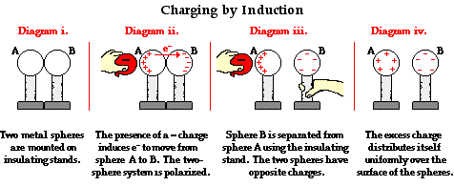

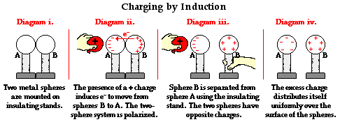

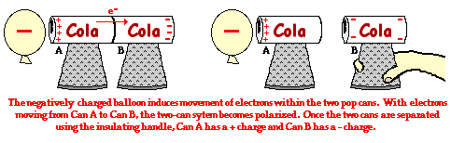

<http://somup.com/cr10oOqsjp> Transfer of Charge & Charge by Induction (1:44)

<http://somup.com/cY1QFtQlBS> Components of Static Electricity (5:31)

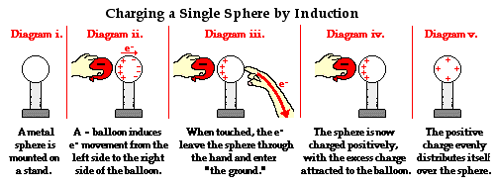

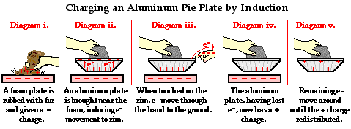

Lightning – Charges are polarized

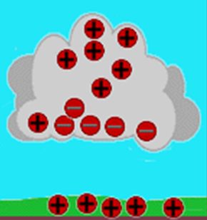

During thunderstorm conditions, the turbulence in the cloud causes the charges to separate in such a way that the negative charges concentrate in the base of the cloud.

Since like charges repel, some of the negative charges on the ground are pushed down away from the surface, leaving a net positive charge on the earth’s surface.

Opposite charges attract, so the positive and negative charges are pulled toward each other.

Since the negative charges are smaller, they move quicker and easier.

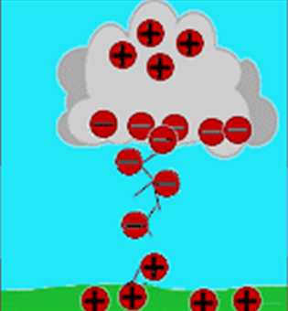

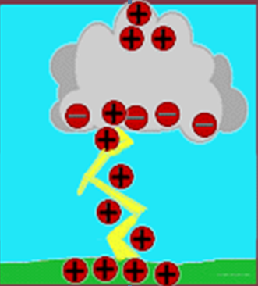

A jagged, jerky movement of negative charges towards earth is called a “Stepped Leader”.

As soon as the negative and positive parts of the stepped leader connect there is a [conductive](http://www.mos.org/sln/toe/glossary.html) path from the cloud to the [ground](http://www.mos.org/sln/toe/glossary.html) and the negative charges rush down it causing the visible stroke.

* Conservation of Charge

Charge is not created nor destroyed, but only transferred.

* Electrical energy

The energy needed to overcome an electrostatic force (attraction or repulsion)

* An electrostatic force exists between two LIKE charges that pushes them APART.
* An electrostatic force exists between two UNLIKE charges that pulls them TOGETHER.

Coulomb’s Law

Coulomb’s Law is a relationship of the force between two charges and the distance between the charges. Common sense tells us that if the size of the charges increases, the force between them will also increase. We can also say that as the distance between charges **increases**, the force between them would **decrease**. We can express this mathematically:

F = k q1 q2 / d2

F 🡪 the force in Newton’s (N)

K 🡪 a constant 🡪 9.0 x 109 N m2 / C2

q1 🡪 charge 1 measured in Coulomb’s (C)

q2 🡪 charge 1 measured in Coulomb’s (C)

d 🡪 distance between the charges in meters (m)

Other Units:

µC = 1 x 10-6 C

±1.6 x 10-19 C 🡪 elementary charge (proton or electron)

Problem Solving (AGES):

1. “**A**” 🡪 What is the problem ASKING for?

Find the force between a +45 µC and a -60 µC that are 0.1 meters apart. **Find F.**

2. “**G**” 🡪 Write out the information / amounts GIVEN

K = 9.0 x 109 N m2 / C2

q1 = +45 µC = +4.5 x 10-6 C

q2 = -60 µC = -6.0 x 10-6 C

d = 0.1 m

3. “**E**” 🡪 Plan: what EQUATION / formula do you need?

F = k q1 q2 / d2

4. “**S**” 🡪 SOLVE by plugging in the numbers; does the answer make sense?

= (9.0 x 109 N m2/C2)( +4.5 x 10-6 C)( -6.0 x 10-6 C) / (0.1 m)2

= 24.3 N

Electric Field versus Magnetic Field

An electric field moves away from a positive charge.

An electric field moves towards a negative charge.

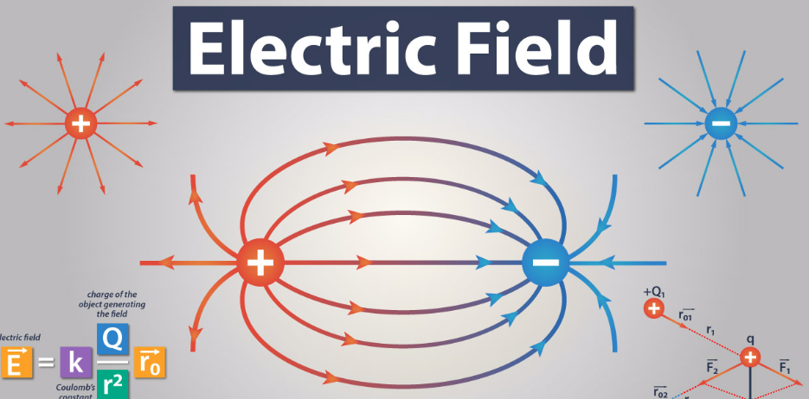

Magnetic fields lines around a typical magnet.

Outside the magnet, field lines go from N to S in a somewhat concentric manner. Inside the magnet, the field lines go S to N.

N

S

N

S

What determines the strength of an electric field?

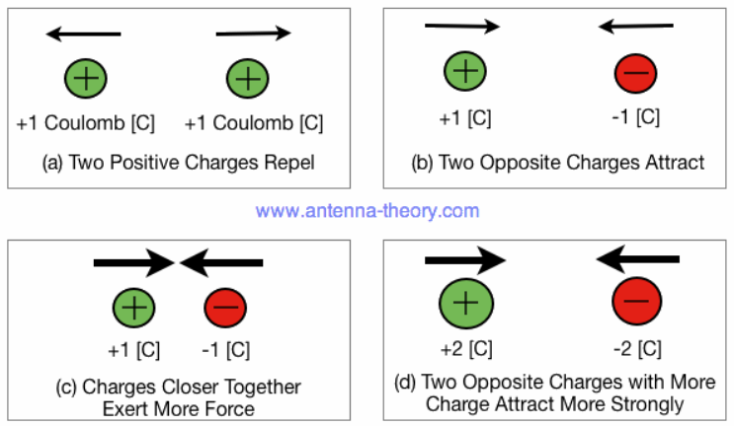

F = kq1q2 / d2 μC = 1 x 10-6 C k = 9.0 x 109 Nm2/C2

* + The SIZE of the electric charges
  + The DISTANCE between the charges