**Science Skills Chapter 1B**

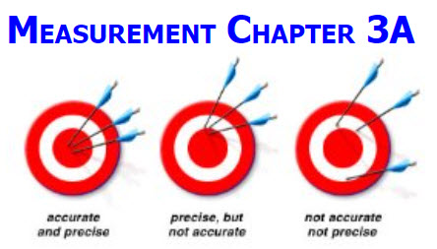

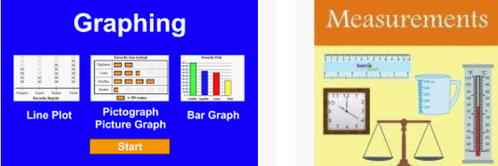

**See** [**https://www.learningctronline.com/courses**](https://www.learningctronline.com/courses) **for Materials and Resources.**

**Topics:**

1. Chemistry Introduction, Measurement & Mathematics

**Objectives:**

* *Define Chemistry and understand its place in science.*
* *Present steps of the scientific method and be able to distinguish each and explain their components.*
* *Use the Metric System versus the English System. Interconvert metric units using prefixes.*
* *Evaluate Accuracy & Precision in Measurements (significant figures).*
* *Use the Metric System versus the English System. Interconvert metric units using prefixes.*
* Write numbers & do calculations in scientific notation.
* Evaluate Accuracy & Precision in Measurements (significant figures).
* Distinguish various types of graphs. Organize data using tables and graphs.
* Define Chemistry and understand its place in science.

TAKE NOTE

1. Review Policies
   1. Late Policy
   2. Grading & Pedagogy – expect to spend 6-8 hrs/week on Physical Science
   3. Test Corrections
2. Create a Physical Science folder on your Desktop with the following SUBfolders:
   1. Class Notes
   2. Homework
   3. Lab
   4. Test
   5. Reference Tables / Resource
      1. Periodic Tables
      2. Equation / Formula Sheet
      3. Reference Tables
3. Technology
   1. Zoom
   2. Tablet
   3. Lab Supplies
   4. Text
4. Review Conduct, Integrity, Plagiarism policy (<https://www.learningctronline.com/policies-conduct-integrity-plagiari>)
5. Guided Reading Note-Taking Worksheet (Pearson Text)

1. Pearson Concepts in Action Worksheets (last week)
2. Lab Metric Measurement
3. Test Chapter 1 Science Skills
4. Week 2 Devotional (<https://www.learningctronline.com/devotional>)

Pearson Text Chapter 1: Science Skills pp. 12-31

**Guided Reading Note-Taking Worksheet:**

Complete the worksheet for Chapter 1: Science Skills (1.3 – 1.4).

**Class Notes: PowerPoint or PDF**

**Homework**:

* Text Overview Worksheet (weeks 1 & 2)
* *1.3 Measurement Worksheet from Pearson Concepts in Action (last week)*
* Practice Quiz Measurement (Review)
* *Assignments will be “spot checked” during class or submitted via email.*

**Lab**: 1.4L Metric Measurement

* Perform the lab as directed using the worksheet provided.
* Complete all calculations and data, showing work whenever appropriate.
* Conclusions should be answered in complete sentences that convey a complete thought.
* Save the documents into your LAB folder in the Physical Science folder on your desktop.
* *Assignments will be “spot checked” during class or submitted via email.*

**TEST:** Science Skills

1) the academic integrity policy

* Tests must be completed **WITHOUT** referring to books, notes, the internet, people, or any outside resources.
* Students **MAY** use the approved Periodic Tables, approved Reference Tables, or approved equation (formula) sheet (provided by the teacher) along with calculators and scratch paper.
* A guardian should be proctoring the test. Proctoring means to monitor the following:

2) The test is composed of 20 multiple choice questions and some written problems.

* The **multiple-choice test must be taken "in one sitting"**, meaning that once you start the test, you must complete it without interruption. (40 minutes)
* Take a short break (5-10 minutes)
* The **written portion of the test must be taken "in one sitting"**, meaning that once you start the test, you must complete it without interruption. (30 minutes)

3) There is a **90-minute time limit** on this test. Please have the proctor write the time taken at the top of your answer sheet with their signature or initials.

4) Proctors should NOT be reading the test or engaging students during the test.

5) Do NOT use RED font. Black font is best.

Supplemental Resources (Optional)

1. Vocabulary Crossword
2. Scientific Notation Measurement Review

[**http://somup.com/cFQbqeVWXQ**](http://somup.com/cFQbqeVWXQ) **Measurement Overview: Metric System, Factor Labeling, Scientific Notation & Uncertainty ctr (2:20)**

<http://prezi.com/zc-alvezwvy9/metric-versus-english-measurement/> Measurement: Metric System Versus English ctr ... prezi

<http://somup.com/cF6hIanVSb> Metric Units Song (2:51) ... metric units for each category of measurement (m, l, g)

<http://somup.com/cFjtqBV9bc> Metric Progression Song ctr (1:08) ... learn the metric units

[**http://somup.com/cFQj2UVR9h**](http://somup.com/cFQj2UVR9h) **Metric Progression & Factor Labeling Basics ctr (4:13)**

[**http://somup.com/cFQjoQVR9b**](http://somup.com/cFQjoQVR9b) **Factor Labeling "Thumbs Up / Thumbs Down" Rule ctr (4:10)**

<http://somup.com/cFQ6lpVShM> Factor Labeling Example (negative exponents) ctr (3:34)

[**http://somup.com/cFQjbdVRRi**](http://somup.com/cFQjbdVRRi) **Scientific Notation Overview ctr (3:31)**

<http://somup.com/cFQjFhVRRX> Scientific Notation: Adding/Subtracting ctr (1:22)

<http://somup.com/cFQjFoVRR2> Scientific Notation: Multiplying/Dividing ctr (0:58)

[**http://somup.com/cFQjrRVRSV**](http://somup.com/cFQjrRVRSV) **Significant Figures: Precision Part 1 ctr (3:28)**

<http://somup.com/cFQj0cVRS6> Significant Figures: Precision Part 2 ctr (6:24)

<https://screencast-o-matic.com/watch/cYhlqngMG3> New Creation; 2 Corinthians 5:17 (5:23)

AGES (Problem Solving Method) <http://somup.com/crnlDND2dj> (5:45)