**Food Additives 2**

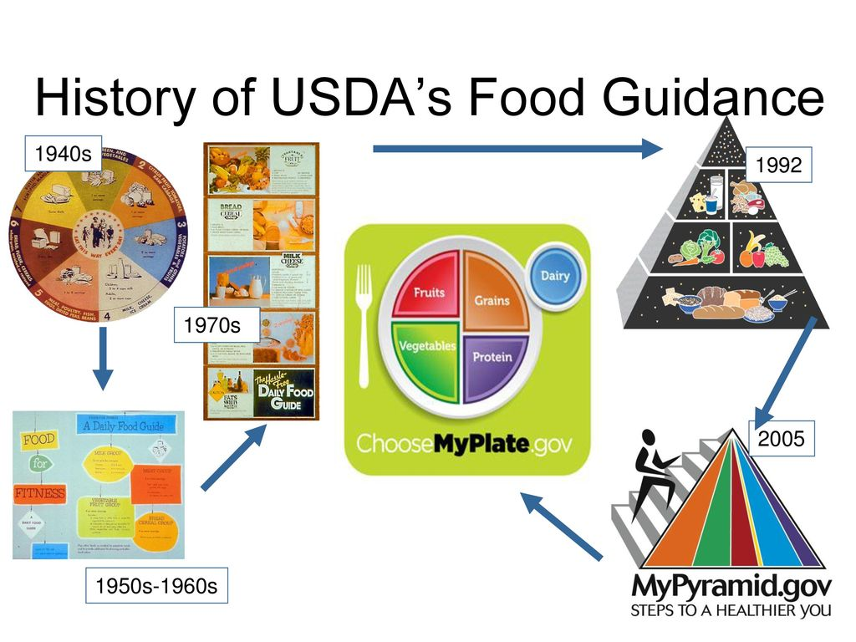

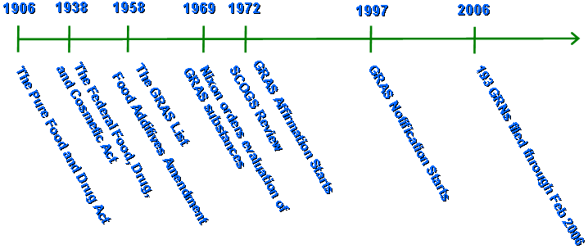

**See** [**https://www.learningctronline.com/courses**](https://www.learningctronline.com/courses) **for Materials and Resources.**

**Topics:**

1. Food Additives 2

**Objectives:**

* + *Identify food types (organic, natural, processed).*
  + *Recognize types of food additives (natural, intentional, incidental).*
  + *Understand the establishment of safety standards (GRAS, Delaney, FDA).*
  + *Discuss FDA standards of identity, quality and fill.*
  + *Explain food labels (nutritional information) and compare foods.*
  + Discuss/research dietary options (vegan, vegetarian, diet plans).

TAKE NOTE

1. In Class Research: Dietary Options (Vegan, Vegetarian, diet plans)
2. Lab: Incidental Food Additives
3. Lab: Calorimeter of Food
4. Food Labels Project
5. Project: Food Additives Letter
6. Quiz Food Additives
7. Film Review “Unnatural Causes” [2021] (John Ritter, Alfre Woodard)
8. Week 13 Devotional (<https://www.learningctronline.com/devotional>)

**Text**:

**Reference Material: Food Additives**

**Homework**:

* Film Review: “Unnatural Causes”
* Food Additives Letter

**Lab**: Incidental Food Additives

* Perform the activity as directed using the worksheet provided.
* Save the document into your LAB folder in the Projects in Science folder on your desktop.

**Lab**: Calorimeter of Food

* Perform the lab as directed using the worksheet provided.
* Save the document into your LAB folder in the Projects in Science folder on your desktop.

**Lab**: Film Review

* Obtain the movie “Unnatural Causes” [1986, John Ritter, Alfre Woodard]
  + Complete the **generic** film review in the course Resources folder.
* Save the document into your LAB folder in the Projects in Science folder on your desktop.

**TEST:** Quiz Food Additives

1) the academic integrity policy

* Tests must be completed **WITHOUT** referring to books, notes, the internet, people, or any outside resources.
* Students **MAY** use the approved Periodic Tables, approved Reference Tables, or approved equation (formula) sheet (provided by the teacher) along with calculators and scratch paper.
* A guardian should be proctoring the test. Proctoring means to monitor the following:

2) Take the **"in one sitting"**, meaning that once you start the test, you must complete it without interruption.

3) There is a **30-minute time limit** on this test. Please have the proctor write the time taken at the top of your answer sheet with their signature or initials.

4) Proctors should NOT be reading the test or engaging students during the test.

5) Do NOT use RED font. Black font is best.

Supplemental Resources (Optional)

1. Crossword Review Food Additives
2. Lab Esters