DNA RNA GENES

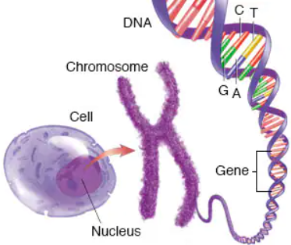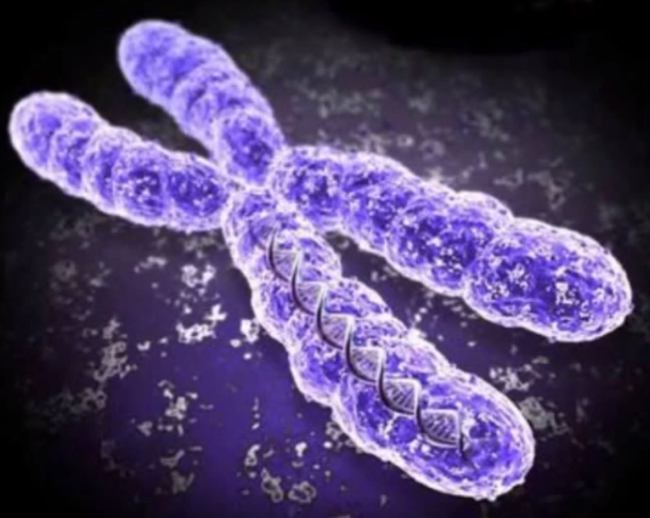

**See** [**https://www.learningctronline.com/courses**](https://www.learningctronline.com/courses) **for Materials and Resources.**

**Topics:**

1. DNA RNA Genes

**Objectives:**

1. Distinguish chromosome, gene, and DNA.
2. Identify and label the anatomy of chromosomes and DNA.
3. Name the scientists who discovered DNA and their contributions.
4. Review the process of DNA replication.
5. Contrast DNA and RNA, introducing protein synthesis.
6. Explain gene expression.

TAKE NOTE

1. Test Corrections (due before next week’s class)
2. Notes/Study Guide (2 weeks)
3. Homework from Text (2 weeks)
4. DNA Extraction Lab
5. Upcoming
   1. Protein Synthesis Lab Report
   2. (week 16): Semester Exam (Chapters 1-8, 10-16)
6. Week 13 Devotional (<https://www.learningctronline.com/devotional>)

**Text**: Chapter 9: DNA RNA Proteins pp. 152 – 173

Read the assigned pages in the text.

**Class Notes: PowerPoint or PDF**

**Notes/Study Guide:** Fill in the Chapter 9 Study Guide worksheet to understand the class notes.

**Homework**: (2 weeks)

* Study Questions (end of the chapter in the text) #1-10, 12-13 (explain true/false), 17-18
* Use a Word document format as follows:
  + Heading: Your name, Chapter in Text, Study Questions
  + Number the appropriate questions you are to answer
  + Write the answer in a complete sentence use the question as the template (do not copy the question, but reword it into a statement that answers the question).
* Use the same document each week by starting a new “Study Question” for a different chapter on the next page.
* Assignments will be “spot checked” during class or submitted via email.

**Lab**: DNA Extraction

* Complete the "DNA Extraction" lab using the lab worksheet provided.
* There is a simulation (link in worksheet) and a video to watch for guidance (*on the second part of the lab*):

[**http://somup.com/c3fuFsOprt**](http://somup.com/c3fuFsOprt) **DNA Extraction from Strawberries** (2:42)

* After completing the Lab worksheet, email it to [learningctronline@gmail.com](mailto:learningctronline@gmail.com) for grading.
* Save document into your LAB folder in the Biology folder on your desktop.

**TEST:** No Quiz this week

Supplemental Resources (Optional)

1. DNA Structure Worksheet

[**http://somup.com/c3fuFsOprt**](http://somup.com/c3fuFsOprt) **DNA Extraction from Strawberries** (2:42)

<https://youtu.be/mBq1ULWJp_M> (7:32) The Amoeba Sisters Channel – **Chromosomes & Karyotype**

<https://youtu.be/8m6hHRlKwxY> (8:17) The Amoeba Sisters Channel – **DNA** **Chromosomes Genes & Traits**

<http://somup.com/c3fl0hOqmJ> (2:08) **DNA Replication Animation**