Animal Kingdom /

Porifera - Cnidaria





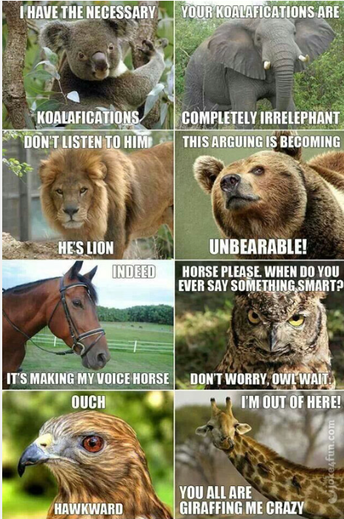

**See** [**https://www.learningctronline.com/courses**](https://www.learningctronline.com/courses) **for Materials and Resources.**

**Topics:**

1. Animal Kingdom / Classification / Porifera

**Objectives:**

1. Identify the two branches of the animal kingdom (invertebrates and vertebrates).
2. Explain five common characteristics of organisms in the animal kingdom.
3. Describe the process of embryonic maturation (blastula, gastrula, true tissues).
4. Distinguish the five Animal Body Plans and how this relates to animal phyla.
5. Understand and explain the general features of invertebrate animals (non-chordates), including porifera and cnidarians.
6. General Features include:
   1. Phylum
   2. Examples of organisms
   3. Location
   4. Symmetry
   5. Body plan (tissue layers)
   6. Coelom relationship (acoelomate, pseudocoelomate, coelomate)
   7. Protostome or deuterostome
   8. Reproduction
   9. Special features

TAKE NOTE

1. Test Corrections (due before next week’s class)
2. Notes/Study Guide (1 week)
3. Homework from Text (1 week)
4. Recognizing Symmetry Activity (1 week)
5. Animal Phyla Project (2 weeks)
6. Purchase a Frog Dissection Kit (optional for General Biology, but recommended; Required for HONORS.)
7. Week 25 Devotional (<https://www.learningctronline.com/devotional>)

**Text**: Chapter 26: Kingdom Animalia I pp. 552 – 570

Read the assigned pages in the text.

**Class Notes: PowerPoint or PDF**

**Notes/Study Guide:** Fill in the Study Guide worksheet to understand the class notes.

**Homework**: (1 week)

* Study Questions (end of the chapter 26 in the text) #1, 5-6, 15 (explain true/false)
* Use a Word document format as follows:
  + Heading: Your name, Chapter in Text, Study Questions
  + Number the appropriate questions you are to answer
  + Write the answer in a complete sentence use the question as the template (do not copy the question, but reword it into a statement that answers the question).
* Use the same document each week by starting a new “Study Question” for a different chapter on the next page.
* Assignments will be “spot checked” during class or submitted via email.

**Lab**: Recognizing Symmetry Activity

* Complete the "Recognizing Symmetry Activity" using the worksheet provided.
* After completing the project PowerPoint, email it to [learningctronline@gmail.com](mailto:learningctronline@gmail.com) for grading.
* Save document into your LAB folder in the Biology folder on your desktop.

**Lab**: Animal Phyla Project (2 Weeks)

* Complete the "Animal Phyla Project" using the PowerPoint provided.
* A worksheet with instructions is also provided on the Learning CTR Online website.
* This project is due in two weeks.
* After completing the project PowerPoint, email it to [learningctronline@gmail.com](mailto:learningctronline@gmail.com) for grading.
* Save document into your LAB folder in the Biology folder on your desktop.

**TEST:** No Quiz this week

Supplemental Resources (Optional)

<https://somup.com/c36eqQURjS> Cnidarian Warfare (**Nematocysts**) [1:34]

<https://somup.com/c36eqgURXL> (4:49) **Cnidarians** General Features

<https://youtu.be/fcGDUcGjcyk> (5:09) The Amoeba Sisters Channel – **Asexual & Sexual Reproduction**