Heading

Title

**Introduction**

**Purpose** To work through the entire process of cellular respiration.

**Discussion**

All living cells, including the cells in your body and the cells in yeast, need energy for cellular processes such as pumping molecules into or out of the cell or synthesizing needed molecules. **ATP** is a special molecule which provides energy in a form that cells can use for cellular processes. Each cell in our body and each yeast cell can use the energy stored in organic molecules in food to make ATP.

**When O2 is available**, cells use **aerobic** **cellular respiration** to transfer energy from the organic molecules in food to ATP. As shown in the figure, aerobic cellular respiration is a complex process that begins with **glycolysis**, followed by the **Krebs cycle** and the **electron transport chain**. Aerobic cellular respiration can make up to 36 molecules of ATP per molecule of glucose. Most of this ATP is produced by the electron transport chain which can only function if O2 is available.

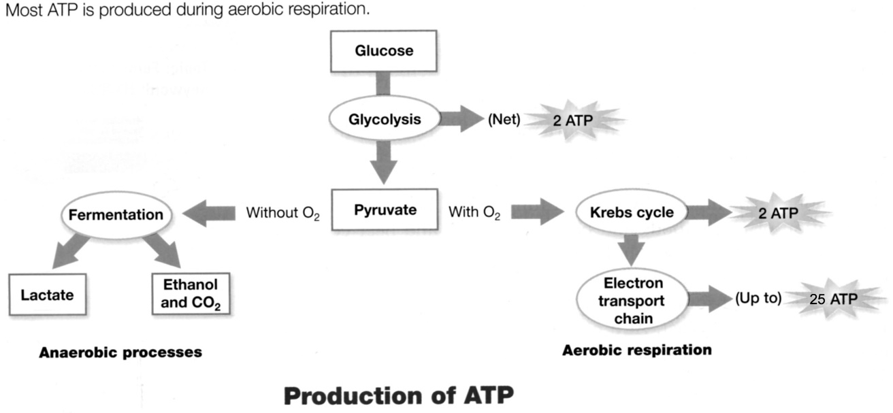

**36**

**ATP**

**When O2 is not available**, cells can make ATP using glycolysis followed by **fermentation**. Glycolysis produces 2 ATP and fermentation restores molecules needed for glycolysis to continue. Glycolysis followed by fermentation produces much less ATP than aerobic cellular respiration, but fermentation is useful when O2 is not available. In the figure, fermentation is referred to as **anaerobic** processes. The "an" in front of aerobic means "not” aerobic (no oxygen). There are two types of anaerobic fermentation:

1. **lactate** **fermentation** (e.g. in muscles when an animal exercises hard)
2. **alcoholic fermentation** (e.g. in yeast, which can be used to make wine or beer)

**Materials**

<https://biomanbio.com/HTML5GamesandLabs/PhotoRespgames/respiration-interactive-page.html>

**Procedures**

1. Click on the link above and click “Start a New Game”.

2. Click “Intro and Glycolysis”

a. Read and complete each slide … then click “next”.

b. Watch the video. Then, click “Link to Video” and then return to the simulation.

<https://screencast-o-matic.com/watch/c3fnYfVqTsM> (4:44)

1. What was the purpose of the explosion demonstration?

2. Why do living things do respiration?

c. Complete the “Glycolysis” simulation?

1. What gets oxidized and broken-down during glycolysis?

2. What are the products of glycolysis?

3. Which of the following is a true statement about glycolysis?

4. What is the purpose of the NADH made during glycolysis?

5. Where in the cell does glycolysis happen?

3. Click on “Main Menu” and proceed to the “Link Reaction”.

<http://somup.com/c3fnYiOhzG> (1:07)

1. What are the products of the link (transition) reaction?

2. What will happen to the carbon dioxide produced by the link reaction in an animal?

3. We see NADH produced. Why is this NADH important?

4. Why is the acetyl-CoA produced in the link reaction important?

4. Click on “Main Menu” and proceed to the “The Krebs Cycle”.

<http://somup.com/c3fnYlOhzL> (2:53)

1. What are the products of the Krebs Cycle?

2. Why are the electron carriers NADH and FADH important?

3. Which fact illustrates that the Krebs cycle is a cycle?

4. Why is the acetyl-CoA produced in the link reaction important?

5. Why does it make sense that 6 carbon dioxide molecules (2 from link reaction and 4 from the Krebs cycle) have been released?

5. Click on “Main Menu” and proceed to the “The Electron Transport Chain (ETC)”.

<http://somup.com/c3fnYDOhA1> (4:28)

1. How do electrons get to the electron transport chain?

2. Why are the electron carriers NADH and FADH important?

3. What do electrons do in the electron transport chain?

4. What is the role of oxygen in the ETC and why is this important?

5. How does ATP synthase work?

6. How do protons (hydrogen ions) move through ATP synthase?