**Empirical Formula of a Copper Oxide Lab**

*Use this worksheet as a guideline for the lab. Fill in the blanks and complete the worksheet based on the video. You may also need to use the class notes to answer some of the ten (10) questions. Once completed, go to Study Place and complete the Lab Test.*

**Learning Objective:**

Compare the empirical and molecular formula of a substance. Use experimental data to find the empirical formula of a substance.

Use the **Empirical Formula of a Copper Oxide Lab Video** to complete the worksheet below.

<https://screencast-o-matic.com/watch/cqj1r7OsVE>

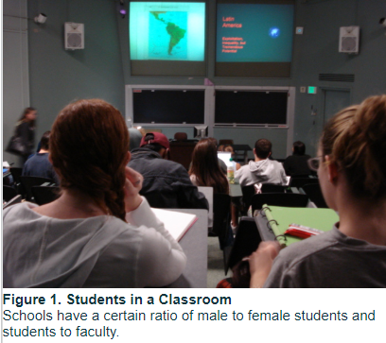

**How Many Are There?**

Have you noticed how schools often times use _____instead of total numbers? For example, brochures will state that the ratio of male to female students is 2:1, or the ratio of faculty to students is 1. Sometimes, pictures such as **Figure 1** accompany these ratios. However, these ratios do not tell you how many faculty members or how many female students are on campus. To determine the total number of female students, you would need the total number of students. Similarly, an _____formula of a compound contains the _____between the _____of each element in the compound, but you need to know the __________ of the compound to determine the total number of atoms of each element in the compound.

**Empirical and Molecular Formulas**

Chemical formulas describe the composition of a compound. The formula of a compound can be empirical or molecular. An _____ *formula* gives the _____ratio for the number of each type of atom that a compound contains, whereas the _____ *formula* gives the _____number of each type of atom in that compound. The molecular formula is a whole number multiple of the empirical formula. For example, the empirical formula of glucose is CH2O, whereas its molecular formula is C6H12O6. Therefore, the molecular formula of glucose contains six empirical formula units.

To determine the empirical formula of a compound experimentally, first find the _____of each element in the compound. Then convert the mass to number of moles for each of the elements in the compound using their molar masses. To obtain the number of moles, use the formula below.

begin mathsize 12px style n space equals space fraction numerator m over denominator M M end fraction end style

… where *n* is the number of _____, *m* is the _____of the element, and *MM* is the element’s __________.

To obtain the simplest ratio, _____the number of moles of each element by the _____number of moles. This molar ratio represents the simplest ratio for the number of atoms of each element in a particular compound rather than the total number of atoms in the compound.

Record the following (Be sure to use units):

Mass of empty crucible: _____

Mass of Copper added: _____

Mass of Crucible + Copper: _____

Mass of Crucible + Copper Oxide (after heating): _____

Calculations

Determine the **Mass of the Copper Oxide** formed after heating by subtracting the original “Mass of empty crucible” from the “Mass of Crucible + Copper Oxide (after heating):

Notice that the mass of the copper oxide is greater than the original mass of the copper added to the crucible, indicating that a new substance was formed. Therefore, a (chemical and/or physical) reaction took place. No other products were formed in this reaction. Therefore, it is a (synthesis, decomposition, single replacement, or double displacement) reaction.

Calculate the **mass of oxygen** formed in the copper oxide (*subtract out the mass of copper*):

Calculate the number of **moles of oxygen** produced in this reaction (*mass of oxygen/molar mass of oxygen*):

Calculate the number of **moles of copper** used in this reaction (*mass of copper/molar mass of copper*):

What is the **mole ratio of copper to oxygen** in the copper oxide formed in the experiment?

Therefore, what is the **empirical formula of the copper oxide** formed in the experiment?

What is the balanced chemical equation for the formation of the copper oxide in the experiment?

What are the oxidation states of copper and oxygen in the copper oxide formed in the experiment?