**Reaction Rate & Equilibrium Chapter 7B**

 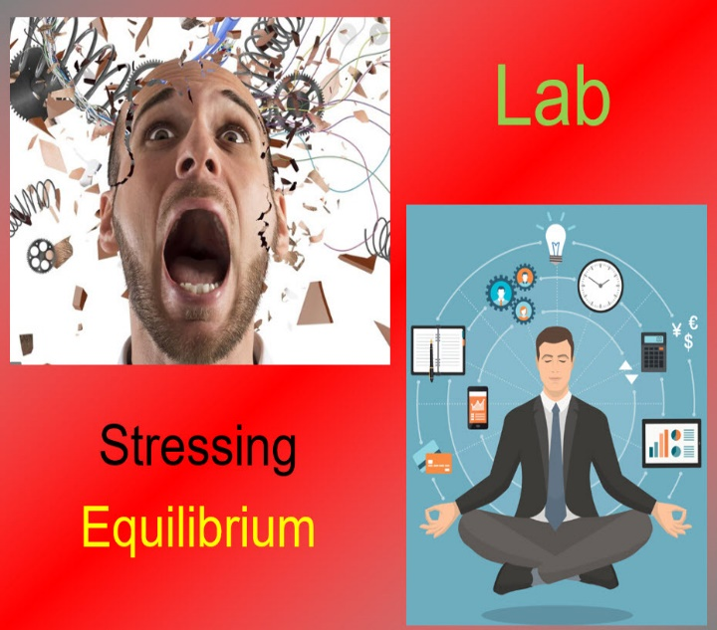

**See** [**https://www.learningctronline.com/courses**](https://www.learningctronline.com/courses) **for Materials and Resources.**

**Topics:**

1. Reaction Rate & Equilibrium

**Objectives:**

* *Define and incorporate the law of conservation of mass.*
* *Analyze components (reactants, products, coefficients) of chemical equations in order to balance them.*
* *Understand and calculate quantities using the Mole related to balancing chemical equations.*
* *Describe and identify the five types of chemical reactions (synthesis, decomposition, single replacement, double replacement, and combustion). Give examples of each type.*
* *Distinguish Chemical reactions that involve the transfer of electrons (reduction/oxidation reactions) based on the discovery of subatomic particles.*
* Label and identify components of energy relations in chemical reactions (activation energy, endothermic and exothermic energy flow).
* Recognize and analyze reaction rate and factors that affect it (temperature, surface area, pressure, concentration, stirring, catalysts).
* Distinguish physical and chemical equilibrium in terms of forward and reverse changes.
* Explain how equilibrium is shifted when changes in temperature, pressure, or concentration are introduced in a system.

TAKE NOTE

1. Guided Reading Note-Taking Worksheet (Pearson Text)

1. Pearson Concepts in Action Worksheets
2. Lab Reaction Rate vs Temperature
3. Lab Stressing Equilibrium Simulation
4. Week 12 Devotional (<https://www.learningctronline.com/devotional>)

Pearson Text Chapter 7: Chemical Reactions pp. 212-225

**Guided Reading Note-Taking Worksheet:**

Complete the worksheet for Chapter 7: Chemical Reactions (7.4 – 7.5).

**Class Notes: PowerPoint or PDF**

**Homework**:

* 7.4 Reaction Rates Worksheet (Pearson Concepts in Action)
* 7.5 Equilibrium Worksheet (Pearson Concepts in Action)
* *Assignments will be “spot checked” during class or submitted via email.*

**Lab**: Reaction Rate vs Temperature

* Perform the lab as directed using the worksheet provided.
* Complete all calculations and data, showing work whenever appropriate.
* Conclusions should be answered in complete sentences that convey a complete thought.
* Save the documents into your LAB folder in the Physical Science folder on your desktop.
* *Assignments will be “spot checked” during class or submitted via email.*

**Lab**: Stressing Equilibrium Simulation

* Perform the lab as directed using the worksheet provided.
* Complete all calculations and data, showing work whenever appropriate.
* Conclusions should be answered in complete sentences that convey a complete thought.
* Save the documents into your LAB folder in the Physical Science folder on your desktop.
* *Assignments will be “spot checked” during class or submitted via email.*

**TEST:** Chemical Reactions

1) the academic integrity policy

* Tests must be completed **WITHOUT** referring to books, notes, the internet, people, or any outside resources.
* Students **MAY** use the approved Periodic Tables, approved Reference Tables, or approved equation (formula) sheet (provided by the teacher) along with calculators and scratch paper.
* A guardian should be proctoring the test. Proctoring means to monitor the following:

2) The test is composed of 20 multiple choice questions and some written problems.

* The **multiple-choice test must be taken "in one sitting"**, meaning that once you start the test, you must complete it without interruption. (40 minutes)
* Take a short break (5-10 minutes)
* The **written portion of the test must be taken "in one sitting"**, meaning that once you start the test, you must complete it without interruption. (30 minutes)

3) There is a **90-minute time limit** on this test. Please have the proctor write the time taken at the top of your answer sheet with their signature or initials.

4) Proctors should NOT be reading the test or engaging students during the test.

5) Do NOT use RED font. Black font is best.

Supplemental Resources (Optional)

1. Vocabulary Crossword Chapter 7
2. Electrochemistry Lemon Battery Lab
3. Practice Questions (Reactions)

<http://somup.com/cF6vqVnhdn> Activation Energy Demo: Sulfuric Acid + Sugar (1:05)

<http://somup.com/crXjoU39FI> Reaction Rate Vs Temperature & Surface Area (6:50)

<http://somup.com/cYhDIkjUhi> The Word is Living and Operative Hebrews 4:12-13; The Word is Alive (6:22)