**Stoichiometry Chapter 12A**

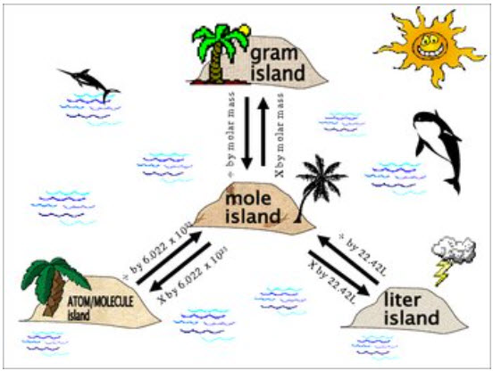

**See** [**https://www.learningctronline.com/courses**](https://www.learningctronline.com/courses) **for Materials and Resources.**

**Topics:**

1. Stoichiometry

**Objectives:**

1. Understand and use stoichiometry in balanced chemical equations (particularly regarding molar quantities of mass, volume, and number).
2. Explain and calculate the interconversion of reactants and products using mole ratios (coefficients).

TAKE NOTE

1. Notes/Study Guide (2 weeks)
2. Lesson Check & Sample Problems or Alternative Worksheets (2 weeks)
3. Lab Quiz: Empirical Formula of a Copper Oxide
4. Test Corrections (Chemical Reactions)
5. Class Song: “AGES” (Yankee Doodle)
6. Week 19 Devotional (<https://www.learningctronline.com/devotional>)

**Text**: Chapter 12: Stoichiometry pp. 382-399

Read the assigned pages in the text.

**Class Notes: PowerPoint or PDF**

**Notes/Study Guide:** Fill in the Chapter 12 worksheet to understand the class notes.

**Homework**: Text

(1) Answer the KEYED **“Lesson Check”** questions at the end of each.

(2) Answer the **“Sample problems”** found in the “Sample Problem” boxes throughout the chapter. An answer KEY is provided for you to use to self-correct your homework problems.

* Put your answers into complete thoughts in a Word document. Do NOT just put the answer, but write a phrase or sentence that you can study from for your tests. Save your work in a WORD document and SAVE into your HOMEWORK folder in the Chemistry folder on the desktop.
* Assignments will be “spot checked” during class or submitted via email.

**Alternate Homework**:

1. Stoichiometry Worksheet

**Lab**: Empirical Formula of a Copper Oxide

Perform the **"**Empirical Formula of a Copper Oxide **"** experiment using the **Videos** and worksheet.  
  
[Empirical Formula of Copper Oxide](http://somup.com/cqj1r7eFiy) (2:26)

* Answers are provided at the end of the document for guidance. Do NOT copy and paste these answers, but write using your own words.
* Save the document into your LAB folder in the Chemistry folder on your desktop.
* Study for understanding, and when ready, take the Lab Quiz.
* You may **NOT** use the worksheet on this lab test.

**TEST:** The test will be given after next week’s lesson.

Supplemental Resources (Optional)

[Stoichiometry Rules](https://screencast-o-matic.com/watch/cFX63EYWEX) (1:53) Song by Mark Rosengarten  
  
[Stoichiometry Sample Problem](http://somup.com/cqVvrBnbd0) (9:21) Khan Academy  
  
[Knowledge Puffs Up Love Builds Up 1 Corinthians 8:1-2; Basin and the Towel](http://somup.com/cYhFoTjyjP) (3:41)