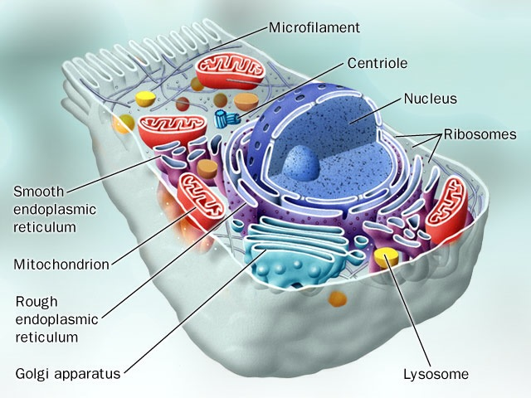Chapter 5 Study Guide

Cell Interior and Function

I. O_____

A. Specialized structures found _____ a cell in the _____.

B. Each has a specific job or _____.

C. May or may not be _____-_____.

D. _____Cell Organelles

1. C_____:

* + 1. _____substance enclosed by the _____.
    2. Provides a medium for _____ _____ to take place.
    3. Contains _____ to carry out specific jobs.
    4. Found in _____ cells.

2. N_____

* + 1. _____ Center of the cell.
    2. Contains nearly all the cell’s _____.
    3. DNA has the instructions for making _____ and other important molecules.
    4. Surrounded by a_____ _____.
       1. _____ membrane surrounding the nucleus
       2. Contains _____ _____ that allow materials to move _____ and _____ of the nucleus.
    5. DNA is found _____ the nucleus
       1. DNA is spread out and appears as _____ in non-dividing cells
       2. DNA is condensed and wrapped around proteins forming _____ in dividing cells.
       3. The Chromosomes/Chromatin have two functions
          1. Contain the _____ _____ that is passed from one generation to the next (_____)
          2. Controls the cells _____ and _____.
    6. N_____
       1. Inside the _____
       2. The cell may have _____ to _____ nucleoli
       3. _____ when the cell divides.
       4. Manufactures the subunits that make up _____.

3. R_____

* + 1. The most _____ organelle in the cell.
    2. Ribosomes are responsible for _____ _____ where amino acids are joined together to make _____.
    3. They are found in two locations
       1. free floating in the _____.
       2. attached to the _____ _____ _____ (RER)

4. E_____ _____ (ER)

* + 1. Internal _____ _____ of a cell
    2. Connects the _____ _____ to the cell membrane
    3. Two Types of ER
       1. _____ Endoplasmic Reticulum (RER)
          1. RER is studded with _____.
          2. This type of ER is involved in making _____.
          3. Newly made proteins leave the ribosome and are inserted into spaces of the ER where they are _____ and **________** into a functioning _____**.**
       2. _____ Endoplasmic Reticulum (SER)
          1. Lacks _____ on its surface
          2. Functions in:

_____ _____ that will be used in the cell membrane.

_____ of drugs and pesticides (especially in human liver cells).

5. G_____ A_____

* + 1. Stacks of _____ sacs (like a stack of pancakes)
    2. _____ produced in the RER move to the Golgi apparatus.
    3. The Golgi Apparatus is responsible for _____ _____ produced in the RER.
       1. The golgi apparatus _____, _____, and _____ proteins made by the RER.
       2. The finishing touches are put on _____ here before they are _____ off to their final destination:
          1. stored _____ the cell
          2. secreted to the _____ of the cell

6. L_____

* + 1. “_____” of the cell
       1. Contains _____ _____.
       2. _____ carbohydrates, proteins, and lipids into small molecules that can be used by the rest of the cell.
    2. Cell’s demolition sites.
       1. _____ the cell’s own organic materials, breaking them down into building blocks and returning them to the cytoplasm to be used again.
       2. _____ old organelles that can no longer carry out their functions.

7. V_____

* + 1. _____ filled sacks for _____.
    2. _____ of sugars, proteins, minerals, lipids, wastes, salts, water, and enzymes.

8. M_____

* + 1. “_____” of the cell.
    2. The site of _____ _____.
       1. the process of converting _____ into a usable form of _____ for the cell (_____).
       2. 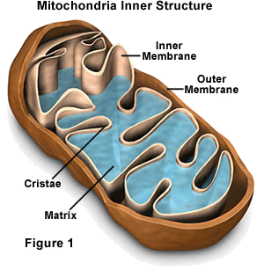Generates cellular _____ (ATP).
    3. Found in both plant and animal cells.
    4. 100’s or 1000’s may be found in a cell.
    5. Structure of the mitochondria
       1. Double _____: surrounds the mitochondria
          1. smooth _____ membrane
          2. folded _____ membrane, called _____ which helps to increase the surface area for cellular respiration.
       2. Has its own _____
       3. Interior is called the _____.

II. C_____

* 1. The organelles of the cell do not flow freely in the cytoplasm.
  2. The cells must have an internal _____ and _____ system to give shape and _____ to it.
  3. There is a network of _____ tubes and fibers that extend throughout the cytoplasm and help the cell to maintain its _____.
  4. 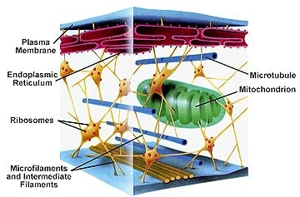It is also involved in _____.
  5. Two types of elements in the framework:
     + 1. _____ (smallest)
          1. Threadlike
          2. Made of _____ (protein)
          3. Structure, support, Intracellular transport
          4. Helps bear the mechanical _____ of the cell.
       2. _____ (largest)
          1. Tube-like (hollow)
          2. Made of _____ (protein)
          3. They can assemble and disassemble rapidly causing _____.
          4. Functions

cell shape

Separation of Chromosomes during _____ _____.

Formation of _____, _____, and _____.

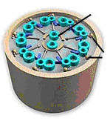III. Cilia and Flagella

* 1. Made of _____ arranged in a 9 + 2 arrangement.
  2. Cilia
     1. move materials across the cell _____.
     2. Shorter and more numerous
     3. Example: the _____ system uses cilia to move mucus out of the lungs.
  3. Flagella
     1. _____ cells
     2. Longer and fewer
     3. Example: human sperm

IV. Centrioles

* 1. Found only in _____ cells.
  2. _____ structures near the nucleus
  3. Made of 9 _____ of microtubules
  4. Appears during _____ _____ forming mitotic spindle.
  5. Helps pull _____ pairs apart to opposite ends of the cell.

V. Distinctive Organelles to Plant and Animal Cells

* 1. Structures only found in animal cells:
     1. L_____
     2. C_____
     3. F_____
  2. Structures only found in plant cells:
     1. C_____ _____
        1. When filled with water it creates _____ _____ to give strength and support to the cell.
        2. This allows the plant to _____ heavy structures such as flowers and leaves.
        3. It also serves as a _____ area for organic molecules.
     2. C_____
        1. found only in _____ (ie. plants or other organisms that perform photosynthesis)
        2. absorb e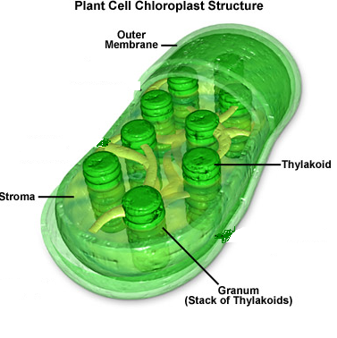nergy from the _____ and covert it to the _____ energy of a molecule of glucose.
        3. Similar to a _____ power plant.
        4. Contains enzymes and pigments for _____.
        5. Contains its own _____.
        6. Never in animal or bacterial cells.
        7. The Chloroplast Structure
           1. Surrounded by a _____ membrane.

_____ outer membrane

Inner membrane: modified into sacs called _____, which contain the green pigment, _____ which is required for photosynthesis.

* + - * 1. _____: Stacks of thylakoids
        2. _____: gel like material surrounding thylakoids
    1. Cell W_____
       1. _____ and _____ cells of plants and fungi.
       2. Found _____ of the cell membrane.
       3. In plants, it is mostly composed of _____, a tough carbohydrate fiber.

Complete table on the next page

|  |  |  |
| --- | --- | --- |
| Component | Type of Cell | Function |
|  | All | Boundary; Gatekeeper; Protection; Selectively Permeable |
|  | Prokaryotes, Plants, Fungi | Protection; Support |
|  | All | Site of most chemical reactions; Contains molecules and ions |
|  | Eukaryotes | Houses Genetic Material; Controls ALL cell activities |
|  | Eukaryotes | Manufactures Ribosomes |
|  | All | Cell Structure; Internal Transport |
|  | Mostly Animal | Cell Division |
|  | All | Locomotion of cell |
|  | Eukaryotes | “Powerhouse of Cell”; Energy Production; Cell Respiration |
|  | All | Protein Synthesis; Attached to RER or Free-floating |
|  | Eukaryotes | Internal Transport; Smooth or Rough |
|  | Eukaryotes | Storage and Packaging; “Stack of Pancakes” |
|  | Animal | Intracellular Digestion; “Stomachs” |
|  | Plant, Fungi, Protists, Animal | Storage |
|  | Plant | Photosynthesis |