**PURPOSE**: To investigate electric force using various activities.

**MATERIALS**: 2 Plastic / black combs Paper punches from hole punch

Balloons (small, large) Wool cloth or sweater

Acrylic tape silk cloth

wool cloth or sweater piece of Styrofoam

**PROCEDURES & DATA**

*Acrylic Tape (*<https://screencast-o-matic.com/watch/cF6elPYlbr> *)*

### 1. Take TWO separate pieces of acrylic tape ~ 7.5 cm long (3 inches).

### 2. Hold them “back” to “back” so the NON sticky sides are facing each other.

### 3. Bring them together slowly and observe. Record what you see.

### 4. NOW, take TWO other separate pieces of acrylic tape ~7.5 cm long (3 inches).

### 5. Hold them by the ends and place one on top of the other on your table so that one sticks to the table & the other sticks to the NON sticky side of the one on the table.

### 6. Pull the pieces off the table. Pull them apart and then bring them together slowly “back” to “back” & observe. Record what you see.

### *Balloon with Paper Punches (second demonstration in video link above)*

1. Find a table with a smooth, glassy top or finish (*a wood table will work if it has a smooth top*).

a. Clean the table top with Windex or some other cleaner.

b. Then, wipe the table top off carefully so that it is absolutely dry.

c. Find a clean, dry, absorbent cloth to do a final wipe off of the table top.

2. Obtain at least 30-50 paper punches from a hole punch and spread out evenly on the table top so that the punches are very close to each other, but touching as little as possible.

3. Fill a LARGE balloon (20-30 cm length) as full as possible without popping it, and tie it off.

4. Hold the balloon at the tied end and RUB the inflated balloon vigorously and all over using a wool cloth (or sweater) for about 30 seconds.

5. Quickly hold the balloon about 10-15 cm ABOVE the small paper punches.

a. Rotate the balloon without changing its level above the paper punches.

b. If nothing happens, lower the balloon 2-3 cm and rotate again.

c. Repeat this process until you see something happen. Record your observations.

d. What is the name of the process involved?

6. Watch closely for a few paper punches to “jump off” the balloon and fly up to 20 cm away. Why?

### statics balloon 1

A few pieces “fly” off

What is the name of the process involved?

### *Balloon sticking to the wall*

1. What happens to a small balloon after being rubbed and placed on the wall?

<https://screencast-o-matic.com/watch/cbe2b96An0>

The following link is to the actual simulation: <https://phet.colorado.edu/en/simulation/balloons> Click on the "PLAY" icon.

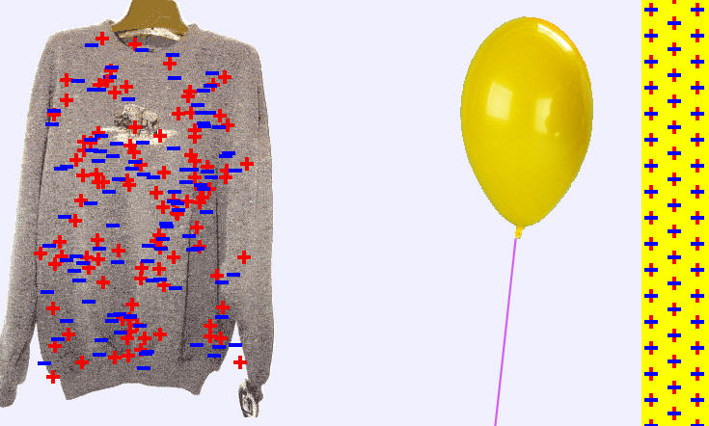 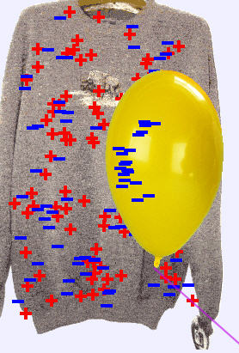 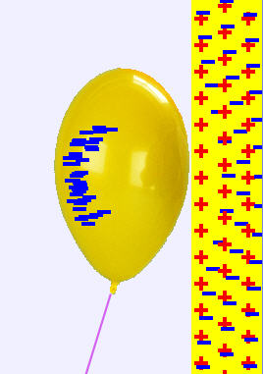

Before Static Forces Wool Sweater & Balloon rubbed balloon & wall

2. Observe the sweater and wall BEFORE doing anything. Consider and write what is meant by having a “neutral” charge.

3. Rub one side of the balloon against the sweater ONCE. Notice the charge on the sweater and the balloon. Record what happens.

4. Move the balloon to the wall and again notice the charges on the balloon and the wall. Record what happens.

### *Van Der Graaf Machine Videos*

Observe the two videos:

<https://screencast-o-matic.com/watch/cFQ22DqKxv> (1:15)

<https://screencast-o-matic.com/watch/cFX2Y3rf9b> (1:12)

3a. What happened to fluorescent bulb? Explain.

3b. Describe what happens to the pie tins, paper punches when set on top of the generator. Explain.

3c. Why did the hair on the wig stand straight out?

#### CONCLUSIONS AND QUESTIONS

1. How many charges exist?

2. How do “like” charges affect each other?

3. How do “unlike” charges affect each other?

4. What conditions need to exist in order to get maximum static electricity? [*Consider why in the winter you get static shocks, but rarely in the summer*.] Why?

5. What phenomenon in nature does the Van Der Graaf machine simulate?

**ANSWER KEY**

### *Acrylic Tape*



### 1. Take TWO separate pieces of acrylic tape ~ 7.5 cm long (3 inches).

### 2. Hold them “back” to “back” so the NON sticky sides are facing each other.

### 3. Bring them together slowly and observe. Record what you see.

**“Attraction”**

<https://screencast-o-matic.com/watch/cF6elPYlbr>

### 4. NOW, take TWO other separate pieces of acrylic tape ~7.5 cm long (3 inches).

### 5. Hold them by the ends and place one on top of the other on your table so that one sticks to the table & the other sticks to the NON sticky side of the one on the table.

### 6. Pull the pieces off the table. Pull them apart and then bring them together slowly “back” to “back” & observe. Record what you see.

**“repulsion”**

### *Balloon with Paper Punches*

1. Find a table with a smooth, glassy top or finish (*a wood table will work if it has a smooth top*).

a. Clean the table top with Windex or some other cleaner.

b. Then, wipe the table top off carefully so that it is absolutely dry.

c. Find a clean, dry, absorbent cloth to do a final wipe off of the table top.

2. Obtain at least 30-50 paper punches from a hole punch and spread out evenly on the table top so that the punches are very close to each other, but touching as little as possible.

3. Fill a LARGE balloon (20-30 cm length) as full as possible without popping it, and tie it off.

4. Hold the balloon at the tied end and RUB the inflated balloon vigorously and all over using a wool cloth (or sweater) for about 30 seconds.

5. Quickly hold the balloon about 10-15 cm ABOVE the small paper punches.

a. Rotate the balloon without changing its level above the paper punches.

b. If nothing happens, lower the balloon 2-3 cm and rotate again.

c. Repeat this process until you see something happen. Record your observations.

* ***The paper pieces were attracted to the balloon without touching it***
* ***Most paper pieces clung to the balloon.***

d. What is the name of the process involved? ***Induction (charges transfer without touch)***

6. Watch closely for a few paper punches to “jump off” the balloon and fly up to 20 cm away. Why?

* ***Some pieces “flew” off the balloon because conduction (charge transfer by touch) caused the same charge and repulsion)***

### statics balloon 1

A few pieces “fly” off

### *Balloon sticking to the wall*

1. What happens to a small balloon after being rubbed and placed on the wall?

<https://screencast-o-matic.com/watch/cbe2b96An0>

2. Observe the sweater and wall BEFORE doing anything. Consider and write what is meant by having a “neutral” charge.

***Neutral means the same amount of negatives and positives***

3. Rub one side of the balloon against the sweater ONCE. Notice the charge on the sweater and the balloon. Record what happens.

***The balloon picks up negative charge, and the sweater has more positive charges than negative charges.***

4. Move the balloon to the wall and again notice the charges on the balloon and the wall. Record what happens.

***The negative charges in the balloon and the wall repel each other. The positive charges of the wall are attracted to the negative charges in the balloon, holding it to the wall.***

  

Before Static Forces Wool Sweater & Balloon rubbed balloon & wall

### *Van Der Graaf Machine Videos*

Observe the two videos:

<https://screencast-o-matic.com/watch/cFQ22DqKxv> (1:15)

<https://screencast-o-matic.com/watch/cFX2Y3rf9b> (1:12)

3a. What happened to fluorescent bulb? Explain.

***It lights up. Charge must be transferred to the bulb.***

3b. Describe what happens to the pie tins, paper punches when set on top of the generator. Explain.

***All the items are pushed off the Van Der Graaf generator. The pie tins are touching the VDG dome so conduction occurs and the tins take on the same charge as the dome, causing repulsion.***

3c. Why did the hair on the wig stand straight out?

***The hair must have taken on the same charge as the dome, causing repulsion.***

#### CONCLUSIONS AND QUESTIONS

1. How many charges exist?

***Two: positive and negative.***

2. How do “like” charges affect each other?

***Like charges repel.***

3. How do “unlike” charges affect each other?

***Unlike charges attract.***

4. What conditions need to exist in order to get maximum static electricity? [*Consider why in the winter you get static shocks, but rarely in the summer*.] Why?

***Dry conditions allow the best static electricity since humidity absorbs charge.***

5. What phenomenon in nature does the Van Der Graaf machine simulate?

***Lightning which is also based on opposite charges building up and attracting each other.***