Name:

Label the compound microscope inside the text boxes.

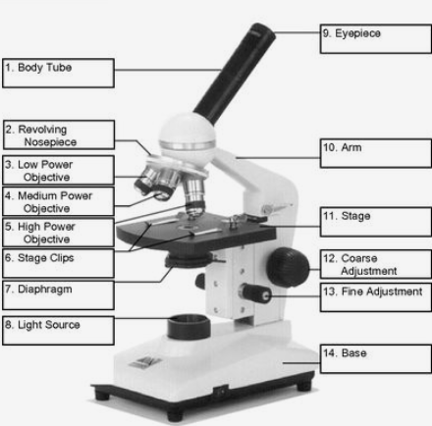

1.

8.

7.

6.

5.

4.

3.

2.

9.

10.

11.

12.

13.

14.