Name ____ Date ____

*Place the letter of the best answer choice for each question below:*

1.

2.

3.

4.

5.

6.

7.

8.

9.

10.

11.

12.

13.

14.

15.

16.

17.

18.

19.

20.

1. What is the name of the point in the earth’s orbit when it is closest to the sun?

a. Perihelion b. Aphelion c. Summer solstice d. Spring equinox

2. A ___ eclipse can happen during a ___ moon phase.

a. Solar, waxing crescent c. Lunar, new

b. Solar, new d. Lunar, first quarter

3. The three reasons for the seasons are

a. tilt, rotation, revolution c. tilt, revolution, equinoxes

b. tilt, revolution, solstices d. tilt, revolution, parallelism

4. Neap tides occur when the moon is at

a. new and 1st quarter moon phases c. full and 1st quarter moon phases

b. full and new moon d. 1st and 3rd quarter moon phases

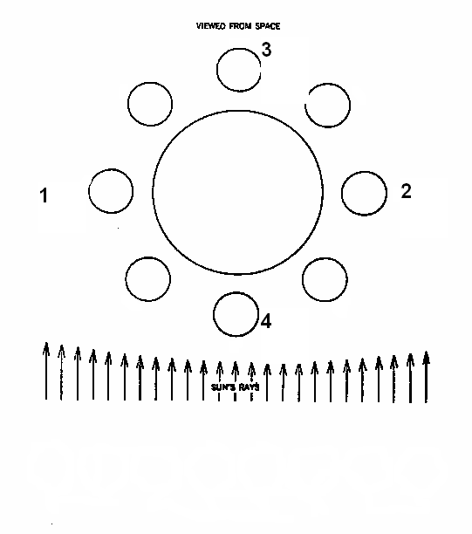5. Which positions represent the phase that the moon is in when the tides are more exaggerated (spring tides)? [*Use the diagram to the right*.]

a. 1 and 2

b. 1 and 3

c. 2 and 4

d. 3 and 4

6. If the Earth is the large central circle in the diagram, what moon phase is represented by the circle between #2 & #4?

a. waning crescent

b. waxing crescent

c. waning gibbous

d. waxing gibbous

7. Spring tides occur when the moon is

a. at full & 1st quarter moon phases c. at new moon & full moon phases

b. at new & 3rd quarter moon phases d. at 1st & 3rd quarter moon phases

8. When would your noon time shadow length be the shortest here in Berkley?

a. May b. December c. June d. September

9. The two major Earth movements are

a. rotation and revolution c. wobble and axis

b. solar and lunar d. high tides and low tides

10. The Earth’s orbit is not a perfect circle, the shape of the orbit is called

a. parsec b. elongated c. parallel d. elliptical

11. The best explanation of why we only see one side of the moon is

a. We rotate very slowly around the sun

b. The moon’s rotational speed is equal to its orbital speed

c. Both sides look the same

d. None of the above

12. Tides are a result of

a. seasons c. the tilt of the earth’s axis

b. gravitational pull from the moon d. background radiation

13. A month (about 30 days) is based on

a. the Earth’s orbit around the sun c. the tides

b. solar flares d. one lunar revolution

14. Parallelism means that

a. Earth’s tilt changes each year c. Earth’s tilt does not change

b. Earth’s tilt changes randomly d. Earth’s tilt will eventually be gone

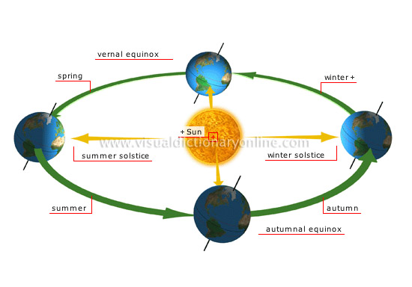15. Which season is shown in the Northern hemisphere in the image below?

a. Winter

b. Spring

c. Summer

d. Fall

16. If the earth’s axial tilt is at 0, the amount of daylight would be

a. Drastically different all year long

b. The same all year long.

c. Long in the summer, and short in the winter.

d. It would be the same as it is now.

17. Which statement is true?

a. Summer solstice (June) is when the sun reaches its highest point in the sky.

b. Winter solstice (December) is when the sun reaches its highest point in the sky.

c. Autumn Equinox (September) is when the sun reaches its highest point in the sky.

d. Spring Equinox (March) is when the sun reaches its highest point in the sky.

18. According to the image below

a. the bottom image is neap tide when the tides are smaller than normal.

b. the top image is neap tide when the tides are smaller than normal.

c. the bottom image is spring tide when the tides are larger than normal.

d. the top image is spring tide when the tides are large than normal.

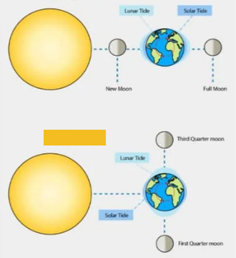

19. Which term describes the condition in which there are two high and low tides per day?

a. semi-diurnal

b. diurnal

c. neap

d. none of the choices

20. Explain why winter solstice in the northern hemisphere is when the Earth is actually closest to the sun.