**Flame Tests Lab**

*Use this worksheet as a guideline for the lab. Fill in the blanks and complete the chart of colors based on the video. You may also need to use the class notes to answer some of the ten (10) questions. Once completed, go to Study Place and complete the Test.*

**Learning Objective:**

Explain the movement of electrons between orbitals in an atom. Use the flame tests to identify substances.

Use the **Flame Tests Lab Video** to complete the worksheet below.

<http://somup.com/cqe2bonZ5o>

### **How Are the Fireworks Colors Made?**

Have you ever wondered how the beautiful colors of the fireworks are generated? Fireworks come in an array of colors from yellows and reds to blues and greens (**Figure 1**). The colors are produced by heating _____ salts. For example, sodium chloride (NaCl) burns _____, and calcium chloride (CaCl2) burns _____.

### **Electron States and Color**

Many elements and crystalline salts have a distinct color when burned over a flame. This color can be used to _____ a chemical compound (_____ property). The distinct color produced by each element is the result of the different _____ electrons in their specific _____.

The _____ state of an element is a specific electron arrangement that is the most energetically favorable. When an element is heated, the valence electrons _____ the energy from the heat, or become _____, and move to a _____ -energy orbital. Given that higher-energy orbitals are not _____, the excited electron quickly _____ to the ground state.

For example, sodium _____ has a 1s2 2s22p6 3s1 ground state _____ configuration. When sodium bonds ionically, its ground state electron configuration becomes 1s2 2s22p6 creating an overall ___ charge. When heated, electrons gain energy and can be _____ into a ____-energy level such as 4s as shown in **Figure 2**. Because this excited state is _____, the excited electron will drop back down to the ground state level and _____ energy as _____.

A **photon** of energy is given off as color so the sodium ion returns to the **ground state**.

One of the 2p electrons gets excited to 4s.

Sodium Ion Na+

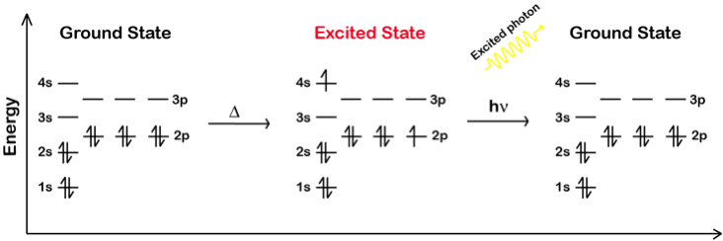

**Figure 2. Sodium Ion Electron Configuration and Flame Color**

Electrons move from the _____ state to an _____ state when _____.

Depending on the amount of energy provided, more than _____ electron can be excited, and therefore more than one wavelength of light will be _____. It is common for ions to display _____ colors in their _____ spectra. In addition, the electron may not return all the way to the ground state, but to an _____ energy level. So, various wavelengths are possible from the same excited electron. The combination of the _____ emitted by an element gives the flame its _____.

The energy the valence electron absorbed when it was excited is re-emitted as a _____ of light. That photon has the _____, specific, _____ amount of energy needed to move that valence electron and thus has a particular _____. Therefore, the particular _____ emitted by an element or compound when it burns is caused by the particular wavelength of light emitted when its _____ electron moves from an _____ state to _____ state.

### **Limitations of the Flame Test**

Although the combinations of wavelengths of light emitted by each element are _____, the colors produced may be _____ enough that the naked eye may _____ be able to _____ similar colored ions from each other. Contaminants may also alter the color of the flame. For example, sodium is present in most compounds and will color the flame. A blue glass can filter out the yellow from sodium if necessary. Another limitation of the flame test is that it cannot detect very _____ concentrations of _____.

Use the **Flame Tests Lab Video** to complete the chart below.

<http://somup.com/cqe2bonZ5o>

|  |  |  |  |  |  |
| --- | --- | --- | --- | --- | --- |
| Ion | Li+ | Na+ | K+ | Ca+ | Sr+ |
| Color |  |  |  |  |  |

|  |  |  |  |  |
| --- | --- | --- | --- | --- |
| Ion | Ba+ | Cu+2 | Cu+1 | Unknown |
| Color |  |  |  |  |