Heading

Title

**Introduction**

**Purpose**

To analyze karyotypes in order to diagnose chromosome abnormalities and disorders.

**Background**

A regular human cell has 46 chromosomes: 44 autosomes, which come in pairs, and 2 sex chromosomes, which specify gender (XX for female and XY for male). The pairs of autosomes are called "homologous chromosomes." One of each pair came from mom and the other came from dad. Homologous chromosomes have all of the same genes arranged in the same order, but with slight differences in the DNA sequences of the genes.

What happens when a person has something different, such as too many or too few chromosomes, missing pieces of chromosomes, or mixed-up pieces of chromosomes? Sometimes chromosomes are incorrectly distributed into the egg or sperm cells during meiosis. When this happens, one cell may get two copies of a chromosome, while another cell gets none. Incorrect distribution of chromosomes is called nondisjunction. If a sperm or egg cell with too many or too few chromosomes underwent fertilization, it will produce a zygote with a genetic disorder. These disorders can be diagnosed with a special genetic mapping called a karyotype.

A karyotype is a picture in which chromosomes of a cell have been stained so that the banding pattern of the chromosome is visible. Cells are treated with a chemical to stop the cell dividing in metaphase. The cells are then strained to show distinct parts of the chromosomes. The cells are photographed, cut, and arranged in homologous pairs according to arm length, centromere position and banding pattern. Karyotypes have become increasingly important to genetic counselors, as disorders and disease have been traced to specific visible abnormalities of the chromosomes.

Rather than working with all 23 chromosome pairs found in humans, for this investigation

we will assume that a new species of insect has been discovered. The insect has 3 large pairs of chromosomes. Researchers have been able to trace four genetic disorders to specific chromosomal abnormalities in this insect species. Study the karyotype as well as the appearance of the chromosomes for the normal male and female of the insect.

**Hypothesis**

**Materials** Scissors Glue Chromosomes scatters photocopies Analysis worksheet

**Procedures**

1. Cut out the chromosomes for insect #1 and arrange them on the line designated for insect #1 in the Calculations and Data section.

2. Pair the homologous chromosomes, by comparing the size, location of centromere and banding pattern. (See the “normal” male and female insects below.)

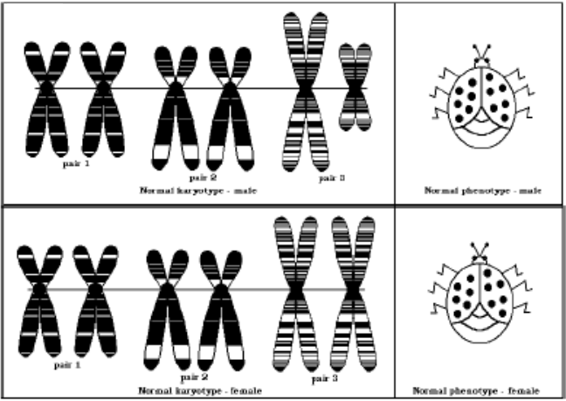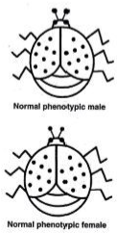

Note that the **normal male** insect has a pair of sex chromosomes similar to those of a human male, one is large and one is much smaller.

In the same way the **normal female** has a pair of sex chromosomes similar to those of the human female, they are both large. These sex chromosomes make up chromosome pair 3 for this insect; in humans it would be the 23rd pair.

3. In the Calculations and Data section, make sure that you place the centromere of each chromosome on the line provided for each insect. This makes it is easier to compare the sizes and banding and to align the chromosomes properly.

4. Be sure to line up chromosomes in the order (from chromosome #1 to #2 to #3) that is shown in the karyotypes of the normal male and female.

5. Once the chromosomes are positioned correctly, glue them into place. Take a picture of the chromosomes and insert the image into the lab worksheet.

6. Repeat the steps above for insects 2-6.

7. The insects in this lab will either be normal or have one of the four chromosome disorders; monosomy, trisomy, deletion, or duplication. Using the metaphase chromosomes, determine the gender for each of the insects. Record this in the Calculations and Data section.

Diagnosing disorders

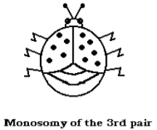

**Size Reduction Disorder**. The disorder known as size reduction appears when there is a monosomy of the sex chromosome pair. A single large chromosome produces a small female insect and a single small chromosome produces a small male insect. This disorder is shown in

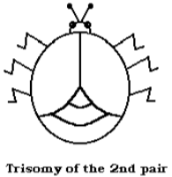

**Clear Wing Disorder**. This disorder appears to result from a trisomy of the chromosomes of pair 2. The extra chromosome of the second pair produces sterile insects that lack color in their wings. Since sterility always results, the clear wing disorder is not passed onto their offspring. A similar genetic disorder in humans might result in Down Syndrome.

**Duplication Disorder**. A duplication of a portion of a chromosome from pair 1 produces an insect with two heads. This duplication also produces banding on the wings and additional body segments. [*Diagram to the right*]

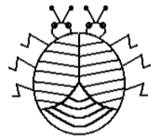

Duplication of part of 1st pair

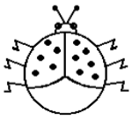

Deletion of part of an “X” Chromosome

**Unsegmented Disorder**. The deletion of a short segment of the large sex chromosome results in a loss of body segmentation and reduces the body size. [*Diagram to the left*]

**Calculations and Data**

A. Use the “Insect Chromosome” page to cut out and align chromosomes as shown on the next page. Take a picture and insert the image below.

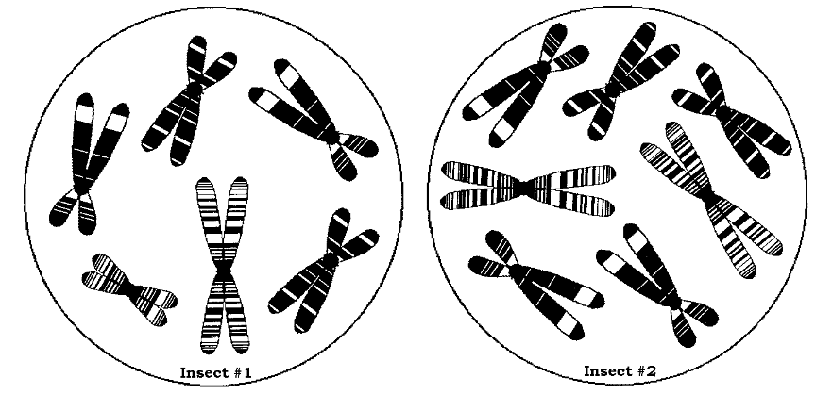

Insect Chromosomes

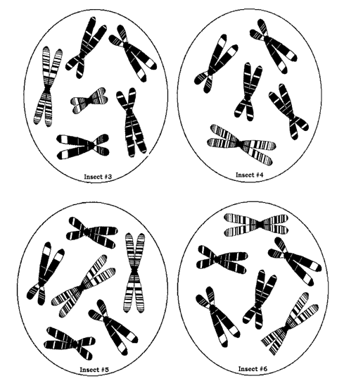

A. After cutting out the chromosomes for each insect, align them on the line for the specific insect. Glue them. Take a picture and insert the image on the previous designated page.

**Insect 1** **Insect 2**

1

3

2

1

3

2

**Insect 3** **Insect 4**

1

3

2

1

3

2

**Insect 5** **Insect 6**

1

3

2

1

3

2

B. *Answer the following questions (use phrases or words … it is not necessary to write in complete sentences in the Calculations and Data section).*

1. Identify the sex, chromosome error, and genetic disorder for each of the fictitious insects.

|  |  |  |  |
| --- | --- | --- | --- |
|  | Sex | Chromosome Error | Genetic Disorder |
| Insect 1 |  | None | Normal |
| Insect 2 |  |  |  |
| Insect 3 |  |  |  |
| Insect 4 |  |  |  |
| Insect 5 |  | None | Normal |
| Insect 6 |  |  |  |

2. What kind of information is needed to figure out if the insects have a genetic disorder or not? Why is it so important to have this step?

3. What phase of the cell cycle are these cells in when the karyotype is created?

4. All normal insect and normal human cells carry … [*Choose one*]

a. at least one X chromosome. c. at least one Y chromosome.

b. a pair of X chromosomes. d. one X and one Y chromosome.

5. Which chromosomal error was most difficult to “diagnose” using the karyotype? Why was it so hard to diagnose?

6. Which chromosomal error was the easiest to see using the karyotype? Why was it so easy to diagnose?

7. How are the X and Y chromosomes different? [*Choose one*]

a. Only one is an autosome. c. The X is smaller than the Y.

b. The Y carries fewer genes than the X. d. Only females have a Y.

**Conclusions**

**Address Hypothesis** (*Was your hypothesis supported by the observations and data from this investigation? Explain.*)

**Analysis** (*Fill in the blanks for this section.*)

A regular human cell has _____ chromosomes: _____ autosomes, which come in pairs, and 2 sex chromosomes, which specify gender (_____ for female and _____ for male). The pairs of autosomes are called "_____ chromosomes." One of each pair came from mom and the other came from dad. Homologous chromosomes have all of the same genes arranged in the same order, but with slight differences in the _____ sequences of the genes.

What happens when a person has something different, such as too many or too few chromosomes, missing pieces of chromosomes, or mixed-up pieces of chromosomes? Sometimes chromosomes are incorrectly distributed into the egg or sperm cells during _____. When this happens, one cell may get two copies of a chromosome, while another cell gets none. Incorrect distribution of chromosomes is called _____. If a sperm or egg cell with too many or too few chromosomes underwent fertilization, it will produce a zygote with a genetic disorder. These disorders can be diagnosed with a special genetic mapping called a _____.

A karyotype is a picture in which chromosomes of a cell have been stained so that the banding pattern of the chromosome is visible. Cells are treated with a chemical to stop the cell dividing in _____. The cells are then strained to show distinct parts of the chromosomes. The cells are photographed, cut, and arranged in homologous pairs according to _____, _____ position and _____ pattern. Karyotypes have become increasingly important to genetic counselors, as disorders and disease have been traced to specific visible abnormalities of the chromosomes.

Copy the information from the Calculation and Data section that identifies the sex, chromosome error, and genetic disorder for each of the insects in this lab.

|  |  |  |  |
| --- | --- | --- | --- |
|  | Sex | Chromosome Error | Genetic Disorder |
| Insect 1 |  | None | Normal |
| Insect 2 |  |  |  |
| Insect 3 |  |  |  |
| Insect 4 |  |  |  |
| Insect 5 |  | None | Normal |
| Insect 6 |  |  |  |

**Questions** (*Keep the question number, but change the question into a statement. Write in complete sentences that convey a complete scientific thought.*)

1. What are homologous chromosomes?

2. Are all chromosomes in insects and humans the same type? If not, explain and give specific numbers of chromosomes.

3. What does a female sex chromosome pair look like in insects and humans? What does a male sex chromosome pair look like in insects and humans?

4. Distinguish the terms haploid and diploid. What is the haploid and diploid number for the insects in this lab and for humans?

5. What is a Trisomy? Give an example that we see in a real organism.

6. What is a Monosomy? Give an example that we see in a real organism.

7. What is a duplication mutation? What impact could this have on an organism?

8. What is a deletion mutation? What impact could this have on an organism?

**Error**

**[***Include* ***errors*** *(human error, experimental error, materials, procedural errors) that were encountered and note why these errors occurred and how the error changed the result. You may also offer any ideas for relevant further study/research of this topic or scientific principle (this is optional).*]

**Bibliography**

Biology Course Site, *Class Notes. Week 18*. Learning CTR Online, n.d. Web. 11 Jan. 2024. <[www.learningctronline.com](https://www.pottersschool.org/teacher/)>.

Bug Karyotype. *Lab Handout*, Biology, Week 3. *Learning CTR Online*, n.d. Web. 11 Jan. 2024. <**Error! Hyperlink reference not valid.**>.

*Human Genetics: Bug Karyotype*. Ch. 14. 2022 © DocPlayer.net. <<http://docplayer.net/37129296-Human-genetics-bug-karyotype-ch-14.html>>