Chapter 3:

Basic Biochemistry of the Molecules of Life

I. Organic Molecules

1. Life’s molecular diversity is based on the properties of ____________.
2. Almost all the molecules a cell makes are composed of _________ bonded to
   1. Other carbons
   2. _____________, oxygen, nitrogen
3. Carbon-based molecules (when combined with hydrogen or possessing a long carbon chain including oxygen or nitrogen) are called _________________.

II. Carbon Atom

* 1. 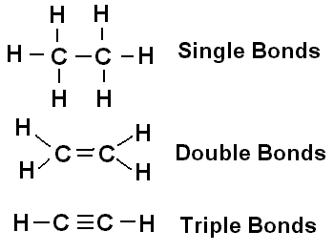Carbon is essential for life: “the ______________ of life”; “_________-based lifeforms”

1. Carbon contains _______ in its outer shell (for bonding).
2. Each carbon atom creates 4 bonds: _________, ___________, or _____________ bonds
3. It is the “_______ _______ ________ of Chemistry.”
   1. Macromolecules or _____________
      1. _________________ (larger) are built from smaller molecules called ____________.
      2. Organic Monomers Organic Polymers
4. Simple sugars (monosaccharides) 🡪 ________________________
5. Fatty acids & glycerol 🡪 ________________________
6. amino acids 🡪 ________________________
7. Nucleotides 🡪 ________________________

III. Organic Reactions

* 1. A_____________ Reactions: ___________ macromolecules from monomers.

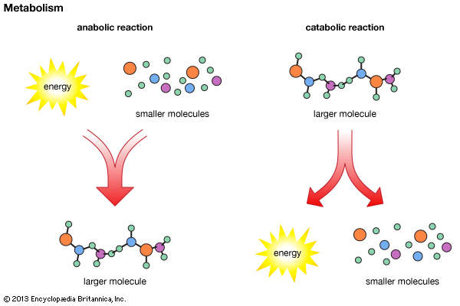

* 1. C_____________ Reactions: ____________ macromolecules into its components (monomers)
  2. D_______________ Synthesis (C________________ Reaction)

1. A___________ reactions which form macromolecules by combining _________ by “removing ___________.”

* 1. H_____________ Reactions
     1. C____________ Reactions which break down _____________ by removing monomers one at a time. [Opposite of ______________ reaction]
     2. Separates monomers by ________________.

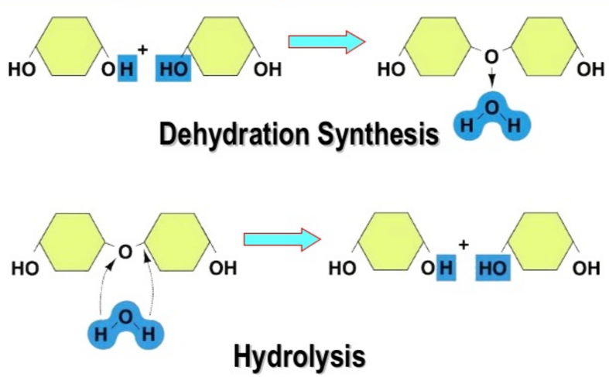

|  |  |  |
| --- | --- | --- |
| Biochemical Molecules | | |
| Category | Monomer | Polymer |
| Carbohydrates |  |  |
|  | Amino acids |  |
|  |  | Lipid |
|  |  | Nucleic acid |

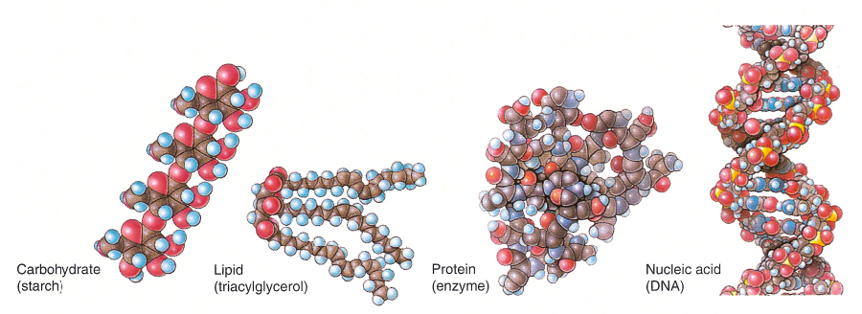

IV. Carbohydrates

* 1. Carbohydrates are an important source of __________ for all life forms.
  2. Carbohydrates are made of only __________, _________, ________ in a _______ Ratio.
     1. CH2O
     2. Includes _________ sugars and _____________ (complex sugars)
     3. Classified according to the number of__________ __________ they contain.
     4. Monomer: ________saccharides

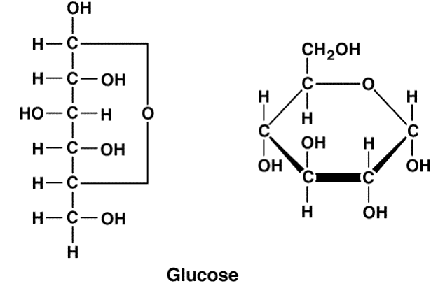

Cyclic

Straight

* + 1. Called _____________
  1. Exist in the following forms
     1. C_________
        1. Occurring in aqueous solutions in life environments
     2. S__________ Chain:
  2. Carbohydrate Synthesis

1. Cells link monosaccharides by __________________ to form more complex sugars and polysaccharides.
2. ____saccharides (Double Sugar):
3. 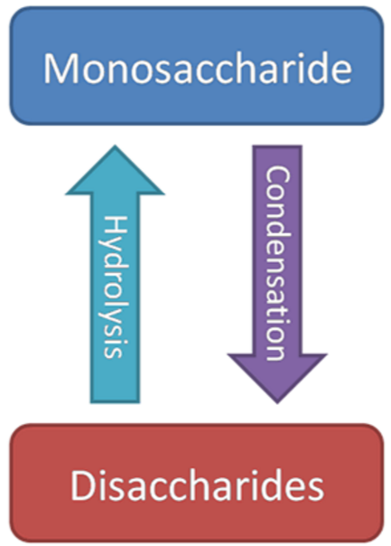Formed by joining ______ monosaccharides by dehydration synthesis
4. Forms a bond called a _______________.
5. Examples are ______________ (table sugar), ____________(milk sugar), _______________(grain sugar).
6. Cells break down disaccharides by _____________ (adding a molecule of water)

3. Polysaccharides (________ Sugars):

1. Chains of thousands of _________________.
2. Also called __________ carbohydrates
3. They function as

_____________ Storage Molecules

_____________ molecules

S________ (Energy _________ molecule)

* Chain of molecules of ___________ formed by __________
* This is the way ___________ store excess _________
* We consume it in products like potatoes and carrots.

G____________ (Energy storage molecule)

* Chain of molecules of ___________ formed by __________
* This is the way __________ store excess _________.
* Stored in the ________ and _________

Structural Molecule:

C___________

* Chain of ___________
* Primary constituent of __________________
* Major component of wood and paper
* ______________ by most animals.

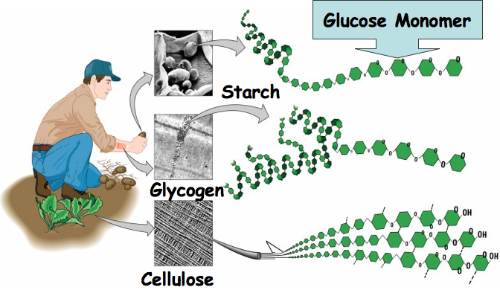

V. L___________

* 1. Contain C________, H__________, and O_________
  2. They are ____________ which means that they are “water fearing” or __________ in water.

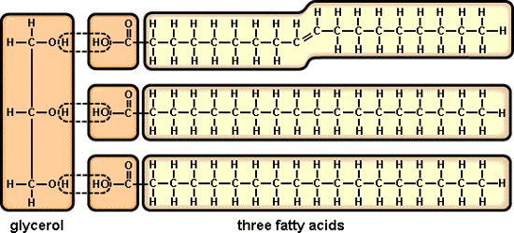

* 1. Protects and ____________ body organs.
  2. Mostly _______________ Molecules.
  3. Type of lipid we will consider: Fats (Triglycerides)
  4. Lipids are composed of ______ monomers: _____________ (1 molecule) + ________ acid tails (3)
     1. Types of Fatty Acid tails:

S_____________ fatty acids have the maximum number of hydrogens bonded to the carbons (all _________ covalent bonds between carbons); Animal _________

U____________ fatty acids contain one or more ________ bonds; _________

1. Saturated fatty acids are ______________ at room temperature (butter, margarine, peanuts, fried foods, whole milk)
2. Unsaturated fatty acids are ___________ at room temperature (avocado, oils, red meats, flax)

G. T_________________ are made from the Dehydration Synthesis of ___________+ _________________ forming E_______ bonds.

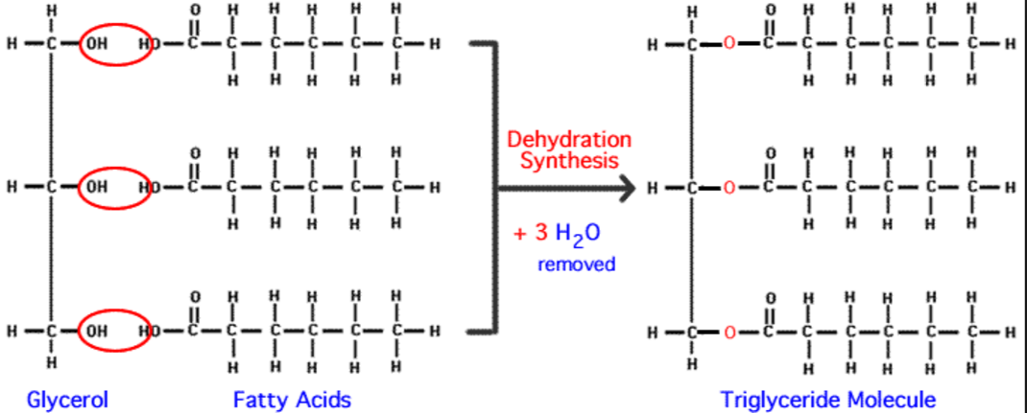

VI. P_____________

* 1. Proteins account for over half of the body’s ___________ matter.
  2. Main Functions:

1. Provide ______________ for body tissues.

2. Play a vital role in _______________

3. Act as _______________, _______________, _____________.

* 1. 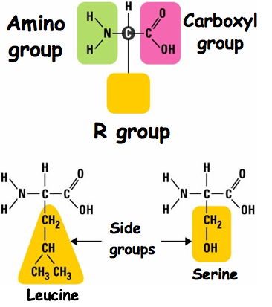Contain: _______________, _______________, _____________ and sometimes ,____________
  2. Monomers: ________________ (____ types in humans)
  3. Amino Acids have a central carbon with ___ groups attached
  4. Dehydration Synthesis
     1. Cells link ___________ together to make _________ by dehydration synthesis.
     2. P__________ Bonds: form to hold the amino acids together.
  5. Protein Structure:
     1. The functions of different types of proteins depend on their individual _______________.
     2. A P_________________ chain contains hundreds or thousands of _______________linked by peptide bonds. Name the 4 levels of protein structure:
        1. _____________, b. ______________, c. _______________, d. ______________
     3. The amino acid ____________ causes the polypeptide to assume a particular shape.
     4. If a protein’s shape is ______________, it can no longer function
     5. In the process of _______________, a protein
        1. Unravels
        2. Loses its specific shape
        3. Loses its ___________
     6. Proteins can be denatured by changes in ___________ concentration, changes in ____, or high _________.

VII. Nucleic Acids

* 1. Make up the ____________ or units of inheritance.

1. Determine the type of organism you will be.

2. Controls ___________ and _____________ by dictating protein structure.

* 1. They are composed of _____________, ___________, ___________, _______________, ____________________
  2. Two Types exist:

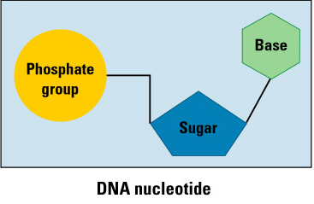 1. D__________________ Acid (_______)

2. R_____________ Acid (______)

* 1. Nucleic Acids are built from _____________ (monomers):

1. Pentose: 5 carbon __________

-______________ in RNA

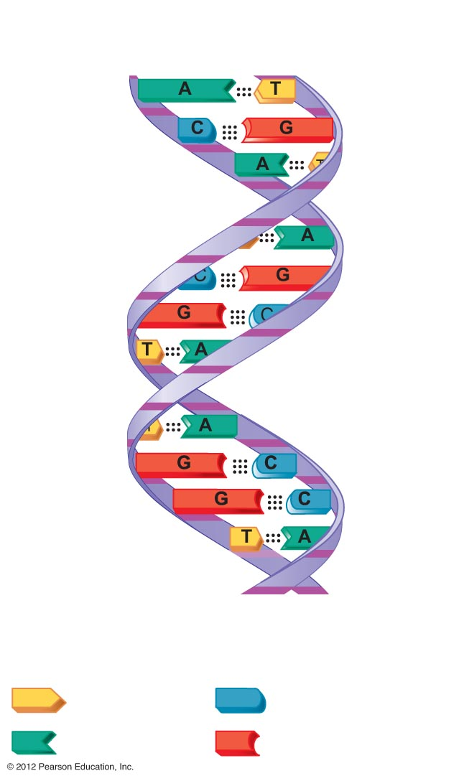 -Deoxyribose in ________.

2. P____________ Group

3. Nitrogenous __________:

- A = _____________

- G = _____________

- C = _____________

- T = _____________ (only in DNA)

- U = _____________ (only in RNA)

* 1. Deoxyribonucleic Acid (DNA)

1. The genetic material found within the ________________.

2. Provides instructions for every ___________ in the body.

3. Organized by complimentary bases to form a ____________________.

4. Contains the sugar deoxyribose and the bases _________, __________, _________, __________.

5. Replicates before ________________.

* 1. Ribonucleic Acid (RNA)

1. Carries out _______ instructions for __________________ (translation) in the cytoplasm.

2. Created from a template of __________________ (Transcription) in the nucleus.

3. Organized by complimentary bases to form a ________ stranded helix.

4. Contains the sugar ___________ and the nitrogenous bases ____________, _____________, ______________, _______________.

* 1. Bonding in Nucleic Acids

1. H________________ Bonds

-Hydrogen bonds form between 2 nucleic acid strands in _______

-____ :: ____ with two hydrogen bonds

-____ ::: ____ with three hydrogen bonds

2. Sugar-Phosphate Backbone: __________ of one nucleotide subunit is connected to ____________ of the next nucleotide (______________ synthesis).

