**Vectors B**

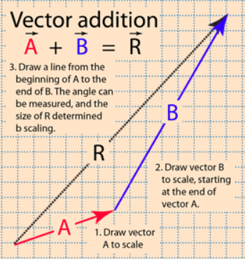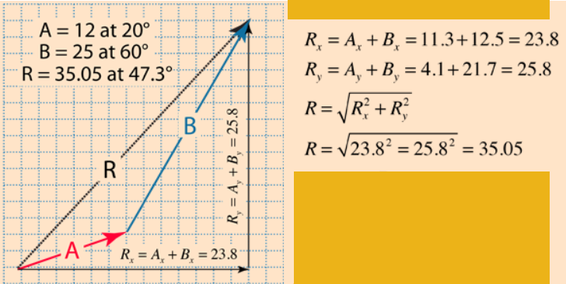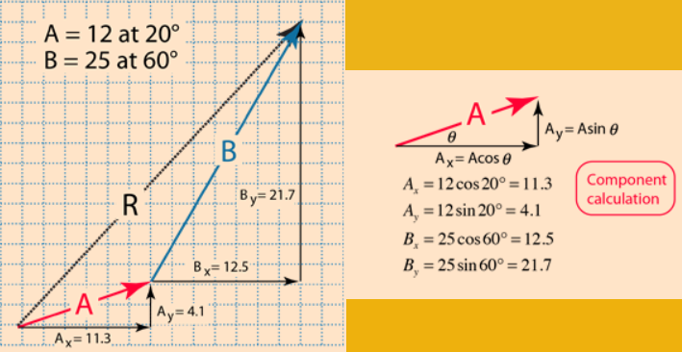

**See** [**https://www.learningctronline.com/courses**](https://www.learningctronline.com/courses) **for Materials and Resources.**

**Topics:**

1. Vectors

**Objectives:**

* Define vectors as compared to scalar quantities.
* Distinguish displacement from distance. Understand that displacement is ∆d = d2 – d1.
* Identify x and y components, cardinal directions, and conventions.
* Utilize properties (addition, subtraction, graphing), including trigonometry to deal with non-right triangle vectors.

TAKE NOTE

1. Reading (Hewitt Text)

1. Problem Set Vectors
2. Lab: 3L Force Tables (Resultant & Equilibrant)
3. Quiz/Test Vectors
4. Week 4 Devotional (<https://www.learningctronline.com/devotional>)

**Text**: Chapter 3: Vectors 3.1 – 3.3 (Hewitt)

**Class Notes: Vectors Document**

**Homework**:

* Problem Set Vectors

**Lab**: 3L Force Tables (Resultant and Equilibrant)

* Perform the lab as directed using the worksheet provided.
* Complete all calculations and data, showing work whenever appropriate.
* Conclusions should be answered in complete sentences that convey a complete thought.
* Save the documents into your LAB folder in the Physics folder on your desktop.

**TEST:**  Quiz Vectors

1) the academic integrity policy

* Tests must be completed **WITHOUT** referring to books, notes, the internet, people, or any outside resources.
* Students **MAY** use the approved Periodic Tables, approved Reference Tables, or approved equation (formula) sheet (provided by the teacher) along with calculators and scratch paper.
* A guardian should be proctoring the test. Proctoring means to monitor the following:

2) Take the **"in one sitting"**, meaning that once you start the test, you must complete it without interruption.

3) There is a **45-minute time limit** on this test. Please have the proctor write the time taken at the top of your answer sheet with their signature or initials.

4) Proctors should NOT be reading the test or engaging students during the test.

5) Do NOT use RED font. Black font is best.

Supplemental Resources (Optional)