Specific Heat of a Metal – Calorimetry

**Introduction**

**Purpose** To investigate the specific heat of a metal by using a calorimeter.

**Discussion**

Chemists identify substances on the basis of their chemical and physical properties. One physical property of a substance is the amount of energy it will absorb per unit of mass per degree of temperature rise. This property can be measured quite accurately and is called specific heat (Cp). Specific heat is the amount of energy, measured in joules, needed to raise the temperature of one gram of the substance one degree Celsius. Often applied to metallic elements, specific heat can be used as a basis for comparing energy, absorption and transfer.

To measure the specific heat in the laboratory, a calorimeter of some kind must be used. A calorimeter is a well-insulated container used in measuring energy changes. The calorimeter is insulated to reduce the loss or gain of energy to or from the surroundings. Energy always flows from an object at a higher temperature to an object at a lower temperature. The heat gained by the cooler substance equals the heat lost by the warmer substance, if we assume no loss of heat to the surrounding environment.

In this experiment, you will determine the specific heat of a metal sample. The metal sample will be heated to a high temperature then placed into a calorimeter containing a known quantity of water at a lower temperature. Having measured the mass of the water in the calorimeter, the temperature change of the water (∆T), and knowing the specific heat of water (4.184 j/g·Cº or 1.0 cal / g·Cº), the heat gained by the water (lost by the metal) can be calculated as follows:

Heat gained = Mass of X Change in Temperature X Specific Heat (Cp) of

by water water (g) ∆T (ºC) water (4.184 j/g·ºC)

The specific heat of the metal can now be calculated:

Specific Heat (Cp) of metal = Heat gained by the water ____

Mass of metal (g) X ∆T of metal (ºC)

**Hypothesis**

If the heat of objects in a closed system are measured, then specific heat can be calculated based on the law of conservation of energy and water will have a higher specific heat than metals.

**Materials**

Metal Can/Pan Styrofoam Cup Graduated Cylinder Goggles

2 Thermometers Mass Scale Tongs or forceps Water

Heat Source Copper Cylinder/Pennies Cadmium Cylinder Other metal?

**Video Demonstration:** [**https://screencast-o-matic.com/watch/cFX609YWH6**](https://screencast-o-matic.com/watch/cFX609YWH6)

**Procedures**

1. Test 2 different metals and water in this experiment to calculate the specific heat of each. Use a minimum of 10 pennies for the copper metal experiment. Use the video for the cadmium metal. You may use other metals beside copper and cadmium for additional tests (e.g. lead fishing sinker, very large steel nut, or ~2 inch long bolt). You will need to look up the specific heat of the metals you use (copper and cadmium are given in this lab).

2. Goggles must be worn at all times during this experiment.

**Part A Metals**

3. Obtain the Styrofoam cup (which will act as a “calorimeter”) and measure the mass carefully using a mass scale.

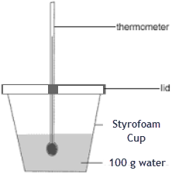

Record the mass in your data table. Add the water from the graduated cylinder to the Styrofoam cup at about room temperature and record the mass in your data table. Calculate the mass of the water alone and record in the chart.

4. Measure the temperature of the water in the Styrofoam container and record this temperature in your data table.

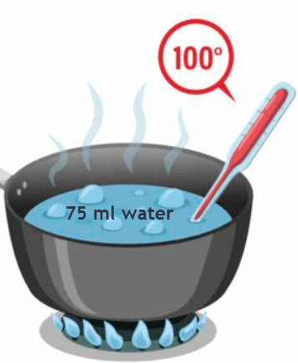

5. Add about 75 ml of water to the metal can / pan. Place the metal can on a heat source. Begin heating the water to the boiling point.

6. Use the 100 ml graduated cylinder (or metric measuring cup) & add water to the 100 ml line.

7. Obtain the metal. Measure and record the mass of the metal cylinder.

8. Use the tongs or forceps & carefully drop the metal cylinder into the metal can of hot water*.* Allow the metal cylinder to be in the boiling water at least 1-2 minutes.

9. While the metal is still in the boiling water bath, measure the temperature of the boiling water with a thermometer and record that temperature in your data table. (*We will assume that the temperature of the metal is the same as the boiling water.*)

10. Remove the thermometer, allowing it to cool or use a different thermometer for the next part.

11. Turn off the heat source. Do the next step as quickly as possible to avoid heat loss to the metal.

12. Cover the metal can / pan and bring to sink. Pour out the boiling water without losing the metal and then immediately place the metal into the water of the Styrofoam calorimeter.

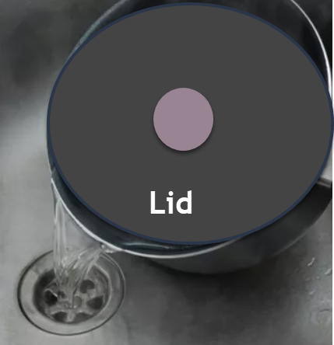

13. Gently swirl the Styrofoam Calorimeter to allow the temperature to equilibrate.

14. Insert the thermometer to measure and record the highest temperature reached by the metal-water mixture.

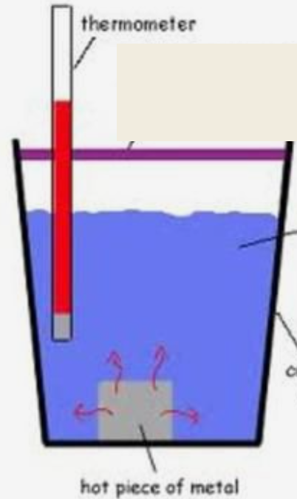

15. Clean up the lab area and prepare for the next metal or water part of the experiment.

16. Calculate the change of temperature for the water in the Calorimeter and record that temperature change in your data table.

17. Once you have calculated the specific heat value (Cp) for the first metal, use **accepted** specific heat of the metal*. (Notice the options listed in the Materials*.) Write the name of that metal in your Calorimetry Table on the Calculations and Data sheet.

**Part B Water**

17. Use the 100 ml graduated cylinder (or metric measuring cup) & add water to the 100 ml line.

18. Obtain the Styrofoam cup (which will act as a “calorimeter”) and measure the mass carefully using a mass scale. Record the mass in your data table.

19. Add the water from the graduated cylinder to the Styrofoam cup at about room temperature and record the mass in your data table.

20. Calculate the mass of the water alone and record in the chart.

21. Measure the temperature of the water in the Styrofoam container and record this temperature in your data table.

22. In a separate container (beaker), measure out the same amount of water using a graduated cylinder as the mass used with the copper (pennies). For example, if the mass of the pennies was 50 g, measure out 50 ml of water.

23. Pour the water into the metal cup / pan for heating. Bring the water to boiling and take the temperature immediately, and quickly go to the next procedures because the water will evaporate.

24. Pour the hot water into the Styrofoam cup of cool water and gently swirl the cup.

25. Take the final temperature of the water in the cup and record that in your data table 3.

**Specific Heat Calculations and Data Sheet**

1. YOU MUST INCLUDE UNITS FOR ALL MEASUREMENTS!

**CALORIMETRY TABLE 1 for Copper (pennies)**

|  |  |  |  |
| --- | --- | --- | --- |
| **MASS DATA** | | **TEMPERATURE DATA** | |
| **Material** | **Mass** | **Material** | **Temperature** |
| Metal cylinder |  | Boiling water |  |
| Water in Calorimeter |  |
| Name of Metal 🡺 | | Water in cup after metal was added |  |
| Calorimeter Styrofoam |  |
| Cup + water |  |  |  |
| Water alone |  | ∆T of water | º C |
|  |  | Heat gained by water |  |

2. Calculate the heat gained by the water (lost by the metal) in the calorimeter using the equation in the discussion. SHOW WORK.

3. Calculate the specific heat (Cp) of the metal using the answers in number 2 and the equation in the discussion. SHOW WORK.

**CALORIMETRY TABLE 2 for Cadmium (using the video**)

|  |  |  |  |
| --- | --- | --- | --- |
| **MASS DATA** | | **TEMPERATURE DATA** | |
| **Material** | **Mass** | **Material** | **Temperature** |
| Metal cylinder |  | Boiling water |  |
| Water in Calorimeter |  |
| Name of Metal 🡺 | | Water in cup after metal was added |  |
| Calorimeter Styrofoam |  |
| Cup + water |  |  |  |
| Water alone |  | ∆T of water | º C |
|  |  | Heat gained by water |  |

2. Calculate the heat gained by the water (lost by the metal) in the calorimeter using the equation in the discussion. SHOW WORK.

3. Calculate the specific heat (Cp) of the metal using the answers in number 2 and the equation in the discussion. SHOW WORK.

**CALORIMETRY TABLE 3 for Water (using the same mass as the copper / pennies**)

|  |  |  |  |
| --- | --- | --- | --- |
| **MASS DATA** | | **TEMPERATURE DATA** | |
| **Material** | **Mass** | **Material** | **Temperature** |
| Water mass matches the metal |  | Boiling water |  |
| Water in Calorimeter |  |
| Water | | Water in cup after metal was added |  |
| Calorimeter Styrofoam |  |
| Cup + water |  |  |  |
| Water alone |  | ∆T of water | º C |
|  |  | Heat gained by water |  |

2. Calculate the heat gained by the water (lost by the metal) in the calorimeter using the equation in the discussion. SHOW WORK.

3. Calculate the specific heat (Cp) of the metal using the answers in number 2 and the equation in the discussion. SHOW WORK.

**Conclusions and Questions**

1. Assume the Law of Conservation of Heat and matter applies and state whether the change in the water’s temperature after receiving the hot metal indicates an endothermic or exothermic process and whether the change in the metal’s temperature after sitting in the water indicates an endothermic or exothermic process. Which substance gains heat and which loses it?

2. How does the specific heat of water compare with that of the metals? Why is water an excellent material to use in a calorimeter?

3. Calculate the specific heat (Cp) of a metallic element if 314 joules of energy are needed to raise the temperature of a 50.0 g sample from 25.0º C to 50.0º C. SHOW WORK.

4. Determine a percent error for the specific heat of the metals you used. Use the internet to find the Cp of the metal you used if different than below:

|  |  |  |  |  |
| --- | --- | --- | --- | --- |
| Substance | **Water** | **Aluminum** | **Copper** | **Cadmium** |
| Specific Heat (j/g ºC) | 4.184 | 0.9025 | 0.38452 | 0.232 |
| Cp (Cal/gºC) | 1.000 | 0.22 | 0.09 | 0.055 |

5. Show how the law of conservation of energy was demonstrated in this lab.

6. Which of the metals has the least tendency to gain or lose heat based on your results? Explain.

**Answers**

1. INCLUDE UNITS FOR ALL MEASUREMENTS!

**CALORIMETRY TABLE 2 for Copper Cylinder or Pennies**

|  |  |  |  |
| --- | --- | --- | --- |
| **MASS DATA** | | **TEMPERATURE DATA** | |
| **Material** | **Mass** | **Material** | **Temperature** |
| Metal cylinder | **53.8 g** | Boiling water | **~100º C** |
| Water in Calorimeter | **20.0º C** |
| Name of Metal 🡺 **Copper** | | Water in cup after metal was added | **23.7º C** |
| Calorimeter Styrofoam |  |
| Cup + water |  |  |  |
| Water alone | **100. g** | ∆T of water | **3.7º C** |
|  |  | Heat gained by water | **1547 j** |

2. Calculate the heat gained by the water (lost by the metal) in the calorimeter using the equation in the discussion. SHOW WORK.

∆H (H20) = mCp∆T (100 g)(4.18 j/g**º**C)(3.7**º** C) = +**1547 j or +370 calories**

3. Calculate the specific heat (Cp) of the metal using the answers in number 2 and the equation in the discussion. SHOW WORK.

Cp = ∆H (H20) / m∆T = 1547 j / (53.8 g)(76.3**º** C) = **0.38 j/gºC or 0.09 cal/gºC**

**CALORIMETRY TABLE 2 for Cadmium**

|  |  |  |  |
| --- | --- | --- | --- |
| **MASS DATA** | | **TEMPERATURE DATA** | |
| **Material** | **Mass** | **Material** | **Temperature** |
| Metal cylinder | **58.95 g** | Boiling water | **~100º C** |
| Water in Calorimeter | **22.0º C** |
| Name of Metal 🡺 **cadmium** | | Water in cup after metal was added | **25º C** |
| Calorimeter Styrofoam |  |
| Cup + water |  |  |  |
| Water alone | **100. g** | ∆T of water | **3.0º C** |
|  |  | Heat gained by water | **1254 j** |

2. Calculate the heat gained by the water (lost by the metal) in the calorimeter using the equation in the discussion. SHOW WORK.

∆H (H20) = mCp∆T (100 g)(4.18 j/g**º**C)(3.0**º** C) = +**1254 j or +300 calories**

3. Calculate the specific heat (Cp) of the metal using the answers in number 2 and the equation in the discussion. SHOW WORK.

Cp = ∆H (H20) / m∆T = -1254 j / (58.95 g)(25**º** C - 100**º** C) = **0.28 j/gºC or 0.068 cal/gºC**

exothermic

**CALORIMETRY TABLE 3 for Water**

|  |  |  |  |
| --- | --- | --- | --- |
| **MASS DATA** | | **TEMPERATURE DATA** | |
| **Material** | **Mass** | **Material** | **Temperature** |
| Water mass matches the metal | **53.8 g** | Boiling water | **~100º C** |
| Water in Calorimeter | **21.2º C** |
| **Water** | | Water in cup after metal was added | **48.7º C** |
| Calorimeter Styrofoam |  |
| Cup + water |  |  |  |
| Water alone | **100. g** | ∆T of water | **27.5º C** |
|  |  | Heat gained by water | **11,495 j** |

2. Calculate the heat gained by the water (lost by the metal) in the calorimeter using the equation in the discussion. SHOW WORK.

∆H (H20) = mCp∆T (100 g)(4.18 j/g**º**C)(27.5**º** C) = +**11,495 j or +2750 calories**

3. Calculate the specific heat (Cp) of the metal using the answers in number 2 and the equation in the discussion. SHOW WORK.

Cp = ∆H (H20) / m∆T = 11,495 j / (53.8 g)(51.3**º** C) = **4.16 j/gºC or 1.0 cal/gºC**

**CALORIMETRY for Aluminum**

|  |  |  |  |
| --- | --- | --- | --- |
| **MASS DATA** | | **TEMPERATURE DATA** | |
| **Material** | **Mass** | **Material** | **Temperature** |
| Metal cylinder | **17.6 g** | Boiling water | **~100º C** |
| Water in Calorimeter | **21.2º C** |
| Name of Metal 🡺 **aluminum** | | Water in cup after metal was added | **24º C** |
| Calorimeter Styrofoam |  |
| Cup + water |  |  |  |
| Water alone | **100. g** | ∆T of water | **2.8º C** |
|  |  | Heat gained by water | **1172 j** |

2. Calculate the heat gained by the water (lost by the metal) in the calorimeter using the equation in the discussion. SHOW WORK.

∆H (H20) = mCp∆T (100 g)(4.18 j/g**º**C)(2.8**º** C) = +**1172 j or +280 calories**

3. Calculate the specific heat (Cp) of the metal using the answers in number 2 and the equation in the discussion. SHOW WORK.

Cp = ∆H (H20) / m∆T = 1172 j / (17.6 g)(76**º** C) = **0.9 j/gºC or 0.22 cal/gºC**

5. Which of the metals has the least tendency to gain or lose heat based on your results?

***Aluminum has a higher specific heat (Cp) and the least tendency to gain or lose heat.***

**Conclusions and Questions**

1. Assume the Law of Conservation of Heat and matter applies and state whether the change in the water’s temperature after receiving the hot metal indicates an endothermic or exothermic process and whether the change in the metal’s temperature after sitting in the water indicates an endothermic or exothermic process. Which substance gains heat and which loses it?

***Water RECEIVES the metals heat 🡪 endothermic***

***The metal RELEASES its heat to water 🡪 exothermic***

2. How does the specific heat of water compare with that of the metals? Why is water an excellent material to use in a calorimeter?

***Water’s specific heat is up to 20 times greater than that of metals. Water is an excellent material to use in a calorimeter because it is inexpensive, stable (non-volatile), and has the second highest specific heat for liquids.***

3. Calculate the specific heat (Cp) of a metallic element if 314 joules of energy are needed to raise the temperature of a 50.0 g sample from 25.0º C to 50.0º C. SHOW WORK.

Cp = ∆H (H20) / m∆T = 314 j / (50.0 g)(50.0**º** C – 25.0**º** C) = **0.250 j/gºC**

4. Determine a percent error for the specific heat of the metals you used. Name some errors that occurred during this experiment.

***The*** ***percent error for the specific heat of a metal is determined by:***

***% error = |(Accepted – Experimental)|/Accepted x 100 %.***

***Errors in this lab would include: (1) heat loss in transferring the metal between beakers, (2) inaccurate measurements (mass, volume, etc.), (3) low boiling point temperature.***

5. Show how the law of conservation of energy was demonstrated in this lab.

***The*** ***amount of heat added (absorbed) and released in this experiment was equal. This was demonstrated by the hot metal losing heat (+1172 J for copper and +1547 J for aluminum) to the water which gained it (the same amount) We do assume that no heat energy was “lost” to the surroundings (e.g. a closed system). In real life, some heat is transferred to the surroundings.***

6. Which of the metals has the least tendency to gain or lose heat based on your results? Explain.

***The metal which has the highest specific heat (Cp) will have the least tendency to gain or lose heat. Aluminum has the highest specific heat, copper is next, then cadmium.***

Final Summary

* **Specific heat** is the amount of energy, measured in joules, needed to raise the temperature of one gram of the substance one degree Celsius. Often applied to metallic elements, specific heat can be used as a basis for comparing energy, absorption and transfer.
* To measure the specific heat in the laboratory, a **calorimeter** of some kind must be used. A calorimeter is a well-insulated container used in measuring energy changes. The calorimeter is insulated to reduce the loss or gain of energy to or from the surroundings.
* **Law of Conservation of Energy** 🡪 The heat gained by the cooler substance equals the heat lost by the warmer substance, if we assume no loss of heat to the surrounding environment. Energy always flows from an object at a higher temperature to an object at a lower temperature.
* **Percent Error** for metal specific heat values would be good.