**Teaching an Elementary Lesson**

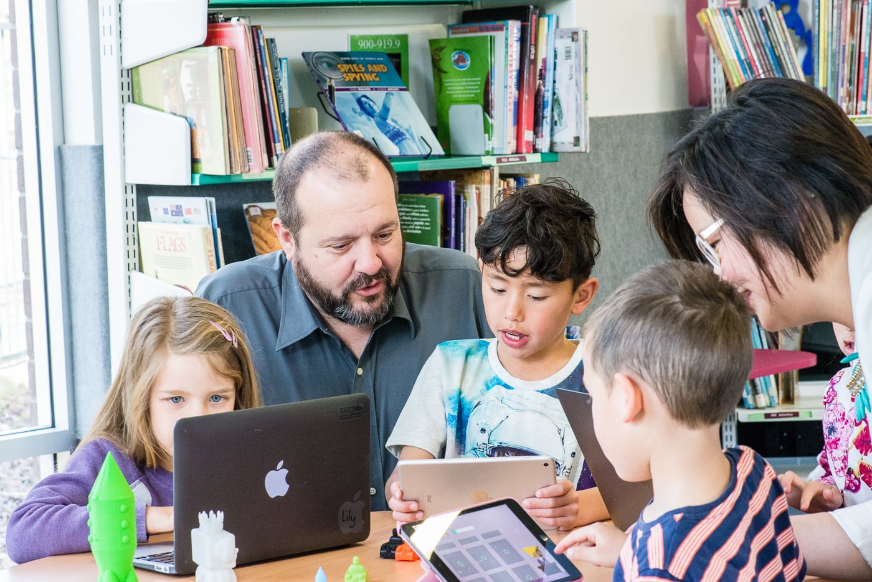

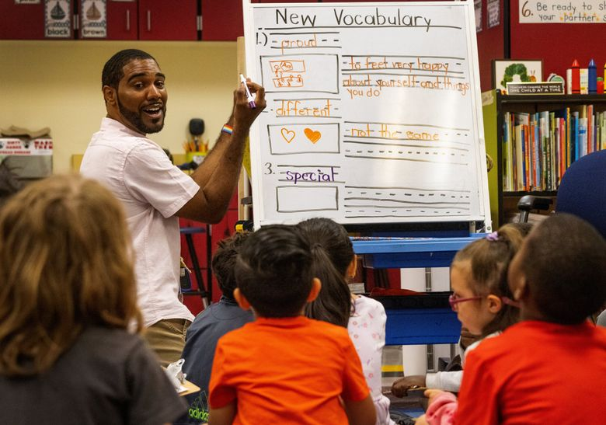

**See** [**https://www.learningctronline.com/courses**](https://www.learningctronline.com/courses) **for Materials and Resources.**

**Topics:**

1. Elementary School Lesson

**Objectives:**

* + Develop an age-appropriate elementary school lesson to teach students at a local elementary school supervised by the cooperating teacher and principal.
  + Include background, motivation, vocabulary (meaning, usage, application), science content activity (game, activity, debate, puppet show, song, video, movie clips, “Show & Tell”, etc.), and bibliography.
  + Incorporate multiple intelligences in teaching styles to target various learning styles.
  + Emphasize clarity of purpose (simplicity, ease of understanding, repeatability) and overall presentation (preparation, enthusiasm, cooperation with teacher and students, execution).
  + Cooperation and collaboration with cooperating teacher, principal and Learning CTR Online.

TAKE NOTE

1. Review state approved curriculum scope & sequence (with objectives) for age-appropriate science concept being taught.
2. Background / Motivation Worksheet
3. Crossword / word search of lesson vocabulary
4. Library research activity or bibliography
5. Project Report (due before lesson is taught at the elementary school)
6. Week 32 Devotional (<https://www.learningctronline.com/devotional>)

**Text**:

**Reference Material: Curriculum Scope & Sequence**

**Homework**:

* Background / Motivation Worksheet
* Crossword / Wordsearch
* Bibliography
* Project Report due before teaching the lesson

**Lab**: Teach the lesson at the Elementary School

* Teacher evaluation form.
* Save the document into your LAB folder in the Projects in Science folder on your desktop.

**TEST:** No test this unit.

* Project Report
* Lesson at Elementary School
* Teacher Evaluation Form

Supplemental Resources (Optional)

1. Qualint.com (crossword / wordsearch maker)
2. Screencast-o-matic (ScreenPal) video recorder / editor
3. Video the lesson at the Elementary School