Section 19.2 (page 662)

fig

**PURPOSE**

To measure the pH of various household materials by using a natural indicator to make an indicator chart.

**MATERIALS**

* knife
* red cabbage leaves
* 1-cup measure
* hot water
* 2 jars
* clean white cloth
* teaspoon
* tape
* 3 sheets of plain white paper
* pencil
* ruler
* 10 clear plastic cups
* white vinegar (CH3COOH)
* baking soda (NaHCO3)
* household ammonia
* dropper
* household items listed in Step 5

**PROCEDURES**

**1.** Put  cup of finely chopped red cabbage leaves in a jar and add  cup of hot water. Stir and crush the leaves with a spoon. Continue the extraction until the water is distinctly colored.

**2.** Strain the extract through a piece of cloth into a clean jar. This liquid is your natural indicator.

**3.** Tape three sheets of paper end to end. Draw a line along the center and label it at 5 cm intervals with the numbers 1 to 14. This is your pH scale.

**4.** Pour your indicator to about 1 cm depth into each of three plastic cups. To one cup, add several drops of vinegar, to the second add a pinch of baking soda, and to the third add several drops of ammonia. The resulting colors indicate pH values of about 3, 9, and 11, respectively. Place these colored positions on your pH scale.

**5.** Repeat Step 4 for household items such as table salt, borax, milk, lemon juice, laundry detergent, dish detergent, milk of magnesia, mouthwash, toothpaste, shampoo, and carbonated beverages.

**ANALYSES AND CONCLUSIONS**

**1.** What was the color of the indicator at acidic, neutral, and basic conditions?

**2.** What chemical changes were responsible for the color changes?

**3.** Label the materials you tested as acidic, basic, or neutral.

|  |  |  |  |
| --- | --- | --- | --- |
|  | **Acidic** | **Neutral** | **Basic** |
| **Table salt** |  |  |  |
| **Borax** |  |  |  |
| **Milk** |  |  |  |
| **Lemon juice** |  |  |  |
| **Laundry detergent** |  |  |  |
| **Dish detergent** |  |  |  |
| **Milk of magnesia** |  |  |  |
| **Mouthwash** |  |  |  |
| **Toothpaste** |  |  |  |
| **Shampoo** |  |  |  |
| **Carbonated beverage** |  |  |  |
|  |  |  |  |

**4.** Which group contains items used for cleaning or for personal hygiene?

**Calculations and Data**

Results can vary based on the particular product.

|  |  |  |  |
| --- | --- | --- | --- |
|  | **Acidic** | **Neutral** | **Basic** |
| **Table salt** |  | **X** |  |
| **Borax** |  |  | **slightly** |
| **Milk** | **slightly** |  |  |
| **Lemon juice** | **X** |  |  |
| **Laundry detergent** |  |  | **X** |
| **Dish detergent** |  | **X** |  |
| **Milk of magnesia** |  |  | **X** |
| **Mouthwash** | **X** |  |  |
| **Toothpaste** |  |  | **slightly** |
| **Shampoo** | **X** |  |  |
| **Carbonated beverage** | **X** |  |  |
| **Baking Soda** |  |  | **slightly** |

**ANALYSES AND CONCLUSIONS**

**1.** What was the color of the indicator at acidic, neutral, and basic conditions?

***The initial color is purple. In an acidic solution, the indicator is red; in a neutral solution, it is blue-purple; and in a basic solution, it is green.***

**2.** What chemical changes were responsible for the color changes?

***Changes in the relative number of H+ and OH- ions present are responsible for the color changes.***

**3.** Label the materials you tested as acidic, basic, or neutral.

***Answers will vary depending on the materials you used.***

**4.** Which group contains items used for cleaning or for personal hygiene?

***Personal hygiene items mainly test neutral; cleaning materials, such as soap, mainly test basic.***

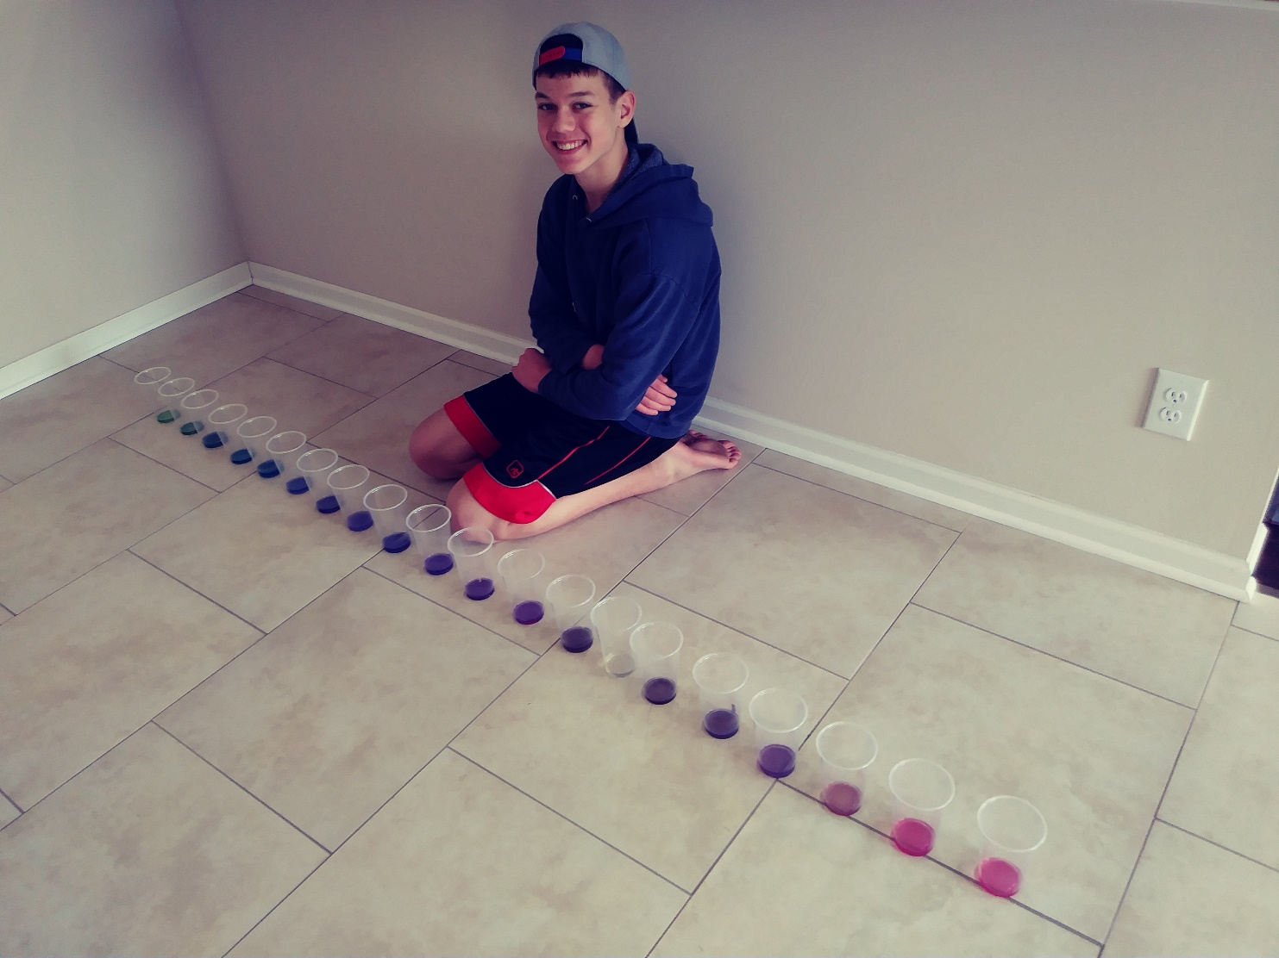

***Red Cabbage Indicator***

