**Covalent Bonding Chapter 8A**



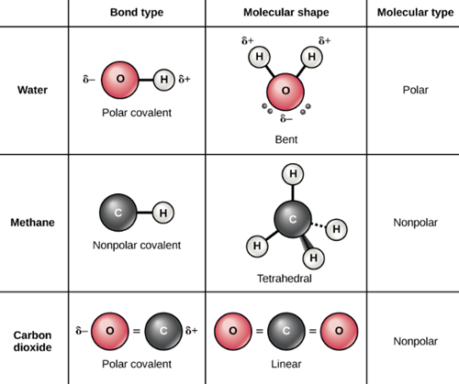

**See** [**https://www.learningctronline.com/courses**](https://www.learningctronline.com/courses) **for Materials and Resources.**

**Topics:**

1. Covalent Bonding

**Objectives:**

1. Explain covalent bonding in terms of bonds (nonpolar, polar, and coordinate covalent) and molecules (nonpolar & polar).
2. Define and recognize polyatomic ions.
3. Understanding how to represent molecules, compounds and types of covalent bonds (single, double, triple) in various ways (molecular & structural formulas, Lewis structures).

TAKE NOTE

1. Test Corrections (Ionic & Metallic Bonding)
2. Lesson Check/Sample problems or Alternative Worksheets (2 weeks)
3. Covalent Bonding Study Guide (pp. 1-4a … up to “Bonding Exceptions”)
4. Lab Ionic Versus Covalent Compounds
5. Quiz: Bonding
6. Class Song: “Chemitis”
7. Week 11 Devotional (<https://www.learningctronline.com/devotional>)

**Text**: Chapter 8: Covalent Bonding pp. 220-239

Read the assigned pages in the text.

**Class Notes: PowerPoint or PDF**

**Notes/Study Guide:** Fill in the Chapter 8 worksheet to understand the class notes.

**Homework**: Text

(1) Answer the KEYED **“Lesson Check”** questions at the end of each.

(2) Answer the **“Sample problems”** found in the “Sample Problem” boxes throughout the chapter. An answer KEY is provided for you to use to self-correct your homework problems.

* Put your answers into complete thoughts in a Word document. Do NOT just put the answer, but write a phrase or sentence that you can study from for your tests. Save your work in a WORD document and SAVE into your HOMEWORK folder in the Chemistry folder on the desktop.
* Assignments will be “spot checked” during class or submitted via email.

**Alternate Homework**:

1. Covalent Bonding Study Guide (pp. 1-4a … up to “Bonding Exceptions”)

**Lab**: Ionic Versus Covalent Compounds

* Complete the Lab Ionic Versus Covalent Compounds using the worksheet and video provided.
* Video: <http://somup.com/c06u0eBR4e> Ionic Versus Covalent Compounds (15:46)
* Save the document into your LAB folder in the Chemistry folder on your desktop.

**TEST:** Bonding Quiz

* Complete the Bonding Quiz.
* Email to the teacher for grading when done.
* 10 minute time limit.

Supplemental Resources (Optional)

[Covalent BONDing (Polar Versus Non-Polar) ctr](http://somup.com/cF6nILnVZt) (5:53)  
  
[Covalent MOLECULES (Polarity & Geometry) ctr](http://somup.com/cF6nF5nVuk) (4:24)  
  
[Recap of BOND Polarity ctr](http://somup.com/cF6hDtnnc6) (4:13) ... molecular models  
  
[Recap of Covalent MOLECULE Polarity & Geometry ctr](http://somup.com/cF6hDEnnct) (2:05) ... molecular models  
  
[The Bonding Song](https://screencast-o-matic.com/watch/cq6e01uoUj) (3:07) ... Ionic & Covalent Bonds (Review).  
  
[Scripture is God-Breathed 2 Timothy 3:16-17; To Express the Lord](http://somup.com/cYhoYZjulb) (7:47)