**Purpose**: To identify the major bones and muscles of the human body.

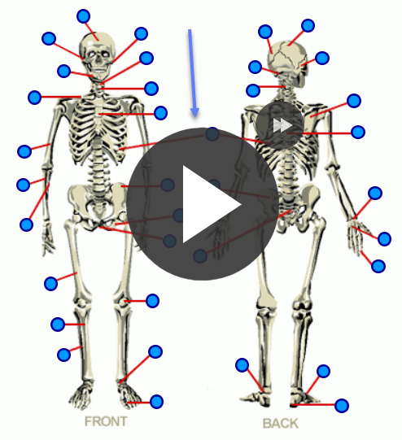

**Procedure**:

* Click on the links provided to gain access to the quiz web sites.
* Begin the game by clicking on the “play” icon.
* Click and drag the appropriate text box to label each bone.
* **After 3 tries, the quiz will give you the answer using a purple dot.**
* **You do NOT have to know the labelled items.**

**Link**: Human Bones: <http://www.purposegames.com/game/183>

Carpals

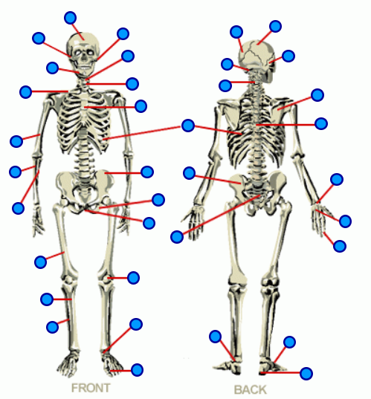

Patella

Pelvis

Phalanges

Phalanges

Toe

Metatarsals

Radius

Ribs

Scapula

Sternum

Tarsals

Tibia

Ulna

Metacarpals

Mandible

Clavicle

Femur

Ischium

Ilium

Humerus

Fibula

Zygomatic

Maxilla

Parietal

Talus

Calcaneus

Axis

Temporal

Sphenoid

Occipital

Atlas

Cervical Vertebrae

Sacrum

Frontal

Coccyx

Thoracic Vertebrae

Human Muscles: <http://www.purposegames.com/game/431>

*Use the same procedures as before.*

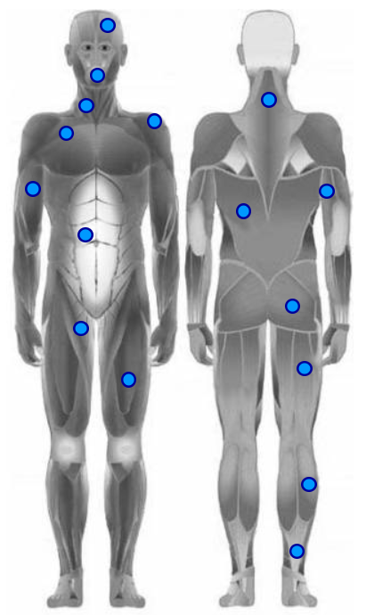

Triceps

Trapezius

Pectoralis

Quadriceps

Latissimus dorsi

Hamstrings

Gluteus

Gastrocnemius

Deltoids

Biceps

Achilles’

Abdominals

Orbicularis Oris

Frontalis

Sartorius

Sternocleidomastoids

SKIN

*Click on the following Link and “Take the Quiz.” Place the answers below:*

<http://kidshealth.org/kid/htbw/SKINquiz.html>

What is your bodies largest organ? _____

The skin does all of the following:

1.

2.

3.

What is the outermost layer of skin called? _____

What gives skin its color? _____

Each hair on your body grows out of a tiny tube in the skin called: _____

What tells your brain how things feel when you touch them? _____

Blood vessels bring **_____** to the skin cells

What is your skin’s natural oil called? _____

Why do you get goose bumps when you are cold? _____

**DIAGRAM ON NEXT PAGE**

**Label the diagram using the numbers:**

***You do NOT have to know the labelled structures (e.g. Stratum corneum)***

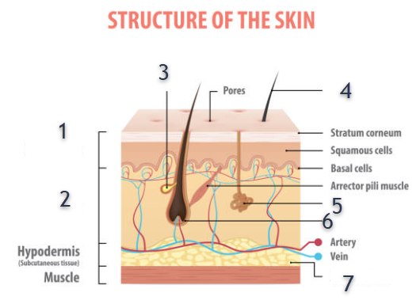

**1**

**2**

**3**

**4**

**5**

**6**

**7**