Heading

Title

**Introduction**

**Purpose**

To measure pulse rate, heart rate, blood pressure, and breathing rate in human at rest and during exercise. To relate these functions to body position and physical fitness.

**Discussion** *Body Posture*

Blood pressure is monitored in our bodies by **pressoreceptors** which send messages to the **medulla** in the brain. Every time we change posture, the receptors register a shift in blood pressure.

Under normal pressure, the pressoreceptors send a few regular impulses to the medulla. When blood pressure drops (as measured in the chest and neck), the medulla must speed the heart rate and contract blood vessels to increase (and restore) blood pressure to normal. If blood pressure is raised, the medulla must slow the heart rate and dilate (open) blood vessels to decrease the blood pressure.

When one rises from a bed or chair, gravity pulls blood from the head and chest into the legs and feet and the heart suddenly pumps less blood. Unconsciousness is imminent unless pressoreceptors respond within a few seconds. Carbon dioxide (CO2) builds up and must be replaced by oxygen (O2) in the brain or fainting will occur.

Standing still for a period of time can be dangerous for many people. As one stands, blood is influenced by gravity so that the weight of blood increases venous blood pressure (systemic veins carry blood back to the heart). As this pressure increases, liquids making up the blood can be forced out of capillaries into the body, so less blood circulates; and therefore, CO2 can build up and cause fainting. (Just as putting a bag over your head can kill you.)

Body movements drop the venous blood pressure because veins have valves. When muscles contract (to produce movement), they squeeze blood through these valves towards the heart. The valves then close to prevent blood from going backwards within the veins.

**Materials** Sphygmomanometer (optional) Stop Watch “Step” (chair, bleacher)

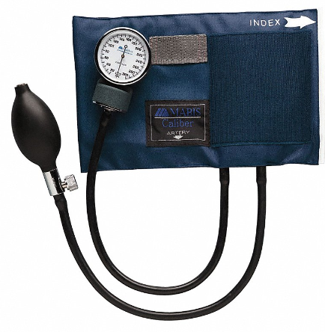 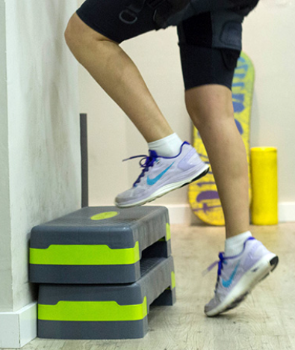

Step Height

Adult Females 16” (41 cm) … Youth 14” (36 cm)

Adult Males 20” (51 cm)

… youth 18” (45 cm)

**Procedures** *Body Posture*

a. Try to determine your blood pressure (systole and diastole) using a sphygmomanometer (bonus). Drug stores often have these. Your doctor or a nurse would have one.

b. You will work with a partner to perform the experiment. Record the results in the Calculations and Data Table.

c. Have someone practice taking your pulse using either the “carotid” artery/vein in the neck OR by using the underside of the partner’s wrist between the tendons. Choose the method that works best for you.

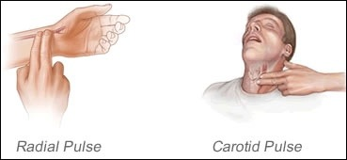

***Lying Down and Standing***

1. Lie down (prostrate) for one minute. Wait about 30 seconds and record your pulse for 10 seconds during that minute.
2. After one minute, the prostrate person will stand erect. Record your pulse for the first 10 seconds of standing.
3. Do TWO trials and record the results in the appropriate Calculations and Data Table.
4. Answer the questions on the Calculations and Data Sheet for this section.

***Standing Still***

1. Take off your shoes and socks. Then, stand erect and perfectly still for one minute.
2. **Take a picture of your feet after one minute. Insert below:**
3. The veins in your feet will swell with blood due to pooling. Note this condition.
4. Run in place for 15 seconds.
5. Answer the questions on the Calculations and Data Sheet for this section.

**Discussion** *Physical Fitness* **<https://somup.com/c3lwqdwLA4> (3:20)**

The Harvard Step Test was developed during World War II as an indicator of physical fitness. Endurance and the speed of recovery after exercise are the two factors used to estimate physical fitness. We will use the Harvard Step Test to estimate physical fitness, and we will also note the correlation of pulse rate with respiratory (breathing) rate.

**Procedures** *Physical Fitness*

1. Set up a “step” of some kind. A chair, a bleacher step. For females, the height of the step should be 14 inches (36 cm). For males, the height of the step should be 18 inches (45 cm).
2. You need a second person for this. Record all results on the Calculations and Data Sheet.
3. Work with a partner to (1) perform the Harvard Step Test, (2) stabilize the chair for doing the stepping, (3) keep time and call the cadence, and (4) count the breaths taken after the Step Test as well as take your pulse.
4. BEFORE starting the Step Test, have your partner take and record your pulse rate (beats per minute) and the respiratory rate (breaths in one minute) while you are seated and relaxed.
5. Harvard Step Test:
6. Start with both feet planted on the floor next to the “climbing” chair or apparatus.
7. Step up with one foot onto the chair into a full standing position on the chair/apparatus with both feet planted.
8. After standing straight up onto the chair, step down with one foot at a time until both feet are planted on the ground again. This completes ONE full cycle.
9. One member of the group will call the cadence for the person performing the test. One cycle should take 3 seconds. So, the person says, “UP” every three seconds.

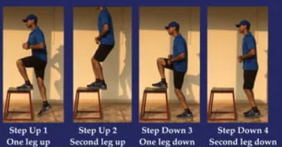

1. Perform the Harvard Step Test for 5 minutes OR until you cannot maintain the 3 second cadence for 15 seconds. If you could NOT maintain the 3 second cadence, record the total time you did exercise up to 5 minutes (in seconds).
2. After 5 minutes or after quitting, immediately sit down.

a. Exactly ONE minute after the Step Test (sitting down), take your pulse for 30 seconds AND count the number of breaths you take in those 30 seconds. You can count your own breaths while your partner takes your pulse count.

b. Repeat the same procedure at the TWO-minute mark after exercise. (Take your pulse and count the breaths in the last 30 seconds of that minute).

c. Repeat the same procedure at the THREE-minute mark after exercise. (Take your pulse and count the breaths in the last 30 seconds of that minute).

8. For bonus, you can perform all the procedures over TWO trials or have another person participate.

**Calculations and Data**

***Blood Pressure*** 🡪 ___(systole) over ___ (diastole) [*bonus*]

***Lying Down and Standing***

A. Record the pulse rate of lying down and standing in the table below:

|  |  |  |  |  |  |
| --- | --- | --- | --- | --- | --- |
|  | You | |  | Person 2 (optional) | |
|  | Trial 1 | Trial 2 |  | Trial 1 | Trial 2 |
| Pulse Rate Prostrate  (10 seconds) |  |  |  |  |  |
| Pulse Rate Standing  (first 10 seconds) |  |  |  |  |  |

1. Describe what you felt or feel at the moment you stand up.

2. At the moment of standing, did your pulse increase, decrease or remain the same during the recorded 10 seconds (compared to lying prostrate)?

3. How does our body respond to standing up after sitting or lying down (see discussion section)?

***Standing Still***

4. What happened to your foot veins when you stood still for one minute?

5. What should a person do who has to stand still for extended periods of time (e.g., marching band, military rank)?

6. How would your response in question 2 affect your body in terms of circulation?

***Physical Fitness Indicator***

A. Prior to exercise, the average pulse rate per minute for men is 75 beats/minute; that of women is 76 beats/minute. A lower pulse rate many times does indicate better physical condition, but this is NOT universal. After exercise, however, the time of recovery (the time it takes to return the pulse rate to normal) is directly associated with one’s state of physical condition. For example, an Olympic runner ran a race with some recreational joggers at a 6-minute mile pace. The joggers were exhausted and three minutes after the run their pulse rates were still nearly as high as immediately after the run. The Olympian, on the other hand, was not too tired and his pulse rate three minutes after running was only slightly higher than his pre-race level.

B. Record the pulse rate & respiratory rate (breaths) of the Harvard Step Test in the table below:

Pulse Rate: heart beats 30 seconds Respiratory Rate: breaths in 30 seconds

|  |  |  |  |  |  |
| --- | --- | --- | --- | --- | --- |
|  | You | |  | Person 2 (optional) | |
| **Before**  Rest | Pulse Rate | Respiratory Rate |  | Pulse Rate | Respiratory Rate |
|  |  |  |  |  |  |
| **After** |  |  |  |  |  |
| 1 min |  |  |  |  |  |
| 2 min |  |  |  |  |  |
| 3 min |  |  |  |  |  |

* Determine the true “pulse rate” (beats per minute) for each person by doubling the pulse rate at REST above from the table above.

|  |  |  |  |
| --- | --- | --- | --- |
|  | You |  | Person 2 (optional) |
| Pulse Rate  Beats/min |  |  |  |

C. Use the Information from the Harvard Step Test table above and the equations below to determine the “Index of Physical Fitness” [*a sample is given*]. 300 seconds represents 5 minutes.

71

# seconds exercised x 100 # seconds exercised x 100 300 seconds x 100

2(pulse rates) 2(1 min + 2 min + 3 min) 2(90 + 70 + 50)

**You** **Person** **2 (optional)**

___ seconds X 100 ___ seconds X 100

2(___+ ___+___) 2(___+ ___+___)

* *An index of 55 or below indicates poor physical fitness. An index of 55 to 90 shows average to good physical fitness. An index over 90 indicates excellent physical condition.*

7. According to the index you calculated above, what physical condition are you in?

8. How does strenuous exercise affect both pulse rate and respiratory rate?

**Conclusions and Questions**

1. What is the relationship of pulse rate and respiration (respiratory rate)?

2. Explain how the Harvard Step Test is an indicator of physical fitness.

**Bibliography**

*Witherspoon, James D. The functions Of Life: A Laboratory Guide for Animal Physiology. Addison-Wesley. 1970.*