**Electric Force & Current Chapter 20A**

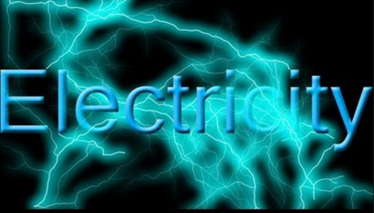



**See** [**https://www.learningctronline.com/courses**](https://www.learningctronline.com/courses) **for Materials and Resources.**

**Topics:**

1. Electric Force & Current

**Objectives:**

* Define & explain aspect of electric force (charged ions, forces of attraction & repulsion, Coulomb’s Law, Electric Fields).
* Understand component of electric current and be able to calculate each related to Ohm’s Law (voltage, current, resistance).
* Distinguish between induction and conduction related to transfer of charges.

TAKE NOTE

1. Guided Reading Note-Taking Worksheet (Pearson Text) (1 week)
2. Pearson Concepts in Action Worksheet
3. Lab Torsion Apparatus – Static Electricity & Magnetism Rub/unrub
4. Lab Electrostatic Forces Activity
5. Electricity & Transmission Worksheet
6. Class Song: Just for Learning (That’s Amore)
7. Week 25 Devotional (<https://www.learningctronline.com/devotional>)

**Text**: Chapter 20: Electricity pp. 598-627

**Guided Reading Note-Taking Worksheet:**

Complete the worksheet for Chapter 20: Electricity (20.1 – 20.4).

**Class Notes: PowerPoint or PDF**

**Homework**:

* 20.2 Electric Current & Ohm’s Law Worksheet (Pearson Concepts in Action)
* Electricity & Transmission Worksheet based on Power Point or PDF
* Assignments will be “spot checked” during class or submitted via email.

**Lab**: Electrostatic Forces Activities

* Complete the activities using the worksheet provided.
* Save the documents into your LAB folder in the Physical Science folder on your desktop.

**Lab**: Torsion Apparatus & Static Electricity Lab 1 Rub/Unrub

* Complete the activities using the worksheet provided.
* Save the documents into your LAB folder in the Physical Science folder on your desktop.
* *Assignments will be “spot checked” during class or submitted via email.*

**TEST:** The test will be given after next week’s lesson.

Supplemental Resources (Optional)

[**http://somup.com/cF6elPnVza**](http://somup.com/cF6elPnVza) **The Atom: Electrostatic Force Demonstrations ctr (2:59)**

**Acrylic Tape Demo (1:30)**

**Balloon with paper punches showing friction, induction and conduction**

[**http://somup.com/cFX2YInjch**](http://somup.com/cFX2YInjch) **Electric Force: Cow Touching an Electric Fence (0:18)**

[**http://somup.com/cFX2YDnjcj**](http://somup.com/cFX2YDnjcj) **Beaker's "Ode to Joy" Beware. This is Shocking! (1:41)**

<http://somup.com/cY1QFtQlBS> Components of Static Electricity (5:31)

<http://somup.com/cFX2YFnjcQ> M & M's Jumping on a Cake! Who'd da Thunk? (0:39)

<http://somup.com/cr10Dfqslf> Electric Forces Attraction & Repulsion (1:24)

<http://somup.com/cYhqIHjaKt> Revealed by Fire 1 Corinthians 3:11-13; Come to Jesus (5:03)