Heading

Title

**Introduction**

**Purpose**

To discover what pigments are present in plants and the role they play in photosynthesis.

**Discussion**

Paper chromatography is a method commonly used to separate pigments. This technique uses a solvent which will make the pigments move up the paper at different rates, thus separating them for identification.

Most pigments work by absorbing certain wavelengths of light. Other wavelengths are reflected or scattered, which cause you to see those colors. Chlorophyll, the green pigment common to all photosynthetic cells, **absorbs** **all wavelengths of visible light except** green, which it reflects. This is why plants appear green to us.

Each pigment has a characteristic absorption spectrum describing how it absorbs or reflects different wavelengths of light. Wavelengths absorbed by chlorophyll and other photosynthetic pigments generate electrons to power photosynthesis. All photosynthetic organisms have chlorophyll a which absorbs **violet-blue** and reddish **orange-red** wavelengths. Chlorophyll a reflects green and yellow-green wavelengths.

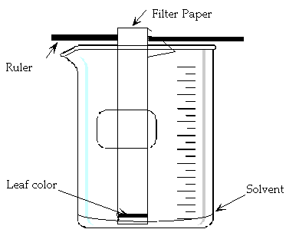Similarly, plants with primarily red (carotenoid) pigments **absorb** **green** and **blue** light rays, making their leaves appear yellow, red, or orange, meaning they reflect the latter colors. Violet-blue light in the 400 – 520 nanometer range encourages chlorophyll absorption, photosynthesis, and growth. Red light in the 610 – 720 spectrum range promotes flowering and budding.

**Materials**

Green and red leaves 1 filter paper

Ruler Rubbing alcohol

2 – 500 mL beakers Graduated cylinder

Plastic wrap Pencil

<http://somup.com/c3eZFyTN15> Pigments Used in Photosynthesis (2:04)

**Procedures**

1. Collect red and green leaves from outside. Spinach and red cabbage can work.

2. Obtain 2 beakers and tear the leaves into little pieces, red leaves in one beaker, green leaves in the other beaker.

3. Pour just enough rubbing alcohol to cover the torn leaves.

4. Cover with plastic wrap and let sit for 24 hours.

5. Obtain a piece of filter paper and a ruler. Attach the paper to the ruler so it sticks down into the beaker. (*See the image above*) [*Coffee filters should work for filter paper*.]

6. Place the ruler on the top of the beaker so it is spanning the opening.

7. Carefully cover the beaker with plastic wrap. ***Try not to slosh the solvent around***.

8. **Repeat for the other beaker.**

9. Observe the solvent moving and the pigment separation (*this takes about 40-60 minutes*).

10. Record your results by taking a picture of your filter paper with pigments present from the leaves and insert it below. Label everything!

The diagram below shows the electromagnetic spectrum (energy waves). Use the visible light spectrum to help you answer question 4.

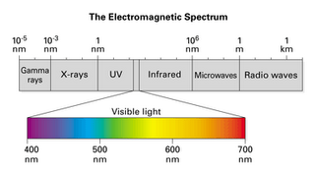

4. What color of light does chlorophyll (appears green) and carotenoid (appears red or yellow) pigments absorb?

5. What color of light will optimize photosynthesis activity?

6. Explain what will happen to a plant if it is only exposed to green light.

7. What difference did you see between the green leaf pigments and the red leaf pigments?

8. Can red leaves (like the one from the Crimson King Maple) do photosynthesis?

9. Why might those trees grow slower than trees with green leaves?

**Errors**

* Not crushing the leaves enough to produce the pigments in solution.
* Not waiting long enough for the chromatography to fully work.
* The filter paper may not be absorbent enough.

**Bibliography**

Photosynthesis. Class Notes. Biology Course Site, Week 8. Learning CTR Online, n.d. Web. 11 Nov. 2022. <[www.learningctronline.com](http://www.learningctronline.com)/biology-course-site-s1>.

Pigments Used in Photosynthesis Lab. *Lab Worksheet*. Biology Course Site, Week 8. Learning CTR Online, n.d. Web. 4 Nov. 2022. <[www.learningctronline.com](http://www.learningctronline.com)/biology-course-site-s1>.

Pigments Used in Photosynthesis Lab Video. *Week 8* *Overview*. Biology Course Site, Week 8. Learning CTR Online, n.d. Web. 11 Nov. 2022. <<http://somup.com/c3eZFyTN15>>.