**Stressing Equilibrium & Spontaneity Chapter 18B**

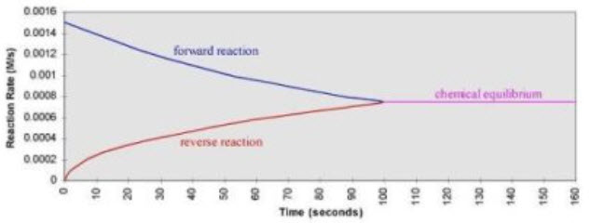

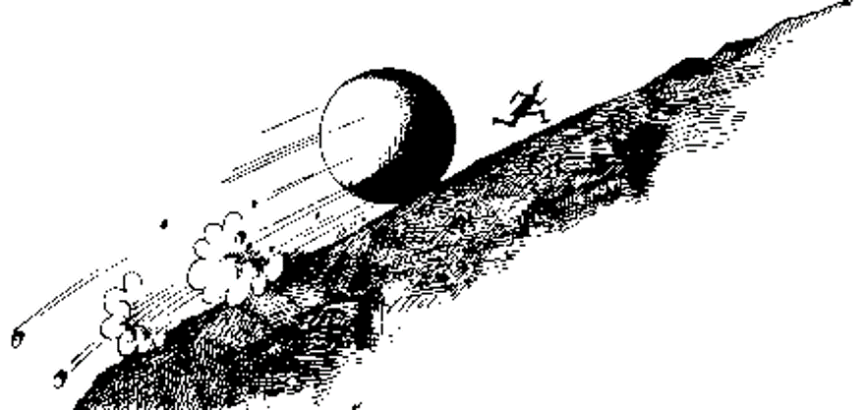

**See** [**https://www.learningctronline.com/courses**](https://www.learningctronline.com/courses) **for Materials and Resources.**

**Topics:**

1. Stressing Equilibrium & Spontaneity

**Objectives:**

1. Use Le Chatelier’s principle to predict shifts in equilibrium caused by changes in pressure, concentration, and temperature.
2. Write expressions for the solubility product constant (Ksp) and solve problems involving Ksp and ion concentrations.
3. Use Ksp to predict the solubility of compounds.
4. Compare spontaneous and nonspontaneous reactions.
5. Describe and give examples of entropy and describe how enthalpy and entropy affect a reaction's spontaneity.
6. Define free energy and use Gibbs free energy equation to determine whether a reaction is spontaneous.
7. Explain the concept of reaction rate.
8. Describe collision theory and explain how various factors, including concentration, temperature, and pressure affect the rate of a chemical reaction.
9. Interpret reaction pathways (PE diagrams) to identify exothermic versus endothermic reactions and to define and explain the role of the activation energy in a chemical reaction.
10. Explain what a reaction mechanism is and understand the concept of rate determining step for a reaction.
11. Write equilibrium expressions, distinguishing molar concentrations of reactants and products for reactions.

TAKE NOTE (All assignments due by next week’s class)

1. Notes / Study Guide
2. Lesson Check/Sample Problems in Text or Alternative Worksheets
3. Lab: LeChatelier’s Principle: Stressing Equilibrium
4. **HONORS Optional Assignment #1** (Stressing Equilibrium Simulation)
5. Chapter 18 Test
6. Class Song: You’re Welcome! Just Say Thank You!
7. Week 28 Devotional (<https://www.learningctronline.com/devotional>)

**Text**: Chapter 18: Stressing Equilibrium & Spontaneity pp. 621-623; 627-643

Read the assigned pages in the text.

**Class Notes: PowerPoint or PDF**

**Notes/Study Guide:** Fill in the Chapter 18 worksheet to understand the class notes.

**Homework**: TEXT

(1) Answer the KEYED **"Lesson Check"** questions at the end of each of the chapter.

(2) Answer the **"Sample problems"** found in the "Sample Problem" boxes throughout the chapter. An answer KEY is provided for you to use to self-correct your homework problems.

* Put your answers into complete thoughts in a Word document. Do NOT just put the answer, but write a phrase or sentence that you can study from for your tests. Save your work in a WORD document and SAVE into your HOMEWORK folder in the Chemistry folder on the desktop.
* Assignments will be “spot checked” during class or submitted via email.

**Alternate Homework**:

1. Chapter 18 Review Exam (Reaction Rate & Equilibrium)
2. Honors 🡪 Optional Assignment #1 (Stressing Equilibrium Simulation)

**Lab**: LeChatelier’s Principle: Stressing Equilibrium

1. Perform the “LeChatelier’s Principle: Stressing Equilibrium” lab using the worksheet provided.

[LeChatelier's Principle: Stressing Equilibrium Simulations Part 1](http://somup.com/cbeo3rRvD) (7:33)  
  
[LeChatelier's Principle: Stressing Equilibrium Simulations Part 2](https://www.youtube.com/watch?v=Kiidcw39Y0U) (5:06)

1. Answers are provided at the end of the document for guidance, but do NOT copy and paste. Use your own words.

* Answers are provided at the end of the document for guidance. Do NOT copy and paste these answers, but write using your own words.
* Save the document into your LAB folder in the Chemistry folder on your desktop.

Revise Heating Curve of Water (Formal Lab Report)

**Use the Heating Curve of Water Sample Lab Report and the teacher comments.**

[How to do Lab Report Revisions (Density Lab)](http://somup.com/cqXOD6fZeE) (9:00) ... video tutorial.  
  
Revise your Heating Curve of Water lab report and resubmit it.

1. Leave your original lab content and place the corrections BELOW your original content IN EACH SECTION to show the revision. (e.g. If you made errors in the Calculations and Data section, leave those errors, but add the corrections below your content IN THE Calculations and Data section by using a **blue font color**.)
2. Refer to the sample Heating Curve of Water lab report, but Do NOT copy and paste the model Heating Curve of Water lab information. Retype in your own words and fill in tables for yourself.
3. Make all the major corrections needed, not just a partial revision (You are being offered an opportunity to learn from your mistakes and receive bonus points for doing so. Please use integrity and respect by doing your own work and using the Model only as a guide).
4. If you follow the designated format, you can earn 1/2 of the points deducted from your grade.
5. When completed, go to "Assignments" and change the "Upcoming" tab to "Graded" and find the Heating Curve of Water Lab Report.
6. The revised Heating Curve of Water Lab Report is due before week 30's class.

**TEST:** Reaction Rate, Equilibrium, Spontaneity

1) the academic integrity policy

* Tests must be completed **WITHOUT** referring to books, notes, the internet, people, or any outside resources.
* Students **MAY** use the approved Periodic Tables, approved Reference Tables, or approved equation (formula) sheet (provided by the teacher) along with calculators and scratch paper.
* A guardian should be proctoring the test. Proctoring means to monitor the following:

2) The test is composed of 20 multiple choice questions and some written problems.

* The **multiple-choice test must be taken "in one sitting"**, meaning that once you start the test, you must complete it without interruption. (40 minutes)
* Take a short break (5-10 minutes)
* The **written portion of the test must be taken "in one sitting"**, meaning that once you start the test, you must complete it without interruption. (40 minutes)

3) There is a **80-minute time limit** on this test. Please have the proctor write the time taken at the top of your answer sheet with their signature or initials.

4) Proctors should NOT be reading the test or engaging students during the test.

5) Do NOT use RED font. Black font is best.

Supplemental Resources (Optional)

1. Stressing Equilibrium Simulation (PPT / Worksheet) [Stressing Equilibrium Simulations](https://screencast-o-matic.com/watch/cYhhY0gVYp) (8:52)
2. Tutorial Equilibrium & LeChatelier’s Principle
3. Gibb’s Free Energy Practice Problems
4. Chapter 18 Study Guide Pearson

<http://somup.com/c3fVb5OfCE> (8:14) ... Gibb’s Free Energy Tutorial (Class notes) general overview and 4 practice problems  
  
[Endothermic yet spontaneous](https://screencast-o-matic.com/watch/cYeXldx3A7) (0:47)  
  
[Being Weak Makes Us Strong 2 Corinthians 12:9-10; The Warrior is a Child](http://somup.com/cYhqoMjzX0) (5:24)