Page 324 in Pearson Chemistry Text:

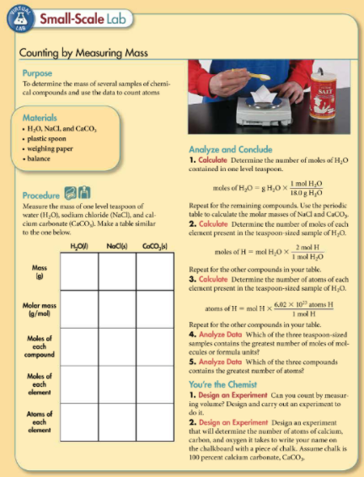

or NaHCO3

Fill in the data table provided on the next page.

or NaHCO3.

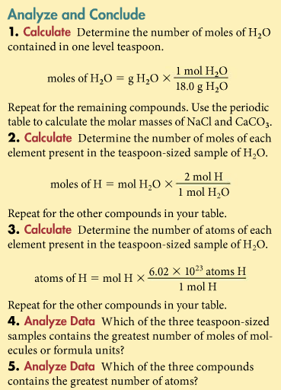

Fill in the data table:

|  |  |  |  |
| --- | --- | --- | --- |
|  | H2O (l) | NaCl (s) | NaHCO3 (s) |
| Atoms of each element in formula |  |  |  |
| Mass (g) |  |  |  |
| Molar Mass (g/mol) |  |  |  |
| Moles of compound |  |  |  |
| Moles of each element | H  O | Na  Cl | Na  H  C  O |
| Atoms of each element | H  O | Na  Cl | Na  H  C  O |

Answers for Data Table when using Baking Soda:

|  |  |  |  |
| --- | --- | --- | --- |
|  | H2O (l) | NaCl (s) | NaHCO3 (s) |
| Atoms of each element in formula | 2 H and 1 O | 1 Na and 1 Cl | 1 Na, 1 H, 1 C, 3 O |
| Mass (g) | 4.30 g | 5.09 g | 9.68 g |
| Molar Mass (g/mol) | H 2 x 1.0 g/mol  O 1 x 16.0 g/mol  **18.0 g/mol** | Na 1 x 23.0 g/mol  Cl 1 x 35.5 g/mol  **58.5 g/mol** | Na 1 x 23.0 g/mol  H 1 x 1.0 g/mol  C 1 x 12.0 g/mol  O 3 x 16.0 g/mol  **84.0 g/mol** |
| Moles of compound | 4.30 g / 18.0 g/mol  **0.239 mol** | 5.09 g / 58.5 g/mol  **0.0870 mol** | 9.68 g / 84.0 g/mol  **0.115 mol** |
| Moles of each element | H 0.239 mol x 2  **0.478 mol**  O 0.239 mol x 1  **0.239 mol** | Na 0.0870 mol x 1  **0.0870 mol**  Cl 0.0870 mol x 1  **0.0870 mol** | Na 0.115 mol x 1  **0.115 mol**  H 0.115 mol x 1  **0.115 mol**  C 0.115 mol x 1  **0.115 mol**  O 0.115 mol x 3  **0.346 mol** |
| Atoms of each element | H 0.478 mol x NA  **2.88 x 1023**  O 0.239 mol x NA  **1.44 x 1023** | Na 0.0870 mol x NA  **5.24 x 1022**  Cl 0.0870 mol x NA  **5.24 x 1022** | Na 0.115 mol x NA  **6.92 x 1022**  H 0.115 mol x NA  **6.92 x 1022**  C 0.115 mol x NA  **6.92 x 1022**  O 0.346 mol x NA  **2.08 x 1023** |

4. Water contains the greatest number of moles of the three compounds.

5. Water contains the greatest number of atoms of the three compounds.

When using Calcium Carbonate:

|  |  |  |  |
| --- | --- | --- | --- |
|  | H2O (l) | NaCl (s) | CaCO3 |
| Atoms of each element in formula | 2 H and 1 O | 1 Na and 1 Cl | 1 Ca, 1 C, 3 O |
| Mass (g) | 4.30 g | 5.09 g | 9.68 g |
| Molar Mass (g/mol) | H 2 x 1.0 g/mol  O 1 x 16.0 g/mol  **18.0 g/mol** | Na 1 x 23.0 g/mol  Cl 1 x 35.5 g/mol  **58.5 g/mol** | Ca 1 x 40.1 g/mol  C 1 x 12.0 g/mol  O 3 x 16.0 g/mol  **100.1 g/mol** |
| Moles of compound | 4.30 g / 18.0 g/mol  **0.239 mol** | 5.09 g / 58.5 g/mol  **0.0870 mol** | 9.68 g / 100.1 g/mol  **0.0967 mol** |
| Moles of each element | H 0.239 mol x 2  **0.478 mol**  O 0.239 mol x 1  **0.239 mol** | Na 0.0870 mol x 1  **0.0870 mol**  Cl 0.0870 mol x 1  **0.0870 mol** | Ca 0.0967 mol x 1  **0.0967 mol**  C 0.0967 mol x 1  **0.0967 mol**  O 0.0967 mol x 3  **0.2907 mol** |
| Atoms of each element | H 0.478 mol x NA  **2.88 x 1023**  O 0.239 mol x NA  **1.44 x 1023** | Na 0.0870 mol x NA  **5.24 x 1022**  Cl 0.0870 mol x NA  **5.24 x 1022** | Ca 0.0967 mol x NA  **5.82 x 1022**  C 0.0967 mol x NA  **5.82 x 1022**  O 0.290 mol x NA  **1.75 x 1023** |