1. The difference between the potential energy of the products and that of the reactants of a chemical reaction is the

a) entropy of reaction c) rate of reaction

b) heat of reaction d) heat of activation

2. For a given system at equilibrium, lowering the temperature will always

a) increase the rate of reaction c) favor the exothermic reaction

b) increase the concentration of products d) favor the endothermic reaction

3. At constant temperature in the reaction: N2 (g) + O2 (g)  2 NO (g)

an increase in pressure at equilibrium will

a) increase the rate of decomposition of the NO, only

b) not affect the relative amounts of the products and reactants

c) result in the formation of more NO, only

d) result in the formation of more O2, only

4. A chemical reaction is most likely to occur spontaneously if the

a) free energy change (∆G) is negative c) activation energy (Eactiv) is positive

b) entropy change (∆S) is negative d) heat of reaction (∆H) is positive

5. Which phrase best describes the reaction: C (s) + ½ O2 (g)  CO (g) + 26.4 kcal

a) exothermic with an increase in entropy c) endothermic with an increase in entropy

b) exothermic with an decrease in entropy d) endothermic with an decrease in entropy

6. As 1 gram of H2O (g) changes to 1 gram of H2O (l), the entropy of the system

a) decreases b) increases c) remains the same

7. Given the system: CO2 (s) → CO2 (g) the entropy of the forward reaction

a) decreases b) increases c) remains the same

8. A description of the experimentally verified steps in a reaction is an example of

a) the net reaction b) the activated complex c) Hess’ law d) the reaction mechanism

9. A catalyst can increase the rate of a chemical reaction by:

1. increasing the energy of the products c) decreasing the required activation energy

b) decreasing the energy of the products d) inhibiting the rate-determining step

10. A magazine ripped into individual pages will burn faster than a rolled magazine because of

a) the presence of a catalyst c) increased surface area

b) the presence of ions d) a higher temperature

11. Which expression represents the solubility product constant, Ksp, of AgCl (s)

a. Ksp = [Ag+][Cl-] b. Ksp = [Ag+] + [Cl-] c. Ksp = [Ag+] / [Cl-] d. Ksp = [Cl-] / [Ag+]

12. At a constant temperature, a system tends to undergo a reaction so that its final state, compared to its initial state, has:

a) higher energy and higher entropy c) lower energy and lower entropy

b) higher energy and lower entropy d) lower energy and higher entropy

13. Given the expression: ΔG = ΔH - TΔS. A chemical reaction would most likely occur spontaneously if:

a) ΔH was positive and ΔS was positive c) ΔH was positive and ΔS was negative

b) ΔH was negative and ΔS was positive d) ΔH was negative and ΔS was negative

14. The activation energy for the forward reaction of: A + B 🡪 C + 35 kcal is 25 kcal. The activation energy for the same reaction reversed is:

a) 10 kcal b) 60 kcal c) 25 kcal d) -25 kcal

15. Which statement best explains why an increase in temperature usually increases the rate of a chemical reaction?

1. the activation energy of the reaction is decreased

b) the ΔH of the reaction is increased

c) the free energy of the reaction is decreased

d) the effectiveness of collisions between particles is increased

16. In the equilibrium system: 2 SO2 (g) + O2 (g)  2 SO3 (g) + heat

the concentration of SO3 (g) may be increased by

a) increasing with pressure c) increasing the temperature

b) decreasing the concentration of SO2 (g) d) decreasing the concentration of O2 (g)

17. In the equilibrium reaction: A (g) + 2 B (g) + heat  AB2 (g)

the rate of the forward reaction will increase if there is

a) an increase in pressure or temperature c) a decrease in temperature

b) increasing the volume of the reaction vessel d) a decrease in the concentration of A (g)

18. Given the reaction at equilibrium: N2 (s) + 3 H2 (g) → 2 NH3 (g) . If the volume of the reaction vessel is decreased at constant temperature, there will be an increase in the number of moles of

a) N2 only b) H2 only c) NH3 only d) N2 , H2 , and NH3

19. The equilibrium constant for a given system changes when

a) the temperature of the system is changed

b) the pressure of the system is changed

c) the concentration of one or more of the reactants is changed

d) a catalyst is added

20. The Ksp of barium sulfate is 8.7 x 10-11 at 18˚ C and 1.1 x 10-10 at 25˚ C. This indicates that as the temperature increases from 18˚ C to 25˚ C, the solubility of barium sulfate

a. decreases b. increases c. remains the same

21. When a catalyst is added to a system at equilibrium, the rate of the forward reaction

a) decreases and the rate of the reverse reaction decreases

b) decreases and the rate of the reverse reaction increases

c) increases and the rate of the reverse reaction decreases

d) increases and the rate of the reverse reaction increases

22. In a chemical reaction, the use of a catalyst results in a decrease in the

a) activation energy c) heat of reaction

b) potential energy of the reactants d) amount of products

23. A chemical reaction has reached equilibrium when

a) the reverse reaction begins

b) the forward reaction ceases

c) the concentrations of the reactants and products become equal

d) the concentrations of the reactants and products become constant

24. Which is true in all chemical reactions in which equilibrium has been reached?

a) the forward reaction stops

b) the reverse reaction stops

c) the concentrations of the reactants and products are equal

d) the rates of the forward and reverse reactions are equal

25. Based on the equilibrium expression, which represents the reactants of the forward reaction?

K = [A] [B]

[C] [D]

a) A and B b) B and D c) C and D d) A and C

26. In the general equation: A + 2 B 2 C , which equilibrium constant most favors the production of A + 2B?

a. 9.1 x 10-10 b. 4.3 x 10-7 c. 4.7 x 10-12 d. 3.5 x 10-3

27. For the equilibrium system: 2 NO (g) + O2 (s)  2 NO2 (g) + 27 kcal, as the temperature of the system is increased, the amount of O2 (s)

a. increases b. decreases c. remains the same

28. Which set of thermodynamic characteristics is associated with a spontaneous reaction at all temperatures?

a) ∆H positive, ∆S negative c) ∆H negative, ∆S negative

b) ∆H positive, ∆S positive d) ∆H negative, ∆S positive

29. Which compound would produce the largest concentration of CO3-2 ions in a saturated aqueous solution at 25 C?

a) BaCO3 (Ksp = 8.1 x 10-9) c) PbCO3 (Ksp = 3.3 x 10-14)

b) MgCO3 (Ksp = 2.6 x 10-5) d) SrCO3 (Ksp = 1.6 x 10-9)

***Question 30 is based upon the potential energy diagram below****:*

Potential Energy

Reaction Coordinate

A + B

C

30. Which phase describes the reverse reaction: C → A + B

a) ∆H is positive, endothermic c) ∆H is positive, exothermic

b) ∆H is negative, endothermic d) ∆H is negative, exothermic

***Questions 31 – 33 are based upon the potential energy diagram and equation below****:*

Potential Energy

Reaction Coordinate

A + B

AB

A + B  AB

∆H = + 15 kcal

31. The enthalpy change in kilocalories per mole for the reverse reaction is

a) + 15 b) - 15 c) + 30 d) - 30

32. The activation energy in kilocalories per mole for the forward reaction is closest to

a) 5 b) 15 c) 20 d) 30

33. The forward reaction is

a) exothermic b) endothermic c) isothermic d) geothermic

34. Given the reaction at equilibrium:

2 SO2 (g) + O2 (g)  2 SO3 (g) + 47 kcal

The amount of SO3 (g) will increase if there is

a) an increase in temperature c) an increase in concentration of SO2 (g)

b) a decrease in pressure d) a decrease in concentration of O2 (g)

35. What is the equilibrium expression (Keq) for the following reaction?

H2 (g) + I2 (g) 2 HI (g)

a. 2 [HI] c. [H2][ I2]

[H2][ I2] [HI]2

b. [H2] [ I2] d. [HI]2

2 [HI] [H2][ I2]

36. For the general equilibrium system: A + B C, which equilibrium constant results in the highest concentration of C?

a) 3 x 10-6  b) 3 x 10-3 c) 7 x 10-10 d) 7 x 10-6

37. Given the dissociation equation of a saturated solution of a slightly soluble salt:

AB (s)  A+ (aq) + B- (aq)

Which expression is equal to its solubility product constant, Ksp?

a) [A+] [ B-] b) [A+] / [ B+] c) [A+] / [ B-] d) [A] / [B]

***Questions 38 – 42 are based upon the potential energy diagram and equation below****:*

N2 (g) + 3 H2 (g) = 2 NH3 (g) + 22.0 kcal

**2**

**1**

**4**

**3**

Potential Energy

Reaction Coordinate

**5**

38. Which number in the diagram represents the energy of activation for the forward reaction?

a) 1 b) 2 c) 3 d) 4

39. Which number in the diagram represents the heat of reaction (∆H)?

a) 1 b) 2 c) 3 d) 5

40. The energy liberated when 1 mole of NH3 (g) is produced is approximately

a) 5.5 kcal b) 11 kcal c) 22 kcal d) 44 kcal

41. If a catalyst were introduced into the reaction, it would

a) lower the forward activation energy c) raise the potential energy of the reactants

b) lower the heat of reaction d) have no effect on the system

42. Which number in the diagram represents the potential energy of the product?

a) 1 b) 2 c) 4 d) 5

43. Some compounds and their solubility product constants are shown below. Which compound is least soluble?

a) AB, Ksp = 8 x 10-5 c) XY, Ksp = 6 x 10-7

b) AC, Ksp = 7 x 10-6 d) XZ, Ksp = 5 x 10-8

44. For a given substance, as average kinetic energy increases, average molecular velocity

a) increases b) decreases c) remains the same

45. Systems which contain components in more than one phase are described as:

a) exothermic b) endothermic c) heterogeneous b) homogeneous

46. Which equation would have the equilibrium expression for:

[C]2

[A][B]2

a. A + 2 B 2 C c. 2 C A + 2 B

b. A + B2 C2 d. 2 A + B 2 C

47. A decrease in the rate of reaction in a gaseous system could be caused by an increase in

a) temperature b) concentrations c) pressure d) volume

#### Questions 48 – 50

For each statement in questions 23-25, write the number of the potential energy diagram, chosen from those given below, that is described by the statement.

Potential Energy

Reaction Coordinate

(4)

Potential Energy

Reaction Coordinate

(3)

Potential Energy

Reaction Coordinate

(2)

Potential Energy

Reaction Coordinate

(1)

48. The potential energy of the products is less than the potential energy of the reactants

49. There is insufficient activation energy for the reaction to occur.

50. The activation energy is greater for the forward reaction than for the reverse reaction.

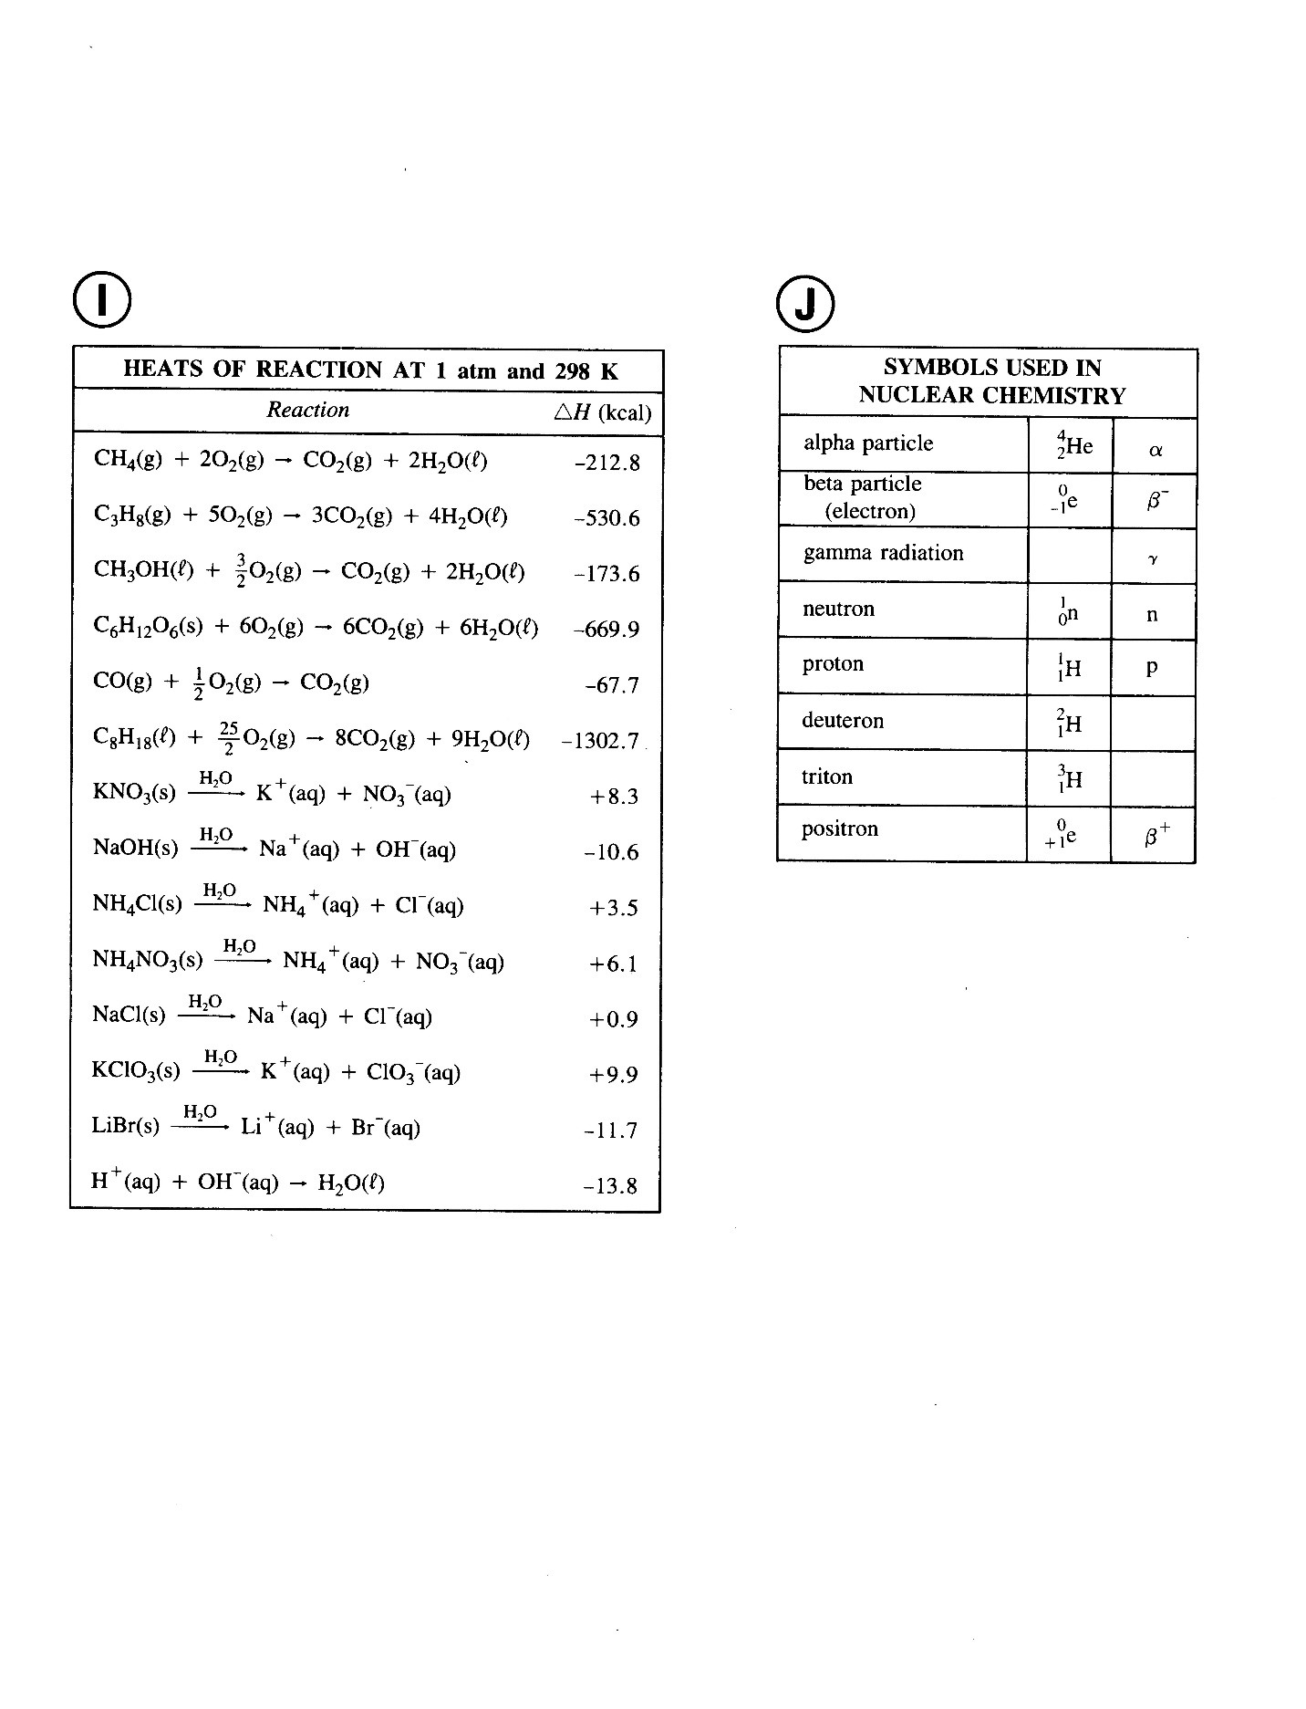 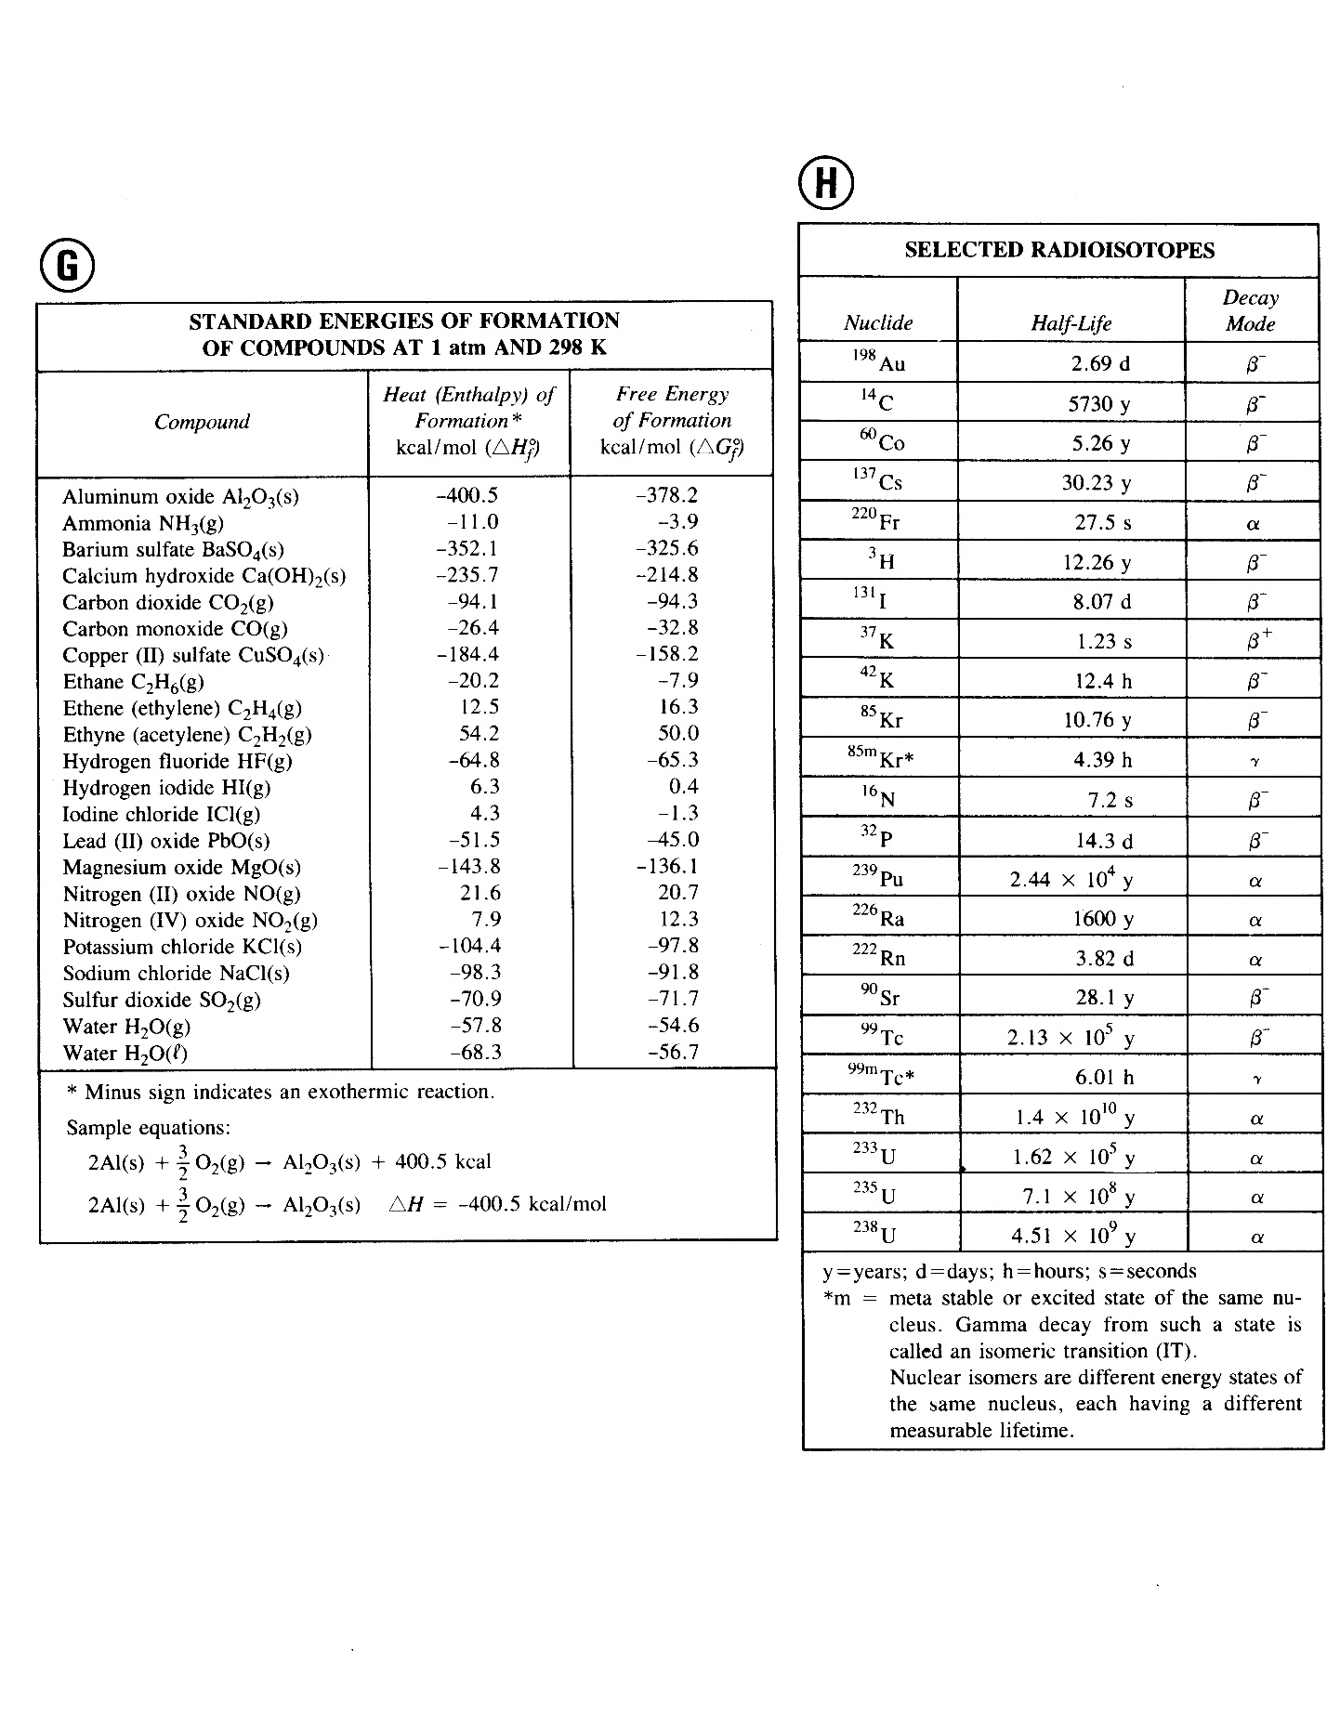

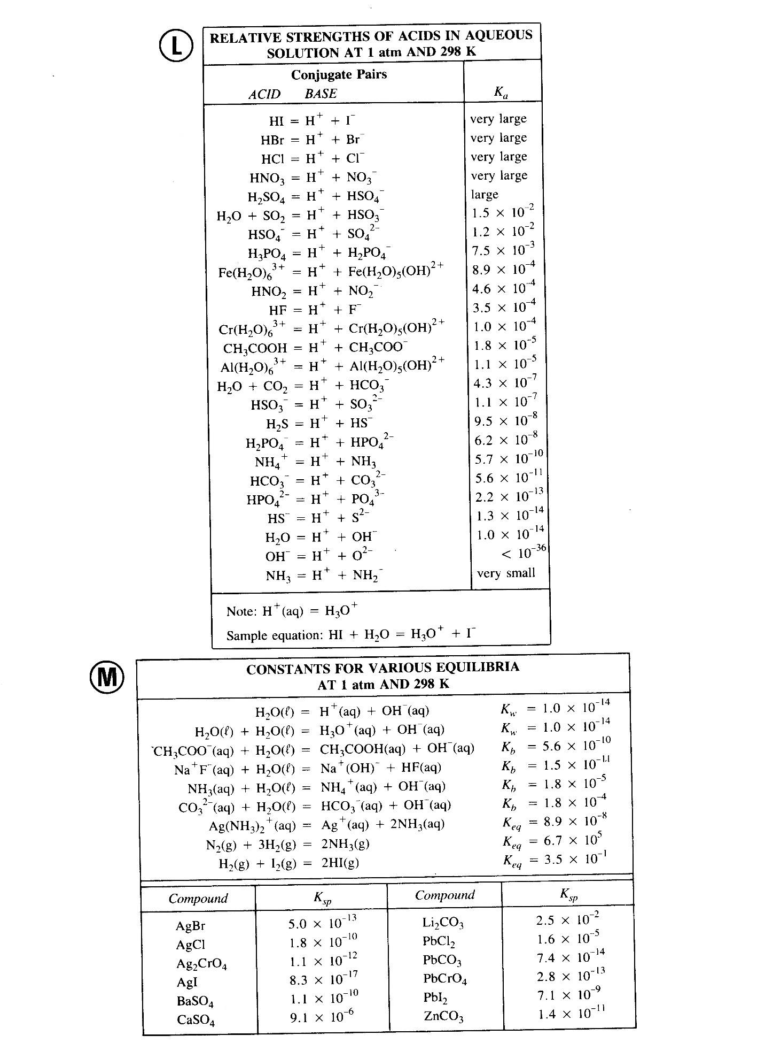

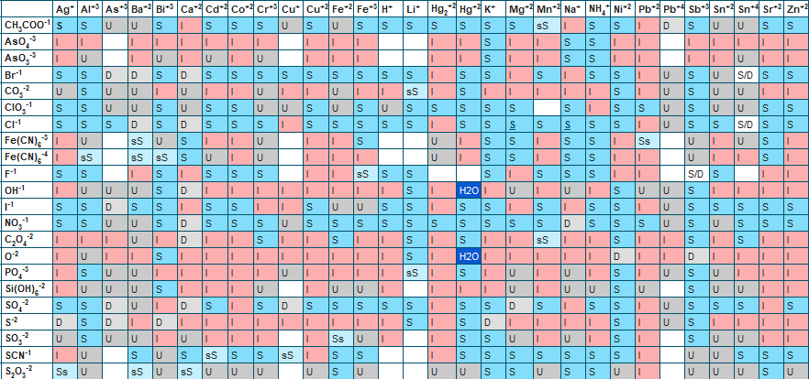

*Questions 51-56 are based on the following Information*:

For the reaction:

CO2 (g) + H2 (g) 🡪 CO (g) + H2O (g)

What happens to the reaction rate resulting from each of the changes described in the table below? Choose one of the following to fill in the blanks of the table (column “Effect on Rate”). Then, give a reason for each answer in terms of frequency & Effectiveness of collisions.

I 🡪 Increases D 🡪 Decreases R 🡪 Remains the same

|  |  |  |
| --- | --- | --- |
| **Change in Conditions** | **Effect on Reaction Rate** | **Reason** |
| 51. Removal of some CO2 molecules |  |  |
| 52. Addition of H2 molecules |  |  |
| 53. Decrease of Pressure by increasing volume |  |  |
| 54. Addition of a catalyst |  |  |
| 55. Increase in Temperature |  |  |
| 56. Addition of a substance that reacts more readily with H2 than does CO2 |  |  |

ANSWER KEY

Form A

1. B Definition of heat of reaction: ∆H = ∆Hproducts – ∆Hreactants

2. C Heat is a product; temp is lowered, shifting Equilibrium to the products

3. B equal mol of gas for reactants and product; no stress on system

4. A Gibb’s Equation … free energy indicates spontaneity when negative

5. A Energy is a product, which is a gas (more disordered … entropy measures disorder)

6. A product is a liquid from a gas reactant … more ordered… entropy measures disorder

7. B solid to gas increases disorder … entropy measures disorder

8. D The key word is “steps”

9. C

10. C

11. A Ksp (product of concentration of products) and has moles as superscripts

12. D lower energy is more stable; entropy will increase spontaneously

13. B ΔG must be NEGATIVE for a spontaneous reaction. If ΔH is negative and ΔS is

positive, mathematically the equation ΔH - TΔS will be negative.

14. B The reverse rxn would include heat of reaction (35 kcal) and the original EA (25 kcal)

15. D increased temperature means molecules move faster, more collisions.

16. A 3 moles of reactants to 2 moles of products

17. A 3 moles of reactants to 1 mol of products; endothermic reaction want more heat

18. C more [ ] of reactants than products, driving forward reaction to product

19. A all reactions are either exo or endothermic (temp). Pressure only affects gases. [ ] only

affects reactions which do not go to completion

20. B the Ksp at 25 C is larger than the Ksp at 18 C, meaning more solubility

21. D Catalysts make any reaction that it is intended for faster … do not affect equilibrium

22. A

23. D

24. D Equilibrium is about RATE of forward vs. reverse rxn… [ ] becomes constant

25. C Keq = [Products] / [Reactants]

26. C lower Keq favors the reverse reaction (towards reactants)

27. A Adding temperature increases (heat) … favors reverse rxn … more reactants

28. D ΔG must be NEGATIVE for a spontaneous reaction. If ΔH is negative and ΔS is

positive, mathematically the equation ΔH - TΔS will be negative.

29. B highest Ksp means more ions

30. D C 🡪 A + B … downhill (exothermic); heat is released

31. B enthalpy change = ∆H; reverse reaction reverses the sign

32. D Activation Energy begins at PE of reactants to peak of curve

Forward rxn

reverse rxn

33. B uphill, energy must be added

34. C more reactant favors the forward reaction (toward products)

35. D Keq = concentration of products/reactants; moles indicated as superscripts

36. B Higher Keq favors products

37. A Ksp = [A+][B-] only considering the product ions

38. A From reactants to peak

39. C Heat of Products – Heat of Reactants

40. B exothermic heat flow of 2 moles of products … 22 kcal/2

41. A

42. D

43. D Smallest Ksp indicates LEAST soluble

44. A KE relates to motion (velocity describes motion)

45. C “hetero” means different

46. A standard Keq equation … [products]/[reactants] … mole coefficients are superscripts

47. D increased volume would put particles farther away from each other and therefore, the

reaction would probably proceed slower

48. B downhill, exothermic

49. D the peak never becomes an activated complex en route to product

50. A EA forward goes from reactant to peak; reverse goes from original “product” to peak.



Yippee! You’re done!

Enthusiastic Excellent Chem Teacher



I love my teacher!

##### Quacked Up Chem Student

*Questions 51-56 are based on the following Information*:

For the reaction:

CO2 (g) + H2 (g) 🡪 CO (g) + H2O (g)

What happens to the reaction rate resulting from each of the changes described in the table below? Choose one of the following to fill in the blanks of the table (column “Effect on Rate”). Then, give a reason for each answer in terms of frequency & Effectiveness of collisions.

I 🡪 Increases D 🡪 Decreases R 🡪 Remains the same

|  |  |  |
| --- | --- | --- |
| **Change in Conditions** | **Effect on Reaction Rate** | **Reason** |
| 51. Removal of some CO2 molecules | D | Fewer collisions … less reactant available |
| 52. Addition of H2 molecules | I | More collisions … more reactant available |
| 53. Decrease of Pressure by increasing volume | D | Fewer collisions because molecules are spread farther apart from each other |
| 54. Addition of a catalyst | I | More effective collisions (lowers the Eactiv requirement) |
| 55. Increase in Temperature | I | More frequent and more effective collisions because molecules move faster on average |
| 56. Addition of a substance that reacts more readily with H2 than does CO2 | D | Fewer collisions; H2 molecules become less available |