O_____ - R_____

* _____ (oxidation-reduction) reactions result from the competition for _____ between atoms. This is indicated by a change in _____ numbers of atoms. Which of the following (or both) is a Redox reaction?

H+Cl- + Na+O-2H+1 🡪 Na+Cl- + H+1O-2H+1

* + *This is* _____ *a REDOX reaction … ___ change in oxidation numbers.*

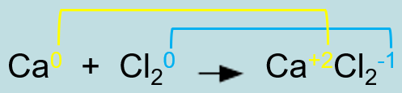

* + _____ reaction 🡪 notice the _____ in oxidation numbers for both Ca (___ to ___) and Cl (___ to ___).

R_____

* An abbreviation that combines the concepts of “Reduction” and “Oxidation.”

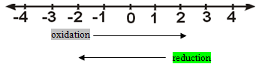

* Oxidation and reduction occur _____ and cannot occur one without the other [*laws of conservation of mass and charge*].

Review of Oxidation Numbers

* + An oxidation number is the _____ an atom or ion possesses to indicate its degree of oxidation or reduction.
  + As a general rule, a bonded atom’s oxidation number is the charge that it would have if the _____ in the bond were assigned to the atom of the more _____ element.

Summary of Rules for determining Oxidation State of Atoms

1. The oxidation number for an atom in its elemental (unbonded) form is always _____ (*includes “Professor* _____*” elements*). Na__, Fe__, S__ (*give oxidation states*)

2. The oxidation number of a _____ ion = charge of the monatomic ion. Na__, Fe__, S__

3. Oxygen’s oxidation number is ___ (except in “peroxides”)

  i.e. H+1O-2H+1 i.e. H2+1O2-1

4. Hydrogen’s oxidation number is ___ (except in “hydrides”)

i.e. H+1O-2H+1 i.e. Na+1H-1

5. Group ___ (1) metals [*alkali metals*] always have an oxidation state of ___ in a compound.

6. Group ___ (2) metals [*alkaline earth metals*] always have an oxidation number of ___ in a compound

7. _____ [VIIA (17)] always has an oxidation number of ___ in a compound.

8. The algebraic sum of oxidation states in a compound = ___.

9. The algebraic sum of the _____ states in a _____ ion equals the _____ on the ion (see Reference Table 1, Chart F or Polyatomic Ion Chart).

R_____

* Any chemical change in which there is a _____ in _____ number of an atom (*formerly defined by the loss of oxygen*).
* There is a _____ of _____ from an atom in the reaction.

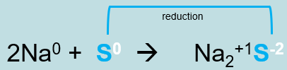

* The oxidation number of S _____ from ___ to ___.
* The element S _____ two electrons.
* S is “_____” in the redox reaction.
* The particle or atom that _____ in oxidation number is said to be _____. The more _____ atom is reduced.
* The particle or atom that is reduced acts as an _____ agent in a Redox reaction.
* S is _____ in the redox reaction.
* S is the _____ agent in the redox reaction, meaning that Na0 will be _____.

O_____

* Any chemical change in which there is an _____ in _____ number of an atom (*formerly defined by the gain of oxygen*).
* There is a _____ of _____ from an atom in the reaction.

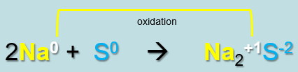

The element Na _____ two electrons total.

* The oxidation number of Na increases from ___ to ___.
* Na is _____ in the redox reaction.
* The particle or atom that _____ in oxidation number is said to be _____.
* The particle or atom that is oxidized acts as a _____ agent in a Redox reaction.
* Na is _____ in the redox reaction.
* Na is the _____ agent in the redox reaction, meaning that S0 will be _____.

Oxidation - Reduction

**REDOX**

* Redox reactions result from the _____ for _____ between atoms to produce the most stable configuration.
* For covalent compounds the more _____ atom _____.
* This is indicated by a _____ in the expected _____ numbers of atoms as they progress from reactants to products.
* An oxidation-reduction reaction occurs when _____ are transferred from one substance to another: _____.
* The substance that is _____ is called the _____ agent (_____ electrons to other substance).
* The substance that is _____ is called the _____ agent (_____ electrons from other substance).

Oxidizing and Reducing Agents

* In the formation of NaCl, a sodium atom _____ an electron (becoming a _____) to a chlorine atom (becoming an _____).
* Sodium gets _____ and acts as the _____ agent and _____ its single valence electron to the chlorine ion.
* Chlorine is _____ as the _____ agent, and _____ an electron to allow both ions to lose their charges.

Describe Oxidation-Reduction Reactions

* Determine which species is oxidized and which is reduced. Which is the oxidizing agent and which is the reducing agent? Explain.

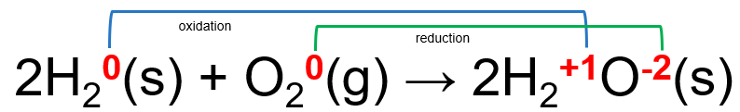

* Oxygen atoms are _____ because they _____ electrons. Oxygen is the _____ agent because it accepts electrons _____ hydrogen.
* Hydrogen atoms are _____ because they _____ electrons. Hydrogen is the _____ agent because it transfers electrons _____ oxygen.

H_____ Reactions

* REDOX reactions are considered in ___ parts.
* Each reaction of the 2 parts is called a ½ reaction (_____ rxn)

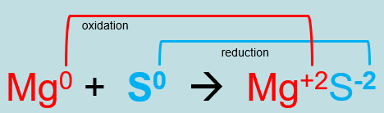

* _____ half reaction Mg0 🡪 Mg+2 + _____
* _____ half reaction S0 + _____ 🡪 S-2
* REDOX reactions are driven by _____.
* The _____ number must be _____ for both _____ reactions.
  + If one half reaction loses e- (_____), the other must _____ e-.
  + If one half reaction gains e- (_____), the other must _____ e-.
* In this redox reaction, _____ are lost & gained overall.

Examples of Oxidation-Reduction Reaction. Oxidation-reduction reactions include:

* C_____
* P_____
* Many reactions of metals (tarnish)
* Many biochemical reactions, including metabolic reactions.

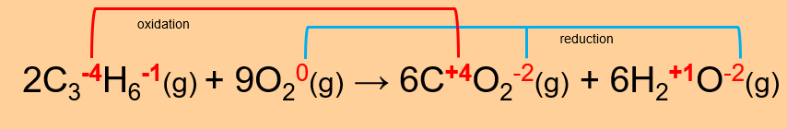

* Metal trash cans made from uncoated steel would _____ or rust if left outside in the rain.
* Silverware and silver cups can _____ as shown to the right.

C_____

* What happens when you leave your bike, skateboard, or wagon outside for a period of time?
* Many _____ corrode, tarnish, or _____ when exposed to weather.
* Can you identify the common chemical characteristic of all metal corrosion?
* Electron transfer from the metal to an oxidizing agent. The _____ gets _____ and the oxidizing agent (often oxygen) is reduced.

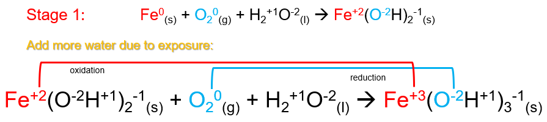

* _____, _____, _____, and exposure all accelerate corrosion.
* Coating the metal, reducing exposure, and replacing metal with plastic or alloys decreases _____.

Balancing Redox Equations

E_____ T_____ – Oxidation Number Method

1. Write _____ for products and reactants in “_____” (unbalanced) equations.

HNO3(aq) + H3PO3(aq) 🡪 NO(aq) + H3PO4(aq) + H2O(l)

2. Assign _____ numbers (states) to each element on both sides of the equation.

H+1**N+5**O3-2(aq) + H3+1**P+3**O3-2(aq) 🡪 **N+2**O-2(aq) + H3+1**P+5**O4-2(aq) + H2+1O-2(l)

* *Notice that Nitrogen and Phosphorus change oxidation states from reactants to products. This reveals the* _____ *reaction*.

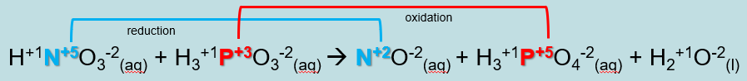

 3. Select the atom that is _____ (_____ e-, _____ oxidation number from _____ to _____) and select the atom that is _____ (_____ e-, _____ in oxidation number from reactants to products).

 _____ half reaction P+3 🡪 P+5 + 2 e-

 _____ half reaction N+5 + 3 e- 🡪 N+2

4. Write _____ half-reactions (oxidation and reduction)

5. Inspect the half-reactions, checking for conservation of mass (same number of atoms on both sides) and conservation of charge (same total charge on both sides)

6. _____ the half-reactions so that the number of _____ lost in _____ equals the number of electrons _____ in _____

Oxidation half reaction _ ( P+3 🡪 P+5 + 2 e- ) … _____ lost

_P+3 🡪 _P+5 + _ e-

Reduction half reaction __ ( N+5 + 3 e- 🡪 N+2 ) … _____ gained

__N+5 + __ e- 🡪 __N+2

7. Return to the overall chemical equation and add in appropriate coefficients (based on the half-reactions) to atoms that were oxidized and reduced.

**2**HNO3(aq) + **3**H3PO3(aq) 🡪 **2**NO(aq) + **3**H3PO4(aq) + H2O (l)

8. Finish by _____ the entire chemical equation ensuring conservation of mass & _____ for all atoms (reactants & products).

* ___ hydrogen atoms, ___ nitrogen atoms, ___ phosphorus atoms, and ___ oxygen atoms on each side of the equation

_____ Reaction Method

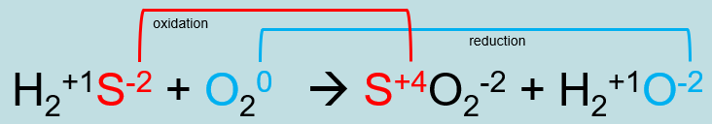

* _____ half reaction

**___** ( S-2 🡪 S+4 + 6e- ) = ___S-2 🡪 ___S+4 + **___ e-**

* _____ half reaction

**___** ( O20 + 4e- 🡪 2O-2 ) = ___O20 + **___ e-** 🡪 ___O-2

* In this redox reaction, _____ are lost & gained overall.
* Use the moles from the ½ reactions to balance the overall chemical equation:

___H2S(g) + ___O2(g) 🡪 ___SO2(g) + ___H2O(l)