**Functional Groups Chapter 23**

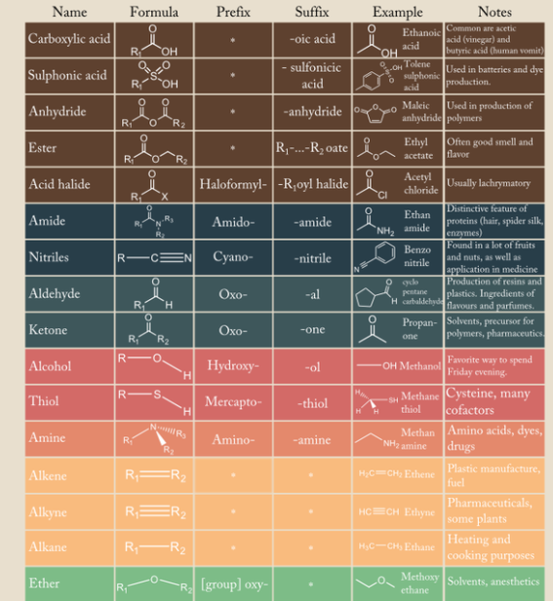

**See** [**https://www.learningctronline.com/courses**](https://www.learningctronline.com/courses) **for Materials and Resources.**

**Topics:**

1. Functional Groups

**Objectives:**

1. *Understand the bonding tendencies of the carbon atom.*
2. *Define hydrocarbon and identify / distinguish unsaturated hydrocarbons from saturated hydrocarbons.*
3. *Draw and identify alkanes, alkenes, and alkynes.*
4. *Describe features and structural characteristics of alkanes, alkenes, and alkynes.*
5. *Explain organic isomers and illustrate with various compounds.*
6. *Distinguish the two types of stereoisomers.*
7. *Identify and describe the general structure of cyclic hydrocarbons with examples.*
8. *Identify hydrocarbons found in nature and explain their origin and refinement.*
9. Classify organic compounds by their functional group.
10. Describe how substitution reactions are used.
11. Identify, draw, and explain the general formula of alcohols, ethers, amines, carboxylic acids, aldehydes, ketones and esters.
12. Describe how polymers are formed.
13. Distinguish addition reactions, dehydrogenation, and condensation reactions and which molecules are involved.

TAKE NOTE

1. Notes/Study Guide [from both weeks]
2. Organics PPT Notes Worksheet
3. Lab Organic Molecular Models
4. Lab Esters (using video)
5. Lesson Check & Sample Problems.
6. Test Organics

**Text**: Chapter 23: Functional Groups pp. 796-835

Read the assigned pages in the text.

**Class Notes: PowerPoint or PDF**

**Notes/Study Guide:** Fill in the Chapter 23 Study Guide worksheet to understand the class notes.

**Homework**: Text

(1) Answer the KEYED **“Lesson Check”** questions at the end of each.

(2) Answer the **“Sample problems”** found in the “Sample Problem” boxes throughout the chapter. An answer KEY is provided for you to use to self-correct your homework problems.

* Put your answers into complete thoughts in a Word document. Do NOT just put the answer, but write a phrase or sentence that you can study from for your tests. Save your work in a WORD document and SAVE into your HOMEWORK folder in the Chemistry folder on the desktop.

(3) Organic Notes (PPT) Worksheet

* Assignments will be “spot checked” during class or submitted via email.

**Lab**: Organic Molecular Models

Perform the **Organic Molecular Models Lab** using the worksheet.

* If you do not have molecular model kit, be creative and use household items as you did last week for the Carbon Compounds Lab.
* Include pictures of the molecules you build.
* Save the document into your LAB folder in the Chemistry folder on your desktop.
* Complete the lab worksheet and submit via email.

**Lab**: Esters

Complete the **Esters Lab** using the worksheet & video provided.

[**http://somup.com/c3VeYpZfMa**](http://somup.com/c3VeYpZfMa) **Making Esters in the Lab (3:08)**

* Answers are provided at the end for guidance.
* Save the document into your LAB folder in the Chemistry folder on your desktop.
* Submit the lab via email.

**TEST: Honors Students [must pass with 75%]**

1) the academic integrity policy

* Tests must be completed **WITHOUT** referring to books, notes, the internet, people, or any outside resources.
* Students **MAY** use the approved Periodic Tables, approved Reference Tables, or approved equation (formula) sheet (provided by the teacher) along with calculators and scratch paper.
* A guardian should be proctoring the test. Proctoring means to monitor the following:

2) The test is composed of 35 multiple choice questions and some written problems.

* The **multiple-choice test must be taken "in one sitting"**, meaning that once you start the test, you must complete it without interruption.
* Take a short break (5 minutes)
* There is **no** **written portion for the test.**

3) There is a **60-minute time limit** on this test. Please have the proctor write the time taken at the top of your answer sheet with their signature or initials.

4) Proctors should NOT be reading the test or engaging students during the test.

5) Do NOT use RED font. Black font is best.

Supplemental Resources (Optional)

1. Alcohols and Ethers Enrichment PPT

[**http://somup.com/c3VeYpZfMa**](http://somup.com/c3VeYpZfMa) **Making Esters in the Lab (3:08)**