**Stoichiometry Percent Yield Chapter 12B**

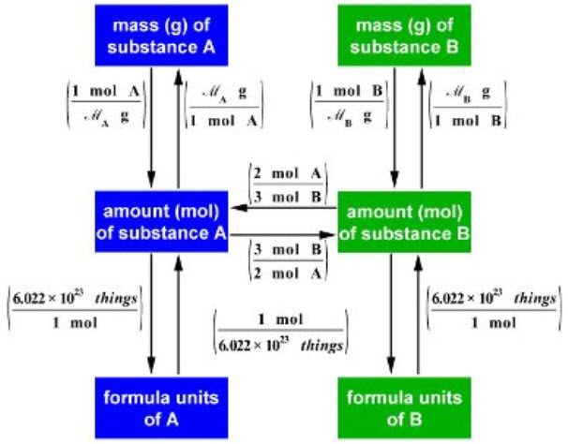

**See** [**https://www.learningctronline.com/courses**](https://www.learningctronline.com/courses) **for Materials and Resources.**

**Topics:**

1. Stoichiometry

**Objectives:**

1. Understand and use stoichiometry in balanced chemical equations (particularly regarding molar quantities of mass, volume, and number).
2. Explain and calculate the interconversion of reactants and products using mole ratios (coefficients).
3. Identify the limiting and excess reactants for a given reaction.
4. Use the limiting reactant to predict the theoretical yield of a reaction.
5. Calculate the percent yield of a reaction.

TAKE NOTE

1. Notes / Study Guide
2. Lesson Check & Sample Problems or Alternative Worksheets
3. Formal Lab Report Percent Yield (Procedures, Calculations and Data)
4. Lab Limiting Reagent
5. HONORS Quantitative Analysis Percent Yield Lab OR Explosive Stoichiometry Lab
6. Chapter 12 Test [NOTE: longer time allowed on this test]
7. Class Song: Don’t Be Distracted (Hey Look Me Over)
8. Week 20 Devotional (<https://www.learningctronline.com/devotional>)

**Text**: Chapter 12: Stoichiometry pp. 400-417

Read the assigned pages in the text.

**Class Notes: PowerPoint or PDF**

**Notes/Study Guide:** Fill in the Chapter 12 worksheet to understand the class notes.

**Homework**: TEXT

(1) Answer the KEYED **"Lesson Check"** questions at the end of each of the chapter.

(2) Answer the **"Sample problems"** found in the "Sample Problem" boxes throughout the chapter. An answer KEY is provided for you to use to self-correct your homework problems.

* Put your answers into complete thoughts in a Word document. Do NOT just put the answer, but write a phrase or sentence that you can study from for your tests. Save your work in a WORD document and SAVE into your HOMEWORK folder in the Chemistry folder on the desktop.
* Assignments will be “spot checked” during class or submitted via email.

**Alternate Homework**:

1. Stoichiometry Worksheet
2. Practice Lab Percent Yield

**Lab**: Limiting Reactant & Excess Reactant

* Perform the **"Limiting Reactant & Excess Reactant"** lab using the lab worksheet and video. You may use class notes to complete the lab worksheet.  
    
  [Limiting Reactant & Excess Reactant](https://screencast-o-matic.com/watch/cqjiqXOMtI) (10:32)
* Answers have been provided for guidance (scroll down the worksheet), but do not copy and paste.
* Save the document into your LAB folder in the Chemistry folder on your desktop.

**Lab**: Formal Lab Report: Percent Yield

* Perform the "Percent Yield" experiment using the worksheet provided below.
* Complete the worksheet as a formal lab report.
* All major aspects of a formal lab report are indicated on the worksheet. Be sure to complete all of them.
* For the conclusion questions, do NOT leave the questions in the lab report, but use the questions to make concluding statements in complete thought supported with evidence from the lab.

-------------------------------------------------------------------------------------------------------

1. Officially, the formal lab report will be due 4 days after week 21's class ends.
2. Consider using the Lab Report Checklist.

* Save the document into your LAB folder in the Chemistry folder on your desktop.

**Lab**: HONORS Quantitative Analysis Percent Yield Lab OR Explosive Stoichiometry Lab

* Save the document into your LAB folder in the Chemistry folder on your desktop.

**TEST:** Stoichiometry

1) the academic integrity policy

* Tests must be completed **WITHOUT** referring to books, notes, the internet, people, or any outside resources.
* Students **MAY** use the approved Periodic Tables, approved Reference Tables, or approved equation (formula) sheet (provided by the teacher) along with calculators and scratch paper.
* A guardian should be proctoring the test. Proctoring means to monitor the following:

2) The test is composed of 20 multiple choice questions and some written problems.

* The **multiple-choice test must be taken "in one sitting"**, meaning that once you start the test, you must complete it without interruption. (60 minutes)
* Take a short break (5-10 minutes)
* The **written portion of the test must be taken "in one sitting"**, meaning that once you start the test, you must complete it without interruption. (45 minutes)

3) There is a **105-minute time limit** on this test. Please have the proctor write the time taken at the top of your answer sheet with their signature or initials.

4) Proctors should NOT be reading the test or engaging students during the test.

5) Do NOT use RED font. Black font is best.

Supplemental Resources (Optional)

1. Explosive Stoichiometry
2. Quantitative Analysis Percent Yield Lab
3. Chapter 12 Study Guide Pearson

[Humility means Obedience unto Death Philippians 2:3, 5-8; If We're Honest](http://somup.com/cYhFoHjyIl) (4:39)