Ecology

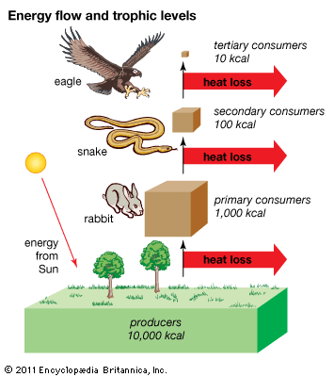

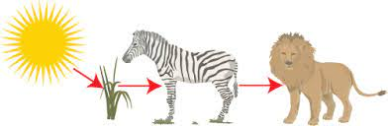

**See** [**https://www.learningctronline.com/courses**](https://www.learningctronline.com/courses) **for Materials and Resources.**

**Topics:**

1. Ecology

**Objectives:**

1. Define ecology and levels of organization within an individual and outside the organism.
2. Identify two major variables that affect all organisms.
3. Understand interactions in an ecosystem.
   1. Distinguish habitat from niche.
   2. Food chains, food webs, food pyramids
   3. Food relationships, cycles of materials in nature
4. Explain how energy flows between trophic levels of a food chain (pyramid).
5. Describe how energy supply limits the length of food chains

TAKE NOTE

1. Notes/Study Guide (1 week) … Ecology Introduction
2. Homework from Text (2 weeks)
3. Lab Creating an Antarctic Food Web (1 week)
4. HONORS or BONUS Lab Pyramid & Biomass
5. Week 28 Devotional (<https://www.learningctronline.com/devotional>)

**Text**: Chapter 34: Ecology pp. 708 – 732

Read the assigned pages in the text.

**Class Notes: PowerPoint or PDF**

**Notes/Study Guide:** Fill in the Study Guide worksheet to understand the class notes.

**Homework**: (2 weeks)

* Study Questions (end of the chapter 34 in the text) #2, 7-8, 11, 15-16 (explain true/false)
* Use a Word document format as follows:
  + Heading: Your name, Chapter in Text, Study Questions
  + Number the appropriate questions you are to answer
  + Write the answer in a complete sentence use the question as the template (do not copy the question, but reword it into a statement that answers the question).
* Use the same document each week by starting a new “Study Question” for a different chapter on the next page.
* Assignments will be “spot checked” during class or submitted via email.

**Lab**: Creating an Antarctic Food Web (due by next class)

* Complete the "Creating an Antarctic Food Web" using the worksheet provided.
* A worksheet with instructions is also provided on the Learning CTR Online website.
* This project is due before next week’s class.
* After completing the lab, email it to [learningctronline@gmail.com](mailto:learningctronline@gmail.com) for grading.
* Save document into your LAB folder in the Biology folder on your desktop.

**TEST:** no Quiz or Test this week. Test after next week’s class.

Supplemental Resources (Optional)

1. Vocabulary Review Crossword (Ecology Introduction)
2. Lab Pyramid & Biomass
3. Aquatic Ecology Reference Material and Worksheet
4. Ecological Pyramids Worksheet

<https://youtu.be/f8G7IulYxiA> (6:22) The Amoeba Sisters Channel – Autotrophs & Heterotrophs

# <https://youtu.be/-oVavgmveyY> (5:48) The Amoeba Sisters Channel – Food Webs and Energy Pyramids: Bedrocks of Biodiversity