**Covalent & Hybrid Bonding Chapter 8B**

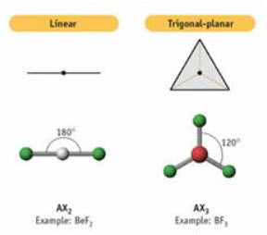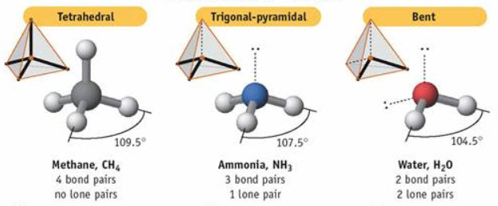

**See** [**https://www.learningctronline.com/courses**](https://www.learningctronline.com/courses) **for Materials and Resources.**

**Topics:**

1. Covalent & Hybrid Bonding

**Objectives:**

1. Define bond dissociation in relation to bond strength.
2. Recognize molecular orbitals (sigma and pi bonds) that relate to single, double and triple bonds.
3. Understand and draw molecules that have exceptions to the octet rule and demonstrate resonance (when bonds are intermediate in length).
4. Understand the theory behind molecular geometric shapes (linear, bent, trigonal planar, pyramidal, and tetrahedral).
5. Explain hybrid orbital theory in terms of molecular geometry.
6. Identify and define intermolecular attractions (Van Der Waals, Hydrogen Bonding, Network Solids) and how these affect chemical properties of the molecules.
7. *Explain covalent bonding in terms of bonds (nonpolar, polar, and coordinate covalent) and molecules (nonpolar & polar).*
8. *Define and recognize polyatomic ions.*
9. *Understanding how to represent molecules, compounds and types of covalent bonds (single, double, triple) in various ways (molecular & structural formulas, Lewis structures).*

TAKE NOTE

1. Lesson Check/Sample problems or Covalent Bonding Study Guide and PowerPoints Lesson Review slides.
2. Lab Polar Vs. Non-Polar Compounds
3. HONORS 🡪 Study Guide; practical application of network solids
4. Covalent & Hybrid Bonding Test
5. Week 12 Devotional (<https://www.learningctronline.com/devotional>)

**Text**: Chapter 8: Covalent & Hybrid Bonding pp. 240-261

Read the assigned pages in the text.

**Class Notes: PowerPoint or PDF**

**Notes/Study Guide:** Fill in the Chapter 8 worksheet to understand the class notes.

**Homework**: TEXT

(1) Answer the KEYED **"Lesson Check"** questions at the end of each of the chapter.

(2) Answer the **"Sample problems"** found in the "Sample Problem" boxes throughout the chapter. An answer KEY is provided for you to use to self-correct your homework problems.

* Put your answers into complete thoughts in a Word document. Do NOT just put the answer, but write a phrase or sentence that you can study from for your tests. Save your work in a WORD document and SAVE into your HOMEWORK folder in the Chemistry folder on the desktop.
* Assignments will be “spot checked” during class or submitted via email.

**Alternate Homework**:

1. Covalent Bonding Study Guide
2. Do the Review slides at the end of each class notes for last week and this week.

HONORS (research a practical application for Network Solids) … [no less than 1 hour, no more than 2 hours]

**Lab**: Polar vs Non-Polar Compounds

Two experiments illustrating some implications of polar and non-polar molecules.

* Use the worksheet provided and perform the experiments as directed.
* Answers are provided at the end of the link for guidance, but you must use your own words (do not copy and paste my answers).
* You may use the following video links to help with the lab:  
    
  [Dancing Water ctr](https://screencast-o-matic.com/watch/cFXiD9YP5e) (1:09) ... Polarity of Water  
    
  [Salt Dissolves in Water](https://screencast-o-matic.com/watch/cFXTY7rbyC) (0:24)
* Save the document into your LAB folder in the Chemistry folder on your desktop.
* Assignments will be “spot checked” during class or submitted via email.

**TEST:** Covalent & Hybrid Bonding

1) the academic integrity policy

* Tests must be completed **WITHOUT** referring to books, notes, the internet, people, or any outside resources.
* Students **MAY** use the approved Periodic Tables, approved Reference Tables, or approved equation (formula) sheet (provided by the teacher) along with calculators and scratch paper.
* A guardian should be proctoring the test. Proctoring means to monitor the following:

2) The test is composed of 20 multiple choice questions and some written problems.

* The **multiple-choice test must be taken "in one sitting"**, meaning that once you start the test, you must complete it without interruption. (40 minutes)
* Take a short break (5-10 minutes)
* The **written portion of the test must be taken "in one sitting"**, meaning that once you start the test, you must complete it without interruption. (30 minutes)

3) There is a **70-minute time limit** on this test. Please have the proctor write the time taken at the top of your answer sheet with their signature or initials.

4) Proctors should NOT be reading the test or engaging students during the test.

5) Do NOT use RED font. Black font is best.

Supplemental Resources (Optional)

1. Chapter 8 Study Guide Pearson

[Sigma & Pi Bonds](http://somup.com/cF6hDVnVWP) (3:12)  
  
[Hybrid Orbitals ctr](http://somup.com/cF6j2nnnFF) (4:43) sp (linear), sp2 (trigonal planar), sp3 (tetrahedral)  
  
[Molecular Attractions (InTRAmolecular bonds versus InTERmolecular Attractions) ctr](http://somup.com/cF61rknnjc) (7:05)  
LDF, H-bonds, VDW, Molecule-ion, Network Solids, Metallic Bonds  
  
[Electron Dot Diagrams (Lewis Structures)](http://somup.com/cFQ3ldVWWC) (4:57) 5 Steps  
  
[Determining Oxidation State](http://somup.com/cFXl25niyM) (7:09)  
Determining oxidation state of atoms and molecules. Oxidation states of molecules add up to zero (as in ionic compounds). Oxidation states of polyatomic ions add up to the charge of the ion. Free elements (including Professor HOFBrINCl diatomic molecules) have oxidation states of zero.  
  
[The Word is Living and Operative Hebrews 4:12-13; The Word is Alive](http://somup.com/cYhDIkjUhi) (6:22)